AI-Powered Virtual Medical Assistant and Smart Doctor Calling Agent

Project Proposal



Supervisor
Dr. Syed Aun Irtaza

Submitted by

Muhammad Aatir
22-CS-09
Mudassir Rizwan
22-CS-30
Shariq Mateen
22-CS-96

Department of Computer Science,
University of Engineering & Technology Taxila.

Introduction
The planned project is called AI-Powered Virtual Medical Assistant and Smart Doctor Calling Agent, the focus of which is to establish a set of artificial intelligence that will facilitate and enhance the process of communication with patients and doctors. Numerous patients find it difficult to explain their symptoms or the specialist to see. We are launching our system, which involves a chatbot that engages with patients in a conversational manner, studies their symptoms with the help of AI, and recommends appropriate doctors, depending on the conditions and the location that they report. The system will also include a calling agent that is specific to doctors and will handle calls from patients, appointments, and even inquiries automatically, thus eliminating the administrative burden on medical personnel.
The solution will be developed on Next.js as a front-end interface, Express.js as a backend API service, and PostgreSQL as a database manager. Workflow automation and integration between system modules will be done through n8n; the conversational chatbot will be powered by the OpenAI API. VAPI will be used in automating the doctor-side call management to facilitate a smooth process in voice-based communication.

Objective
The main goal of the project is to deploy a smart, AI-based medical assistant, which, having learned about the symptoms of the patient, will be able to give appropriate medical advice, will be able to recommend doctors nearby, and will be able to manage doctor calls automatically. The system is supposed to improve the availability, precision, and effectiveness of healthcare communication.

Problem Description
The healthcare industry is struggling with the problem of serving a large number of patients, particularly in the case of the first consultation. Patients experience a problem of finding the correct doctor and knowing whether their condition needs urgent medical care or not [1]. The use of manual systems to manage calls and book appointments results in time delays, misunderstandings, and time wastage for the doctors. [2].
These problems can be resolved in our project because it introduces a conversational AI system that could communicate with patients, recognize possible diseases based on symptom analysis, and suggest appropriate doctors. [3] [4]. The system offers personalized recommendations where names of doctors and their addresses are available, and patients are empowered to make decisions. The VAPI-powered n8n smart calling agent automates the management of calls, booking of appointments, and dissemination of information on the side of the doctor when patients call the doctor's office.
The system alleviates workload, decreases the response time, and guarantees a more seamless experience between a patient and a doctor by integrating AI, workflow automation, and communication APIs, without the necessity to operate within a centralized healthcare network.

Methodology
The suggested system will be built on a modular and scalable architecture. The front-end interface of patient interactions will be the AI chatbot module, which will be developed using OpenAI. Patients will report their symptoms in natural language, and they will be analyzed with a developed and trained machine learning model that was created with the help of healthcare data, including the publicly available Kaggle Disease Symptom Prediction dataset. [5] [6] [7]. The model will detect the likely situations and give applicable recommendations.
Express.js backend will be used to facilitate communication between the chatbot and the database, as well as automation services. The records of all the interactions and outcomes of the patient will be registered in a PostgreSQL database to keep them safe and analyze them further.
In the case of doctors, the smart calling agent with VAPI will automatically control the incoming calls of patients. It will also give voice-based replies in case of frequent questions, handle the booking of appointments, and receive messages in case the doctor is not available.
It will have the Next.js frontend with a responsive and intuitive interface, where the patient and doctor can see chatbot logs, doctor recommendations, call logs, and appointment details.

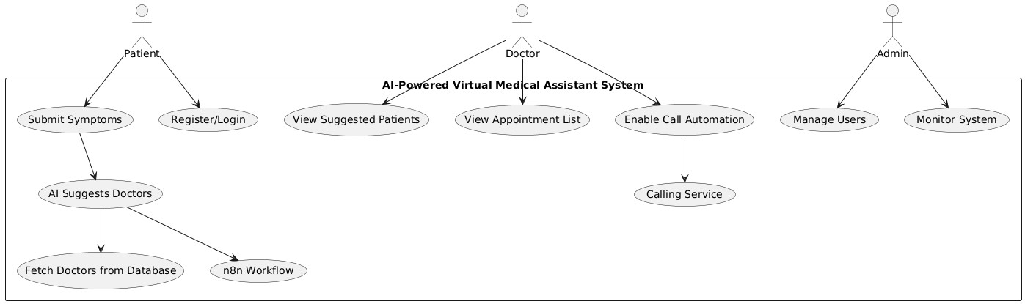
Figure 1: Use Case Diagram

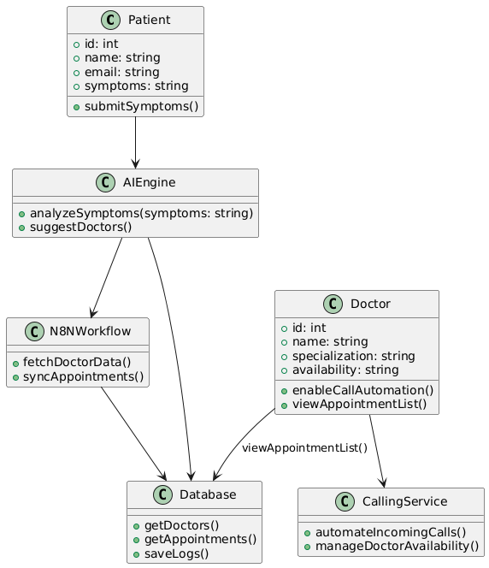
Figure 2: Class Diagram
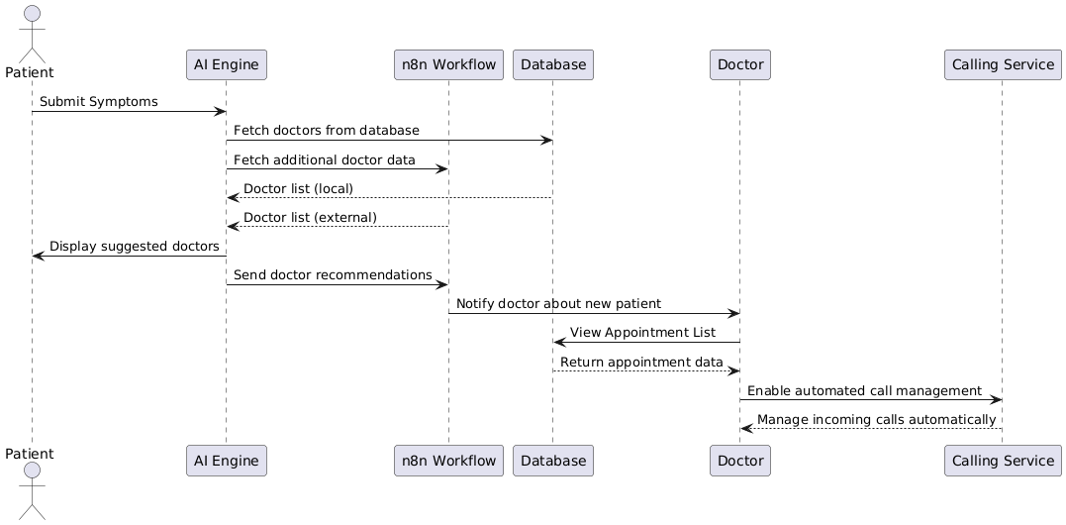
Figure 3: Sequence Diagram

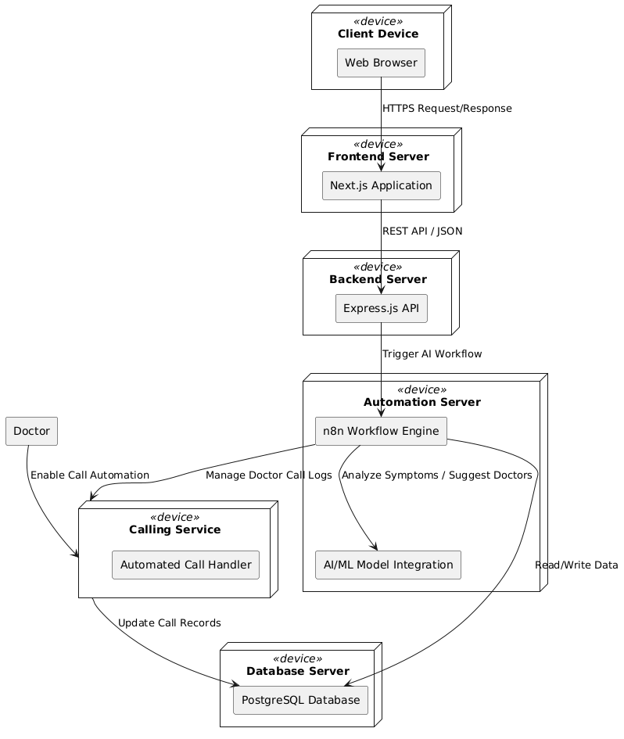
Figure 4: Deployment Diagram

Project Scope
The system will address AI-based interaction with patients, their symptom analysis, and doctor recommendations, as well as the automation of calls on the doctor's side. The system also assumes that users have access to the internet and gives the correct information regarding their symptoms. This project does not involve integration with hospital management systems or real-time medical device monitoring; however, it can be considered in case of expansion.

Feasibility Study
The project is highly feasible due to the availability of reliable APIs and frameworks.
    - Risks Involved: The main risks include the accuracy of the analysis of AI symptoms and the safety of sensitive patient information. These issues will be reduced with the help of the careful selection of the dataset, the ethical processing of data, and the safe design of the database.
    - Resource Requirement: The necessary assets are the development machines, access to OpenAI and VAPI API, an n8n instance to automate all these, and PostgreSQL cloud hosting. The schedule of the project fits the academic schedule quite well, and the experience of working in the team guarantees the timely performance.

Solution Application Areas
This project has great potential in telemedicine, online consultation sites, and hospital support systems. Clinics can use it to automate their appointment management, and health organizations can use it to help patients engage in preliminary self-assessment. It can also be useful to NGOs and government initiatives to refer patients to the right medical care in places with poor healthcare facilities.

Tools/Technology
The proposed system will be based on Next.js as the frontend, Express.js as the backend, PostgreSQL as the database management tool, OpenAI APIs as conversational intelligence, Python for the ML model-training, VAPI as the call management tool, and n8n as the workflow automation and integration tool. The tools that will be used in the development will be VS Code, Docker, and Postman to test and deploy the API.

Expertise of the Team Members
All three members of the team are qualified in terms of technical and analytical skills for the project. Muhammad Aatir will work on the AI model training and workflow automation with n8n and make sure that the machine learning model, chatbot, and external services work well together. The frontend based on Next.js will be designed and implemented by Mudassir Rizwan, who will make sure that the interface is user-friendly between the patients and the doctors, and also implement the calling functionality that will allow patients to get a recommendation and begin communication with the system by using this functionality. Shariq Mateen will build the server with Express.js and PostgreSQL, which deals with the data processing, API endpoints, and the logic of the system. This project will be the best synthesis of the skills and interests of the team, who have already taken courses in Artificial Intelligence, Database Systems, Software Engineering, and Web Technologies.

Milestones
The key milestones include:
- Project Planning and Literature Review
- System Design and Architecture Development
- Dataset Preparation and Machine Learning Model Training
- Backend Development (Express.js + PostgreSQL)
- Frontend Development (Next.js)
- Workflow Automation with n8n
- Integration and Testing
- Deployment and Hosting
- Documentation and Final Report Preparation

References
[1] K. S. Alraddadi, F. Al-Adwani, Z. A. Taher, M. Al-Mansour, and M. Khan, "Factors influencing patients’ preferences for their treating physician," Saudi medical journal, vol. 41, no. 8, p. 866, 2020.
[2] A. Ala and F. Chen, "Appointment scheduling problem in complexity systems of the healthcare services: A comprehensive review," Journal of Healthcare Engineering, vol. 2022, no. 1, p. 5819813, 2022.
[3] L. Laranjo et al., "Conversational agents in healthcare: a systematic review," Journal of the American Medical Informatics Association, vol. 25, no. 9, pp. 1248-1258, 2018.
[4] D. Perez-Marin and I. Pascual-Nieto, Conversational agents and natural language interaction: Techniques and effective practices: Techniques and effective practices. IGI Global, 2011.
[5] D. Ajmera, T. N. Pandey, S. Singh, S. Pal, S. Vyas, and C. K. Nayak, "Early-Stage Disease Prediction from Various Symptoms Using Machine Learning Models," EAI Endorsed Transactions on Internet of Things, vol. 10, 2024.
[6] S. S. Al-qarni and A. Algarni, "Disease Prediction from Symptom Descriptions Using Deep Learning and NLP Technique," International Journal of Advanced Computer Science & Applications, vol. 16, no. 5, 2025.
[7] K. S. Kumar, M. S. Sathya, A. Nadeem, and S. Rajesh, "Diseases Prediction based on Symptoms using Database and GUI," in 2022 6th International Conference on Computing Methodologies and Communication (ICCMC), 2022: IEEE, pp. 1353-1357.

