# CompSys

## compSys.sql

## Project Brief

**PC Solutions** is considering implementing a computerised system to handle their staffs, customers, repairs, inventory and account records. The following is a description of the system:

Details of all the **Staff**, including managers, interns and normal staff, is recorded in the **Staff File.** Each staff is identified by a unique staff ID and has staff details – surname, forename, DOB, gender, address1, address2, town, county, telephone, mobile, e-mail, staff type and status. The company has the ability to Add, Amend and List the details of all the staff in the Staff File.

The company will record every customer before they can proceed with a new repair, therefore, the company needs to store all the **Customers** in the **Customers File**. Each customer is identified by a unique customer ID and has the details – Surname, Forename, DOB, Gender, Address1, Address2, Town, County, Telephone, Mobile, E-Mail, Customer Type and Status. The company has the ability to Add, Amend, Query and List the details of all the customers in the Customers File.

The requirements of an incoming repair job are logged in the **Repairs File.** Each job is assigned a job reference number and may be for a new customer or an existing customer. For new customers, the customer details are recorded in the Customer File. A job is for only one ‘Repair ID’ but a customer may have several jobs on-going at the same time.

# SELECT

**SELECT DISTINCT c.cust_id, c.surname, c.forename, c.town, c.county, c.tel FROM customers c ORDER BY c.cust_id;**

**Location: ajax/getCustomers.php**



**Data produced: (COURTESY angularcode.com)**

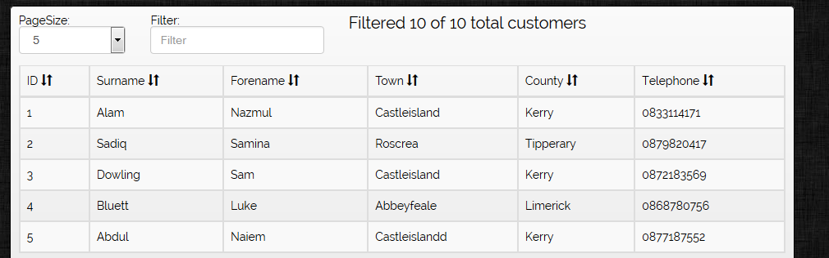

**SELECT status, COUNT(status) AS total**

**FROM Repairs**

**WHERE month(repairDate) = EXTRACT(month FROM (NOW()))**

**GROUP BY status**

**ORDER BY repairDate DESC;**

**Location: piechart.php**

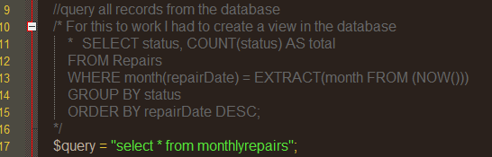

**Created a ‘MySQL View’ to display the piechart using google’s Chart module**

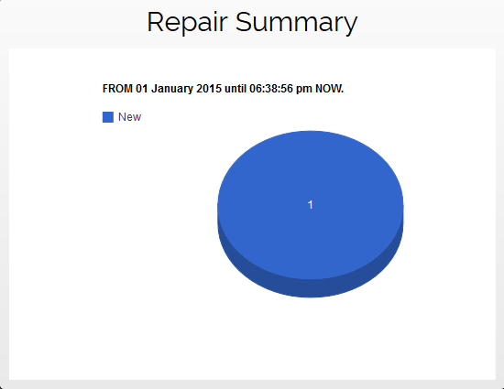

# INSERT

INSERT INTO staff (forename, surname, username, password, email, town, county, tel)

VALUES ('$forename', '$surname', '$username', '$password', '$email', '$town', '$county', '$tel')

Location: addNewStaff.php



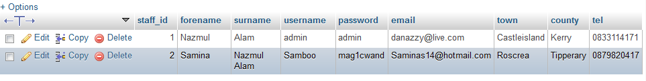

# DELETE

DELETE from stock WHERE stock_id = $stockid

Location: delete/inventoryDelete.php



# UPDATE

"UPDATE customers SET surname ='$ud_name', forename ='$ud_forename', town = '$ud_town', county = '$ud_county', tel = '$ud_tel' WHERE cust_id=$ud_id";

Location: update/customerUpdated.php



# PROCESS

products.php

displayproducts.php

cart.php

ordered.php

newOrder.php