Meeting Minutes
Date: 29/05/2024 Time: 10:10 am
Project Title: AlmaBridge
Members:
Name | Attendance/ Remark
Dr. Faiza Iqbal | Present
Muhammad Abdullah | Absent
Shahzaib Ijaz | Absent
Fatima Awais | Present
Zoya Naveed | Present

Type of Meeting: Physical
Location: Faculty Office, Computer Science Department

Agenda:
- Technology to be used
- Division of Modules
- Pattern for next meetings
- Use of Slack for formal conversation

Discussion or Feedback:
- Use of web 3.0 backend (Blockchain)
- It is recommended that each group member works on a different module (Gen AI, Next JS, AR, etc.), according to their interest in the field.
- An elaborated document has to be shared with the advisor (Dr. Faiza Iqbal) before every meeting.
- Ideas related to the project should be discussed and brainstormed in a formal way on Slack.

Signature:

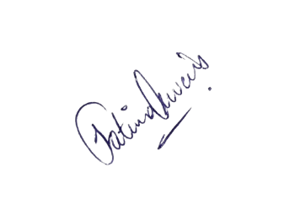


________________
Dr. Faiza Iqbal
________________
Fatima Awais
________________
Zoya Naveed

