**Meeting Minutes**

**Date:** 12/07/24 **Time:** 09:00 pm – 10:00 pm

**Project Title: AlmaBridge (Building Bridge Across Generations)**

**Members:**

|  |  |
| --- | --- |
| **Name** | **Attendance/ Remark** |
| **Dr. Faiza Iqbal** | **Absent** |
| **Muhammad Abdullah** | **Present** |
| **Shahzaib Ijaz** | **Present** |
| **Fatima Awais** | **Present** |
| **Zoya Naveed** | **Present** |

**Type of Meeting:** Online

**Platform:** Google Meet

**Agenda:**

* **Discuss points provided by Dr. Samyan for the idea defense**
* **Assign responsibility for each point.**
* **Discuss the potential appointment of Ma’am Ramsha as Co-supervisor.**

**Discussion or Feedback:**

1. Responsibilities were assigned: Zoya Naveed will explain the project’s purpose, emphasizing our unique solution problem and also describe the final product. Fatima will research existing systems, identify gaps, and gather data about our university’s system.
2. Abdullah and Shahzaib will outline the tentative methodology, including detailed steps, phases of work, and roles for each team member and they will also discuss commercialization strategies.
3. The potential appointment of Ma’am Ramsha as co-supervisor was considered.
4. A survey was conducted to collect data from students of different universities, accessible through the provided [link](https://forms.gle/TmurRLo2m35R4vP47).
5. The slides template has been uploaded to onedrive and all the members are added via email. Everyone can access the slides and start working.

**Signature:**

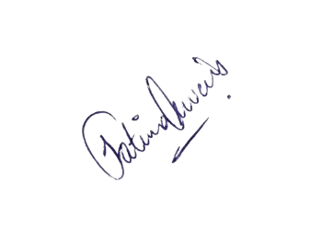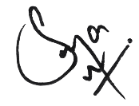

________________  
 Dr. Faiza Iqbal

________________  
 Fatima Awais

________________  
 Zoya Naveed

________________  
 Shahzaib Ijaz

________________  
 Abdullah Talib

