**Meeting Minutes**

**Date:** 29/05/2024 **Time:** 10:10 am

**Project Title: AlmaBridge**

**Members:**

|  |  |
| --- | --- |
| **Name** | **Attendance/ Remark** |
| **Dr. Faiza Iqbal** | **Present** |
| **Muhammad Abdullah** | **Absent** |
| **Shahzaib Ijaz** | **Absent** |
| **Fatima Awais** | **Present** |
| **Zoya Naveed** | **Present** |

**Type of Meeting:** Physical

**Location:** Faculty Office, Computer Science Department

**Agenda:**

* **Technology to be used**
* **Division of Modules**
* **Pattern for next meetings**
* **Use of Slack for formal conversation**

**Discussion or Feedback:**

1. Use of web 3.0 backend (Blockchain)
2. It is recommended that each group member works on a different module (Gen AI, Next JS, AR, etc.), according to their interest in the field.
3. An elaborated document has to be shared with the advisor (Dr. Faiza Iqbal) before every meeting.
4. Ideas related to the project should be discussed and brainstormed in a formal way on Slack.

**Signature:**

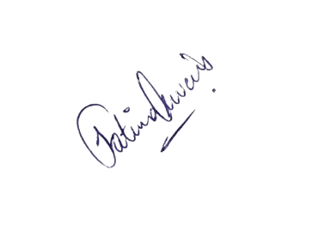

________________  
 Dr. Faiza Iqbal

________________  
 Fatima Awais

________________  
 Zoya Naveed