Column Graph:

Pi Graph:

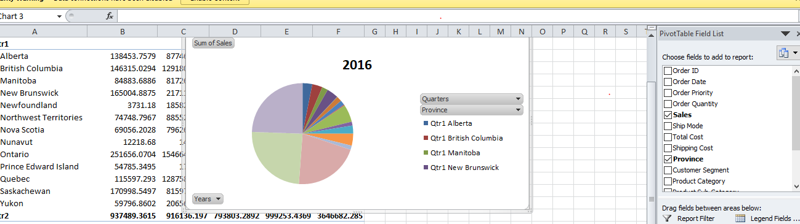

Line Graph: