Muhammad Abdullah

L1F21BSCS0379

Human Computer Interaction

Assignment 01

Section D11

Good Design Bad Design

Picture 1

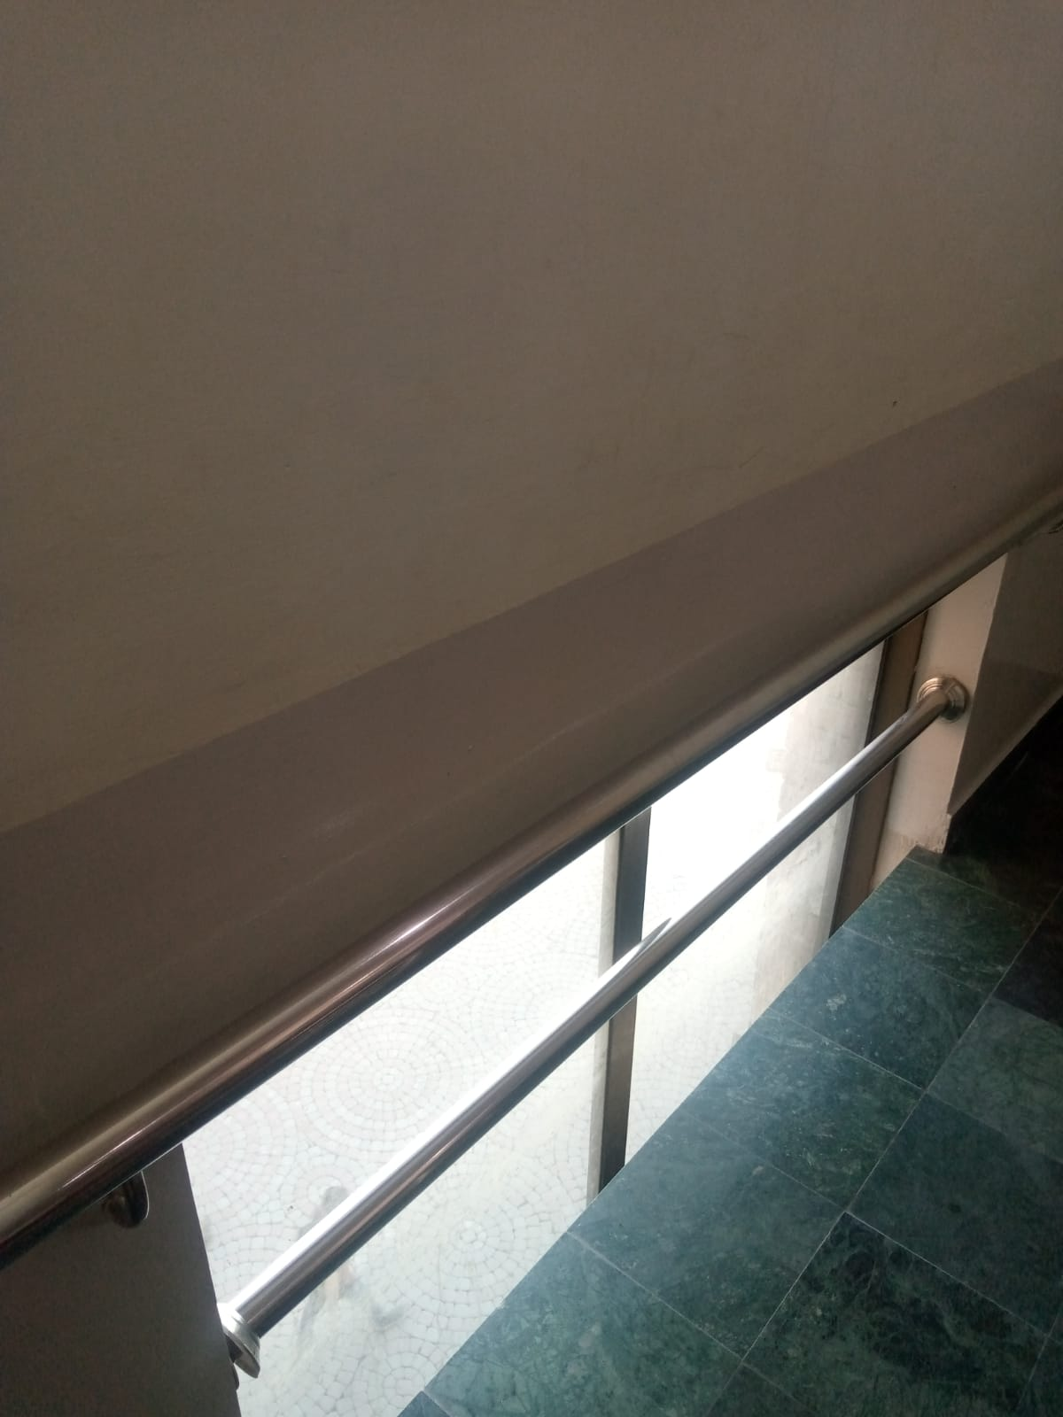

In this picture you can see that half of the window is below ground level and half is above, which is completely pointless.This window could have been useful if it had been built a little up from the ground level.

Picture 2

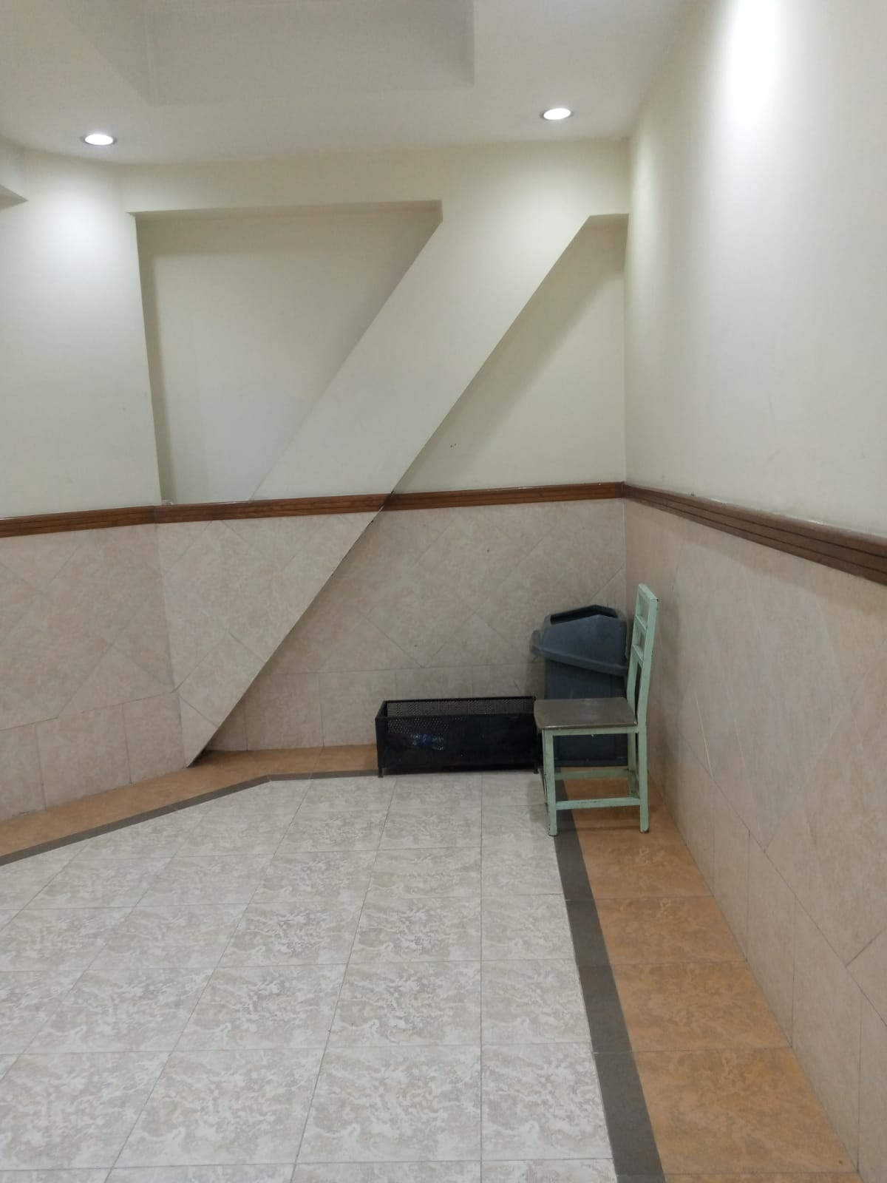

It is a closed wall and there is a pillar built in the middle of it which is totally unnecessary.Either this wall could have been made completely plain or some blocks and racks could have been made in it so it could have been used as a cupboard etc..

Picture 3

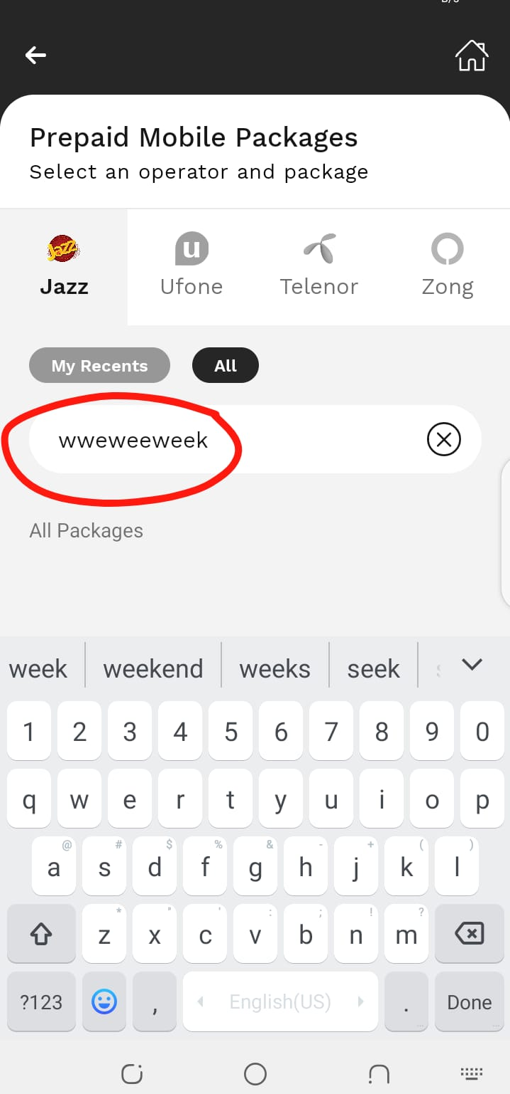

Here is the screenshot taken of Jazzcash app you can see that it has a lot of problem when you type something in it to select your package. I tried just writing the week to select the weekly packages and it was all written automatically. This is a huge problem that causes a lot of trouble for the users and should be addressed and can be solved by using programming on the backend with the help of appropriate app developers.