1. SECTION: A9
2. ROLL NUMBER: LF2BSCS0379

**3**. NAME: **Muhammad** **Abdullah**

Question No 1

**Puzzle bridges**

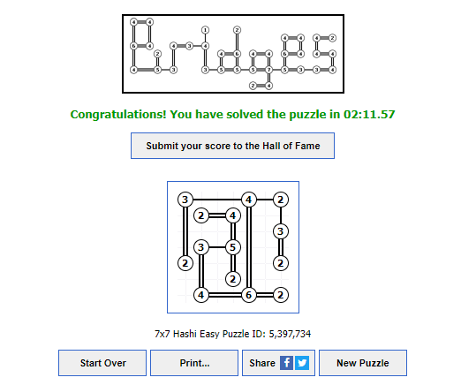

**Question No 2**

**Puzzle nonograms**

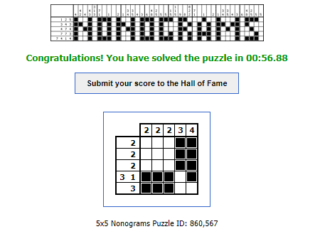

Question No 3

**Minesweeper**

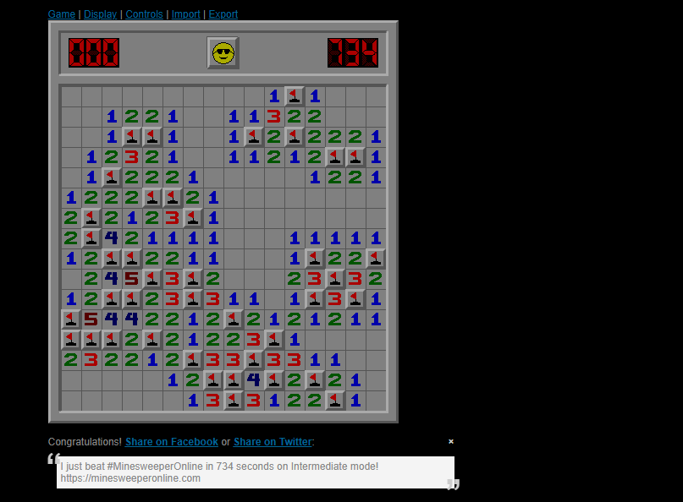

**Question No 4**

**Brainbashers (futoshiki)**

|  |  |
| --- | --- |
|  | **DECLARATION:**  I am aware of and understand the University’s policy on plagiarism and I certify that this assignment is my own work**,** except where indicated by referencing, and that I have followed the good academic practices noted above  Signed Muhammad Abdullah |

**kh**