**Logic thinking Assignment no 2**

**NAME: Muhammad Abdullah**

**Reg. no: L1F21BSCS0379**

**Section: A9**

**QUESTION NO 1**

1. **If the weight of the ball is quadrupled there will be no effect in the distance.**

**Also the weight is same in the whole table.**

1. **If the particular time is doubled it will increase the distance four times which a ball travels.**
2. **0.25 sec will be required to travel a ball 1.5 inches because if a ball is travelling 6 inches in 1 sec so it will take 0.25 sec for covering the distance of 1.5 inches.**
3. **The ball will travel nearly 13 inches in 1.5 seconds.**

**QUESTION NO 2**

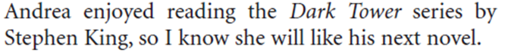

**Ans: The above paragraph is an example of inductive reasoning because it is based on assumption.**



**Ans: The above paragraph is an example of deductive reasoning because it is indicating about someone’s fixed and continuous habit.**



**Ans: The above paragraph is also an example of deductive reasoning because it is indicating about someone’s fixed and continuous habit.**

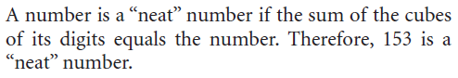

**Ans: The above paragraph is an example of deductive reasoning because it is mentioning the pure logic.**

**QUESTION NO 3**

Find a counter example to show that the statement is false

A.



**Here’s if we take 0 as the value of x then the above statement will be false so this the counter example**

**0+0>0**

B.



**Assign a random value to x and same for the y but in negative so in this case this will become a counter example for the above equation.**

C.

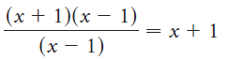

**Now here if we take 1 as a value to x hereby you can see the denominator value of the above given equation becomes infinity so this can be taken as counter example in this case.**

D.

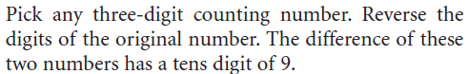

**There is no counter example for the above statement because tens always contain a 9 in it.**

E.

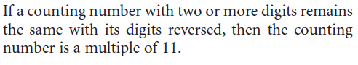

**787 is the counter example for above statement as you can see if we rewrite the values like 787-787 so here you see it remains same and also the value is not the multiple of 11.**

**QUESTION NO 4**

**Coin collectors met in Philadelphia**

**Stamp collectors met in Atlanta**

**Comic book collectors met in Seattle**

**Baseball cards collectors met in Chicago**

**QUESTION NO 5**

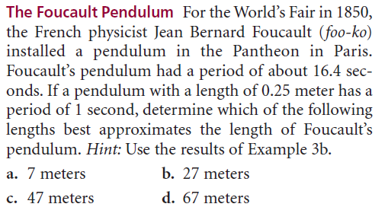

**Ans: By using the formula of time pendulum which is T = 2π Square root of√L/g**

**47 meters is the best approximates the length of Foucault’s pendulum**