Department of Computer and Software Engineering- ITU
SE102T: Object Oriented Programming
Course Instructor: Usama Bin Shakeel | Dated: 6th May, 2024
Teaching Assistants: Abdullah, Zain | Semester: Spring 2024
Session: 2023-2027 | Batch: BSCE2023

Assignment 10 & 11. Python & Java: Inheritance

Name | Roll number | Obtained Marks/35

Checked on: ____________________________

Signature: ___________________________

10.1 Objective
The objective of this assignment is to refresh the concept covered so far in this semester. These concepts form the backbone of OOP.

10.2 Equipment and Component
Component Description | Quantity
Computer | 1

10.3 Conduct of assignment
- Students are required to perform this assignment individually. Copying from other fellows is strictly prohibited. All assignments will be checked for plagiarism.
- Seek help from the course instructor, lab engineers, assigned teaching assistants (TA) only.

10.4 Theory and Background
This week primarily focused on Inheritance, Operator Overloading, Member & Non-Member Functions). Inheritance, operator overloading and member/non-member functions are powerful features that contribute to the flexibility and extensibility of the language.

Task 1: Accept the assignment posted in Google Classroom and after accepting clone the repository to your computer for this ensure you have logged into github app with your account.
Task 2: Solve the given problems written after task instructions, write code through IDE like CLion
Task 3: Ensure your code/solution is in the cloned folder.
Task 4: Commit and Push the changes through the Github App
Write code in functions named q1, q2, and so on, after completing each part, verify through running code using “make run” on Cygwin. Make sure to test the code “make test”
Problem Title: Hospital Management System
Problem Description:
The objective of this assignment is to make a hospital management system. Find the following UML diagram for the implementation:
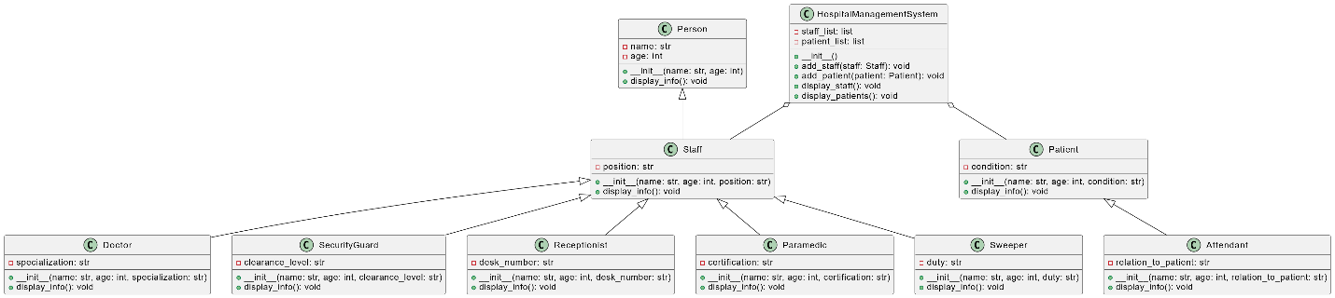
Note:
- Keep the classes in different files and import your classes in your main
- Make a responsive menu, do extensive testing and add results in your lab report for the documentation marks

//Paste code here

Assessment Rubric for Assignment
Performance metric | CLO | Able to complete the task over 80% (4-5) | Able to complete the task 50-80% (2-3) | Able to complete the task below 50% (0-1) | Marks
- Realization of experiment | 3 | Executes without errors excellent user prompts, good use of symbols, spacing in output. Through testing has been completed . | Executes without errors, user prompts are understandable, minimum use of symbols or spacing in output. Some testing has been completed . | Does not execute due to syntax errors, runtime errors, user prompts are misleading or non- existent. No testing has been completed.
- Conducting experiment | 2 | Able to make changes and answered all questions. | Partially able to make changes and few incorrect answers. | Unable to make changes and answer all questions.
- Computer  use | 3 | Document submission timely. | Document submission late. | Document submission not done.
- Teamwork | 4 | Actively engages and cooperates with other group member(s) in effective manner. | Cooperates with other group member(s) in a reasonable manner but conduct can be  improved. | Distracts or discourages other group members from conducting the experiment
- Laboratory safety and disciplinary rules | 4 | Code comments are added and does help the reader to understand the code. | Code comments are added and does not help the reader to understand the code. | Code comments are not added.
- Data collection | 4 | Excellent use of white space, creatively organized work, excellent use of variables and constants, correct identifiers for constants, No line-wrap. | Includes name, and assignment, white space makes the program fairly easy to read. Title, organized work, good use of variables. | Poor use of white space (indentation, blank lines) making code hard to read, disorganized and messy.
- Data analysis | 3 | Solution is efficient, easy to understand, and maintain . | A logical solution that is easy to follow but it is not the most efficient. | A difficult and inefficient solution .
Total (out of 35):

