Department of Computer and Software Engineering- ITU
SE101: Object Oriented Programming
Course Instructor: Usama Bin Shakeel | Dated: 20th Febrary, 2023
Teaching Assistants: Abdullah, Zain | Semester: Spring 2024
Session: 2023-2027 | Batch: BSCE2023

Assignment 4. Classes: Scope, Operator Overloading

Name | Roll number | Obtained Marks/35

Checked on: ____________________________

Signature: ___________________________

4.1 Objective
The objective of this course to refreshen your computer fundamentals and programming concept for the jumpstart of OOP course for this semester.

4.2 Equipment and Component
Component Description | Quantity
Computer | 1

4.3 Conduct of assignment
- Students are required to perform this assignment individually. Copying from other fellows is strictly prohibited. All assignments will be checked for plagiarism.
- Seek help from the course instructor, lab engineers, assigned teaching assistants (TA) only.

4.4 Theory and Background
This week primarily focused on classes, scope of variables, UML diagram for visualizing the visualizing, specifying, constructing, and documenting the artifacts of a system. Last major concept that is delivered in this week is the operator overloading.

Task 1: Accept the assignment posted in Google Classroom and after accepting clone the repository to your computer for this ensure you have logged into github app with your account.
Task 2: Solve the given problems written after task instructions, write code through IDE like CLion
Task 3: Ensure your code/solution is in the cloned folder.
Task 4: Commit and Push the changes through the Github App
Write code in functions named q1, q2, and so on, after completing each part, verify through running code using “make run” on Cygwin. Make sure to test the code “make test”.
Q1. Implement the classes Card, Deck, Player, and CardGame based on the provided UML diagram below:
The CardGame class should have a method displayGameState() that prints the current state of the game, showing the cards in the main deck and the hands of each player.
Write a program to simulate a simple card game using these classes. The program should create a game with a specified number of cards, perform a series of turns, and display the state of the game after each turn.
USE DIFFERENT HEADER FILE FOR EACH CLASS
In case of any issue, reach me at @msee22007@itu.edu.pk

- For all private members, create a getter to display the game state at any point.
- There are three decks: one on each player’s hand and one main deck.
- Create a bool variable in CardGame, to maintain the turn of the player, you can manipulate the playerTurn in the drawcard and discardCard to indicate next turn (“!” you can use set the value for the bool)
- Draw card takes one card out of the desk and adds to players hand’s deck.
- Discard card adds one card back to main deck, function will have two parameters now, one of card, and main deck.
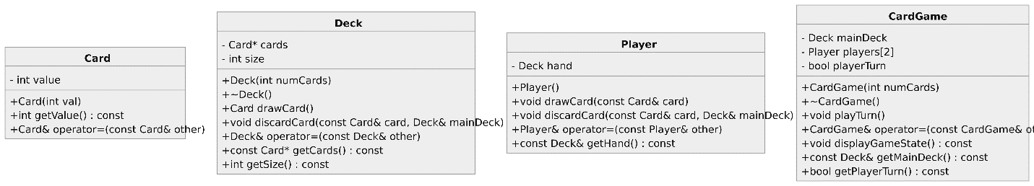
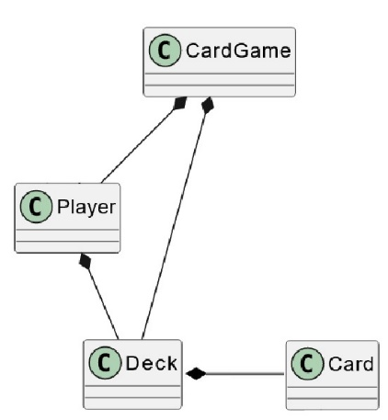

//Paste code here

Q2. Design classes for Car, Customer, and RentalAgency. Implement the necessary functionality as the provided UML diagram below:

The RentalAgency class should manage a collection of Car objects and Customer objects. Cars can be rented by customers, and returned cars should be marked as available for rent again. Implement the necessary logic to maintain car information and customer rentals.

USE DIFFERENT HEADER FILE FOR EACH CLASS
In case of any issue, reach me at @msee22007@itu.edu.pk
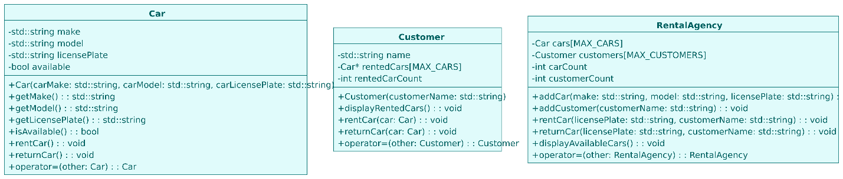

//Paste code here

Assessment Rubric for Assignment
Performance metric | CLO | Able to complete the task over 80% (4-5) | Able to complete the task 50-80% (2-3) | Able to complete the task below 50% (0-1) | Marks
- Realization of experiment | 3 | Executes without errors excellent user prompts, good use of symbols, spacing in output. Through testing has been completed . | Executes without errors, user prompts are understandable, minimum use of symbols or spacing in output. Some testing has been completed . | Does not execute due to syntax errors, runtime errors, user prompts are misleading or non- existent. No testing has been completed.
- Conducting experiment | 2 | Able to make changes and answered all questions. | Partially able to make changes and few incorrect answers. | Unable to make changes and answer all questions.
- Computer  use | 3 | Document submission timely. | Document submission late. | Document submission not done.
- Teamwork | 4 | Actively engages and cooperates with other group member(s) in effective manner. | Cooperates with other group member(s) in a reasonable manner but conduct can be  improved. | Distracts or discourages other group members from conducting the experiment
- Laboratory safety and disciplinary rules | 4 | Code comments are added and does help the reader to understand the code. | Code comments are added and does not help the reader to understand the code. | Code comments are not added.
- Data collection | 4 | Excellent use of white space, creatively organized work, excellent use of variables and constants, correct identifiers for constants, No line-wrap. | Includes name, and assignment, white space makes the program fairly easy to read. Title, organized work, good use of variables. | Poor use of white space (indentation, blank lines) making code hard to read, disorganized and messy.
- Data analysis | 3 | Solution is efficient, easy to understand, and maintain . | A logical solution that is easy to follow but it is not the most efficient. | A difficult and inefficient solution .
Total (out of 35):

