Department of Computer and Software Engineering- ITU
SE102T: Object Oriented Programming
Course Instructor: Usama Bin Shakeel | Dated: 11th March, 2023
Teaching Assistants: Abdullah, Zain | Semester: Spring 2024
Session: 2023-2027 | Batch: BSCE2023

Assignment 7. Aggregation, composition, and polymorphism

Name | Roll number | Obtained Marks/35
Muhammad Abdullah | BSSE 23100

Checked on: ____________________________

Signature: ___________________________

7.1 Objective
The objective of this assignment is cover the concepts of OOP.

7.2 Equipment and Component
Component Description | Quantity
Computer | 1

7.3 Conduct of assignment
- Students are required to perform this assignment individually. Copying from other fellows is strictly prohibited. All assignments will be checked for plagiarism.
- Seek help from the course instructor, lab engineers, assigned teaching assistants (TA) only.

7.4 Theory and Background
This week primarily focused on Inheritance, Operator Overloading, Member & Non-Member Functions, and polymorphism. These are powerful features that contribute to the flexibility and extensibility of the language.

Task 1: Accept the assignment posted in Google Classroom and after accepting clone the repository to your computer for this ensure you have logged into github app with your account.
Task 2: Solve the given problems written after task instructions, write code through IDE like CLion
Task 3: Ensure your code/solution is in the cloned folder.
Task 4: Commit and Push the changes through the Github App
Write code in separate files for each class, after completing each part, verify through running code using “make run” on Cygwin. Make sure to test the code “make test”.

Q1. Social Media Platform Implementation
Implement a simplified version of a Social Media Platform in C++.
Requirements:
- User Class (Composition- Post):
  - Create a class named User to represent individual users on the platform.
  - Include attributes such as username, userID, and Posts (a list of posts made by the user)
  - Implement appropriate getter and setter methods for these attributes.
  - Overload the output stream operator (<<) to display user details.
- Post Class:
  - Create a class named Post to represent posts made by users.
  - Include attributes such as postID, content, and likes.
  - Implement appropriate getter and setter methods for these attributes.
  - Overload the output stream operator (<<) to display post details.
- SocialMediaPlatform Class (Aggregation and Composition):
  - Implement a class named SocialMediaPlatform for managing users and posts.
  - Compose objects of the User within the SocialMediaPlatform.
  - Aggregate objects of the Posts of all users within the SocialMediaPlatform to create newsfeed.
  - Include methods to add new users, like posts, newsfeed and display user and post details.
- Operator Overloading:
  - Overload the addition operator (+) in the SocialMediaPlatform class to allow adding new users.
  - Overload the output stream operator (<<) to display user and post details.
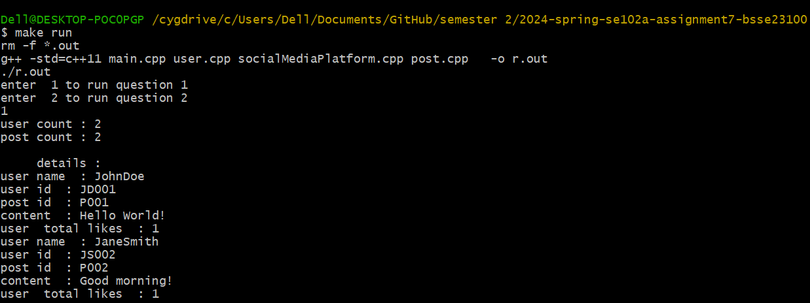

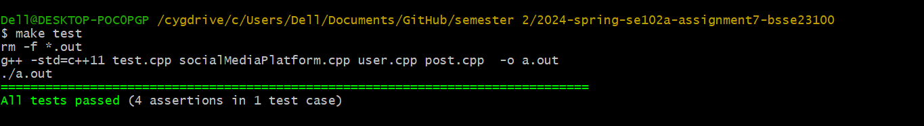
Figure 1 test case of only question 1
//Paste code here

Q2.
Create a C++ program to manage a collection of movies and TV seasons, simulating a simplified version of Netflix's content library.
- Define a base class MediaContent with virtual functions play() and displayDetails().
- Implement derived classes Movie and TVSeason, inheriting from MediaContent.
  - Each derived class should have specific attributes such as title, genre, release year (for movies) or start year and number of episodes (for TV seasons).
  - Override the play() function in each derived class to represent how each media content item is played.
  - Override the displayDetails() function in each derived class to display specific details of the media content item.
- Create a class NetflixLibrary to store and manage a collection of media content items.
  - Implement functions to add media content items to the library, remove media content items from the library, and display details of all media content items in the library.
- Overload the insertion (<<) operator to easily display the details of a media content item.
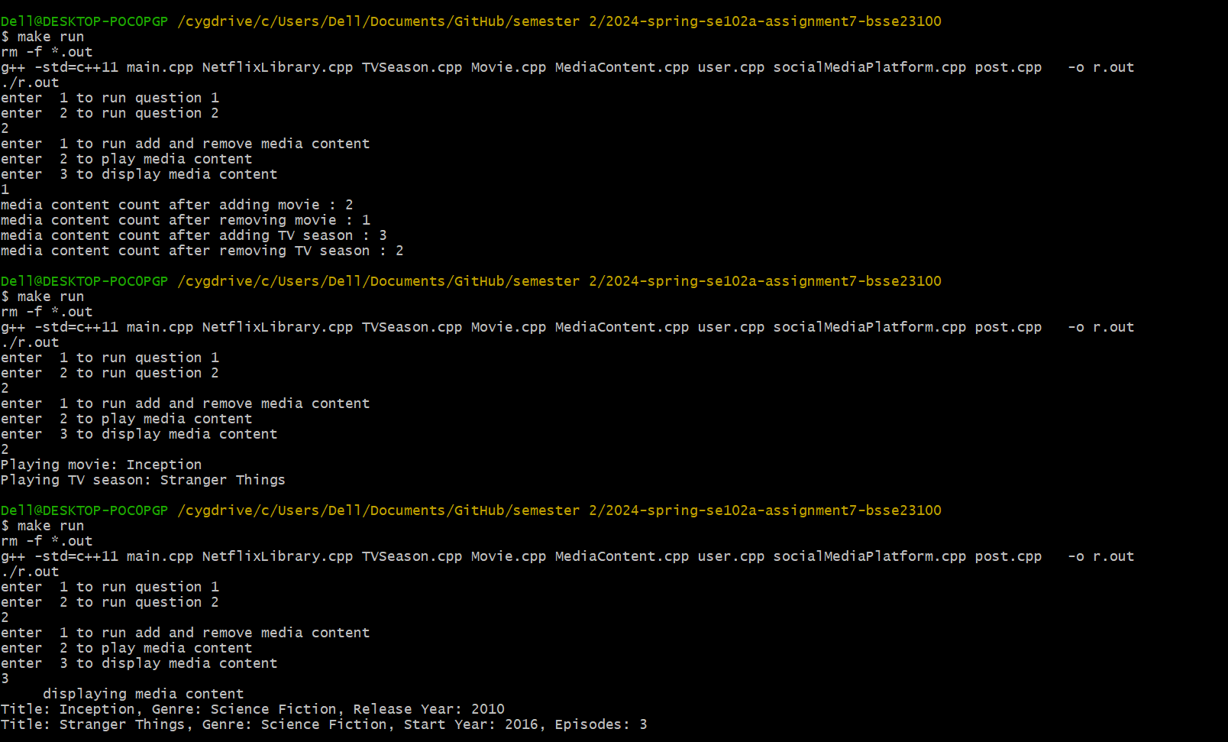
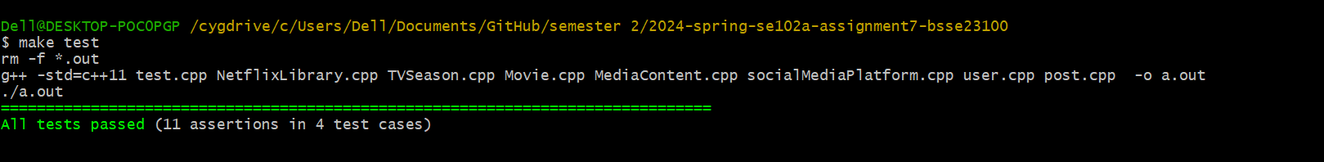
Figure 2 both q1 and q2 make test

//Paste code here

Assessment Rubric for Assignment
Performance metric | CLO | Able to complete the task over 80% (4-5) | Able to complete the task 50-80% (2-3) | Able to complete the task below 50% (0-1) | Marks
- Realization of experiment | 3 | Executes without errors excellent user prompts, good use of symbols, spacing in output. Through testing has been completed . | Executes without errors, user prompts are understandable, minimum use of symbols or spacing in output. Some testing has been completed . | Does not execute due to syntax errors, runtime errors, user prompts are misleading or non- existent. No testing has been completed.
- Conducting experiment | 2 | Able to make changes and answered all questions. | Partially able to make changes and few incorrect answers. | Unable to make changes and answer all questions.
- Computer  use | 3 | Document submission timely. | Document submission late. | Document submission not done.
- Teamwork | 4 | Actively engages and cooperates with other group member(s) in effective manner. | Cooperates with other group member(s) in a reasonable manner but conduct can be  improved. | Distracts or discourages other group members from conducting the experiment
- Laboratory safety and disciplinary rules | 4 | Code comments are added and does help the reader to understand the code. | Code comments are added and does not help the reader to understand the code. | Code comments are not added.
- Data collection | 4 | Excellent use of white space, creatively organized work, excellent use of variables and constants, correct identifiers for constants, No line-wrap. | Includes name, and assignment, white space makes the program fairly easy to read. Title, organized work, good use of variables. | Poor use of white space (indentation, blank lines) making code hard to read, disorganized and messy.
- Data analysis | 3 | Solution is efficient, easy to understand, and maintain. | A logical solution that is easy to follow but it is not the most efficient. | A difficult and inefficient solution.
Total (out of 35):

