Department of Computer and Software Engineering- ITU
SE102T: Object Oriented Programming
Course Instructor: Usama Bin Shakeel | Dated: 19th March, 2023
Teaching Assistants: Abdullah, Zain | Semester: Spring 2024
Session: 2023-2027 | Batch: BSCE2023

Assignment 8. Singleton and runtime polymorphism

Name | Roll number | Obtained Marks/35
Muhammad Abdullah | BSEE23100

Checked on: ____________________________

Signature: ___________________________

8.1 Objective
The objective of this assignment is to refresh the concept covered so far in this semester. These concepts form the backbone of OOP.

8.2 Equipment and Component
Component Description | Quantity
Computer | 1

8.3 Conduct of assignment
- Students are required to perform this assignment individually. Copying from other fellows is strictly prohibited. All assignments will be checked for plagiarism.
- Seek help from the course instructor, lab engineers, assigned teaching assistants (TA) only.

8.4 Theory and Background
This week is primarily focused on singleton and polymorphism.

Task 1: Accept the assignment posted in Google Classroom and after accepting clone the repository to your computer for this ensure you have logged into GitHub app with your account.
Task 2: Solve the given problems written after task instructions, write code through IDE like CLion
Task 3: Ensure your code/solution is in the cloned folder.
Task 4: Commit and push the changes through the GitHub App
Write code in respective classes for each part and keep code in separate .cpp and .h files, verify through running code using “make run” on Cygwin. Make sure to test the code “make test”.
Q1. As you developed an inventory management system. In this problem, you will implement the same system but with the singleton approach to make sure that one instance of the inventory system is created throughout the entire application. This instance should manage product inventory, handle product addition and removal, and provide functionalities for inventory tracking.

Design and implement the Singleton pattern in C++ to fulfill this requirement. Your implementation should guarantee the following:
- Only one instance of the inventory system is created.
- The instance is globally accessible to all parts of the application.
- The Singleton instance encapsulates functionalities to manage product inventory, add and remove products, and track inventory effectively.
- InventorySystem class implements the Singleton pattern.
The constructor is private to prevent external instantiation of the class.
- getInstance() method provides a global point of access to the singleton instance.
- addProduct(), removeProduct(), and displayInventory() methods simulate functionalities of managing the product inventory.

Create a menu in main to demonstrate the functionality otherwise marks will be deducted.

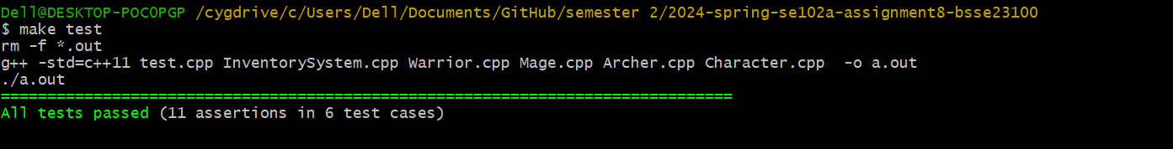
//Paste code here

Q2. You are developing a video game where players control various characters, each with unique abilities and behavior. These characters include warriors, mages, and archers. Each character type has different attack styles and special abilities.

Design and implement a C++ program that utilizes polymorphism and runtime polymorphism to achieve the following:
1. Define a base class called Character, which has virtual functions attack() and useSpecialAbility().
2. Implement derived classes Warrior, Mage, and Archer, each inheriting from the Character base class.
3. Override the attack() and useSpecialAbility() functions in each derived class to provide the specific attack styles and special abilities for each character type.

See test file for the special ability for each warrior and override your class functions accordingly.
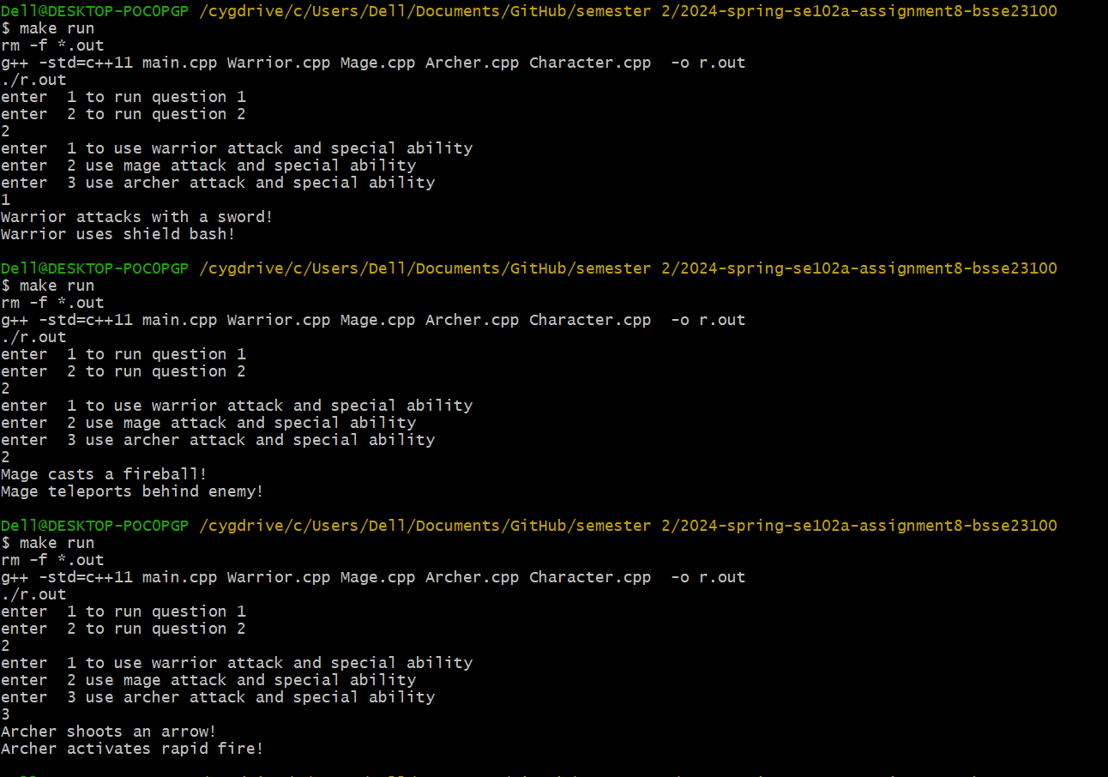


//Paste code here

Assessment Rubric for Assignment
Performance metric | CLO | Able to complete the task over 80% (4-5) | Able to complete the task 50-80% (2-3) | Able to complete the task below 50% (0-1) | Marks
- Realization of experiment | 3 | Executes without errors excellent user prompts, good use of symbols, spacing in output. Through testing has been completed . | Executes without errors, user prompts are understandable, minimum use of symbols or spacing in output. Some testing has been completed . | Does not execute due to syntax errors, runtime errors, user prompts are misleading or non- existent. No testing has been completed.
- Conducting experiment | 2 | Able to make changes and answered all questions. | Partially able to make changes and few incorrect answers. | Unable to make changes and answer all questions.
- Computer  use | 3 | Document submission timely. | Document submission late. | Document submission not done.
- Teamwork | 4 | Actively engages and cooperates with other group member(s) in effective manner. | Cooperates with other group member(s) in a reasonable manner but conduct can be  improved. | Distracts or discourages other group members from conducting the experiment
- Laboratory safety and disciplinary rules | 4 | Code comments are added and does help the reader to understand the code. | Code comments are added and does not help the reader to understand the code. | Code comments are not added.
- Data collection | 4 | Excellent use of white space, creatively organized work, excellent use of variables and constants, correct identifiers for constants, No line-wrap. | Includes name, and assignment, white space makes the program fairly easy to read. Title, organized work, good use of variables. | Poor use of white space (indentation, blank lines) making code hard to read, disorganized and messy.
- Data analysis | 3 | Solution is efficient, easy to understand, and maintain . | A logical solution that is easy to follow but it is not the most efficient. | A difficult and inefficient solution .
Total (out of 35):

