Software Engineering Department - ITU
SE101T: Programming Fundamentals Lab

Course Instructor: Usama Bin Shakeel | Dated: 04/09/2023
Teaching Assistant: Abeera Ashraf | Semester: Fall 2023
Teaching Assistant: Aasma Waheed | Batch: BSSE2023

Lab 2. Introduction to Flowchart and Draw.io

Name | Roll number | Report  (out of 100) | Scaled to 10 | Total  (out of 10)
MUHAMMAD ABDULLAH | Bsse 23100

Checked on: ____________________________

Signature: ___________________________

Conduct of Lab
- Students are required to perform this experiment individually.
- In case the lab experiment is not understood, the students are advised to seek help from the course instructor, lab engineers, assigned teaching assistants (TA)

In this lab you must perform the following steps:

Step 1: Sign in to your Github account. (https://github.com)
Step 2: Accept the assignment through the link posted in Google Classroom and after accepting clone the repository to your computer.
Step 3: Open draw.io from browser to draw flowcharts. ( https://app.diagrams.net/)
Step 4: Solve each question separately using draw.io tool.
Step 5: Save your flowcharts in .png format and paste them in word file, under the corresponding question.
Step 6: Paste all flowcharts in Git cloned folder.
Step 7: Commit the changes through Github App.
Step 8: Push the file to the repository.
Lab Questions

Q1. Draw a flowchart to add two numbers entered by user
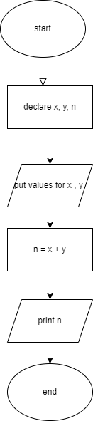
Q2. Draw a flowchart that will read the two sides of a rectangle and calculate its area.
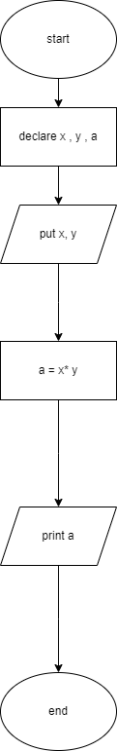

Q3. A person can cast his/her vote if his/her age is 18 years or more than 18. Draw a flowchart to check whether a person can vote or not.
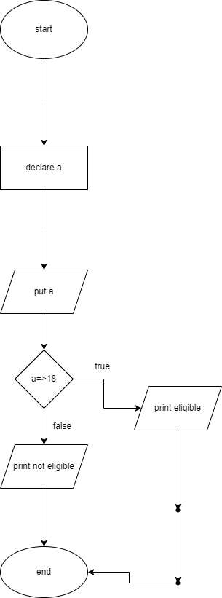

Q4. Draw the flowchart to print the largest of any three numbers
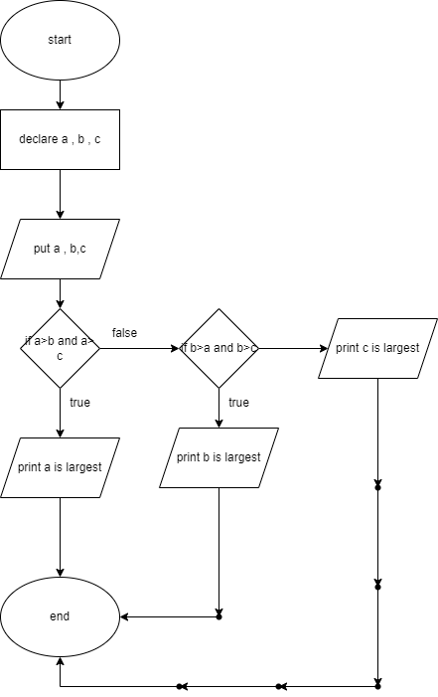

Q5. Draw a flowchart that exchanges the value of two variables: x and y. The output must be: the value of variable y will become the value of variable x, and vice versa.
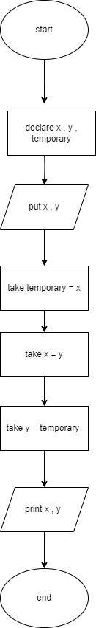

Assessment Rubric for Lab
Method for assessment:

Lab reports and instructor observation during lab sessions. Outcome assessed:
a. Ability to conduct experiments, as well as to analyze and interpret data (P) b. Ability to function on multi-disciplinary teams (A)
c. Ability to use the techniques, skills, and modern engineering tools necessary for engineering practice (P)
Performance metric | Task | CLO | Description | Max marks | Exceeds expectation | Meets expectation | Does not meet expectation | Obtained marks
1. Realization of experiment (a) | 1 | 1 | Functionality | 40 | Executes without errors excellent user prompts, good use of symbols, spacing in output. Through testing has been completed (35-40) | Executes without errors, user prompts are understandable, minimum use of symbols or spacing in output. Some testing has been completed (20-34) | Does not execute due to syntax errors, runtime errors, user prompts are misleading or non-existent. No testing has been completed (0-19)
2. Teamwork (b) | 1 | 3 | Group Performance | 5 | Actively engages and cooperates with other group member(s) in effective manner (4-5) | Cooperates with other group member(s) in a reasonable manner but conduct can be improved (2-3) | Distracts or discourages other group members from conducting the experiment (0-1)
3. Conducting experiment (a, c) | 1 | 1 | On Spot Changes | 10 | Able to make changes (8-10) | Partially able to make changes (5-7) | Unable to make changes (0-4)
 | 1 | 1 | Viva | 10 | Answered all questions (8-10) | Few incorrect answers (5-7) | Unable to answer all questions (0-4)
4. Laboratory safety and disciplinary rules (a) | 1 | 3 | Code commenting | 5 | Comments are added and does help the reader to understand the code (4-5) | Comments are added and does not help the reader to understand the code (2-3) | Comments are not added (0-1)
5. Data collection (c) | 1 | 3 | Code Structure | 5 | Excellent use of white space, creatively organized work, excellent use of variables and constants, correct identifiers for constants, No line-wrap (4-5) | Includes name, and assignment, white space makes the program fairly easy to read. Title, organized work, good use of variables (2-3) | Poor use of white space (indentation, blank lines) making code hard to read, disorganized and messy (0-1)
6. Data analysis (a, c) | 1 | 4 | Algorithm | 20 | Solution is efficient, easy to understand, and maintain (15-20) | A logical solution that is easy to follow but it is not the most efficient (6-14) | A difficult and inefficient solution (0-5)
7. Computer use (c) | 1 | 2 | Documentation & Github Submissions | 5 | Timely (4-5) | Late (2-3) | Not done (0-1)
 | Max Marks (total): |  |  | 100 | Obtained Marks (total):

Lab Engineer Signature: ________________________

