

Easy Parcel: IoT-Based Parcel Storage System for University Villages

Final Year Project I
Interim Report
May 2025

Name: Muhammad Afiq bin Zakaria
Student ID: 21001351
Course: Computer Science
Supervisor: Dr Siti Nurlaili bt Karim

Certification of Originality

This is to certify that I am responsible for the work submitted in this project, that the original work is my own except as specified in the references and acknowledgements, and that the original work contained herein have not been undertaken or done by unspecified sources or persons.

Approved by,



_________________________________ ________________________________
(MUHAMMAD AFIQ BIN ZAKARIA) (DR SITI NURLAILI BT KARIM)

Universiti Teknologi PETRONAS
32610 Seri Iskandar
Perak Darul Ridzuan

Abstract

In recent years, the increasing popularity of online shopping has significantly impacted the lifestyle of university students, particularly those residing in campus accommodations. Despite the convenience of e-commerce, the parcel collection process within universities remains inefficient due to centralized systems like ParcelHub, which often lead to overcrowding, long queues, limited accessibility, and additional costs. These issues can be frustrating for students, especially during peak delivery periods or for those without personal transportation.

This project introduces Easy Parcel, an IoT-based smart parcel locker system tailored specifically for university residential villages. It leverages affordable IoT technologies such as Arduino microcontrollers, barcode scanners, and servo motors, integrated with a Flutter-based mobile application and Firebase backend services. The proposed system enables secure, real-time parcel drop-off and retrieval, incorporating features like OTP-based authentication, mobile notifications, and cloud data logging.

The goal is to provide students and delivery personnel with a user-friendly, decentralized platform to streamline parcel handling and minimize delivery complications. This interim report presents the motivation behind the project, reviews relevant literature and technological gaps, and outlines the development methodology, tools, and expected outcomes of the system. Ultimately, Easy Parcel aims to create a scalable, low-cost solution that enhances the parcel collection experience and sets the groundwork for smarter campus infrastructure.

Acknowledgement

I would like to express my sincere appreciation to everyone who has contributed to the progress and timely development of this project. I am especially grateful to my Final Year Project (FYP) supervisor, Dr. Siti Nurlaili Bt Karim, for her continuous guidance and support throughout the project. Her constructive feedback, especially during the report-writing phase, has been invaluable in shaping the direction and quality of this work.

I would also like to extend my heartfelt thanks to my family and friends for their unwavering encouragement and support. Their belief in me has been a constant source of motivation. Additionally, I am thankful to my fellow Computer Science peers for offering both mental and physical support during the various stages of this project. Their collaboration and encouragement have made this journey both manageable and memorable.
Table of Contents
Certification of Originality 2
Abstract 3
Acknowledgement 4
List of figures 6
1.0 Introduction 7
1.1 Background of Study 7
1.2 Problem Statement 8
1.3 Objectives 9
1.4 Scope of study 10
2.0 Literature Review 12
2.1 Research Gaps 14
2.2 Solutions of Research Gaps 15
3.0 Methodology 18
4.1 Research Methodology 18
4.1.1 Hardware Development 18
4.1.2 Software Development 20
4.1.3 System Integration and Testing 21
3.2 System Architecture 22
4.2 Gantt Chart 22
4.0 Conclusion and Future Works 24
4.1 Conclusion 24
4.2 Future Works 24
References 27

List of figures
Figure 1: Malaysia E-Commerce Growth Forecast (2024-2029) 7
Figure 2: UTP Parcelhub 8
Figure 3: Tinkercad Environment 10
Figure 4: DDR Framework 18
Figure 5: Arduino Uno R3 19
Figure 6: Servo Motor 19
Figure 7: Keypad 19
Figure 8: LCD 19
Figure 9: Locker 19
Figure 10: Barcode Scanner 19
Figure 11: Breadboard, capasitor, LED, wires 19
Figure 12: Buzzer 19
Figure 13: OV7670 19
Figure 14: ESP32 19
Figure 15: Flutter 20
Figure 16: Firebase 20
Figure 17: Easyparcel system architecture 22
Figure 18: FYP1 Gantt Chart 22
Figure 19: FYP2 Gantt Chart 23

1.0 Introduction

Background of Study
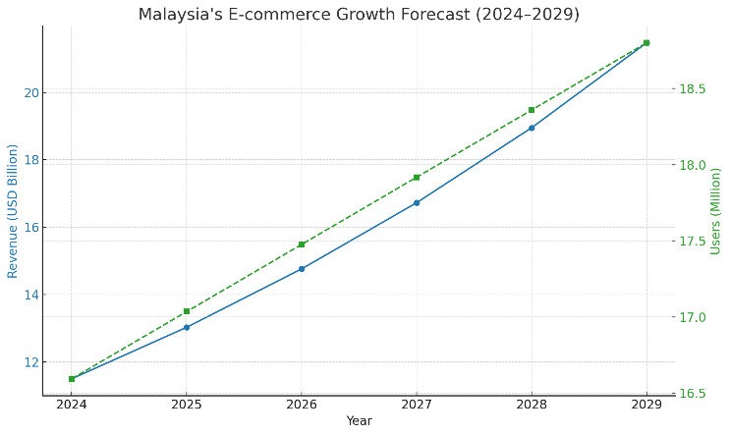
Figure 1: Malaysia E-Commerce Growth Forecast (2024-2029)
Over the past decade, Malaysia has experienced rapid growth in digital transformation, particularly within the e-commerce sector. Driven by increased internet penetration, mobile device usage, and the rise of digital payment platforms, online shopping has become a preferred choice for many Malaysians. According to a 2024 report by Statista, Malaysia's e-commerce market generated over USD 11.5 billion in revenue and is expected to grow at an annual rate of 13.3%, reaching approximately USD 21.7 billion by 2029. The number of users is projected to surpass 18.8 million within the same period, reflecting a significant shift in consumer behaviour towards online purchases and digital convenience (Statista, 2024).

Among this growing population of online shoppers, university students represent a substantial and influential segment (Kaur, 2024). Students are typically tech-savvy, highly connected through mobile and internet technologies, and increasingly reliant on digital platforms for both academic and personal needs. Their busy schedules and limited transportation options further increase their preference for online shopping, which allows for convenient, on-demand access to a wide variety of products. The appeal of promotions, student discounts, free delivery services, and the convenience of comparing prices across platforms has made e-commerce the default shopping method for many in this demographic.

However, the rise in online shopping among students has also placed pressure on university parcel collection systems. Most higher learning institutions, including Universiti Teknologi PETRONAS (UTP), handle parcel deliveries using a centralized hub model such as the ParcelHub system. While centralized hubs can manage a large volume of deliveries in one place, they are often located far from student residential villages. This creates accessibility issues, especially for students without personal transportation. Furthermore, long queues during peak delivery hours, limited operating times, and additional collection fees add to the inconvenience. Students may face delays, missed deliveries, or, in some cases, lost parcels due to overcrowding or mismanagement.

These limitations highlight the urgent need for a more student-friendly and technologically advanced parcel collection system. An ideal solution should prioritize convenience, accessibility, and security while being cost-effective and scalable within a campus environment. This project proposes Easy Parcel, an IoT-based smart locker system designed specifically for student residential villages. By decentralizing parcel storage and integrating mobile app functionality, the system aims to enhance the overall parcel-handling experience for university students.

Problem Statement
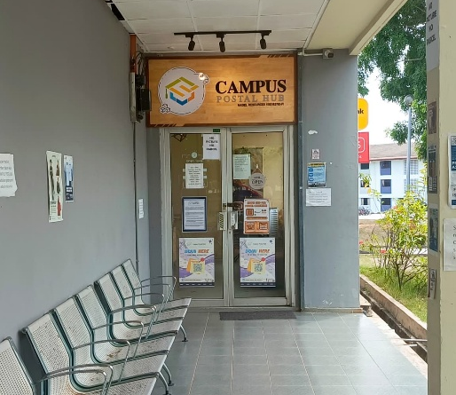
Figure 2: UTP Parcelhub
Despite the implementation of centralized parcel systems like ParcelHub in universities such as Universiti Teknologi PETRONAS (UTP), several key issues persist that affect student convenience and overall system effectiveness:

- Distant Collection Location
The ParcelHub is located far from most student residential villages, making it difficult for students to access especially those without personal vehicles. Students often have to walk long distances or rely on others for transport, which becomes a major inconvenience during bad weather, busy academic schedules, or nighttime hours.

- Long Queues During Peak Hours
During high-volume periods such as after semester breaks, public holidays, or major online shopping sales, students experience long waiting times due to overcrowding at the hub. This not only wastes time but also causes unnecessary stress, particularly for students balancing academic commitments.

- Limited Parking and Campus Congestion
For students who drive, limited parking near the ParcelHub leads to traffic congestion and safety concerns. The high number of vehicles in a small area during peak hours can result in delays and frustration, reducing the efficiency of the system.

- Additional Handling Charges
Students are often required to pay handling or service fees to retrieve their parcels. While these charges may seem minor individually, they add up over time and can be a financial burden, particularly for students who frequently shop online or are on a limited budget.

These challenges indicate that the current system does not fully address the needs of the student population. A more accessible, decentralized solution that prioritizes convenience, affordability, and security is needed. This project proposes Easy Parcel, an IoT-based smart locker system integrated with a mobile application to provide a modern, efficient, and student-friendly alternative for parcel collection on campus.

Objectives
This project consists of four main objectives:
- To design and develop an IoT-based smart locker system for student villages to store small parcels securely.
- To build a mobile application for both students and couriers to manage locker access, track deliveries, and receive parcel notifications.
- To implement a random password lock system and barcode scanning for secure identification of parcel senders (couriers) and receivers (students).
- To evaluate the usability and effectiveness of the Easy Parcel system through user testing and feedback from students and couriers.

Scope of study
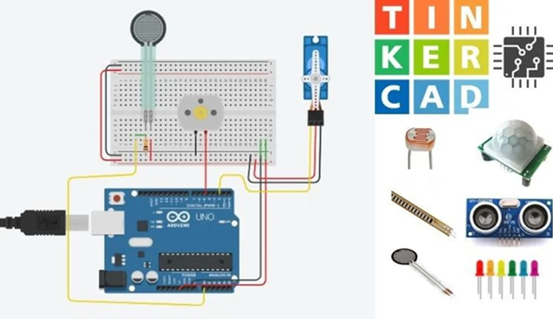
Figure 3: Tinkercad Environment
This project involves the development of a smart locker system that leverages Internet of Things (IoT) technologies to improve parcel handling within student residential areas. The hardware development will begin with circuit simulations using Tinkercad to validate the logic and component interaction before proceeding to physical assembly. Core components such as an Arduino Uno R3 microcontroller, servo motors, LCD, buzzer, and keypad will be used to construct a functional prototype that can simulate real-world parcel storage. The prototype will replicate the experience of securing and retrieving parcels through electronically controlled lockers. Each step in the assembly and configuration process will be tested to ensure stable performance and integration between components.

To support interaction between users and the locker system, a mobile application will be developed using the Flutter framework. This application will serve two main user roles: couriers and students. For couriers, the app will allow secure access to specific locker compartments to drop off parcels, while students will be able to receive real-time parcel notifications, track delivery status, and unlock lockers using a secure code. Firebase will be used as the backend to manage user authentication, store parcel data, and send push notifications through Firebase Cloud Messaging (FCM). The Firestore database will store all user activity and system events, ensuring the locker system operates in real time and remains accessible from anywhere on campus.

To ensure secure and verifiable parcel transactions, a barcode scanning feature will be implemented for both delivery and collection. When a courier delivers a parcel, they will scan a barcode to register the delivery and log the parcel’s entry into the system. Upon retrieval, the student will also scan the barcode to verify their identity and record the time of collection, ensuring complete traceability. In addition to this, an OTP-based access system will be implemented using Firebase Authentication. A unique, randomly generated one-time password will be sent to the student’s mobile app upon delivery confirmation, which they must enter to unlock the designated locker. This combination of OTP verification and barcode scanning provides a dual-layered security mechanism, significantly reducing the risk of unauthorized access or parcel misplacement.

2.0 Literature Review

The study by Refaningati et al. (2020) provides a foundational understanding of how smart locker systems can improve the efficiency of last-mile delivery. Conducted in the Jabodetabek region of Indonesia, the research evaluated operational characteristics and the overall performance of smart lockers in an urban context. Using travel diary data from a smart locker operator, the study demonstrated that the total trip length for parcel delivery was significantly reduced from 717.8 km for traditional delivery down to 497.83 km using smart lockers. This translates to a 30.65% increase in delivery efficiency. However, the study also revealed operational shortcomings. Notably, locker coverage areas varied, affecting usage rates and overall effectiveness. Additionally, issues like waiting times for pick-up and delivery due to inconsistent usage patterns across hubs were identified. While the research supports the viability of smart lockers in reducing traffic and emissions, it indicates that more context-specific design is necessary, especially in localized communities like university campuses.

In Malaysia, Wang et al., (2024) explored the key factors influencing the adoption of online shopping platforms through a systematic literature review spanning articles from 2004 to 2023. The study, rooted in theoretical frameworks such as the Technology Acceptance Model (TAM) and the Unified Theory of Acceptance and Use of Technology (UTAUT), found that convenience, perceived ease of use, trust, digital infrastructure, and system responsiveness were critical to user adoption of e-commerce platforms. The authors emphasized the need for systems that are intuitive, reliable, and tailored to user needs especially in developing countries. These findings are directly relevant to parcel locker systems, as these systems must align with the behavioural patterns and expectations of online shoppers, particularly students who represent a major e-commerce consumer group. If the technology behind parcel management lacks user-friendliness or trustworthiness, it is unlikely to be embraced, regardless of its technical sophistication.

The POLIKU Parcel System, developed by Noraimi Mahran et al., (2024) at Politeknik Kuching Sarawak, offers a practical case study on the implementation of a parcel management system in an academic setting. Built using Agile methodology, the system was designed through an iterative process, incorporating feedback from students and staff during development. It features a web-based interface, parcel tracking functions, status notifications, and a dashboard for administrators. What makes this system particularly notable is its academic context it addresses parcel congestion in dormitories and improves administrative communication. However, it lacks IoT-based automation, real-time mobile control, and courier integration. While its interface is user-friendly, the absence of features such as smart locks, barcode scanning, or integrated mobile apps means it still requires human intervention for parcel sorting and management. The study underlines the benefits of digital systems in reducing administrative workloads but also signals the need for further automation to fully resolve logistical inefficiencies on campus.

In contrast, the Smart and Secure Locker System developed by Naik et al., (2020) brings a security-focused approach to smart locker technology. This system integrates Raspberry Pi hardware with facial recognition software to validate user access. The image of each person attempting to open a locker is checked against a database, and in cases of unauthorized attempts, a photograph is taken and encrypted before being sent to the legitimate user. Advanced encryption methods such as RSA, AES, and Elliptic Curve Cryptography (ECC) are utilized to secure communications. This model excels in terms of locker-level security and surveillance. However, it is resource-intensive and requires significant hardware and technical maintenance. Such a system may be excessive for university parcel lockers where theft risk is relatively low, and operational simplicity is more critical than complex encryption. Nevertheless, the approach illustrates the potential of IoT and computer vision in enhancing locker systems when adapted to appropriate contexts.

Closer to home, the University Parcel Centre (UPC) at Universiti Utara Malaysia (UUM) serves as a real-world example of centralized parcel management for students. As outlined in the study by NIZAMUDDIN ZAINUDDIN et al. (2021), UPC acts as a collection hub for student parcels delivered by third-party couriers such as Pos Malaysia and DHL. Using the SERVQUAL framework, the research assessed student satisfaction across five dimensions: tangibility, reliability, responsiveness, assurance, and empathy. While the physical infrastructure and reliability of UPC received positive feedback, students expressed dissatisfaction with long wait times, unclear procedures, and inconsistent pricing for parcel collection. For instance, additional charges based on parcel weight and registration status were seen as unfair, and the location of the centre was inconvenient for students in remote dorms. Security concerns also arose due to inadequate parcel tracking and poor handling practices. The findings underscore the limitations of conventional, semi-manual parcel systems in handling high volumes efficiently. The UPC experience points to a pressing need for decentralized, automated, and student-accessible smart locker systems.

Together, these studies build a comprehensive view of the evolving parcel delivery and management landscape. While smart lockers and digital systems have shown promise in improving delivery efficiency and user satisfaction, the lack of student-focused design, seamless mobile integration, and cost-effectiveness continues to hinder their widespread adoption in university settings. These insights form the basis for identifying key research gaps and justifying the development of a more practical and tailored solution, such as the proposed Easy Parcel system.

2.1 Research Gaps
Despite several advancements in parcel management systems, many existing solutions fall short when evaluated against the specific needs of student communities living in campus residential areas. From the literature reviewed, five key research gaps were identified:

- Student-specific design
Most existing parcel systems are designed with general users in mind and often fail to consider the unique circumstances of students living in residential campuses. These systems tend to be located far from student accommodation areas, which creates accessibility issues for students without personal transport. As a result, students must rely on inefficient or inconvenient methods to collect their parcels, which diminishes the effectiveness of the service.

- Lack of integrated mobile control
Systems such as POLIKU and the University Parcel Centre (UPC) primarily operate using web-based platforms. While functional, they do not incorporate mobile applications or IoT-based features that allow users to interact with lockers in real-time. This gap leads to reduced convenience, as students cannot receive live parcel status updates or access lockers directly via smartphones features that are increasingly expected in modern service systems.

- Access and security balance
A recurring issue with current systems is the inability to strike a balance between ease of use and security. Some systems lean heavily on security features, such as biometric verification or complex access controls, which can be excessive and hinder user experience in shared campus environments. Others adopt overly simplistic security models that fail to safeguard parcels effectively. This imbalance either overcomplicates user interactions or fails to instill user confidence in parcel safety.

- Courier-side support
Existing locker systems often neglect the needs of delivery personnel. Features that support secure and efficient parcel drop-offs such as dedicated courier access, barcode scanning, or OTP-based parcel logging are rarely implemented. This oversight can lead to delivery errors, delays, or parcels being left unattended, reducing overall system reliability and effectiveness.

- Affordability and scalability
Many commercial locker solutions come with high infrastructure and maintenance costs, making them impractical for widespread deployment across smaller campuses or student residential areas. Their complexity can also require specialized installation and support, which further limits their scalability. For educational institutions with limited budgets, these systems are often neither affordable nor adaptable.

2.2 Solutions of Research Gaps
To address these gaps, the proposed system, Easy Parcel, was designed as a practical, IoT-based smart locker solution specifically tailored for student residential environments. The system is intended to be both user-friendly and cost-effective while also supporting courier-side functionalities. Below are the key features and how they solve each identified research gap:

- Student-specific design
Easy Parcel is developed with the student lifestyle in mind, particularly for those residing in campus villages. The system prioritizes accessibility by being installed near or within residential blocks, ensuring that students do not need personal transport to collect parcels. This placement is critical in reducing reliance on centralized pickup points and improving service reach and convenience for students with limited mobility.

- Lack of integrated mobile control
To enhance user interaction and control, Easy Parcel includes a dedicated mobile application. Through this app, students receive real-time parcel notifications, view parcel status, and open lockers using One-Time Passwords (OTPs). The mobile-first approach ensures that the system fits seamlessly into students’ daily digital habits while reducing manual processes and the need for on-site supervision.

- Access and security balance
Instead of implementing complex biometric authentication, Easy Parcel adopts a practical OTP-based security model. This method is both secure and straightforward, providing students with temporary access codes delivered through the mobile app. This avoids unnecessary technical barriers while maintaining parcel safety and user accountability, especially in shared or high-traffic areas.

- Courier-side support
Easy Parcel also addresses the courier experience. The system allows delivery personnel to securely drop off parcels into designated lockers using unique OTPs or QR code verification. This ensures contactless delivery, reduces parcel misplacement, and speeds up the entire drop-off process particularly valuable for courier companies managing multiple deliveries on tight schedules.

- Affordability and scalability
The system is built using cost-effective hardware such as Arduino microcontrollers and readily available IoT modules. This design not only lowers the initial development cost but also makes it easier for institutions to deploy and maintain the system at multiple residential sites. By avoiding expensive proprietary hardware, Easy Parcel becomes a viable solution for universities operating on tight budgets.

3.0 Methodology

Research Methodology
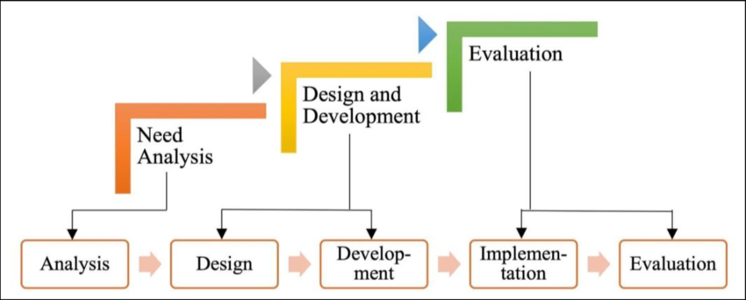
Figure 4: DDR Framework
This project follows a Design and Development Research (DDR) methodology, which is well-suited for engineering-based solutions that aim to address real-world problems through the creation of functional systems. The process focuses on iterative development, where both hardware and software components are designed, implemented, tested, and refined based on continuous evaluation. The methodology is divided into two major streams: the development of the IoT-based smart locker hardware system, and the creation of the mobile application and backend integration that supports user interaction and system automation.

Hardware Development
The hardware development phase focuses on building a smart locker prototype that functions as a secure and automated storage system for small parcels. This process begins with the design and simulation of the circuit system using Tinkercad. Through simulation, component logic and functional flow are tested virtually, helping to identify and resolve errors early in development. This step ensures that the system’s core design is stable and feasible before moving on to physical assembly, which helps save time and cost.
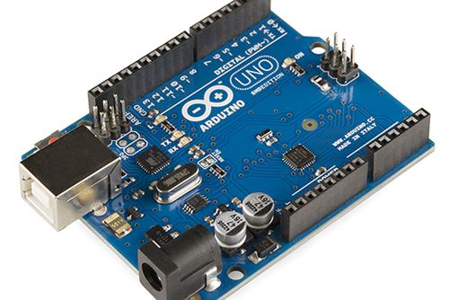  Figure 5: Arduino Uno R3 | 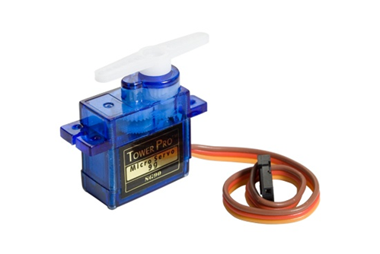  Figure 6: Servo Motor | 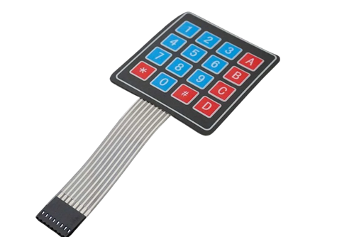  Figure 7: Keypad | 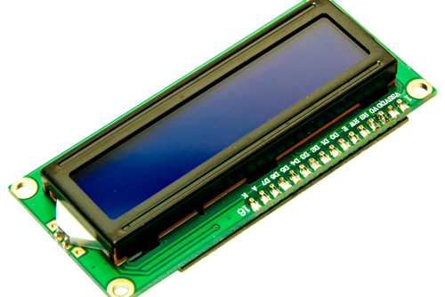  Figure 8: LCD
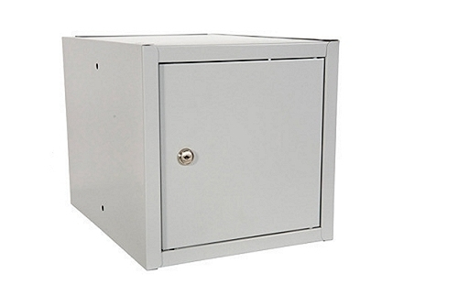  Figure 9: Locker | 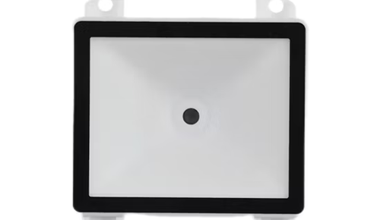  Figure 10: Barcode Scanner | 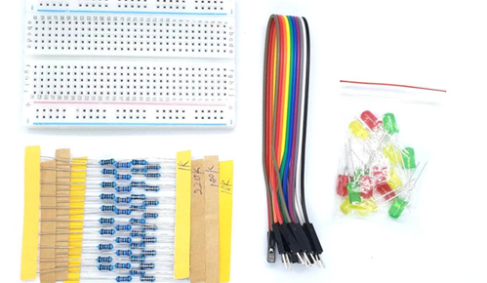  Figure 11: Breadboard, capasitor, LED, wires | 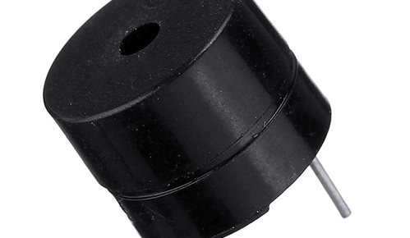  Figure 12: Buzzer

Once the circuit logic has been verified, physical assembly of the components begins. The main controller used is an Arduino Uno R3, which handles the input and output processes of the system. A servo motor is used to lock and unlock the locker compartment, while a keypad and LCD display provide manual input and visual feedback to users. Additional components such as a buzzer and LEDs are included for status alerts, and a barcode scanner is used to capture delivery and collection data. These elements are assembled on a breadboard and tested in sequence to ensure proper communication and synchronization between each module.

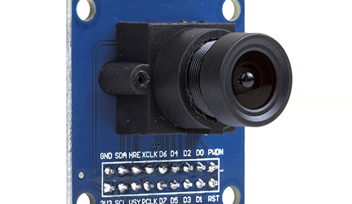  Figure 13: OV7670 | 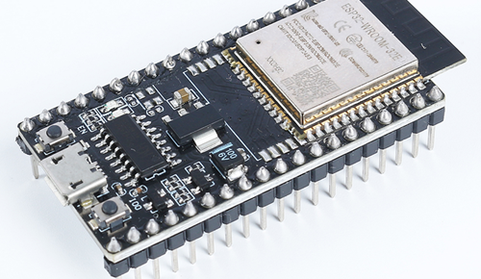  Figure 14: ESP32

Integration is a critical stage where all components are connected to function as a complete system. The Arduino is programmed to interpret keypad inputs (including OTPs), control the servo motor for locker access, read barcodes for parcel tracking, and display real-time statuses on the LCD. The locker is tested in multiple scenarios involving both courier delivery and student retrieval. In future stages, the locker will be connected to a Firebase cloud backend using a Wi-Fi-enabled board such as the ESP32, enabling real-time data exchange between the hardware and the mobile application.

Software Development

Figure 15: Flutter
In parallel with hardware development, the software component involves designing and building a cross-platform mobile application to serve both students and couriers. The mobile application is developed using Flutter, a UI toolkit by Google that allows the creation of responsive apps for both Android and iOS from a single codebase. This approach ensures consistency in design, efficient development time, and broad device compatibility.

The application features a role-based system with two user types: couriers and students. For couriers, the app allows logging of parcel deliveries, scanning of barcodes, and controlled access to lockers. For students, the app provides parcel tracking, real-time notifications, and a secure interface for unlocking lockers using a one-time password (OTP). Firebase Authentication is used to manage user logins and generate unique OTPs tied to each parcel delivery, ensuring that only the rightful recipient has access to the locker.

Figure 16: Firebase
All data related to parcels, user activity, and locker status is stored in Firebase Firestore, a cloud-based NoSQL database. This database is structured to allow real-time synchronization between the mobile app and the smart locker system, enabling updates and notifications to occur instantly. Firebase Cloud Messaging (FCM) is also implemented to send push notifications to students whenever a parcel has been delivered and is ready for collection.

After development, the application undergoes thorough testing across different devices and environments to ensure it performs reliably. Functional testing includes login, OTP access, barcode scanning, and locker control operations. Usability testing is also carried out to evaluate the user experience and interface intuitiveness, with improvements made based on feedback and test results.

System Integration and Testing
Once both hardware and software components have been tested independently, they are integrated into a complete system. The mobile application communicates with the Firebase backend, which in turn synchronizes data with the hardware controller. When a courier delivers a parcel, they scan a barcode to register the delivery, triggering the system to generate and send an OTP to the intended student. The student then uses the mobile app to retrieve the OTP and enters it into the locker’s keypad. Upon successful verification, the locker unlocks, and the student scans the barcode again to log the collection time.

This integration ensures the entire delivery process is secure, traceable, and efficient. All events from delivery to collection are logged in the cloud, creating a transparent and accountable system. The integration phase also includes testing the system in realistic use cases to ensure communication between the mobile app, Firebase, and the locker hardware is seamless and stable.

3.2 System Architecture
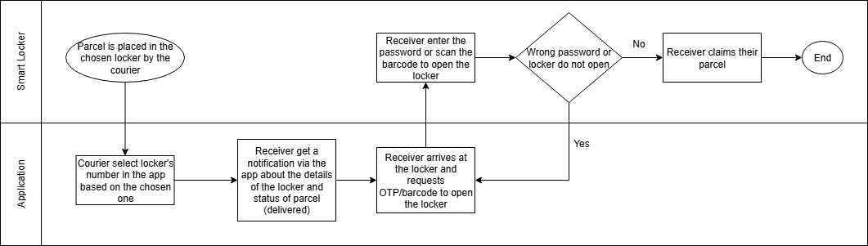
Figure 17: Easyparcel system architecture
The system architecture illustrates the interaction between the smart locker, the mobile application, and the Firebase backend. It shows how couriers initiate the delivery process through the app, which then updates the parcel status and notifies the student. The student retrieves the parcel using a secure OTP and completes the process by scanning a barcode to log collection details. All actions are synchronized and stored in Firebase for real-time tracking and verification, ensuring a secure and user-friendly parcel management experience.

Gantt Chart
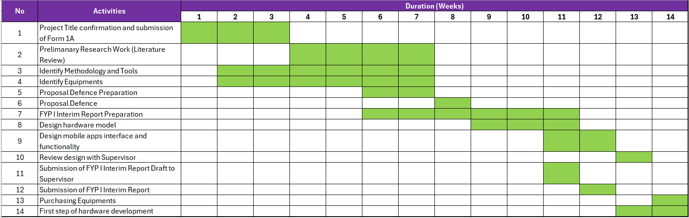
Figure 18: FYP1 Gantt Chart

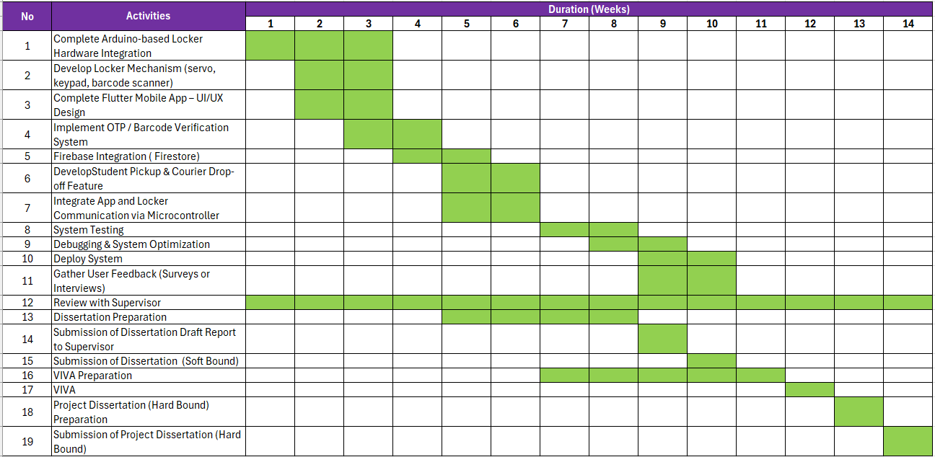
Figure 19: FYP2 Gantt Chart

4.0 Conclusion and Future Works

4.1 Conclusion
At this stage of the project, Easy Parcel: IoT-Based Parcel Storage System for University Villages remains in the development phase. Most progress so far has focused on designing and building the core components of the system, including both the smart locker hardware and the supporting mobile application. While the overall system has not yet been fully integrated or tested in a live environment, initial development efforts have laid a solid technical foundation for continued work in the next phase.

On the hardware side, key components such as the Arduino Uno, servo motor, keypad, and LCD display have been identified and partially tested in simulation environments. Similarly, the mobile application developed using Flutter has been connected to Firebase for authentication, basic data storage, and notification services. These components are currently being built and tested individually, and full system integration will be pursued in the following project stages.

Although no results or performance evaluations are available yet, the conceptual framework and system architecture have been clearly defined. The work completed so far has allowed for a deeper understanding of the technical challenges involved and the feasibility of combining IoT technology with cloud-based services to improve parcel handling for students. With further development, the project is expected to evolve into a fully functional prototype ready for evaluation.

4.2 Future Works
As the project is still in development and no final integration or testing has been completed, several important areas have been identified for further work in the next phase of the project:

- Deeper Understanding of Flutter
To enhance the mobile application, continued learning and exploration of advanced Flutter features will be necessary. This includes improving the app's user interface and user experience (UI/UX), as well as optimizing performance and maintainability. As the app becomes more complex with features such as real-time parcel tracking, barcode scanning, and OTP management, maintaining clean and efficient code will be essential. Gaining a deeper understanding of Flutter will also support better cross-platform compatibility and long-term scalability of the app.

- Enhance System Integration
One of the most critical tasks moving forward is to improve the communication between the mobile application and the hardware components. While Firebase has been successfully implemented in parts of the system, full real-time communication between the app and smart locker hardware still needs to be established. This includes ensuring stable and reliable responses from the locker when a student inputs an OTP, as well as enabling smooth data synchronization between the locker’s status and the cloud database. Strengthening this integration will allow the system to function seamlessly as a single, unified platform.

- Optimize Firebase Usage
Firebase has been chosen as the backend due to its powerful real-time database, authentication services, and cloud messaging. Moving forward, the system can be further improved by exploring and implementing additional Firebase functionalities such as cloud functions for automating backend processes (e.g., OTP expiration), real-time syncing for locker access, and Firebase Analytics to monitor user behavior. These enhancements will contribute to the system’s reliability, efficiency, and overall user satisfaction.

- Improve Hardware Troubleshooting Skills
As the project involves several electronic components, strengthening hardware troubleshooting skills is essential. Future development will focus on gaining deeper hands-on experience with Arduino modules and other IoT components used in the system. This will include diagnosing common issues such as power instability, connection failures, or component misbehaviors during testing. Being able to quickly identify and resolve these problems will help maintain project momentum and ensure the reliability of the final product.

These future tasks are aligned with the project’s overall aim to develop a functional, secure, and student-friendly parcel management solution. Addressing these areas will be critical to achieving all outlined objectives and completing the system within the planned timeline.

References

- Kaur, N. (2024, January 24). A Statistical Analysis of E-Commerce in Malaysia. Wecorporate. https://wecorporate.com.my/blog/statistical-analysis-ecommerce-in-malaysia/

- Statista. (2024). E-commerce market in Malaysia - Statistics & facts. Statista Research Department. Retrieved from https://www.statista.com/statistics/869648/malaysia-e-commerce-market-size/

- Refaningati, T., Nahry, Tangkudung, S. W., & Kusuma, A. (2020). Analysis of Characteristics and Efficiency of Smart Locker System (Case Study: Jabodetabek). Evergreen, 7(1), 111–117. https://doi.org/10.5109/2740966

- Wang, J., Qasim Hamakhurshid Hamamurad, & Normal Mat Jusoh. (2024). Factors influencing e-commerce users’ adoption of online shopping platforms infrastructure in Malaysia. Journal of Infrastructure Policy and Development, 8(14), 5441. https://doi.org/10.24294/jipd5441

- Naik, R., Agarwala, S., Raisinghani, S., Satam, S., & Sawant, S. (2020). Smart and Secure Locker System. SSRN Electronic Journal. https://doi.org/10.2139/ssrn.3597444

- Noraimi Mahran, Jamaah Suud, & Ahmady Solong. (2024, November 9). POLIKU PARCEL SYSTEM: AN INTELLIGENT APPROACH TO PARCEL SORTING AND DELIVERY. ResearchGate; unknown. https://www.researchgate.net/publication/385682869_POLIKU_PARCEL_SYSTEM_AN_INTELLIGENT_APPROACH_TO_PARCEL_SORTING_AND_DELIVERY

- NIZAMUDDIN ZAINUDDIN, NORITA DERAMAN, KAMIS, K. N., & DARVINTH MARIMUTHU. (2021). Students’ Satisfaction on the Quality of Service University Parcel Centre (Upc): a Focus on Uum. Quantum Journal of Social Sciences and Humanities, 2(3), 14–19. https://media.neliti.com/media/publications/348774-students-satisfaction-on-the-quality-of-533f890e.pdf

‌

‌

‌

