**Dataset details:**

**The dataset is being taken from kaggle. The link is as follows:**

[**https://www.kaggle.com/code/vascodegama/uk-covid-19-omicron-case-fatality-rate-cfr**](https://www.kaggle.com/code/vascodegama/uk-covid-19-omicron-case-fatality-rate-cfr)

**I have used one of the excel sheet which I will attach in my repository. The data containes**

**Visualization 1 Line plot: Number of Covid Cases with respect to region, date and daily deaths.**

The code generates a line plot of the total number of COVID-19 cases in the UK by date. The data is stored in an Excel file called 'covid_data.xlsx' and is read into a Pandas DataFrame. The lineplot function takes this DataFrame and a list of column headers as input and generates a line plot of each column on the same plot.

The first column header in the list is 'cumCasesByPublishDate', which represents the total number of confirmed COVID-19 cases by the date they were published. The second and third headers are 'sine' and 'cosine', respectively, which represent the sine and cosine functions applied to the date column. These are not related to the COVID-19 data, but were included to demonstrate how to plot multiple lines on the same plot using the lineplot function.

The resulting plot shows the total number of confirmed COVID-19 cases in the UK over time, with each date corresponding to a point on the x-axis and the total number of cases corresponding to a point on the y-axis. The plot can be used to visualize the trend of the COVID-19 outbreak in the UK and to compare the total number of cases at different points in time.

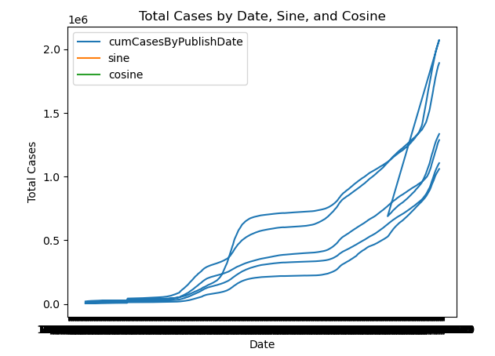

**Visualization 2 Pie Chart: Total cases with respect to UK regions**

Certainly! The pie chart represents the distribution of total COVID-19 cases by region in the United Kingdom. Each slice of the pie corresponds to a region, and the size of the slice corresponds to the percentage of total cases that are in that region. The legend next to the pie chart shows the region and the corresponding percentage of cases.

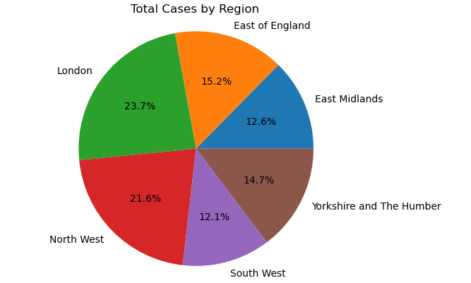

**Visualization 3 Bar chart: Daily deaths from march 2020 to 2021**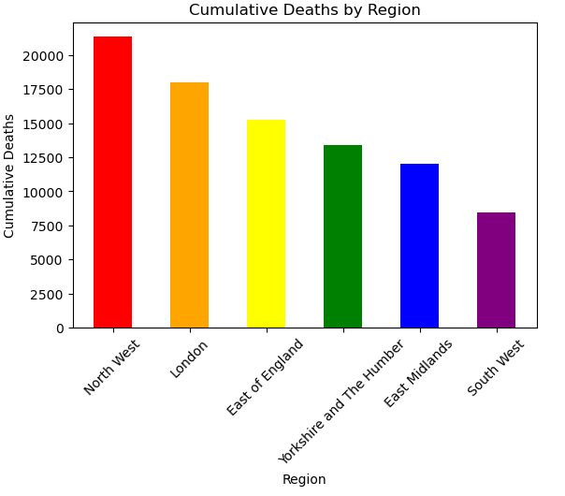

The bar chart that we created above represents the daily number of deaths cases in the United Kingdom from March 2020 to February 2021. Each bar on the chart represents a single day, and the height of the bar represents the number of confirmed cases on that day. The chart allows us to see the pattern of how the number of cases fluctuated over time, and identify any significant spikes or dips in the number of cases.