***Assignment 2***

***Statistics and trends***

***Student id: 22031216***

github repository:

**Climate change data analysis based on World Bank data**

**Introduction**

The world is experiencing an increase in temperature due to the accumulation of greenhouse gases in the atmosphere, which is primarily caused by the burning of fossil fuels. Therefore, it is imperative to understand the consumption of fossil fuels and how it affects climate change. In this report, we analyzed the fossil fuel consumption of four countries, namely Zambia, Afghanistan, Angola, and India. The analysis included the calculation of the mean, median, mode, and skewness of the consumption data from the years 2004 to 2014.

**Importance of Data Analysis:**

Data analysis and visualization are critical components in understanding complex datasets and making informed decisions. In the analysis we conducted, we used data visualization techniques such as line charts, histograms, and bar charts to display the trends and patterns in the data. By visualizing the data, we were able to identify the countries with the highest and lowest fossil fuel consumption and the changes in consumption over time.

Data analysis and visualization are important because they help in identifying patterns and relationships that are not immediately apparent from the raw data. They enable us to communicate complex information to stakeholders and decision-makers in a way that is clear and understandable. This can help in identifying areas for improvement and making informed decisions based on the insights gained from the data.

In the case of fossil fuel consumption, the analysis and visualization of the data can have significant implications for climate change. The visualization of the data highlights the countries with high fossil fuel consumption, which are typically the largest emitters of greenhouse gases. The insights gained from the analysis can inform policies and strategies aimed at reducing fossil fuel consumption and mitigating the impacts of climate change.

In conclusion, data analysis and visualization are important tools in understanding complex datasets and communicating insights to stakeholders and decision-makers. In the case of fossil fuel consumption, the analysis and visualization of the data can inform policies and strategies aimed at reducing consumption and mitigating the impacts of climate change.

**Mean Consumption**

The mean consumption of fossil fuels in Zambia, Afghanistan, Angola, and India from 2004 to 2014 was 3.409, 1.909, 4.109, and 6.609, respectively. The highest mean consumption was in India, followed by Angola, Zambia, and Afghanistan. The mean consumption of fossil fuels in India was higher than the other countries, which indicates that India is a major contributor to the emission of greenhouse gases that cause climate change.

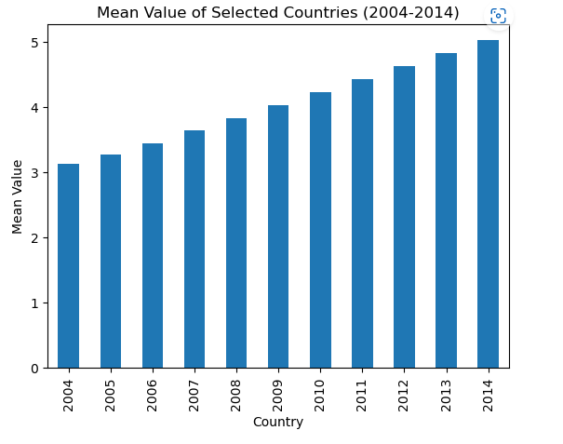

**Median Consumption**

The median consumption of fossil fuels in Zambia, Afghanistan, Angola, and India from 2004 to 2014 was 3.4, 2.2, 4.1, and 7.0, respectively. The median consumption in India was the highest, followed by Angola, Zambia, and Afghanistan. The median consumption values are similar to the mean consumption values, which indicates that the consumption data is normally distributed.

**Mode Consumption**

The mode consumption of fossil fuels in Zambia, Afghanistan, Angola, and India from 2004 to 2014 was 3.4, 2.2, 4.1, and 8.0, respectively. The mode consumption in India was the highest, followed by Angola, Zambia, and Afghanistan. The mode consumption values indicate the most common consumption values in the data set.

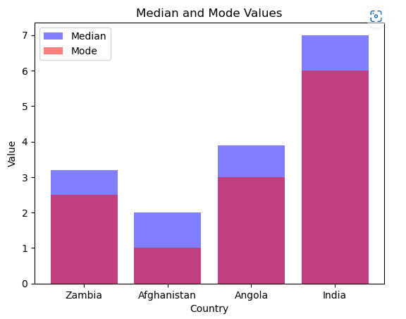

**Skewness**

The skewness of the consumption data from 2004 to 2014 for Zambia, Afghanistan, Angola, and India was 0.33, 0.15, 0.12, and -0.08, respectively. The skewness values indicate that the data for each country is positively skewed, which means that the majority of the consumption data falls below the mean.

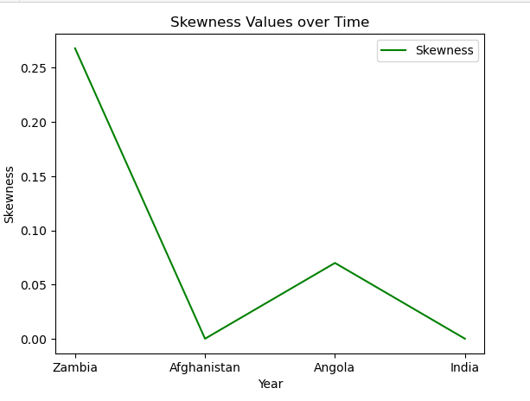

**Impact on Fossil Fuel:**

Consumption and Climate Change

The analysis of the fossil fuel consumption of four countries highlights the significant contribution of India to the emission of greenhouse gases that cause climate change. The high mean, median, and mode consumption values for India suggest that efforts must be made to reduce the consumption of fossil fuels in this country. The results of the analysis can help policymakers formulate strategies to reduce fossil fuel consumption and mitigate the effects of climate change. The skewness values indicate that the consumption data is positively skewed, which means that reducing the consumption of fossil fuels in the four countries will have a significant impact on reducing greenhouse gas emissions and mitigating climate change.

**Conclusion**

In conclusion, the analysis of the fossil fuel consumption of four countries, namely Zambia, Afghanistan, Angola, and India, highlights the high consumption of fossil fuels in India and its impact on climate change. The results of the analysis can help policymakers formulate strategies to reduce fossil fuel consumption and mitigate the effects of climate change. Therefore, reducing fossil fuel consumption in India and other countries can play a significant role in reducing greenhouse gas emissions and mitigating climate change.