LAB 1
Step 1 downloading python
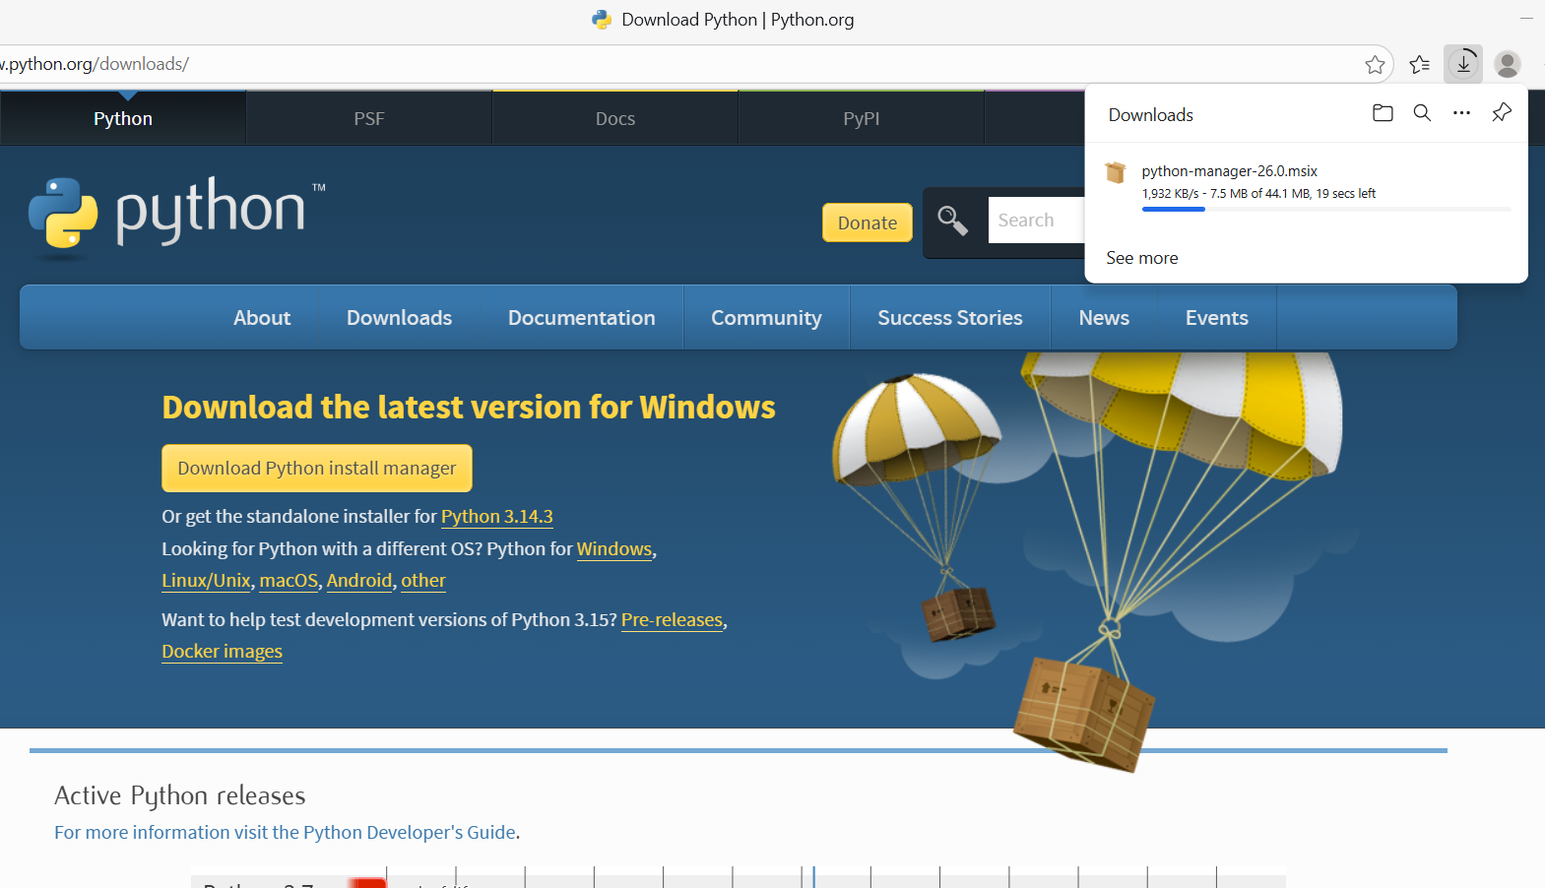
Since Python is already been setup in my PC
So I won’t go further

Step 2 Downloading Anaconda
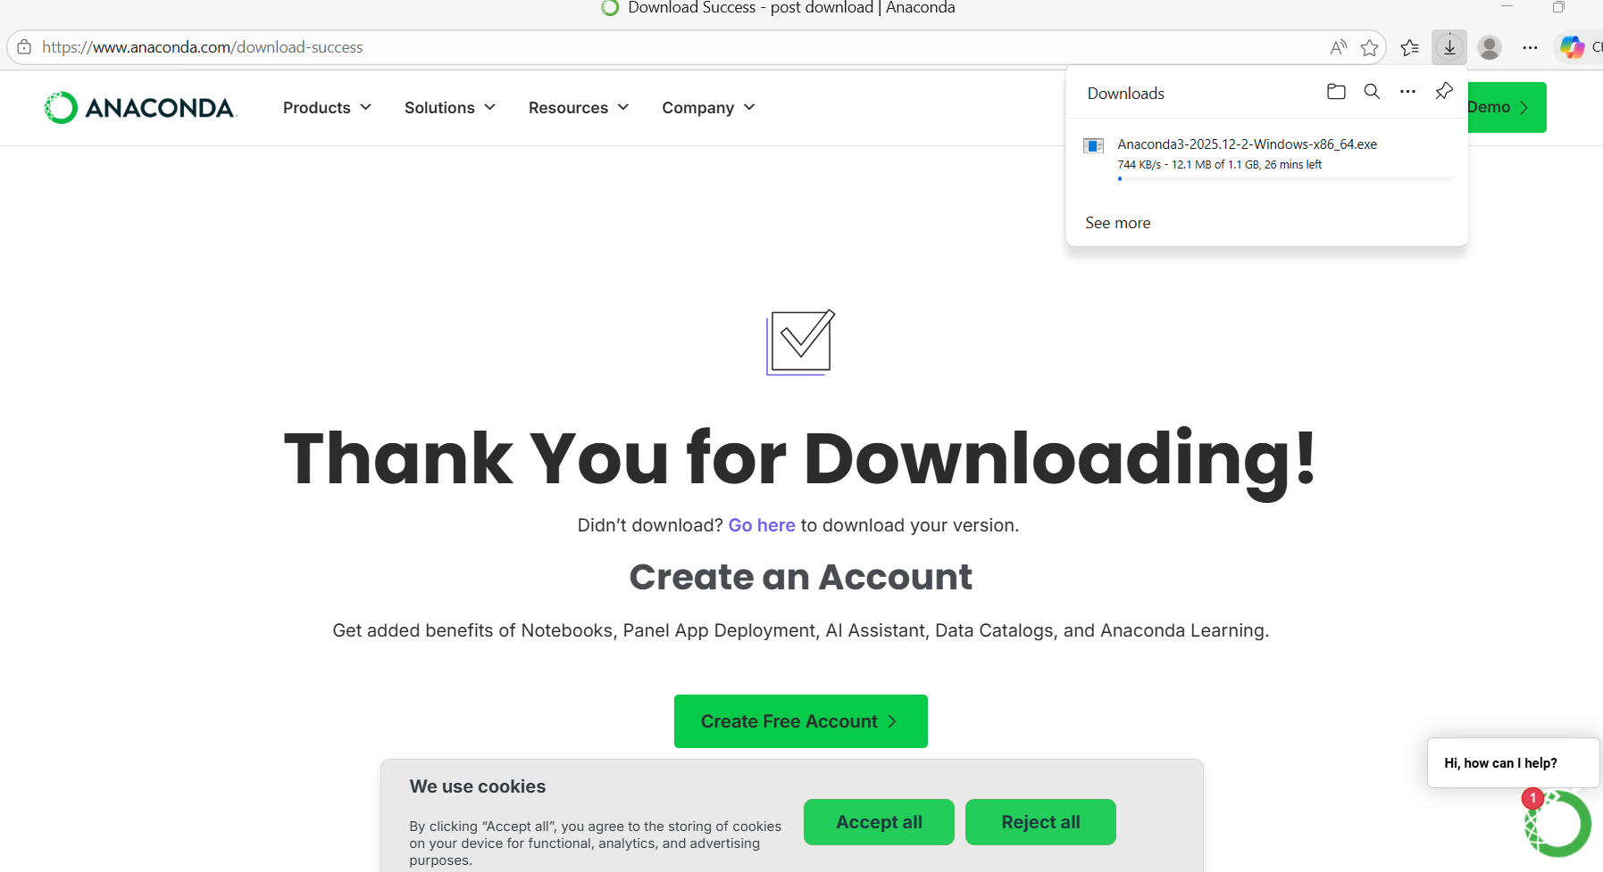

Adding to Github
muhammadahmediqbal12-eng/Computer-Vision-LAB-1: Computer Vision Lab 1
