

**Assignment 02**

**Submitted to**: Ma’am Isma ul Hasan

**Submitted by**: Ammer Hamza (22I-2579)

Sanaan Azfar (22I-2594)

Hamza Aftab (22I-2523)

Muhammad Ali (22I-1516)

**Subject**: Introduction to Software Engineering

**Sprint 1 Overview:**

In this sprint we decided to work on one out of two modules of our app which was customer’s module. We decided to make all UX design related to customer’s module and do the coding later on.

The User stories that we worked on are as follows:

## Story Number: 1

|  |  |
| --- | --- |
| As a | Student |
| I want | A create separate account |
| So that | I can store my money safely and use app accordingly |

## Story Number 2:

|  |  |
| --- | --- |
| As a | Student |
| I want | Login/Logout option |
| So that | I can access my account and safely exit |

**Story Number: 3**

|  |  |
| --- | --- |
| As a | Student |
| I want | Product Purchase option |
| So that | I could buy product |

**Story Number: 4**

|  |  |
| --- | --- |
| As a | Student |
| I want | Add to cart option |
| So that | I could buy multiple items at the same time |

## Story Number: 5

|  |  |
| --- | --- |
| As a | Student |
| I want | To transfer money to my account and then to café only |
| So that | In case I forget my wallet, I would still be able to buy |

## Story Number: 6

|  |  |
| --- | --- |
| As a | Student |
| I want | To see available products and their prices |
| So that | I buy accordingly, according to my preferences and budget |

## Story Number: 7

|  |  |
| --- | --- |
| As a | Student |
| I want | Take away option |
| So that | I buy items and move on |

## Story Number: 8

|  |  |
| --- | --- |
| As a | Student |
| I want | Dine in option |
| So that | I can eat food at café |

## Story Number: 9

|  |  |
| --- | --- |
| As a | Student |
| I want | Feedback option |
| So that | I could give feedback on café faculty and specially the food |

## Story Number: 10

|  |  |
| --- | --- |
| As a | Student |
| I want | Product options divided by their type, e.g., Snacks, Beverages etc. |
| So that | I don’t have to search them in a long list |

## Story Number: 11

|  |  |
| --- | --- |
| As a | Student |
| I want | Profile viewer |
| So that | I could see my information, amount of money and change password |

## Story Number: 12

|  |  |
| --- | --- |
| As a | Student |
| I want | Product reviews |
| So that | I could see its success and reviews about it |

## Story Number: 13

|  |  |
| --- | --- |
| As a | Student |
| I want | Product rating |
| So that | I could see its success, quality and rate it |

## Story Number: 14

|  |  |
| --- | --- |
| As a | Student |
| I want | To view cart |
| So that | I could see what I added to cart, their quantity and total price. I could remove items from cart and proceed to payment |

## Story Number: 15

|  |  |
| --- | --- |
| As a | Student |
| I want | To go to main menu |
| So that | I could again buy or view another product |

## Story Number: 16

|  |  |
| --- | --- |
| As a | Student |
| I want | Table selecton |
| So that | I could see if there’s any tables available where I could eat my food |

## Story Number: 17

|  |  |
| --- | --- |
| As a | Student |
| I want | A back button |
| So that | I could go to previous page |

## Story Number: 18

|  |  |
| --- | --- |
| As a | Student |
| I want | To see a message prompt |
| So that | I could see my table has been booked and my order is on the way |

**Burndown Chart:**

**Sprint 2 Planning:**

In the next phase we have decided to work on UX design of customer’s module along with some implementation of the previous UX on Flutter.

The user stories that we will be working on are as follows

## Story Number: 1

|  |  |
| --- | --- |
| As a | Café manager |
| I want | Create An account |
| So that | I receive money and orders |

## Story Number 2

|  |  |
| --- | --- |
| As a | Café manager |
| I want | Login/Logout option |
| So that | I can access my account and safely exit |

|  |  |
| --- | --- |
| As a | Café manager |
| I want | Product manage option |
| So that | I could update quantity, price and remove items |

**Story Number: 3**

|  |  |
| --- | --- |
| As a | Café manager |
| I want | An option to add product |
| So that | Students could see available products |

**Story Number: 4**

## Story Number: 5

|  |  |
| --- | --- |
| As a | Café manager |
| I want | A unique product ID |
| So that | In case some issue arrives and I could simply see their ID’s instead of whole name |

## Story Number: 6

|  |  |
| --- | --- |
| As a | Café manager |
| I want | A notification when I receive orders |
| So that | I get notified when someone orders something online |

|  |  |
| --- | --- |
| As a | Café manager |
| I want | To want an automated order id |
| So that | So, I don’t mix up orders and fulfill them quickly |

**Story Number: 7**

|  |  |
| --- | --- |
| As a | Café manager |
| I want | done order option |
| So that | The students don’t repeatedly buy products and cheat with the café |

**Story Number: 8**

**Story Number: 9**

|  |  |
| --- | --- |
| As a | Café manager |
| I want | A reset order id option |
| So that | At the start of a new day, I could start with first customer |

## Story Number: 10

|  |  |
| --- | --- |
| As a | Café manager |
| I want | An automatic product quantity counter, which will decrease as students buy that item |
| So that | Me and students could see its availability |

## Story Number: 11

|  |  |
| --- | --- |
| As a | Café manager |
| I want | View Product Rating |
| So that | I could see if the product is successful |

## Story Number: 12

|  |  |
| --- | --- |
| As a | Café manager |
| I want | View Product Reviews |
| So that | I could see if the product is successful |

## Story Number: 13

|  |  |
| --- | --- |
| As a | Café manager |
| I want | View feedback |
| So that | I could check how the café faculty and food is doing and what could be improved |

## Story Number: 14

|  |  |
| --- | --- |
| As a | Café manager |
| I want | A Time limit for booked tables |
| So that | Students don’t sit there for a longer period of time |

## Story Number: 15

|  |  |
| --- | --- |
| As a | Café manager |
| I want | To see table number with order |
| So that | I could send the order to the respected table |

**Work Division:**

|  |  |
| --- | --- |
| **Name** | **Work Done** |
| Ammer Hamza | Sprint meeting, Figma Task Division, Product Display, Product Types, Product Rating, Product Reviews, Main Menu(button), back button, Feedback Pages |
| Sanaan Azfar | Login, Logout, Sign up, Profile pages, Page connection |
| Muhammad Ali | GitHub, Cart, Online Payment pages |
| Hamza Aftab | Document creation, Table pages |

**GitHub:**

**Link Address:**

**https://github.com/muhammadali015/FAST-Wallet-cafe-**

**Trello:**

**Link Address:** [**https://trello.com/invite/b/OrHEso85/ATTIbc32e4fa7168f372969d1e35730b3e10527CB416/1**](https://trello.com/invite/b/OrHEso85/ATTIbc32e4fa7168f372969d1e35730b3e10527CB416/1)

**Snapshots:**

**1)**

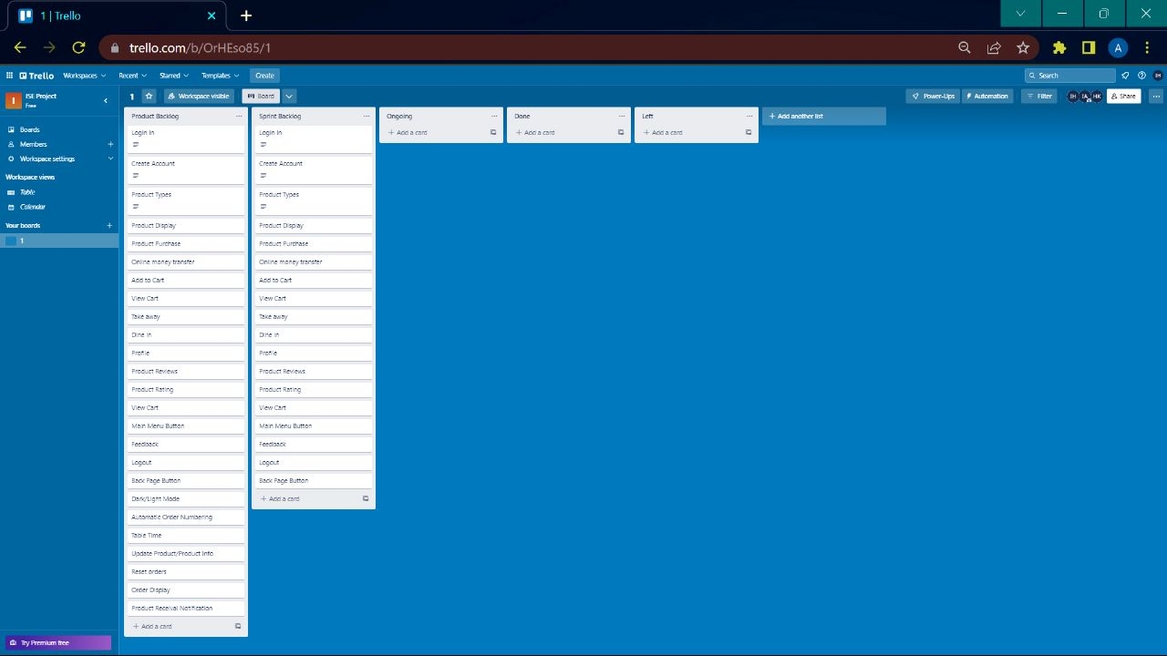

**2)**

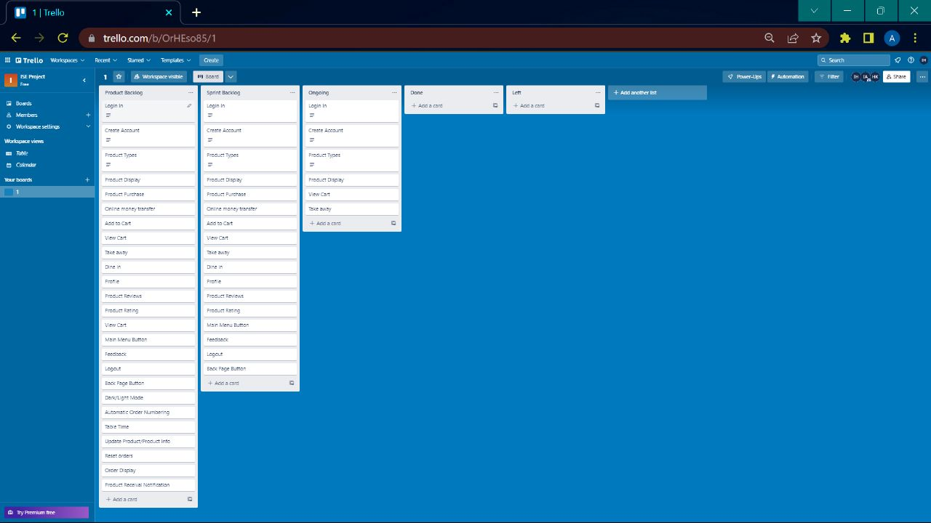

**3)**

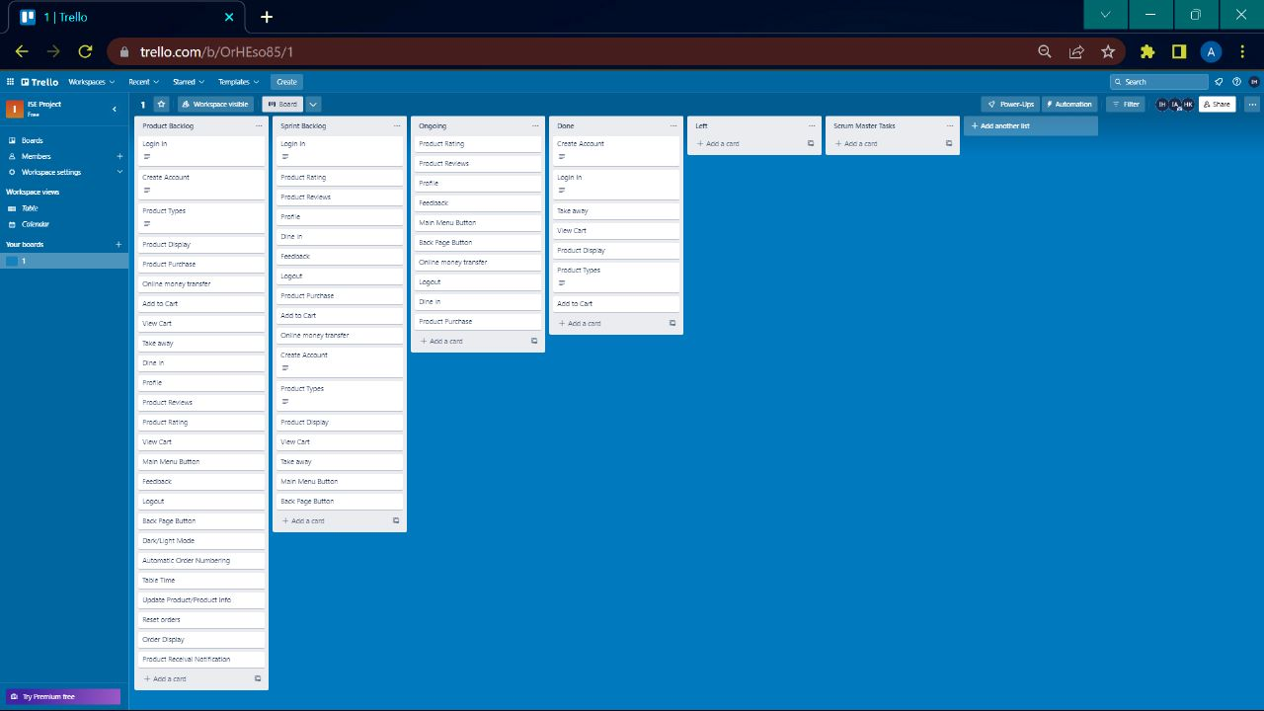

**4)**

