Script no. 1:
Code:

#script1
#! /bin/bash
clear
echo "Program 1"
echo "==============================="
#mail -s "Test Subject" muhammadali19960@outlook.com < /dev/null
echo "Files before moving in current directory: $(ls)"
echo "===================================================="
echo
echo "Files before moving in temp directory: $(ls /home/muhammad/UniMaterial/temp)"
echo "===================================================="
echo
echo "Making some files in this directory"
touch helloworld.txt byeworld.txt
echo "Copy files to temp directory removing them from the current directory";
mv * /home/muhammad/UniMaterial/temp/
echo "===================================================="
echo
echo "Files after moving in current directory: $(ls)"
echo "===================================================="
echo
echo "Files after moving in temp directory: $(ls /home/muhammad/UniMaterial/temp)"
echo "Now deleting files over 10 days old in temp directory";
find /home/muhammad/UniMaterial/temp/ -mtime +10 -type d -delete
find /home/muhammad/UniMaterial/temp/ -mtime +10 -type f -delete
echo "===================================================="
echo
echo "Files after deleting 10 days over files in temp directory: $(ls /home/muhammad/UniMaterial/temp)"

echo "Task 1 Completed"

Terminal:

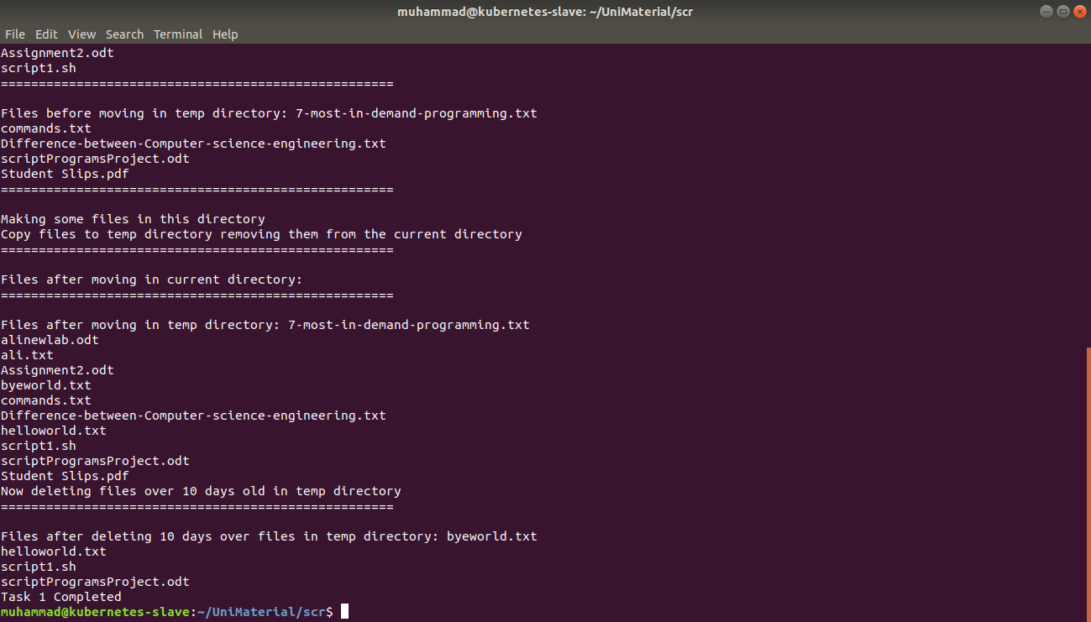

Script no. 2:
Code:

Code:
let "a=1"
clear
while test $a -eq 1
do
echo " Commands Menu "
echo "================================"
echo "1. Who is logged in"
echo "2. Date Time"
echo "q Quit"
echo "================================"
echo -n "Enter your choice:"
read b
case "$b" in
1)
echo "Who is logged in:"
echo "$(whoami)"
sleep 2
clear
;;
2)
echo
echo "Date Time:"; date
sleep 2
clear
;;
q)
exit 0
;;
*)
echo
echo "Wrong Option...Try again"
sleep 2
clear
;;
esac
done

Terminal:

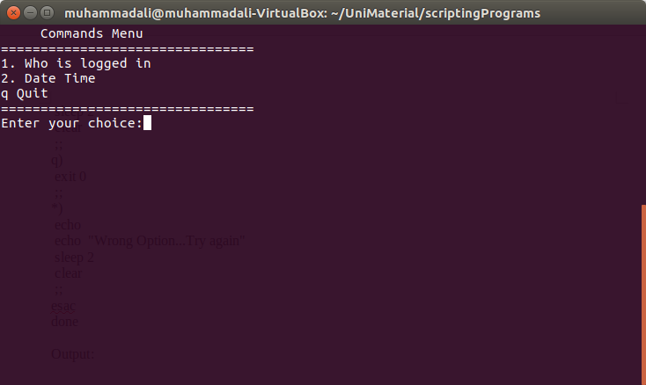

Script no. 3:
Code:
let "a=1"
while test $a -eq 1
do
clear
echo "1. Display a file on monitor"
echo "2. Delete a file"
echo "q. Quit"
echo "================================"
echo -n "Enter your choice:"
read b
case "$b" in
1)
echo "Enter a filename you want to monitor: ";
read filename
less $filename
sleep 2
clear
;;
2)
echo "Enter a filename you want to delete"
read filename
rm $filename
sleep 2
clear
;;
q)
exit 0
;;
*)
echo
echo "Wrong Option...Try again"
sleep 2
clear
;;
esac
done

Terminal:

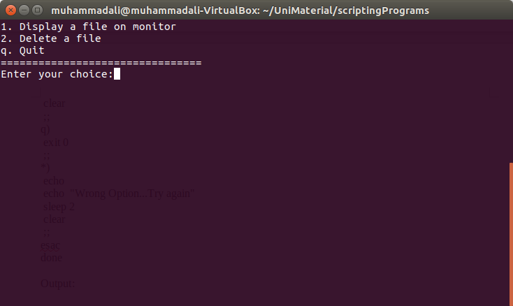

Script no. 4:
Code:
clear
let "a=1"
while test $a -eq 1
do
echo "re. For 1 most recent file"
echo "recent. For 10 most recent files"
echo "recent n. For n most recent files"
echo "q. Quit"
echo "================================"
echo -n "Enter your choice:"
read b
case "$b" in
re)
echo "1 most recent file is: $(ls -1t | head -1)"
sleep 2
clear
;;
recent)
echo "10 most recent files are: $(ls -1t | head -10)"
sleep 2
clear
;;
"recent "*)
NUMBER=$(echo "$b" | tr -dc '0-9')
echo "$NUMBER most recent files are: "; ls -1t | head -$NUMBER
sleep 2
clear
;;
q)
exit 0
;;
*)
echo
echo "Wrong Option...Try again"
sleep 2
clear
;;
esac
done

Terminal:

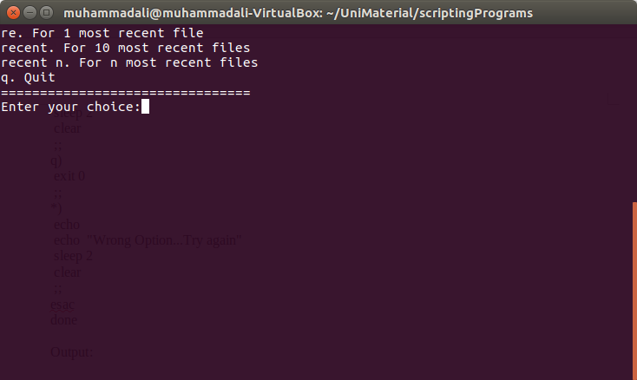

Script no. 5:
Code:
clear
let "a=1"
while test $a -eq 1
do
echo " Commands Menu "
echo "================================"
echo "1. To start the task"
echo "q Quit"
echo "================================"
echo -n "Enter your choice:"
read b
case "$b" in
1)
echo "Enter the filename you want to copy content from "
read file1
echo "Enter the filename you want to copy the content to "
read file2
if [ -e $file2 ] ; then
echo "$file2 exist"
if [ -w $file2 ]; then
echo "$file2 have write permissions"
echo "Do you want to proceed copy the file 1 to file2?? ( y for yes )"
read b
if [ $b == y ]; then
cp $file1 $file2
echo "File contents copy"; cat $file2
else
echo "Oky you dont want to copy"
fi
else
echo "$file2 dont have write permission"
fi
else
echo "$file2 not exist"
fi
sleep 5
clear
;;
q)
exit 0
;;
*)
echo
echo "Wrong Option...Try again"
sleep 2
clear
;;
esac
done

Terminal:

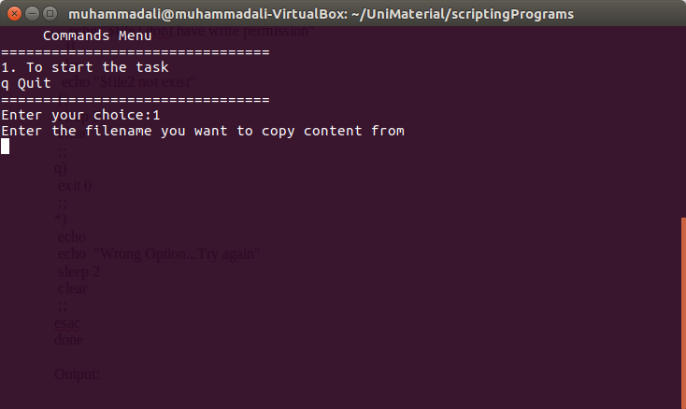

Script no. 6:
Code:

hour=$(date +%H)
print=""
if [ $hour -ge 0 -a $hour -lt 12 ]
then
print="Good Morning, $USER"
elif [ $hour -ge 12 -a $hour -lt 18 ]
then
print="Good Afternoon, $USER"
else
print="Good Evening, $USER"
fi
echo $print

Terminal:
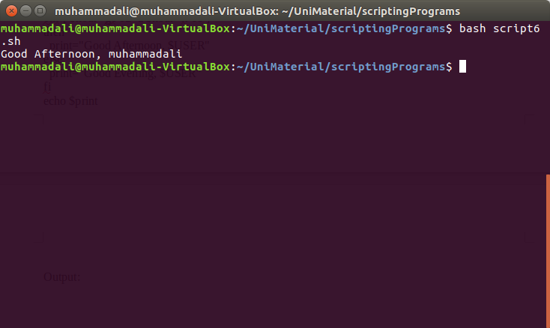

Script no. 7:
Code:
clear
echo "Enter file names you want see on terminal"
flag=false
totalDisplay=0
read filenames
# pr -m -t a.txt b.txt c.txt
for filename in $filenames
do
if [[ -f $filename ]]
then
printfiles+="$filename "
#totalDisplay=$((totalDisplay + 1))
let totalDisplay++
else
notprintfiles+="$filename "
flag=true
fi
done
echo "These $totalDisplay out of $(ls | wc -l) files can be display: "; tail -n +1 $printfiles
numfiles=(*)
numfiles=${#numfiles[@]}
notDisplay=`expr $numfiles - $totalDisplay`
echo "$notDisplay files not display in this directory"
if [ $flag == true ]
then
echo "These files can't be display because these are not exist: $notprintfiles"
fi

Terminal:
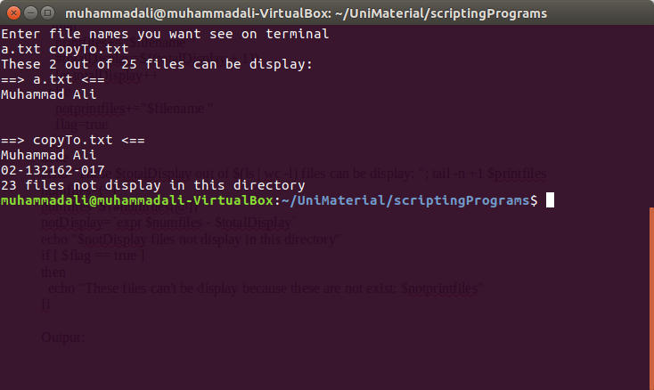

Script no. 8:
Code:
clear
echo "Your old mail box id is: ma6627863@gmail.com"
echo "Your new mail box id is: muhammadali19960@gmail.com"
echo "The content of the old mailbox ID is transfered to the new mailbox ID"
fi

Terminal:
