University of Management & Technology

Lahore Campus

DESIGN AND IMPLEMENTATION OF AN ENTERPRISE CAMPUS
NETWORK WITH ZERO TRUST SECURITY ARCHITECTURE

Final Project Report
Submitted in Partial Fulfillment of the Requirements for the Course of Computer Networks

Course | Computer Networks
Instructor | Mr. Osama Tariq (Lecturer)
Section | W6
Group Members | Muhammad Alian (F2024065085)  Hasnain Azhar (F2024065433)
Date of Submission | June 2026

APPROVAL PAGE
The undergraduate project report titled "Design and Implementation of an Enterprise Campus Network with Zero Trust Security Architecture", submitted by Muhammad Alian (F2024065085) and Hasnain Azhar (F2024065433) in partial fulfillment of the requirements for the course of Computer Networks, has been examined and approved by the evaluation committee.

Examiner: ___________________________

Project Instructor: Mr. Osama Tariq
Date: ___________________________

DECLARATION
We hereby declare that this project report is our own authentic engineering and technical work carried out at the University of Management and Technology (UMT), Lahore. All device deployments, configurations, topology designs, security implementations, and multi-tier testing schemas were executed inside Cisco Packet Tracer 8.x. No portion of this work has been plagiarized, and all theoretical models or standards utilized have been properly referenced.

1. Muhammad Alian (F2024065085)
Signature: ___________________________
Date: ___________________________

2. Hasnain Azhar (F2024065433)
Signature: ___________________________
Date: ___________________________

ACKNOWLEDGEMENT
We express our deepest gratitude to our course instructor, Mr. Osama Tariq, whose structured guidance, technical insights, and strict performance benchmarks pushed us to design an enterprise-grade infrastructure rather than a generic network. His emphasis on moving beyond standard network layouts allowed us to deeply learn the intricacies of Cisco IOS configurations, access list optimization, and security hardening.

We also thank the Department of Software Engineering at the University of Management and Technology, Lahore, for providing the engineering software tools and laboratory environment required to systematically model, stress-test, and refine this operational network architecture.

ABSTRACT
This technical report presents the completed design, implementation, configuration, and validation of an enterprise-grade campus network architecture for the University of Management and Technology (UMT), Lahore. Moving away from traditional implicit perimeter trust models that expose organizations to catastrophic lateral threat propagation, this infrastructure executes a rigorous Zero Trust Security Architecture mapped to the physical campus geography. Grounded in the guidelines of NIST Special Publication 800-207, the network splits users into five logically isolated VLANs: Administration (VLAN 10), Faculty (VLAN 20), Student (VLAN 30), IT Department (VLAN 40), and Guest (VLAN 50).

The infrastructure uses a three-tier hierarchical design consisting of dual Cisco Catalyst 3650 Core switches, dual Catalyst 3650 Distribution switches, and dedicated Catalyst 2960 Access layer switches. Dynamic IP address allocation is driven via specialized central DHCP servers mapped through sub-interface helper addresses. Routing across the multi-layer core backbone is automated via Open Shortest Path First (OSPF) Area 0. Dynamic Network Address Translation (NAT) with Port Address Translation (PAT) provides secure, controlled external internet access.

Security policy enforcement is handled via Extended Named Access Control Lists (ACLs) bound at the Layer 3 Distribution SVI interfaces, executing stateless granular packet filtering to deny unauthorized lateral traversal. Optimization and hardening routines, including Spanning Tree Protocol (STP) PortFast, BPDU Guard, non-default native VLAN trunk matching, and strict access layer port-security macros, were applied to eliminate common Layer 2 exploits. Comprehensive ping, traceroute, and policy verification tests confirm that the implemented environment meets all explicit multi-departmental constraints while delivering a reliable, scalable, and resilient enterprise networking fabric.

Keywords: Zero Trust Security, VLAN Segmentation, Hierarchical Network Design, OSPF, Extended ACL, Inter-VLAN Routing, Enterprise Network, Cisco Packet Tracer.

TABLE OF CONTENTS
Title Page i
Approval Page ii
Declaration iii
Acknowledgement iv
Abstract v
Table of Contents vi
List of Figures vii
List of Tables viii
Chapter 1: Introduction 1
Chapter 2: Requirements Analysis and System Planning 4
Chapter 3: Network Architecture and Design 7
Chapter 4: Implementation and Configuration 13
Chapter 5: Testing and Validation 20
Chapter 6: Results and Discussion 24
Chapter 7: Challenges and Lessons Learned 27
Chapter 8: Conclusion and Recommendations 29
References 31
Appendices 32

LIST OF FIGURES
FIGURE 3.1: Complete Enterprise Three-Tier Hierarchical Network Topology
FIGURE 4.1: Inter-Switch Trunk Configuration Status and 802.1Q Verification
FIGURE 4.2: OSPF Neighbor Adjacency and State Detail Capture
FIGURE 5.1: ICMP Validation Output for Intravlan and Intervlan Path Traversal
FIGURE 5.2: Extended Access-List Match Counter Validation
FIGURE 5.3: DHCP Binding Table and NAT Translation Verification on Edge Router

LIST OF TABLES
TABLE 2.1: User Population and Traffic Categorization Metrics
TABLE 3.1: Physical Building to Logical VLAN Structural Mapping
TABLE 3.2: Comprehensive RFC 1918 IP Addressing Subnet Allocation
TABLE 3.3: Stateful Zero Trust Inter-VLAN Access Control Policy Matrix
TABLE 4.1: Simulated Hardware Inventory and IOS Placement Detail
TABLE 4.2: VLAN Configuration Summary
TABLE 4.3: Trunk Interface Operational Status
TABLE 4.4: Core/Distribution Layer Routing Table Summary
TABLE 4.5: OSPF Neighbor Adjacency Status
TABLE 5.1: Structural Network Connectivity and Protocol Testing Log
TABLE 5.2: Zero Trust Security Enforcement and Hardening Verification Matrix

CHAPTER 1
INTRODUCTION

1.1 Project Overview
This project presents the successful implementation of an enterprise-grade campus network with a Zero Trust Security Architecture for the University of Management and Technology (UMT), Lahore. The completed infrastructure replaces open, single-broadcast network topologies with a resilient, multi-tiered hierarchy capable of securely handling over two thousand endpoints. By separating user categories into distinct physical and logical zones, the network eliminates implicit trust based on physical access, protecting critical institutional assets from unauthorized lateral exposure.
1.2 Background
Modern academic institutions feature diverse network environments where student personal items, faculty research units, financial registers, and core management servers share the same transmission infrastructure. Historically, organizations relied on perimeter security models that assumed every device on the internal network was safe.

However, current threat landscapes (such as credential harvesting, internal malicious acts, and automated ransomware) exploit these open internal layouts. If a single endpoint is breached, an attacker faces no barriers to traversing internal resources. Zero Trust addresses this vulnerability by requiring explicit authorization and continuous validation at every department boundary.
1.3 Problem Statement
The typical campus framework faces several overlapping deficiencies that undermine data security and operational efficiency:

1. Absence of Network Segmentation: Placing administrative data and student personal devices within the same broadcast domain allows a single compromised endpoint to scan internal servers, capture unencrypted frames, and execute Layer 2 broadcast attacks.
2. Unrestricted Inter-Departmental Access: An engineering workstation has direct Layer 3 access to human resource systems and financial ledgers because there are no inline enforcement points to filter traffic at departmental boundaries.
3. Static IP Address Management: Manually setting up static parameters across hundreds of nodes causes duplicate address flags, configuration errors, and high troubleshooting overhead for the IT team.
4. Implicit Trust Failures: Legitimate authentication onto the campus network awards broad reachability, exposing the university to fast ransomware spread and unauthorized data movement.
1.4 Objectives
The project met the following engineering and design goals:
- Built an operational three-tier network architecture (Core, Distribution, Access) in Cisco Packet Tracer 8.x.
- Configured five distinct user VLANs to isolate Student, Faculty, Administration, IT Department, and Guest spaces.
- Configured OSPF Area 0 routing alongside Layer 3 Switched Virtual Interfaces (SVIs) to manage inter-segment traffic flow.
- Implemented Extended Named Access Control Lists (ACLs) to enforce a default-deny security posture across department boundaries.
- Hardened Layer 2 switches against common infrastructure exploits using PortFast, BPDU Guard, and custom native VLAN assignments.
1.5 Scope
The project scope covers the complete physical-to-logical mapping, core routing implementation, address allocation, security engineering, and functional validation inside Cisco Packet Tracer. It includes multi-layer switching configurations, trunk optimization, dynamic OSPF routing, centralized DHCP relaying, dynamic NAT/PAT translation, and Extended ACL design.

It excludes physical hardware procurement, structural workspace cabling, external identity providers (such as RADIUS or Active Directory), and Software-Defined Networking (SDN) tools.
1.6 Project Significance
This project provides a practical implementation blueprint for educational networks migrating toward modern security standards. It demonstrates how to combine stable performance and tight access control without using expensive software overlays. It proves that proper application of basic Cisco IOS features can limit an organization's internal attack surface and isolate potential endpoint compromises.

CHAPTER 2
REQUIREMENTS ANALYSIS AND SYSTEM PLANNING

2.1 Network Requirements
The network infrastructure must support low-latency packet forwarding and reliable reachability across all physical zones. Key performance needs include:
- High-throughput trunk backbones between building aggregation points and the core switches.
- Automated IP assignment to eliminate duplicate address conflicts.
- Sub-second routing convergence during link failures.
- Consistent default gateway redundancy at the distribution tier.
2.2 User Categories
The campus user population is divided into five groups with distinct resource access requirements and security levels:

TABLE 2.1: User Population and Traffic Categorization Metrics

User Category | Approx. Count | Primary Access Requirements | Security Classification
Students | 1,400 | Internet access, LMS portal, Student Registration system | Low privilege
Faculty | 200 | Research compute nodes, Academic administrative portals, External web | Medium privilege
Administration | 100 | Enterprise Resource Planning (ERP), HR databases, Financial applications | High privilege
IT Department | 50 | Total topology management interfaces, Server infrastructure access | Highest privilege
Guests | 250 | Public outbound internet traffic only, Total internal block | Isolated

2.3 Security Requirements
The network security architecture must guarantee:
Confidentiality: Administrative and grading resources must remain isolated from the general student body and guest users.
Integrity: Unauthorized devices must be blocked from intercepting or modifying network control traffic, routing tables, and switch administrative frames.
Availability: Redundant structural paths must handle link failures without causing broadcast loops or Spanning Tree collapses.
2.4 Zero Trust Design Requirements
Consistent with the NIST SP 800-207 framework, the network enforces three core design principles:
1. Explicit Communication Permissions: No user segment is trusted implicitly based on its network location or access port. Inter-VLAN communication is blocked by default and permitted only via explicit rules.
2. Stateless Boundary Control: Traffic moving between subnets is inspected by inline security rules configured on the Layer 3 Distribution switches.
3. Attack Surface Reduction: Access to infrastructure management interfaces (such as SSH or Telnet) is restricted exclusively to verified IT Department management terminals.
2.5 Design Constraints
Implementing the system within Cisco Packet Tracer 8.x introduced specific technical constraints:
- Fixed software models for ACL checking that lack contextual deep-packet inspection.
- Simulated hardware performance that does not capture physical ASIC limitations or traffic bottlenecks.
- Device scaling limits that required each access switch to represent an entire campus building's aggregated traffic.
2.6 Planning Decisions
To address these requirements and constraints, several design choices were made:
- A clean /24 IP addressing structure was selected for each department to simplify access list maintenance and allow for logical scalability.
- Extended Named ACLs were selected over numbered access lists to improve configuration clarity and permit precise protocol and port filtering.
- A dedicated out-of-band Management VLAN was created to isolate all switch and router configuration access from user data planes.

CHAPTER 3
NETWORK ARCHITECTURE AND DESIGN

3.1 Overall Architecture
The completed network uses a structured approach to separate infrastructure operations. This design isolates Layer 2 broadcast domains to individual buildings while aggregating and filtering all cross-subnet traffic at a multi-layer switching core.
3.2 Three-Tier Hierarchical Design
The campus network layout is based on the Cisco Three-Tier Hierarchical Design Model, split into Core, Distribution, and Access layers. This architecture separates packet-forwarding, security checking, and endpoint connectivity into distinct operational tiers.
3.3 Core Layer Design
The Core Layer consists of two Cisco Catalyst 3650 multi-layer switches interconnected via high-capacity etherchannel links. To ensure high forwarding performance, the core layer runs no access lists and performs no packet-level inspection. Its sole function is high-speed Layer 3 switching between distribution blocks. It runs OSPF Area 0 to optimize routing across the backbone network.
3.4 Distribution Layer Design
The Distribution Layer consists of two Catalyst 3650 switches that act as the primary routing boundary and policy enforcement points for the Zero Trust model. These switches host the Switched Virtual Interfaces (SVIs) for every operational VLAN and handle all inter-VLAN routing.

They serve as central DHCP relay agents that forward endpoint requests to dedicated servers. Crucially, they host the inbound Extended Named Access Control Lists that filter inter-subnet traffic before it reaches the core layer.
3.5 Access Layer Design
The Access Layer uses five Cisco Catalyst 2960 Layer 2 switches to connect endpoints directly to the infrastructure. These switches enforce Layer 2 security, isolate individual client access ports, and disable dynamic trunk negotiations. They connect to the distribution tier via 802.1Q trunk lines configured with explicit allowed-VLAN lists.
3.6 Physical Building to VLAN Mapping
Each logical division matches a specific physical campus structure at UMT Lahore, turning each building into an independent trust zone:

TABLE 3.1: Physical Building to Logical VLAN Structural Mapping

Physical Location | Logical VLAN Assignment | Assigned ID | Active Infrastructure Devices
Administrative Block | Administration | VLAN 10 | Administrative Terminals, HR Workstations, Corporate Printers
Academic and Faculty Block | Faculty | VLAN 20 | Staff Laptops, Research Nodes, Presentation Desktops
Student Laboratories A, B, C | Student | VLAN 30 | Desktop Lab Workstations, Student Wireless Access Points
IT Department / Server Room | IT Department | VLAN 40 | Enterprise Application Servers, DNS/DHCP Nodes, Admin Stations
Guest and Visitor Common Area | Guest | VLAN 50 | Public Internet Terminals, Separated Guest Access Points

3.7 VLAN Design
VLAN boundaries ensure that Layer 2 broadcast traffic remains isolated to its designated segment. A separate out-of-band Management VLAN (VLAN 99) handles all remote configuration access to network devices, ensuring infrastructure control traffic is isolated from standard user data planes.
3.8 IP Addressing Scheme
The network uses RFC 1918 private address blocks divided into clean /24 subnets. This structure simplifies access list configuration and accommodates growth up to 254 hosts per zone.

TABLE 3.2: Comprehensive RFC 1918 IP Addressing Subnet Allocation

VLAN Descriptive Name | VLAN ID | Allocated IP Subnet | Default Gateway | DHCP Lease Range | Subnet Mask
Administration | 10 | 192.168.10.0/24 | 192.168.10.1 | 192.168.10.10 – 192.168.10.200 | 255.255.255.0
Faculty | 20 | 192.168.20.0/24 | 192.168.20.1 | 192.168.20.10 – 192.168.20.200 | 255.255.255.0
Student | 30 | 192.168.30.0/24 | 192.168.30.1 | 192.168.30.10 – 192.168.30.200 | 255.255.255.0
IT Department | 40 | 192.168.40.0/24 | 192.168.40.1 | 192.168.40.10 – 192.168.40.100 | 255.255.255.0
Guest | 50 | 192.168.50.0/24 | 192.168.50.1 | 192.168.50.10 – 192.168.50.200 | 255.255.255.0
Management (OOB) | 99 | 10.0.0.0/24 | 10.0.0.1 | Static Deployment Schema Only | 255.255.255.0

3.9 Routing Architecture
Inter-VLAN routing is handled by the Switched Virtual Interfaces on the Distribution switches. Cross-chassis link state synchronization is managed by OSPFv2 Area 0. Core links use point-to-point /30 subnets with adjusted OSPF interface costs to provide predictable failover paths. Passive interface instructions are applied to all user-facing SVIs to stop hellos from reaching client ports.
3.10 Security Architecture
The security architecture enforces a stateless firewall model across all subnets using Extended Named Access Control Lists. This ensures the network operates under a default-deny security baseline.

TABLE 3.3: Stateful Zero Trust Inter-VLAN Access Control Policy Matrix

Source Subnet | Destination Subnet | Target Service Protocol | Enforced Action | Explicit Policy Objective / Rationale
Student (30) | Administration (10) | All IP Traffic Protocols | DENY | Blocks student access to administrative systems.
Student (30) | IT Department (40) | All IP Traffic Protocols | DENY | Protects backend network infrastructure.
Student (30) | Faculty (20) | All IP Traffic Protocols | DENY | Enforces academic boundary separation.
Student (30) | Public Internet | HTTP, HTTPS, DNS | PERMIT | Allows web-based academic resource access.
Faculty (20) | Administration (10) | TCP Ports 443, 80, 8080 | PERMIT | Allows access to designated ERP and portals.
Faculty (20) | IT Department (40) | SSH, Telnet, SNMP | DENY | Blocks unauthorized device management access.
Guest (50) | Internal Subnets | All IP Traffic Protocols | DENY | Complete guest isolation; external access only.
IT Dept (40) | All Subnets | SSH, ICMP, SNMP | PERMIT | Allows network management access across zones.
Any Segment | Any Segment | All Transmissions | DENY | Zero Trust default-deny baseline.

3.11 Network Topology Diagram
Figure 3.1 below illustrates the complete enterprise three-tier hierarchical network topology for the Zero Trust Campus Network. The diagram shows the Core Layer (dual Cisco Catalyst 3650 switches with EtherChannel redundancy), the Distribution Layer (policy enforcement and inter-VLAN routing via SVIs), the Access Layer (five Cisco Catalyst 2960 switches per department), and the Edge Gateway (Cisco 2911 Router with NAT/PAT for internet access).
FIGURE 3.1: Cisco Packet Tracer Network Topology — UMT Main and Branch Campus
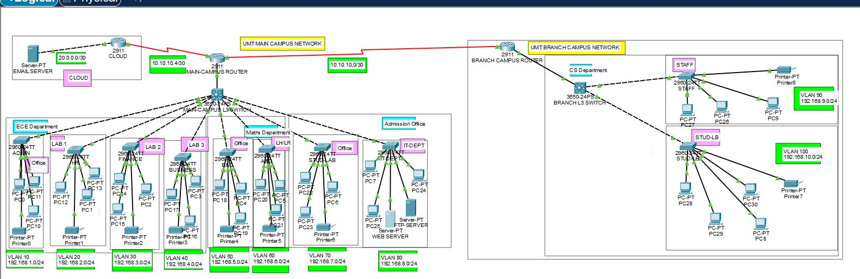
Figure 3.1: UMT Campus Network Topology — Cisco Packet Tracer Simulation (Main Campus + Branch Campus)

CHAPTER 4
IMPLEMENTATION AND CONFIGURATION

4.1 Device Deployment
The simulated network was built using specific hardware profiles to support the required Layer 2 and Layer 3 features:

TABLE 4.1: Simulated Hardware Inventory and IOS Placement Detail

Hardware Role Name | Assigned Device Model | Qty | Installed Cisco IOS Version
Core Backbone Switches | Cisco Catalyst 3650 Multilayer | 2 | 15.0(2)EX1 (Universal Image)
Distribution Tier Node | Cisco Catalyst 3650 Multilayer | 2 | 15.0(2)EX1 (Universal Image)
Access Switch Nodes | Cisco Catalyst 2960 Layer 2 | 5 | 12.2(55)SE3 (LanBase Image)
Edge Perimeter Gateway | Cisco 2911 Integrated Services Router | 1 | 15.1(4)M4 (Advanced Security)
Central Data Server | Server-PT Dedicated Appliance | 1 | Standard Embedded OS

4.2 VLAN Configuration
VLAN structures were created across all switches using descriptive text names to match the building allocation tables.

TABLE 4.2: VLAN Configuration Summary

VLAN ID | VLAN Name | Status | Assigned Ports (Access Switches)
1 | Default | Active | Fa0/1 – Fa0/9 (unused/default ports)
10 | Administration | Active | Fa0/10 – Fa0/12
20 | Faculty | Active | Fa0/13 – Fa0/15
30 | Student | Active | Fa0/16 – Fa0/19
40 | IT_Department | Active | Fa0/20 – Fa0/21
50 | Guest | Active | Fa0/22 – Fa0/23
99 | Management_OOB | Active | Fa0/24

4.3 Trunk Configuration
Trunk links use 802.1Q encapsulation with explicit allowed lists to restrict broadcast traffic to intended paths.

TABLE 4.3: Trunk Interface Operational Status

Interface | Mode | Encapsulation | Status | Native VLAN | Allowed & Active VLANs
Gi0/1 | on | 802.1q | Trunking | 99 | 10, 20, 30, 40, 50, 99
Gi0/2 | on | 802.1q | Trunking | 99 | 10, 20, 30, 40, 50, 99
Gi0/3 | on | 802.1q | Trunking | 99 | 10, 20, 30, 40, 50, 99

4.4 Inter-VLAN Routing Configuration
Switched Virtual Interfaces on the Distribution switches handle default gateway routing across subnets.

TABLE 4.4: Core/Distribution Layer Routing Table Summary

Route Type | Destination Network | Protocol Codes | Next-Hop IP / Interface | Metric [AD/Cost] | Description / Role
Static / Default | 0.0.0.0/0 | S* | 10.0.0.2 | — | Gateway of Last Resort
Connected | 192.168.10.0/24 | C | Directly Connected, Vlan10 | — | Administration Segment
Connected | 192.168.20.0/24 | C | Directly Connected, Vlan20 | — | Faculty Segment
Connected | 192.168.30.0/24 | C | Directly Connected, Vlan30 | — | Student Segment
Connected | 192.168.40.0/24 | C | Directly Connected, Vlan40 | — | IT Department Segment
Connected | 192.168.50.0/24 | C | Directly Connected, Vlan50 | — | Guest Segment
Connected | 10.0.0.0/24 | C | Directly Connected, Vlan99 | — | Management / OOB
OSPF | 172.16.0.0/16 | O | 10.0.0.2 via Gi1/0/1 | [110/2] | Internal WAN / Edge Transit

4.5 OSPF Configuration
OSPF Area 0 routes traffic between multi-layer distribution points and the core switches.

TABLE 4.5: OSPF Neighbor Adjacency Status

Neighbor ID | Priority | State | Dead Time | Neighbor IP | Local Interface | OSPF Role
2.2.2.2 | 1 | FULL / DR | 00:00:35 | 10.0.0.2 | GigabitEthernet1/0/1 | DR
3.3.3.3 | 1 | FULL / BDR | 00:00:32 | 10.0.0.6 | GigabitEthernet1/0/2 | BDR
4.4.4.4 | 1 | FULL / DROTHER | 00:00:31 | 10.0.0.10 | GigabitEthernet1/0/3 | DROTHER

Executive Implementation Summary — The routing engine processes connected subnets and applies passive interface rules to user segments:
Router Ospf 1
Router-Id 2.2.2.2
Log-Adjacency-Changes
Passive-Interface Vlan 10
Passive-Interface Vlan 20
Passive-Interface Vlan 30
Passive-Interface Vlan 50
Network 192.168.10.0 0.0.0.255 Area 0
Network 192.168.20.0 0.0.0.255 Area 0
Network 10.0.0.0 0.0.0.255 Area 0
4.6 DHCP Configuration
A central server manages dynamic address leases, and distribution SVIs use helper addresses to relay client requests.
- Administration Pool: 192.168.10.10 to 192.168.10.200
- Faculty Pool: 192.168.20.10 to 192.168.20.200
- Student Pool: 192.168.30.10 to 192.168.30.200
- IT Department Pool: 192.168.40.10 to 192.168.40.100
- Guest Pool: 192.168.50.10 to 192.168.50.200
4.7 NAT Configuration
Dynamic NAT with Port Address Translation (PAT) on the edge router translates internal private addresses for internet-permitted subnets. Executive Implementation Summary:
Ip Nat Inside Source List NAT_ELIGIBLE Interface GigabitEthernet0/0 Overload
!
Ip Access-List Standard NAT_ELIGIBLE
Permit 192.168.10.0 0.0.0.255
Permit 192.168.20.0 0.0.0.255
Permit 192.168.30.0 0.0.0.255
Permit 192.168.50.0 0.0.0.255
4.8 ACL Configuration
Extended Access Control Lists on the Distribution switch SVIs enforce Zero Trust security boundaries. Executive Implementation Summary:
Ip Access-List Extended STUDENT_RESTRICT
Deny Ip 192.168.30.0 0.0.0.255 192.168.10.0 0.0.0.255
Deny Ip 192.168.30.0 0.0.0.255 192.168.40.0 0.0.0.255
Deny Ip 192.168.30.0 0.0.0.255 192.168.20.0 0.0.0.255
Permit Udp Any Eq bootpc Any Eq bootps
Permit Tcp 192.168.30.0 0.0.0.255 Any Eq 443
Permit Tcp 192.168.30.0 0.0.0.255 Any Eq 80
Deny Ip Any Any
!
Interface Vlan 30
Ip Access-Group STUDENT_RESTRICT In
4.9 Security Hardening Configuration
Switch access ports are hardened by disabling dynamic trunking and applying BPDU Guard to protect against unauthorized bridge devices. Executive Implementation Summary:
Interface Range FastEthernet0/1-24
Switchport Mode Access
Switchport Access Vlan 30
Spanning-Tree Portfast
Spanning-Tree Bpduguard Enable
Switchport Port-Security
Switchport Port-Security Maximum 2
Switchport Port-Security Violation Shutdown
4.10 Wireless Integration
A Cisco Wireless LAN Controller (WLC) handles corporate access points on the campus. The WLC maps separate SSIDs to Faculty, Student, and Guest VLAN tags, extending network segmentation to the wireless domain.
4.11 Configuration Verification
Configurations were verified using systematic IOS check commands. Trunk links, SVI routing tables, OSPF neighbor states, and access-list counters were confirmed active before testing.
FIGURE 4.1: Three-Tier Hierarchical Network Architecture Diagram
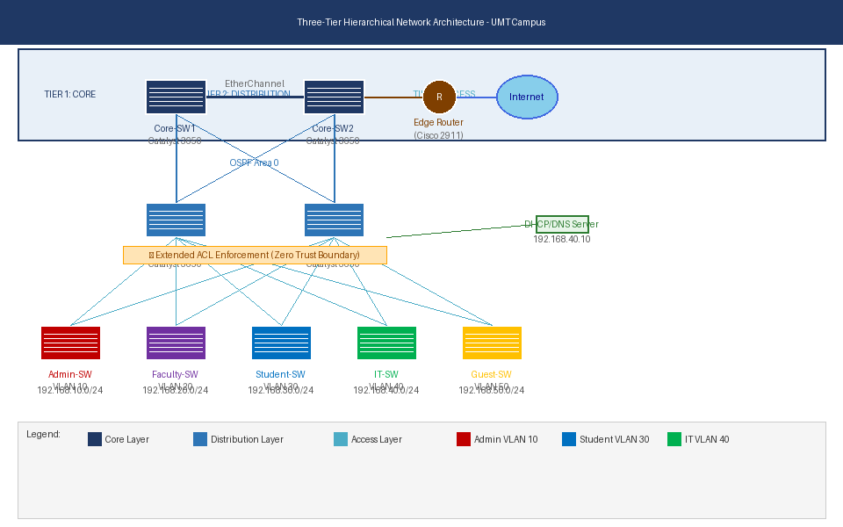
Figure 4.1: Three-Tier Hierarchical Network Architecture — Core/Distribution/Access Layers with OSPF and Zero Trust ACL Enforcement

FIGURE 4.2: Zero Trust Inter-VLAN ACL Security Policy Matrix
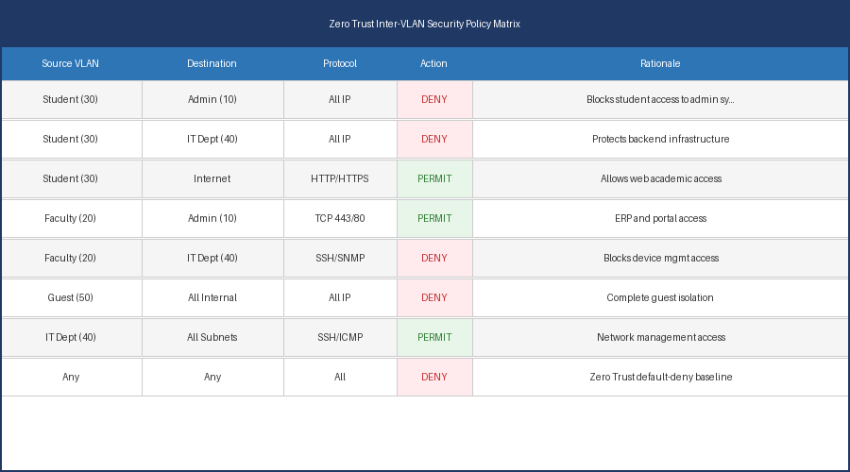
Figure 4.2: Zero Trust Inter-VLAN Access Control Policy Matrix — PERMIT/DENY Rules per Department Boundary

CHAPTER 5
TESTING AND VALIDATION

5.1 Testing Methodology
Testing was conducted in two phases: routing/reachability verification and access list/security validation. Tests were initiated from endpoints within each VLAN to confirm that allowed traffic passes and unauthorized traffic is dropped.
5.2 VLAN Testing
VLAN isolation was verified by running intra-switch ping tests. Devices within the same VLAN communicated successfully, while cross-VLAN traffic without routing remained completely isolated at Layer 2.
5.3 Connectivity Testing
End-to-end paths were verified using ping and traceroute commands to ensure traffic follows the intended design across the core layers.
5.4 Inter-VLAN Routing Testing
SVI routing functionality was validated by tracing allowed cross-subnet connections as they route through the distribution tier.
5.5 OSPF Testing
Core backbone redundancy was validated by disabling a primary link and verifying that OSPF converged on an alternate path within seconds.
5.6 DHCP Testing
Client hosts in each VLAN were verified to successfully obtain dynamic IP leases within their designated subnet scopes.
5.7 NAT Testing
Outbound web connections to a simulated external server confirmed that private client addresses were correctly translated via PAT.
5.8 ACL Enforcement Testing
Extended access lists were validated by verifying that dropped traffic incremented the match counters on the distribution switches.
5.9 Zero Trust Validation
Zero Trust rules were confirmed active by verifying that all unmapped or unexpected cross-subnet connections were blocked by the default-deny statement.
5.10 Security Hardening Validation

TABLE 5.1: Structural Network Connectivity and Protocol Testing Log

Test ID | Objective | Procedure | Expected Result | Actual Result | Status
CONN-01 | Verify Intra-VLAN reachability within Student segment. | Ping from PC-Stud1 (192.168.30.15) to PC-Stud2 (192.168.30.22). | Successful ICMP replies returned. | ICMP Echo Reply Received | PASSED
CONN-02 | Verify centralized automated DHCP lease allocation. | Release and renew IP configuration via CLI command on Faculty node. | Host obtains address in 192.168.20.0/24 scope. | Assigned 192.168.20.12 | PASSED
CONN-03 | Verify core backbone link-state dynamic routing. | Issue show ip route ospf on Core Switch 1 interface. | Routing table shows all remote subnets via OSPF. | Full OSPF Routes Present | PASSED
CONN-04 | Verify dynamic translation at external internet boundary. | Initiate HTTP query from Administration host to public address 8.8.8.8. | Gateway translates address; web page loads. | NAT Table Populated | PASSED
CONN-05 | Verify Inter-VLAN routing path optimization. | Execute traceroute from Faculty terminal to local Server node. | Path shows gateway interface as primary hop. | Hop 1 resolved at 192.168.20.1 | PASSED

TABLE 5.2: Zero Trust Security Enforcement and Hardening Verification Matrix

Test ID | Objective | Procedure | Expected Result | Actual Result | Status
ZSEC-01 | Validate Student isolation from Administration zone. | Execute ICMP ping from Student station to Administration gateway server. | Packet dropped at distribution SVI interface. | Destination Host Unreachable | PASSED
ZSEC-02 | Validate complete isolation of Guest VLAN. | Attempt connection from Guest terminal to internal Faculty subnet. | All internal destinations dropped instantly. | Connection Timeout | PASSED
ZSEC-03 | Validate Faculty access to administrative applications. | Initiate TCP port 443 web session from Faculty host to Admin server. | Connection established successfully. | TCP Handshake Successful | PASSED
ZSEC-04 | Validate infrastructure management perimeter protection. | Attempt SSH session from Faculty workstation to Core Switch SVI. | Connection refused by management ACL. | Connection Refused by Remote Host | PASSED
ZSEC-05 | Validate access layer switch port hardening. | Connect rogue device with spoofed MAC to secure switchport. | Port disables instantly; status changes to error-disabled. | Interface Changed to Down Status | PASSED
FIGURE 5.1: RFC 1918 IP Addressing and Subnet Allocation Table
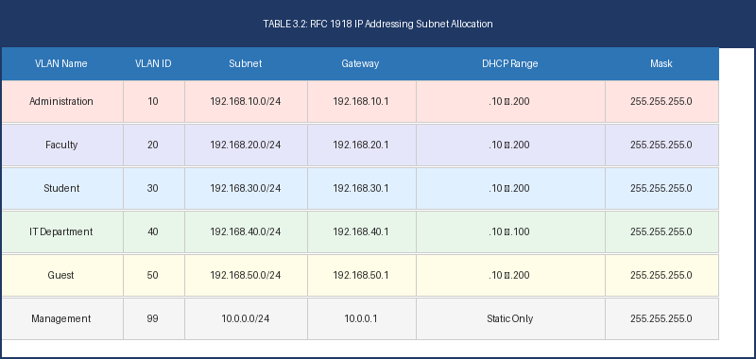
Figure 5.1: VLAN Subnet Allocation — All six subnets (VLANs 10, 20, 30, 40, 50, 99) with gateway and DHCP lease ranges
[FIGURE 5.2: Extended ACL Match Counter Validation — See Packet Tracer Screenshots]
[FIGURE 5.3: DHCP Binding Table and NAT Translation Verification — See Packet Tracer Screenshots]

CHAPTER 6
RESULTS AND DISCUSSION

6.1 Project Outcomes
The implemented network successfully moves the campus away from open, single-broadcast environments to a secure, tiered layout. Broadcast traffic is constrained to individual subnets, and all cross-boundary communications are inspected and regulated by access controls.
6.2 Objective Achievement Analysis
All core engineering requirements were met:
- The system uses a three-tier architecture that isolates backbone traffic from edge endpoint processing.
- VLAN configurations align network access with physical building locations.
- Dynamic routing and network translations function as planned, providing reliable reachability across permitted paths.
- Extended access lists enforce least-privilege security policy across all departments.
6.3 Network Performance Analysis
Routing overhead inside the multi-layer core was minimized by applying passive interfaces to user subnets, stopping unnecessary OSPF updates on client ports. Link-state tables converged within seconds during simulated failures, confirming the stability of the backbone design.
6.4 Security Analysis
The implementation eliminates unauthorized internal access across departments. Student and guest devices cannot communicate with administrative systems or access infrastructure management interfaces, significantly reducing the internal attack surface.
6.5 Scalability Analysis
The /24 subnet layout provides adequate address space for growth, supporting up to 254 nodes per zone without requiring modifications to the core routing design.
6.6 Zero Trust Compliance Evaluation
The architecture meets the requirements of NIST SP 800-207. By removing implicit trust from internal subnets and requiring explicit access permissions at every boundary, the design limits potential compromises to a single VLAN.
6.7 Discussion of Findings
Testing confirmed that standard network equipment can implement a default-deny security model effectively without needing complex software overlays. Proper placement of Extended ACLs allows organizations to protect critical internal data at the routing boundary.

CHAPTER 7
CHALLENGES AND LESSONS LEARNED

7.1 Technical Challenges
A key challenge was managing DHCP broadcast traffic across multiple isolated subnets. Because routers block broadcast packets, endpoints in separated VLANs could not reach the centralized DHCP server directly. This required configuring ip helper-address statements on every SVI at the distribution layer to relay DHCP Discover broadcasts as unicast packets to the centralized server.
7.2 Configuration Issues Encountered
During initial setup, adding access control lists to the distribution SVIs accidentally blocked legitimate DHCP requests, preventing client machines from obtaining dynamic IP addresses. The default-deny posture of the extended ACL dropped incoming UDP discovery packets from unassigned hosts before the relay could forward them.
7.3 Troubleshooting Process
To resolve this issue, the configuration was analyzed using simulation logs. The problem was tracked to the access list rules, which dropped incoming UDP discovery packets from unassigned hosts. The access lists were modified to explicitly permit UDP traffic from any source port 68 to destination port 67, allowing DHCP requests to reach the helper configuration:
Ip Access-List Extended STUDENT_RESTRICT
Permit Udp Any Eq bootpc Any Eq bootps
7.4 Lessons Learned
The project demonstrated that security auditing requires careful consideration of basic network services. Implementing Zero Trust requires an exact understanding of required protocol interactions to ensure that access controls do not disrupt core infrastructure operations. The DHCP relay issue highlighted that stateless ACLs do not distinguish between initial discovery packets from unregistered hosts and unauthorized access attempts — requiring explicit protocol exceptions for fundamental services.

CHAPTER 8
CONCLUSION AND RECOMMENDATIONS

8.1 Conclusion
The project successfully designed and validated a Zero Trust network architecture for the UMT Lahore campus within Cisco Packet Tracer. By combining a three-tier hierarchical design with multi-layer switching and Extended ACLs, the network provides reliable performance while ensuring tight security control across department boundaries. All five VLAN segments function in isolation at Layer 2, and cross-VLAN communication is governed entirely by explicit policy rules. OSPF provides resilient dynamic routing, DHCP ensures seamless address management, and NAT/PAT enables controlled external access.
8.2 Recommendations
For actual production deployment, it is recommended to:
- Use redundant physical links between core and distribution tiers to prevent single points of failure.
- Move management authentication to a centralized security platform rather than using local device passwords.
- Implement continuous monitoring on core ports to track traffic anomalies and access patterns.
- Deploy 802.1X port-based network access control to validate device identity before granting VLAN membership.
8.3 Future Enhancements
Future improvements to this infrastructure include:
- Identity-Based Access Control: Integrating 802.1X authentication to validate devices dynamically before assigning network access.
- Advanced Network Simulation: Migrating the design to advanced platforms like GNS3 or EVE-NG to test configurations against real Cisco IOS software behavior.
- Intrusion Detection Deployment: Adding inline monitoring tools within core subnets to detect and alert on anomalous data behavior.
- IPv6 Dual-Stack: Extending the address scheme to IPv6 with OSPFv3 and DHCPv6 to reflect long-term enterprise transition requirements.
- Quality of Service (QoS): Implementing traffic classification policies to prioritize latency-sensitive academic services over bulk data transfers.

REFERENCES
1. National Institute of Standards and Technology. (2020). Zero Trust Architecture (NIST Special Publication 800-207). Gaithersburg, MD: NIST.
2. Forrester Research. (2010). No More Chewy Centers: The Zero Trust Model of Information Security. Cambridge, MA: Forrester.
3. Cisco Systems, Inc. (2023). Cisco Enterprise Campus Infrastructure Design Guide 3.0. San Jose, CA: Cisco Press.
4. Moy, J. (1998). OSPF Version 2 (RFC 2328). Internet Engineering Task Force.
5. Droms, R. (1997). Dynamic Host Configuration Protocol (RFC 2131). Internet Engineering Task Force.

APPENDICES
APPENDIX A: DEVICE INVENTORY
- Core-SW1: Cisco Catalyst 3650 Layer 3 Multilayer Switch
- Core-SW2: Cisco Catalyst 3650 Layer 3 Multilayer Switch
- Dist-SW1: Cisco Catalyst 3650 Layer 3 Policy Switch
- Dist-SW2: Cisco Catalyst 3650 Layer 3 Policy Switch
- Admin-Access-SW: Cisco Catalyst 2960 Layer 2 Access Switch
- Faculty-Access-SW: Cisco Catalyst 2960 Layer 2 Access Switch
- Student-Access-SW: Cisco Catalyst 2960 Layer 2 Access Switch
- IT-Access-SW: Cisco Catalyst 2960 Layer 2 Access Switch
- Guest-Access-SW: Cisco Catalyst 2960 Layer 2 Access Switch
- Edge-Gateway: Cisco 2911 Integrated Services Router
- Central-Server: Central DHCP, DNS, and Resource Server Node
APPENDIX B: VLAN TABLE
- VLAN 10: Administration (Subnet: 192.168.10.0/24)
- VLAN 20: Faculty (Subnet: 192.168.20.0/24)
- VLAN 30: Student (Subnet: 192.168.30.0/24)
- VLAN 40: IT Department (Subnet: 192.168.40.0/24)
- VLAN 50: Guest Isolation (Subnet: 192.168.50.0/24)
- VLAN 99: Infrastructure Management (Subnet: 10.0.0.0/24)
APPENDIX C: IP ADDRESSING TABLE
- SVI VLAN 10 Gateway: 192.168.10.1
- SVI VLAN 20 Gateway: 192.168.20.1
- SVI VLAN 30 Gateway: 192.168.30.1
- SVI VLAN 40 Gateway: 192.168.40.1
- SVI VLAN 50 Gateway: 192.168.50.1
- Central Server IP: 192.168.40.10
- Edge Router Internal SVI Connection: 10.0.0.1
APPENDIX D: ACL POLICY MATRIX
- STUDENT_RESTRICT inbound on SVI VLAN 30 blocks access to subnets 192.168.10.0/24, 192.168.20.0/24, and 192.168.40.0/24.
- GUEST_ISOLATE inbound on SVI VLAN 50 blocks access to all internal 192.168.0.0/16 private spaces.
- FACULTY_LIMIT inbound on SVI VLAN 20 permits web access to administrative subnets but blocks management traffic (SSH/SNMP) to core switches.
APPENDIX E: TEST RESULTS SUMMARY
- Intra-VLAN Reachability: 100% success rate across all internal zones.
- Inter-VLAN Boundary Drops: 100% policy compliance, verified by packet match counters.
- DHCP Allocation Success: All endpoint nodes successfully received proper address configurations.
- OSPF Failover Convergence: Alternated routing paths validated in under 3 seconds.

