1. Design Database menggunakan MySQL :

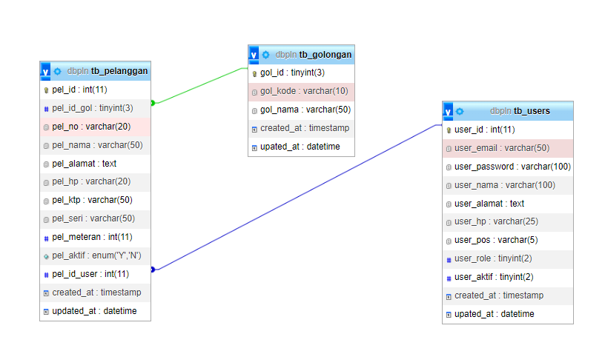

1. Perintah tb users:

CREATE TABLE `tb_users` (

`user_id` int(11) NOT NULL PRIMARY ,

`user_email` varchar(50) NOT NULL,

`user_password` varchar(100) NOT NULL,

`user_nama` varchar(100) NOT NULL,

`user_alamat` text NOT NULL,

`user_hp` varchar(25) NOT NULL,

`user_pos` varchar(5) NOT NULL,

`user_role` tinyint(2) NOT NULL,

`user_aktif` tinyint(2) NOT NULL,

`created_at` timestamp NOT NULL DEFAULT current_timestamp() ON UPDATE current_timestamp(),

`upated_at` datetime NOT NULL

) ENGINE=InnoDB DEFAULT CHARSET=utf8mb4;

1. Perintah tb pelanggan:

CREATE TABLE `tb_pelanggan` (

`pel_id` int(11) NOT NULL PRIMARY,

`pel_id_gol` tinyint(3) NOT NULL,

`pel_no` varchar(20) NOT NULL,

`pel_nama` varchar(50) NOT NULL,

`pel_alamat` text NOT NULL,

`pel_hp` varchar(20) NOT NULL,

`pel_ktp` varchar(50) NOT NULL,

`pel_seri` varchar(50) NOT NULL,

`pel_meteran` int(11) NOT NULL,

`pel_aktif` enum('Y','N') NOT NULL,

`pel_id_user` int(11) NOT NULL,

`created_at` timestamp NOT NULL DEFAULT current_timestamp() ON UPDATE current_timestamp(),

`updated_at` datetime NOT NULL

) ENGINE=InnoDB DEFAULT CHARSET=utf8mb4;

1. Perintah tb golongan:

CREATE TABLE `tb_golongan` (

`gol_id` tinyint(3) NOT NULL PRIMARY,

`gol_kode` varchar(10) NOT NULL,

`gol_nama` varchar(50) NOT NULL,

`created_at` timestamp NOT NULL DEFAULT current_timestamp() ON UPDATE current_timestamp(),

`upated_at` datetime NOT NULL

) ENGINE=InnoDB DEFAULT CHARSET=utf8mb4;

ALTER TABLE `tb_pelanggan`

ADD CONSTRAINT `tb_pelanggan_ibfk_1` FOREIGN KEY (`pel_id_gol`) REFERENCES `tb_golongan` (`gol_id`) ON DELETE CASCADE ON UPDATE CASCADE,

ADD CONSTRAINT `tb_pelanggan_ibfk_2` FOREIGN KEY (`pel_id_user`) REFERENCES `tb_users` (`user_id`) ON DELETE CASCADE ON UPDATE CASCADE;

COMMIT;

1. Design Website dimana sistem terdapat CRUD dan dilindungi dengan sistem login dan di design dengan sangat memudahkan pengguna dalam pemakaian sistem ini.
2. Versi PHP

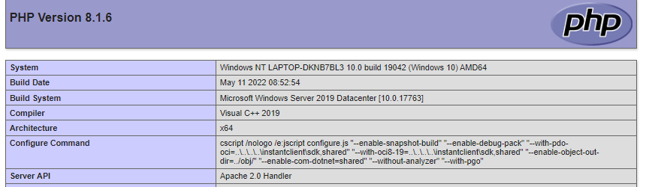

1. halaman login

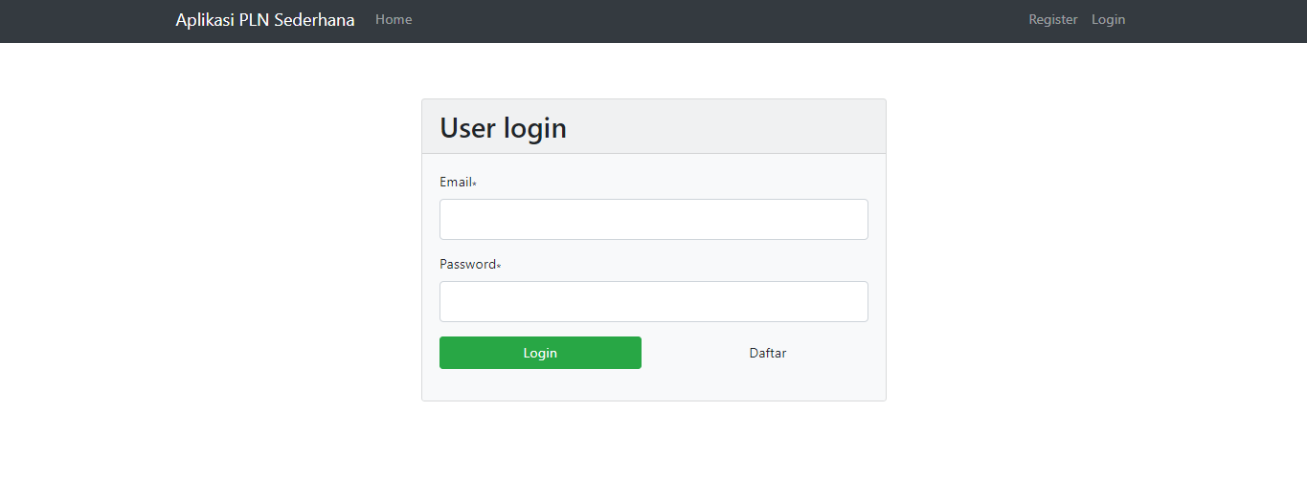

Source Code :

* View :

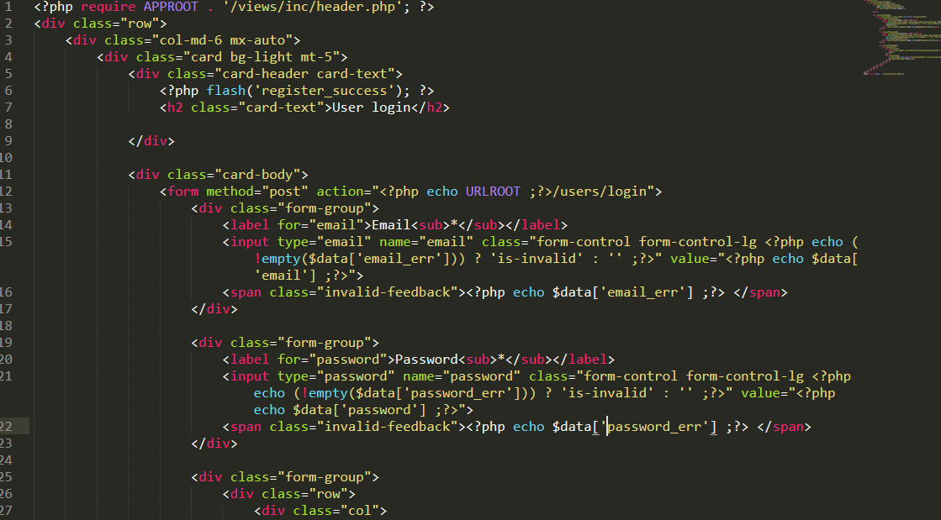

* Control :

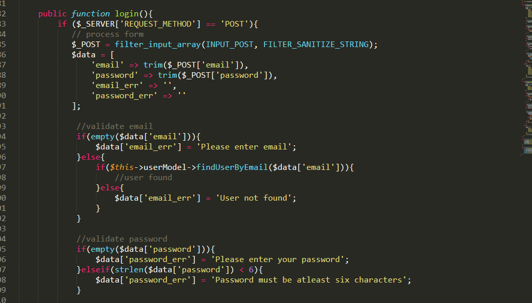

* Model

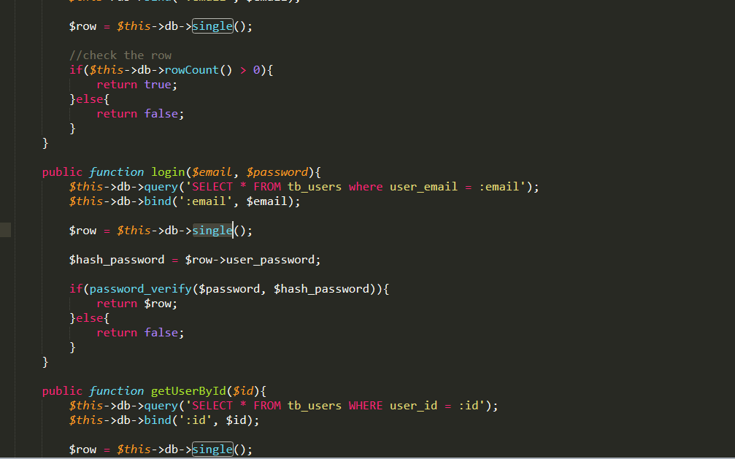

1. Halaman Daftar

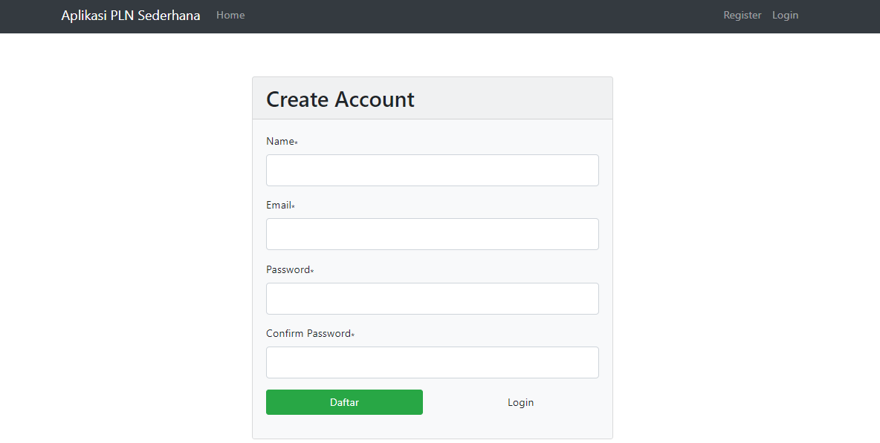

Source Code :

* View

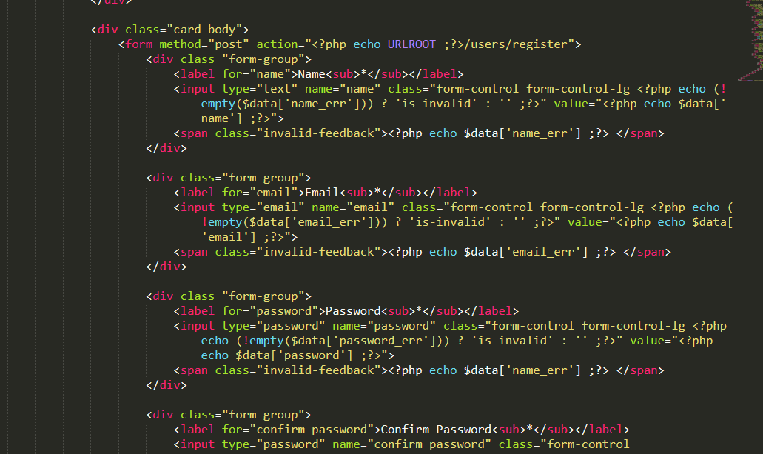

* Control

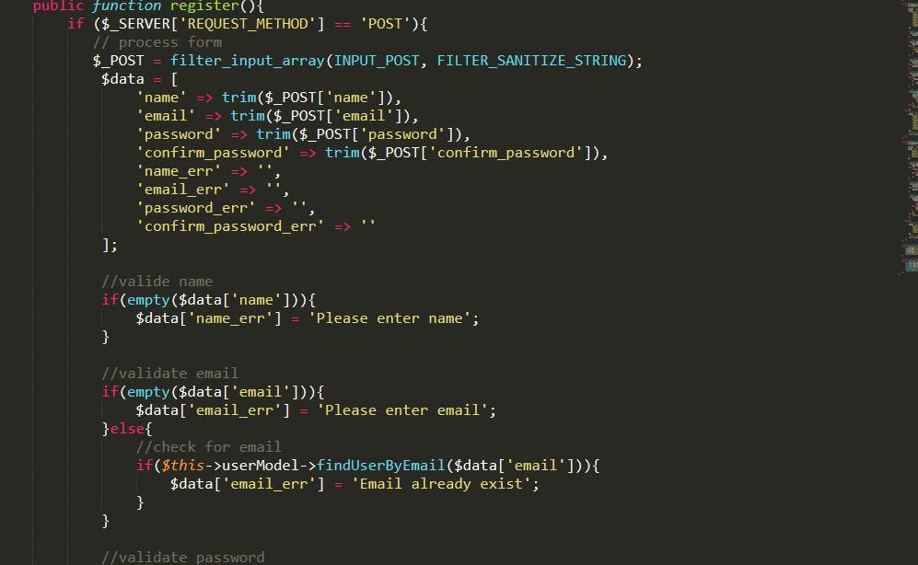

* Model

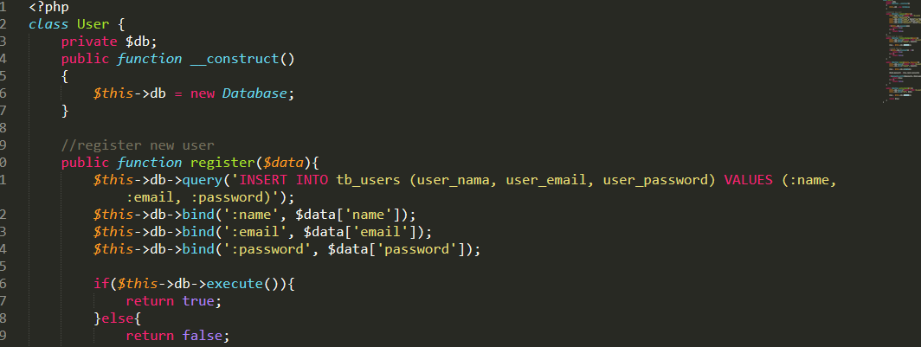

1. Halaman Home **:**

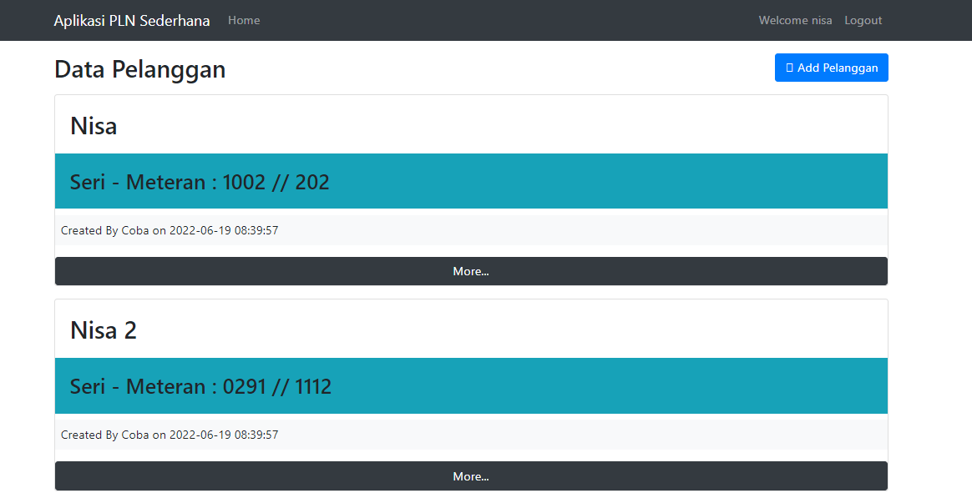

Source Code :

* View

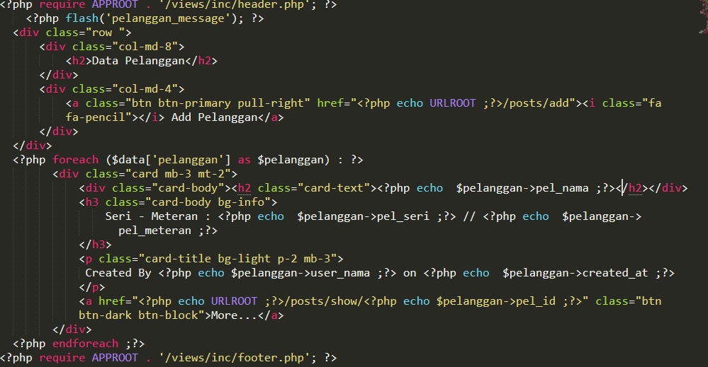

* Control

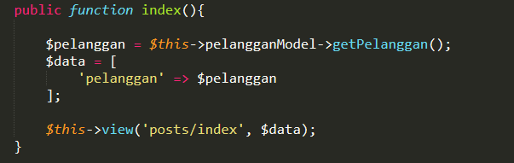

* Model

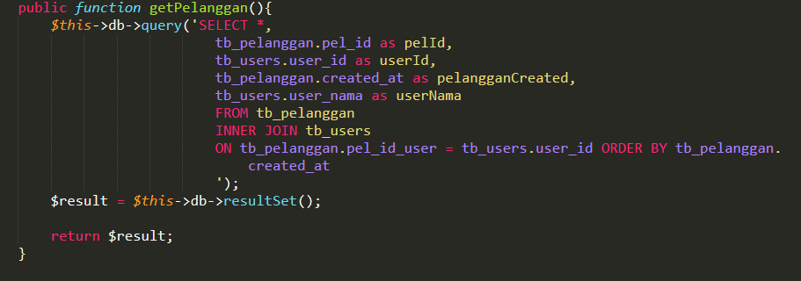

1. Halaman More (Detail Pelanggan)

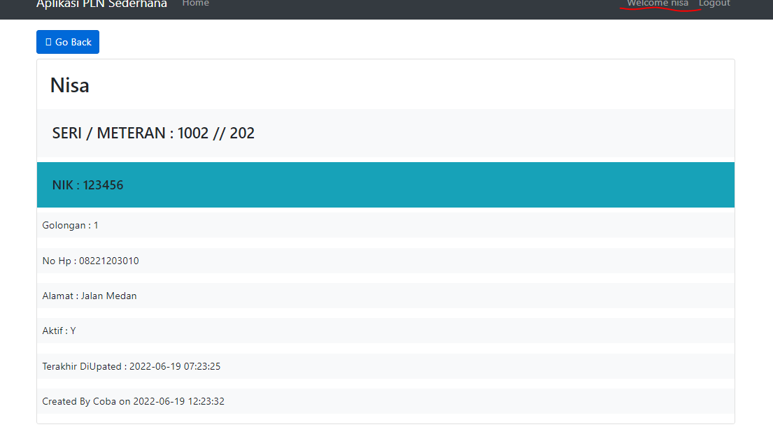

**Note :** Data pelanggan tidak bisa diubah kecuali si penginput data sendiri. Disini saya login sebagai nisa

**Jika Login sebagai COBA maka tampilannya :**

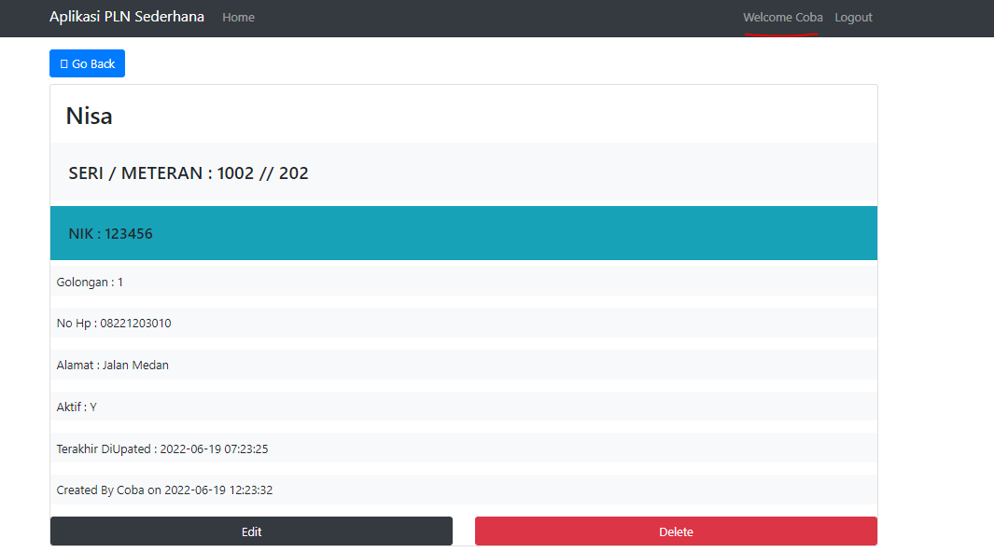

Source Code :

* View

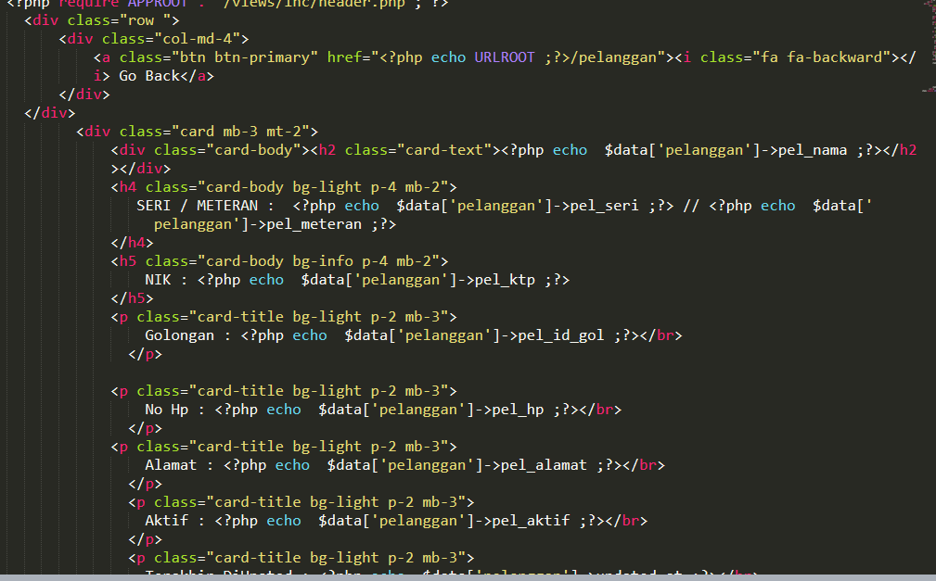

* Control

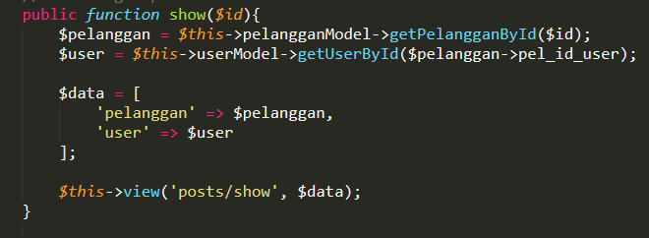

* Model

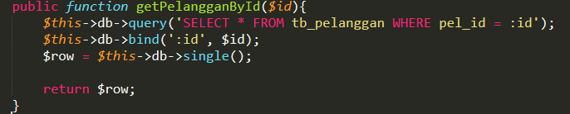

1. Halaman edit & tambah

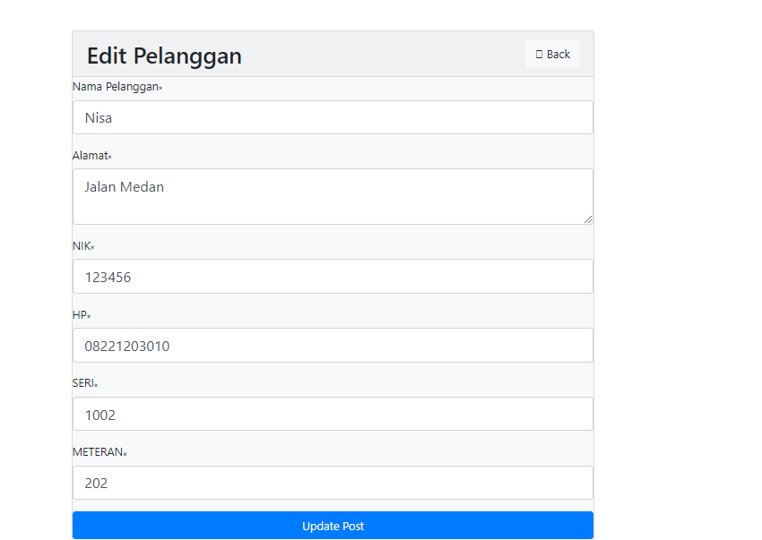

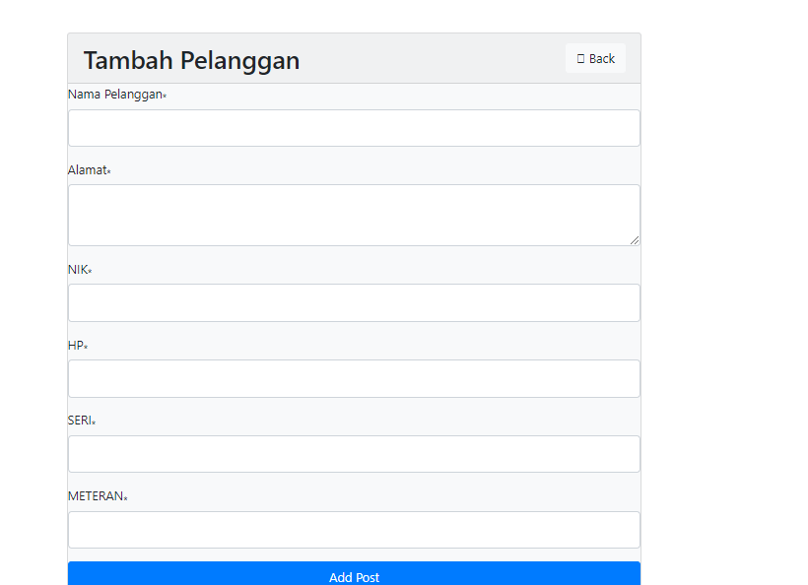

Source Code :

* View

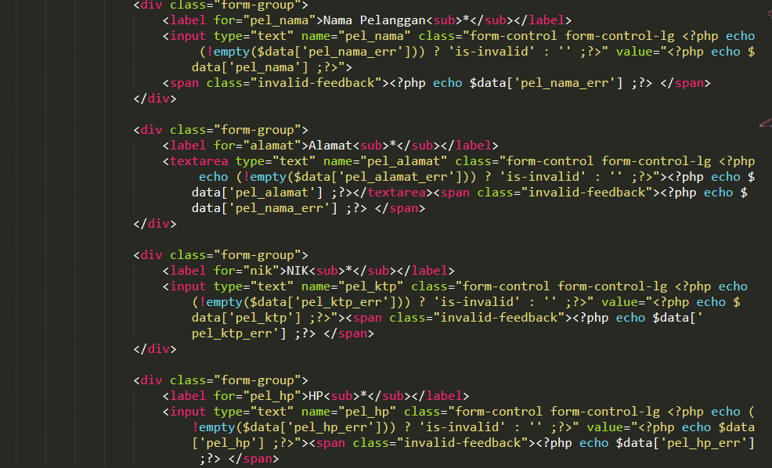

* Control

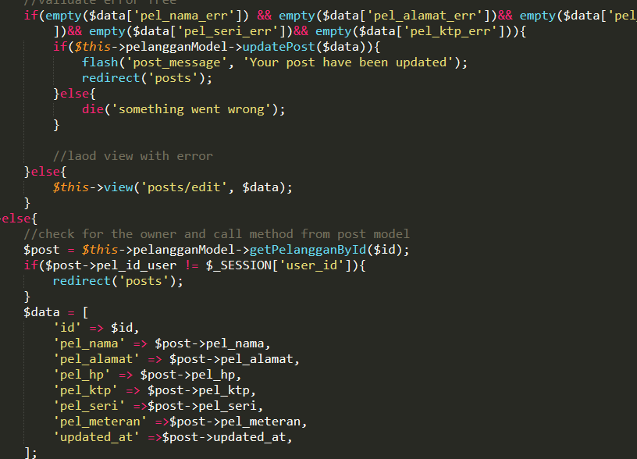

* Model

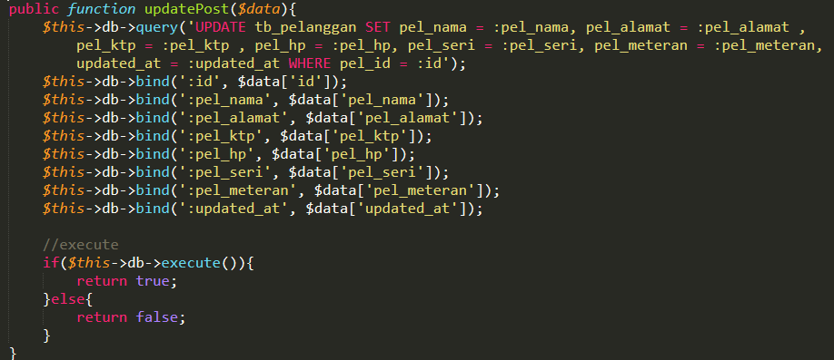

Ketika diklik **tambah menu** :