**BYTEWISE LIMITED FELLOWSHIP**  
**PRACTICE TEST 01**

MUHAMMAD ANAS  
  
  
**Q1) our First NumPy Array**

import numpy as np

baseball = [180, 225, 121, 110, 218, 176, 219, 165]

np_baseball = np.array(baseball)

print(type(np_baseball))

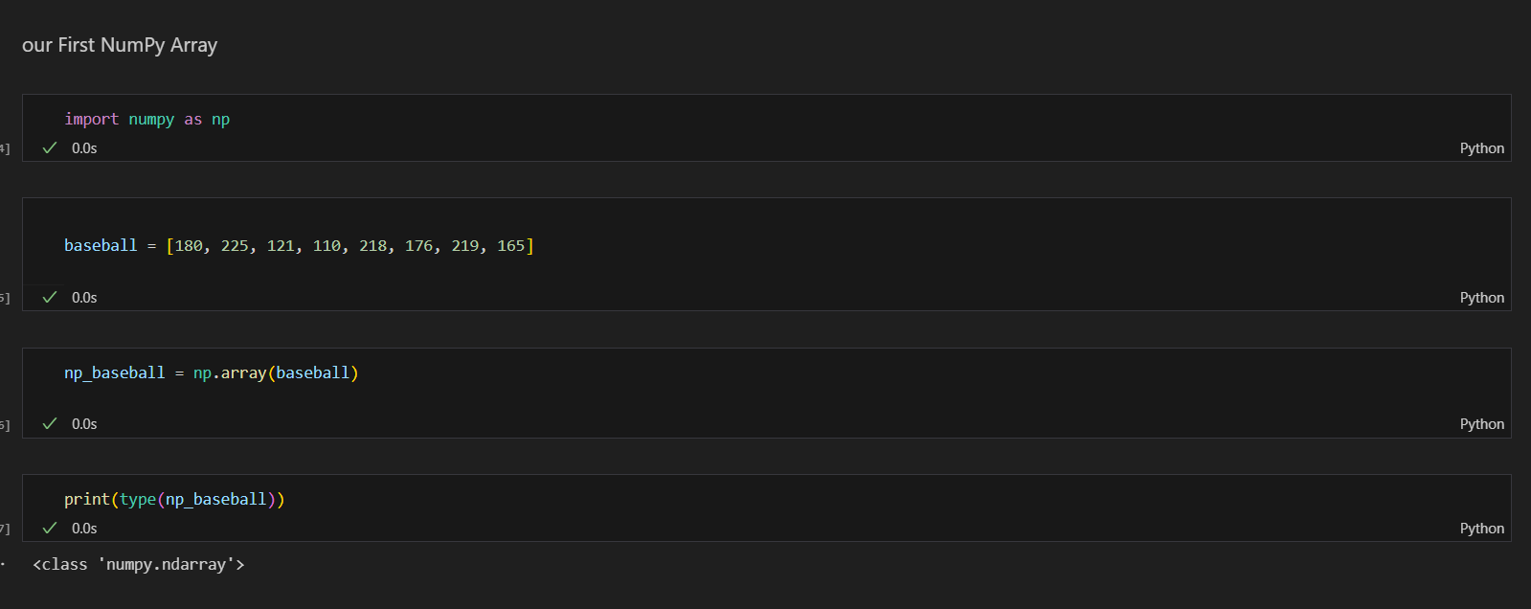

**Q2) Baseball players' height**

height_in = [62, 85, 68, 74, 79, 81, 66, 63]

np_height_in = np.array(height_in)

print("Heights in inches:", np_height_in)

np_height_m = np_height_in * 0.0254

print("Heights in meters:", np_height_m)

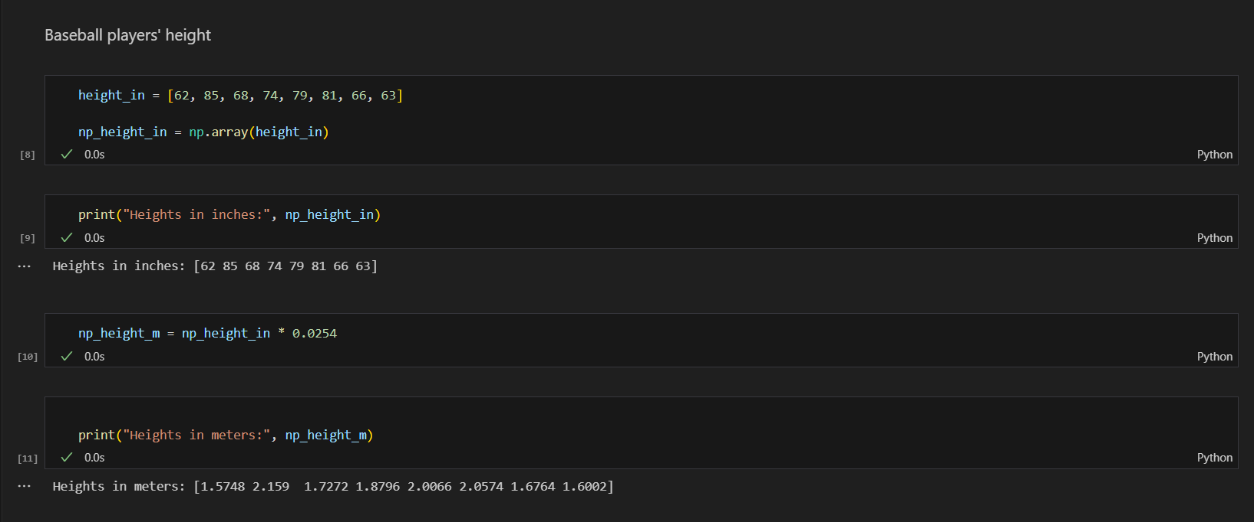

**Q3) Baseball player's BMI**

weight_lb = [180, 215, 210, 210, 188, 176, 209, 200]

np_weight_kg = np.array(weight_lb) * 0.453592

print("Weights in kilograms:", np_weight_kg)

bmi = np_weight_kg / (np_height_m ** 2)

print("BMI:", bmi)

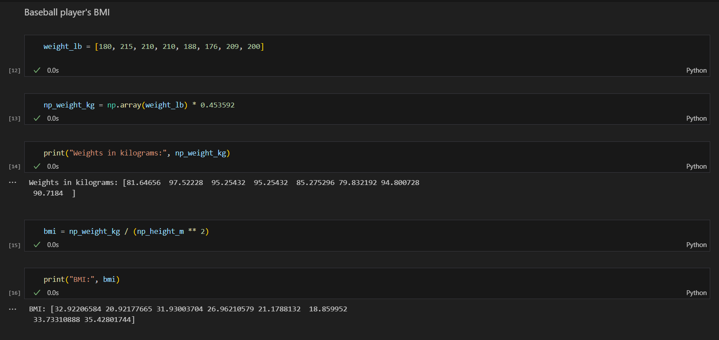

**Q4) Lightweight baseball players**

height_in = [62, 85, 68, 74, 79, 81, 66, 63]

weight_lb = [180, 215, 210, 210, 188, 176, 209, 200]

np_height_in = np.array(height_in)

np_height_m = np_height_in * 0.0254

np_weight_kg = np.array(weight_lb) * 0.453592

bmi = np_weight_kg / (np_height_m ** 2)

light = bmi < 21

print("Boolean array where BMI is below 21:", light)

print("BMIs of players with BMI below 21:", bmi[light])

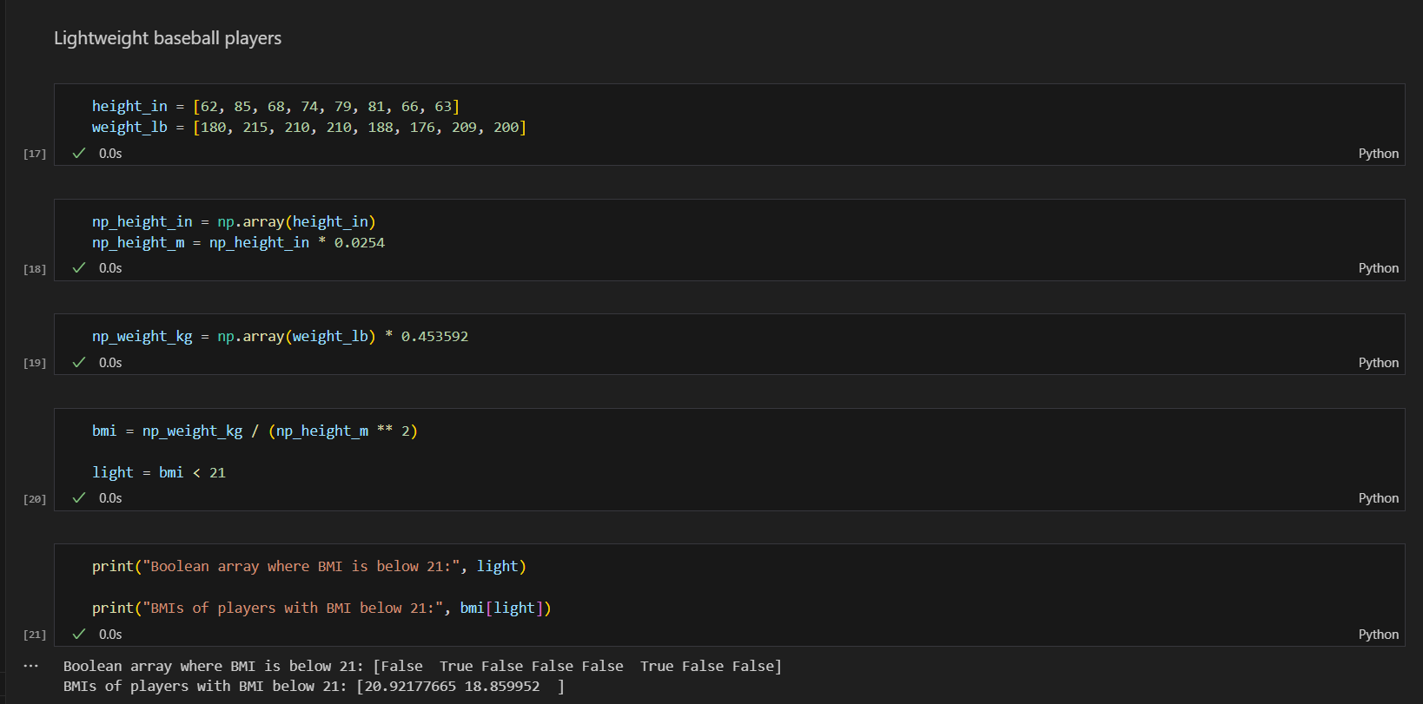

**Q)5**

positions = ['GK', 'M', 'A', 'D', 'M', 'A', 'GK', 'D', 'M', 'A']

heights = [191, 184, 185, 180, 175, 170, 195, 182, 178, 177]

np_positions = np.array(positions)

np_heights = np.array(heights)

gk_heights = np_heights[np_positions == 'GK']

other_heights = np_heights[np_positions != 'GK']

print("Median height of goalkeepers:", np.median(gk_heights))

print("Median height of other players:", np.median(other_heights))

