**NAME: Muhammad Anas REG.NO: CS221004**

1. **Create two tables with at least 6 columns having 4 different data types.**

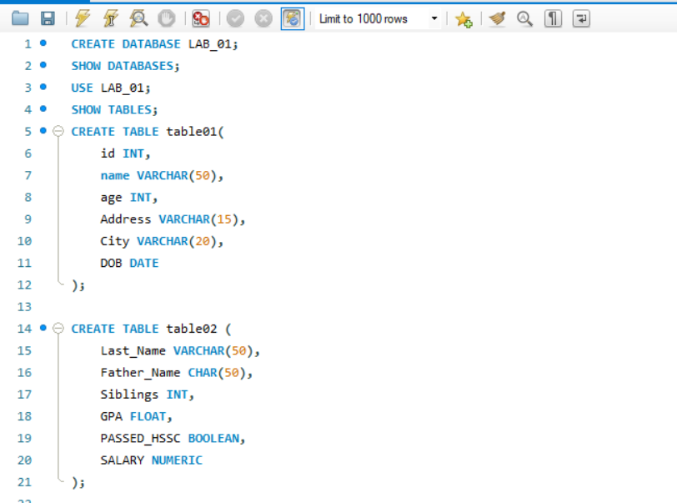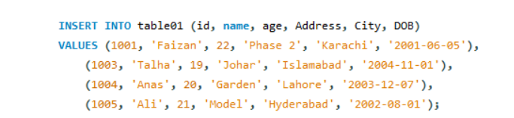

1. **Show the structure of tables created in (1)**

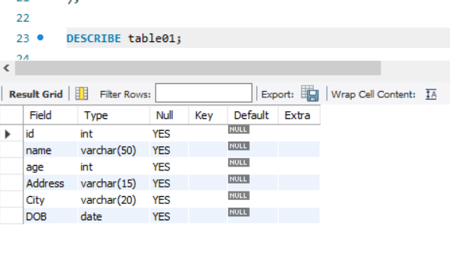

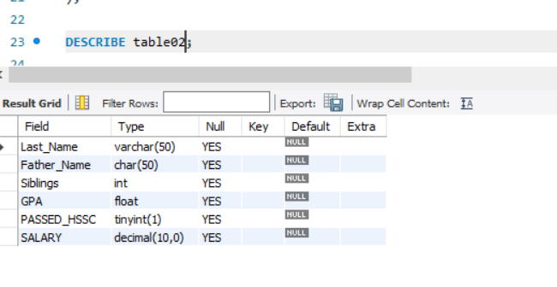

1. **Insert at least 4 records into the first table using column names.**



1. **Insert at least 4 records into the second table without using columns name.**

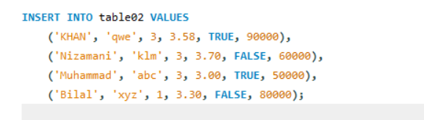

**5)With a separate query for each table, show the table data.**

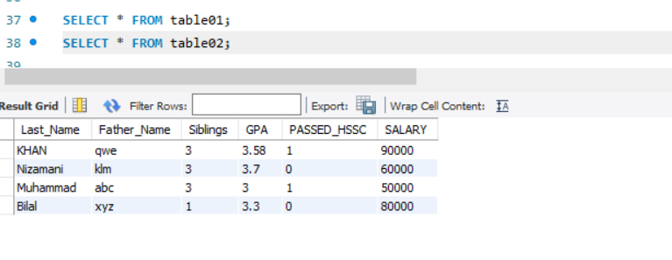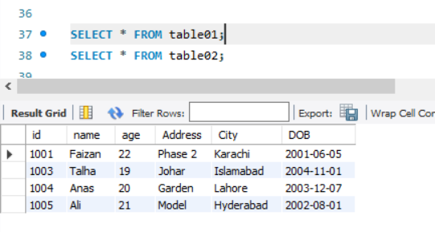

**6. Add two columns into any one table**

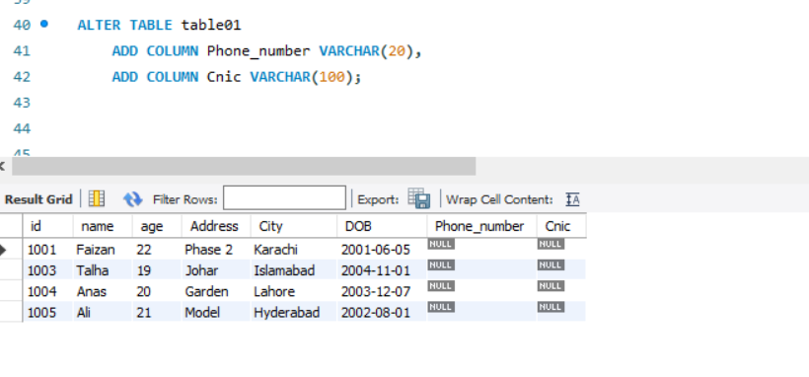

**7. Alter the data type of any two columns from any table.**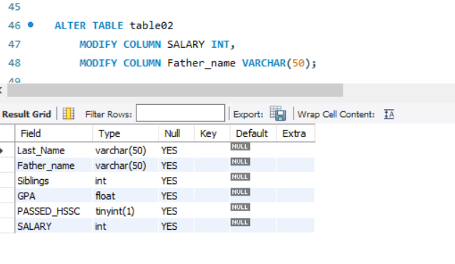

**8. Truncate the first table data.**

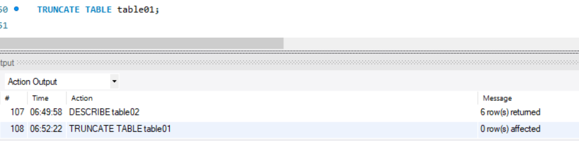

**9. Delete the third record of the second table**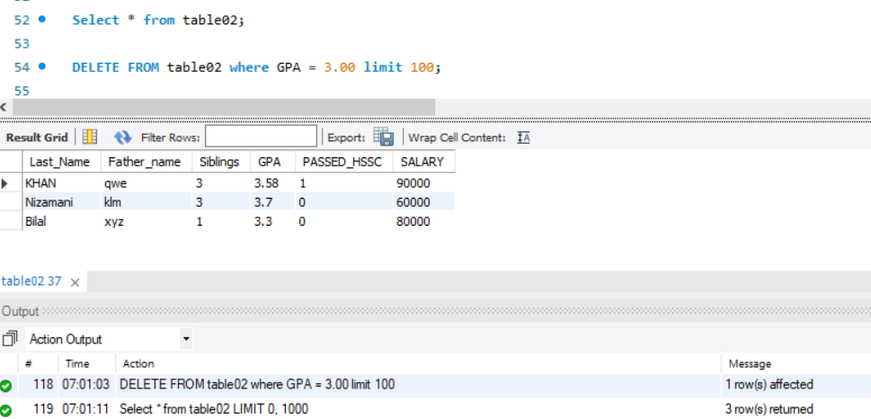

**10. Update the first record of the second table**

