National University of Computer and Emerging Sciences, Karachi
FAST School of Computing
Project Report

Object Oriented Programing(OOP)

Submitted by
Muhammad Anas 25K-0899

Bachelor of Computer Science
Spring 2026

Instructor
Ms. Hijaab Sikander
Table of Contents
Project Overview: 3
Summary: 3
Folder Structure: 3
Core Classes: 4
1.ILoggable Interface – Logging activities 4
2.Image Class – Image Representation 4
3.Analyzers – (Abstract Base class) 6
4.Class Analysis Result 6
5.Class Final Result: 7
Analyzers Implementation 9
Metadata Analysis: 9
Analysis Method: 9
Artifact Analyzer: 11
Frequency Analyzer 12
Watermark Analyzer 13
Hybrid Deep analyzer 14
Image Analyzer - Main Controller 15
Main Program: 16
Tech Stack & Implementation 18
Run command : 18
Libraries & Dependencies 18
Sample Output: 19
Key Features: 23
Limitations: 23
Future Enhancement: 24
OpenCV ( to Load image and process real image) 24
Machine Learning integration TensorFlow: 24
Data base integration: 24
Conclusion: 25
Project Strengths: 25
References: 25
Class Diagram: 26

Project Title: AI Image Detection Stimulation
GitHub Link : Click

Project Overview:

Summary:
AI image detection stimulation is designed to stimulate the image authentication process via Object oriented paradigm in C++ implementation . I implemented this model in five parameters of analyzer’s with the help of each analyzer there is confidence score which is in range of 0.0 – 1.0 which help to analyze the image is it image authentic. Score above 0.5 which represents the image is likely fabricated and from AI. This system gives full complete direct report for logging activity and history. Entire program is implemented in OOP principles of programing.

Folder Structure:
AI-image-detection/
├── include/ # Header files (interface definitions)
│ ├── core/ # Core classes
│ │ ├── Image.h # Image data structure
│ │ ├── Analyzer.h # Abstract analyzer base class
│ │ └── ILoggable.h # Logging interface
│ ├── analyzers/ # Analyzer implementations
│ │ ├── MetadataAnalyzer.h
│ │ ├── ArtifactAnalyzer.h
│ │ ├── FrequencyAnalyzer.h
│ │ ├── WatermarkAnalyzer.h
│ │ ├── HybridDeepAnalyzer.h
│ │ └── ImageAnalyzer.h # Main orchestrator
│ ├── results/ # Result storage classes
│ │ ├── AnalysisResult.h # Single analyzer result
│ ├── FinalResult.h # Aggregated results
│ └── HistoryLog.h # Activity logging
└── utilities/
└── Utils.h # Helper functions
├── source/ # Implementation files
├── analyzers/
├── core/
├── main/
├── results/
└── utilities/
├── build/ # Build scripts
│ ├── build.bat # Windows batch build
│ └── build.ps1 # PowerShell build script
├── bin/ # Compiled executables
├── obj/ # Object files
└── assets/ # Sample images and resources

Core Classes:

ILoggable Interface – Logging activities
This class is introduced to login in all main classes as well as all analyzers and track it.
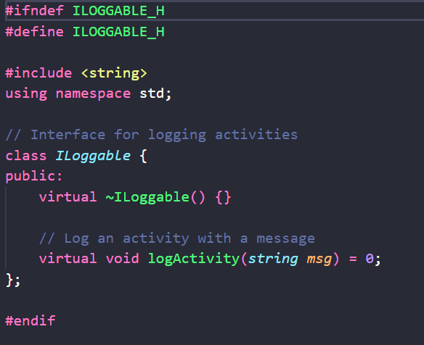

Image Class – Image Representation
It’s the first step int his process it generates all image metadata which is then used by analyzers.

Key Features:
- Encapsulate Image Metadata (dimension, file path, format)
- Stimulate pixel data vector
- Operator overlading to access pixel via its index
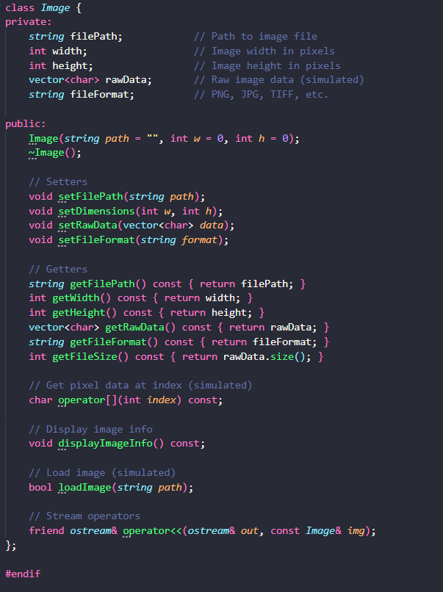

3.Analyzers – (Abstract Base class)
It provided interfaces for all analyzers.

Key features:
- It provides unique ID.
- It also tracks all applied analyzers count.
- It also give msg via override of iloggable class

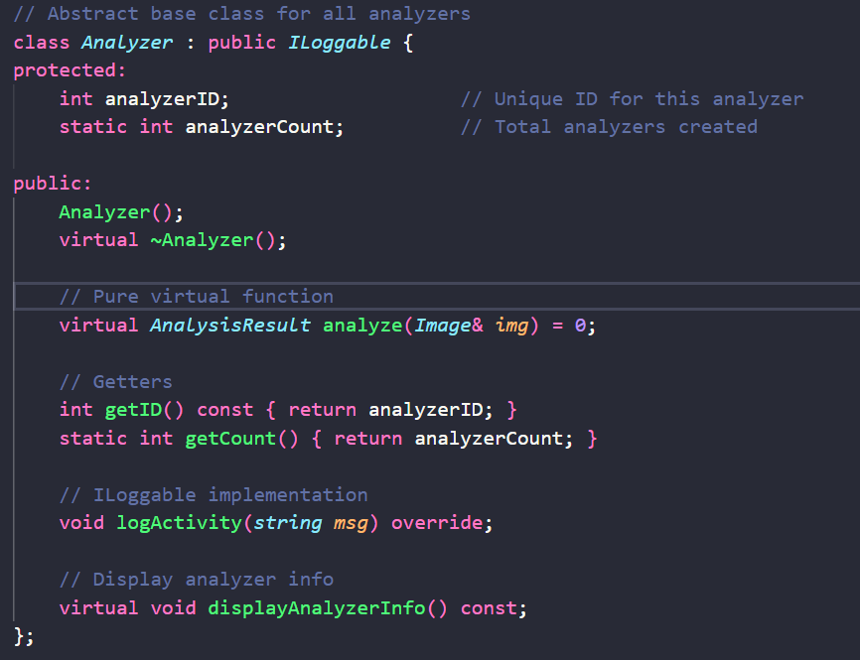

4.Class Analysis Result
It stores each analyzer data.

Key features:
- It has timestamp of analyzing when it is implemented.
- It has different operator overloading functions
- Operator < for sorting
- Operator == for comparison
- Stream operator for report

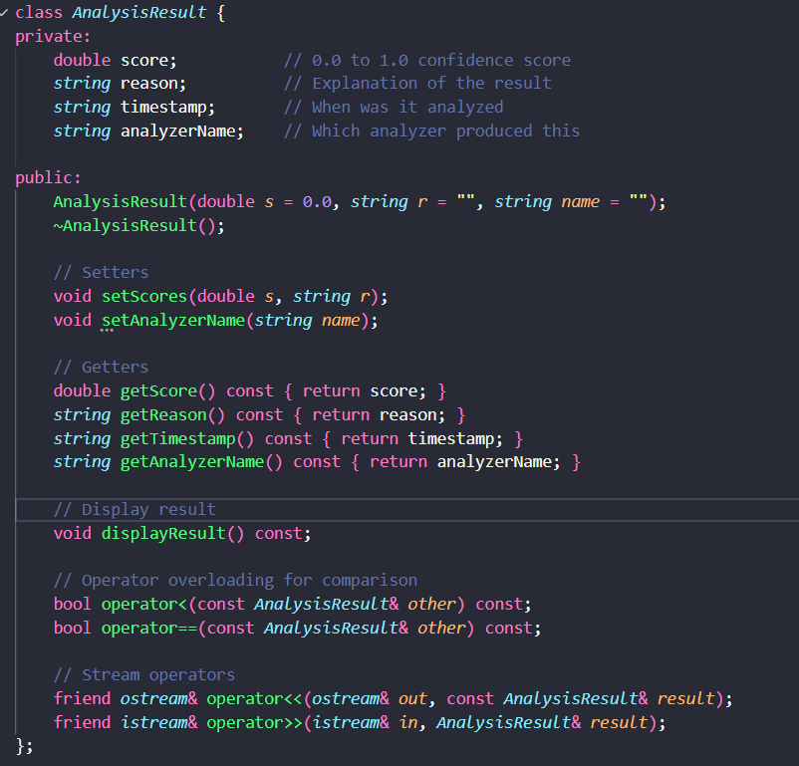

5.Class Final Result:
It combines all analyzers results and gives final score.

Key features:
- It combines all analyzers score then calculate average of it and give final score 0.0 – 1.0
- Score > 0.5 AI generated
- Score <= 0.5 Authentic
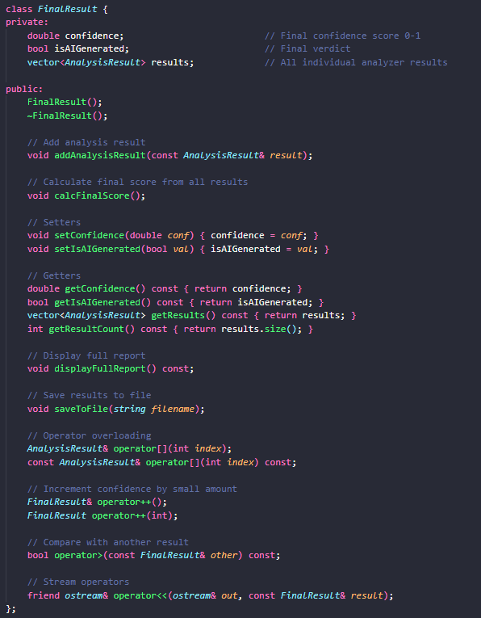

Analyzers Implementation

Metadata Analysis:
Verify source and fetching its Exif data
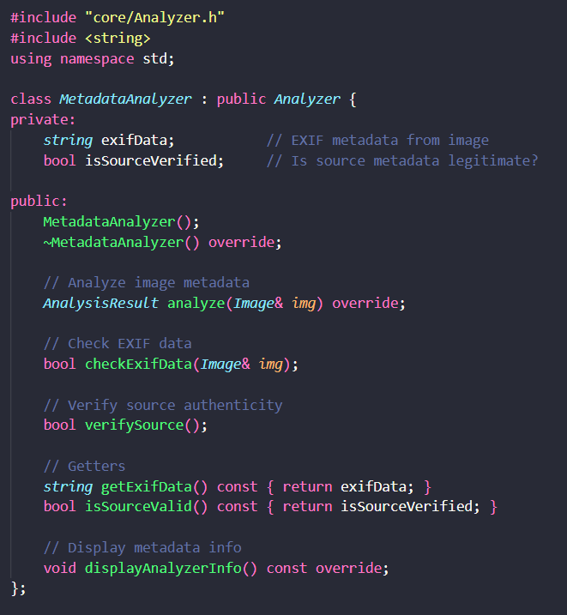

Analysis Method:
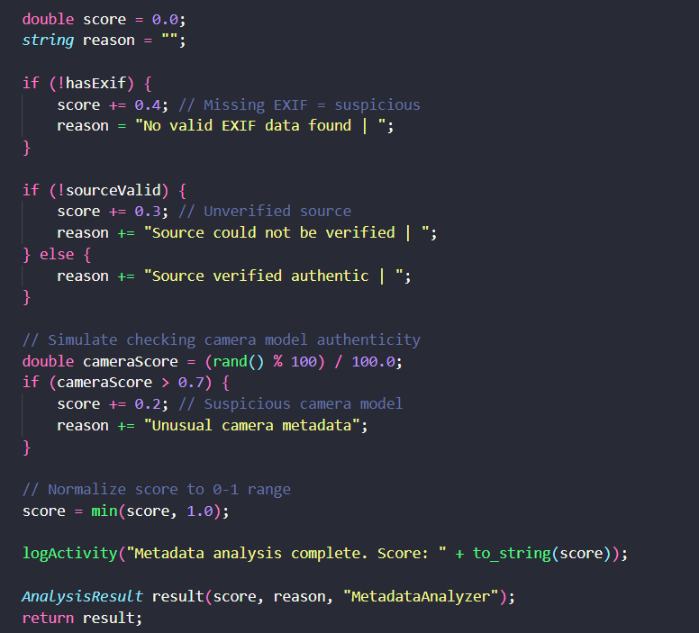
Score Breakdown:
- Missing EXIF data: +0.4 confidence
- Unverified source: +0.3 confidence
- Suspicious camera model: +0.2 confidence
- Verified authentic source: 0.0 confidence.

Artifact Analyzer:
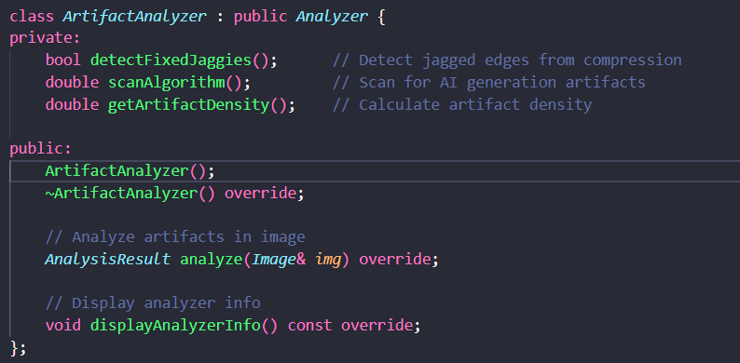

Score Breakdown:
- Fixed jagged edges 0.3 contribution
- Compression artifact 0.3 contribution
- Noise pattern 0.2 contribution
- Artifact density proportional higher for AI generated
- Final range 0.0 – 1.0

Frequency Analyzer
It gives Frequency domain characteristics
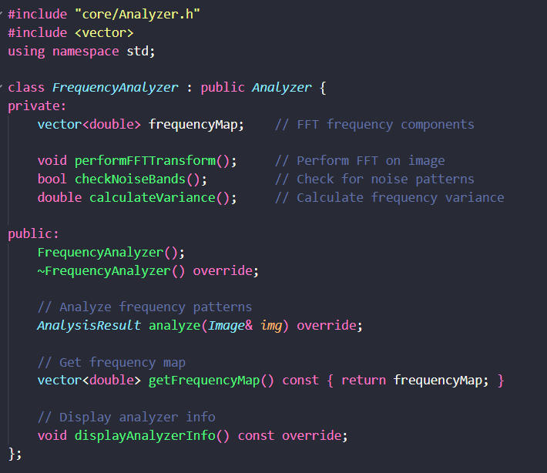
Score breakdown:
- It stimulates image frequency on image data.
- Transform Image → Frequency domain representation.
- Analyze Frequency Bands → Check for unusual patterns.
- Calculate Variance → Natural images have specific variance signature.
- Detect Noise Patterns → AI images show different noise characteristic.

Watermark Analyzer
It checks presence of authenticity of it.
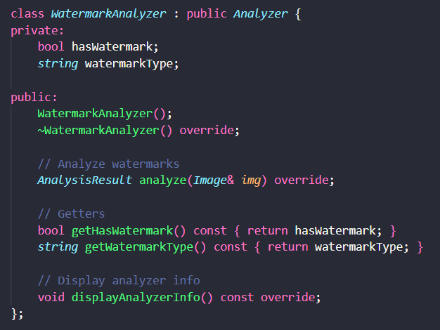
Score breakdown:
- No watermark = +0.2 confidence (potentially AI)
- Verified watermark = 0.0 confidence (likely authentic)
- Suspicious watermark = +0.3 confidence (could be forged)

Hybrid Deep analyzer
It combines multiple analyzer to generate its likable score via composition
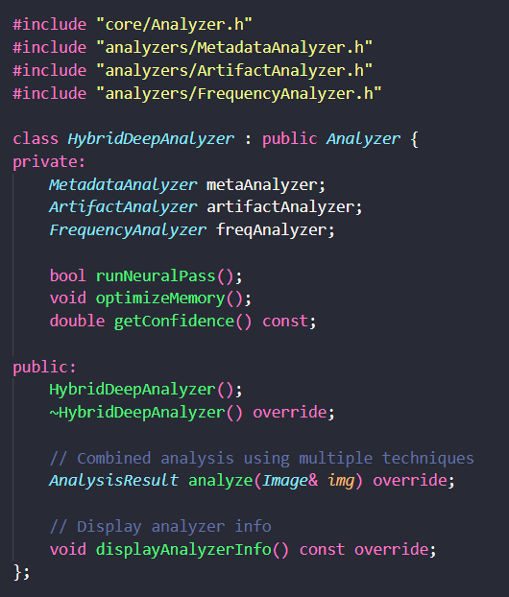
Analysis Method:
Combines three specialized analyzers:
- Metadata Analysis → Source authenticity
- Artifact Analysis → Visual disturbance
- Frequency Analysis → Spectral characteristics

Hybrid criteria: confidence =
(metadata_score × 0.3) + (artifact_score × 0.4) + (frequency_score × 0.3).

Image Analyzer - Main Controller
It manages all analyzers and their result report
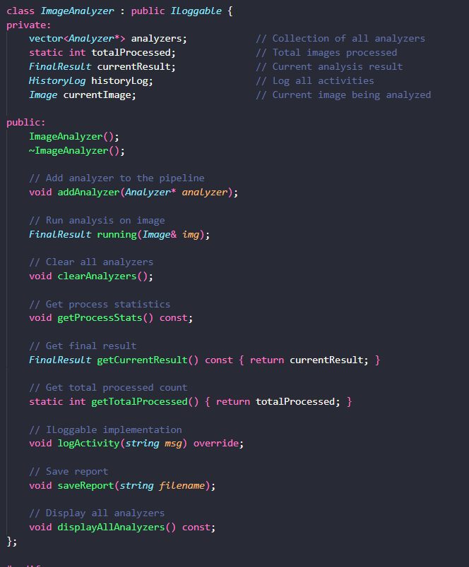
Workflow:
- Create ImageAnalyzer instance
- Add 5 individual analyzers to pipeline Load image file
- Execute running(image) to analyze
- Collect individual results.
- Calculate final confidence score
- Display/save report

Main Program:
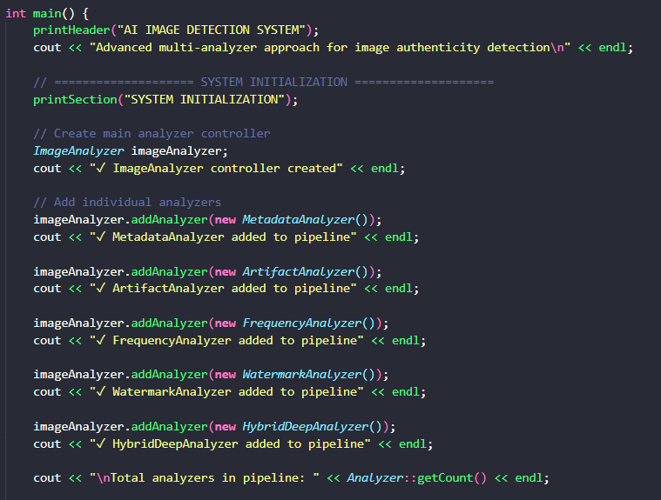
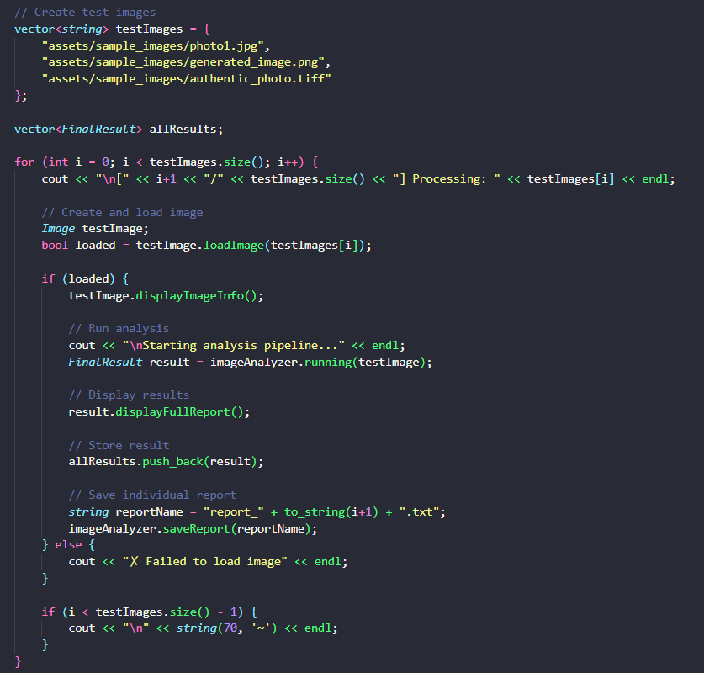
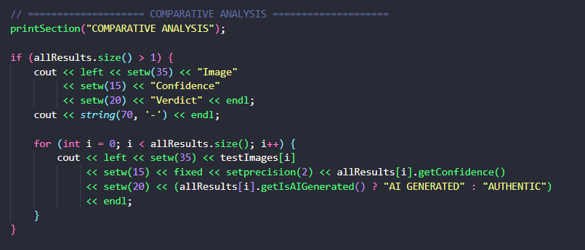

Tech Stack & Implementation

- Programing Language: C++ Standard

- Compiler: GCC/C++(Mingw on windows)

Run command :
Run this command on terminal.

g++ -I./include source/main/main.cpp source/core/Analyzer.cpp source/core/Image.cpp source/analyzers/*.cpp source/results/*.cpp source/utilities/*.cpp -o bin/AIDetector.exe
cd bin
./AIDetector.exe

Libraries & Dependencies

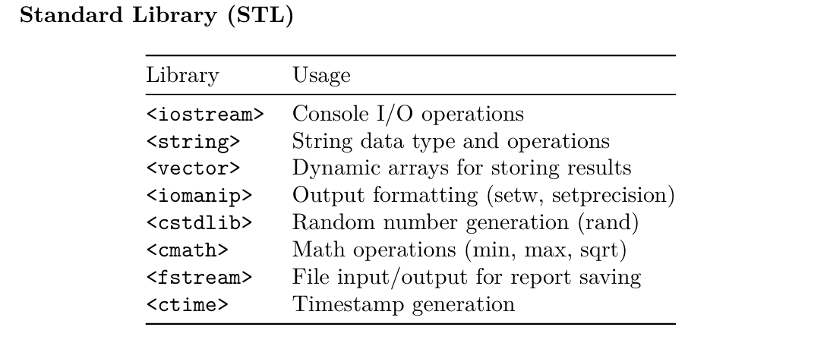
Note : No external libraries purely based on standard C++

Sample Output:
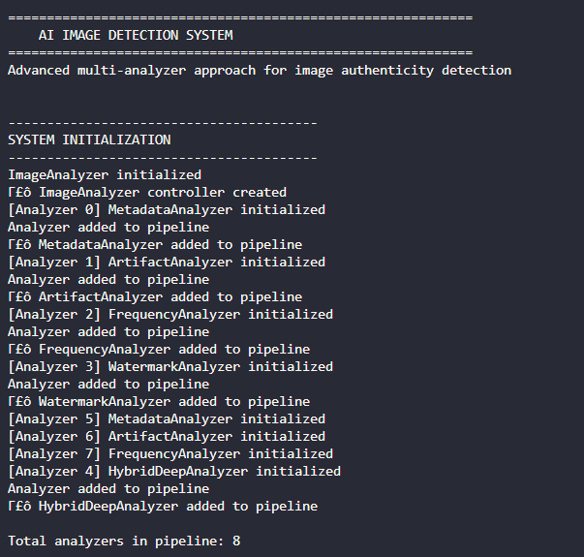
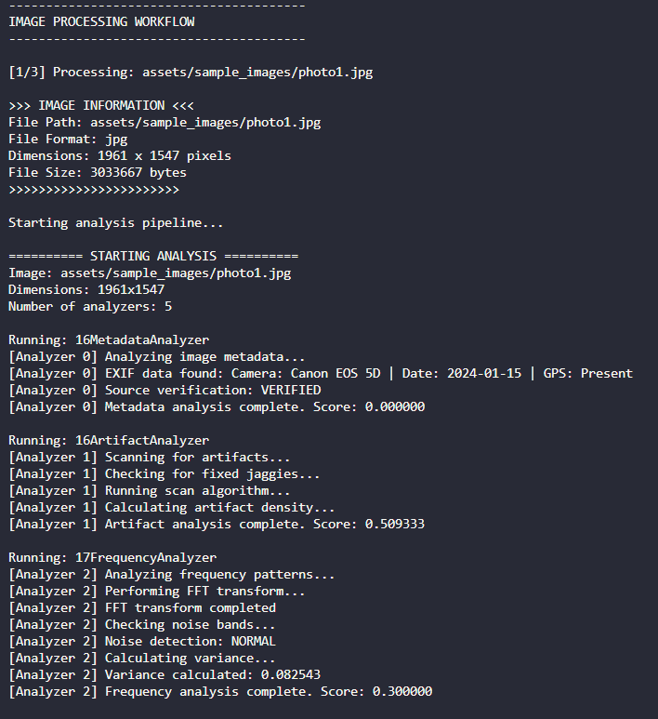
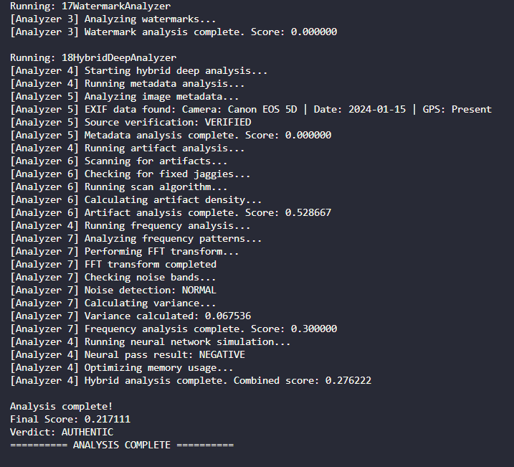
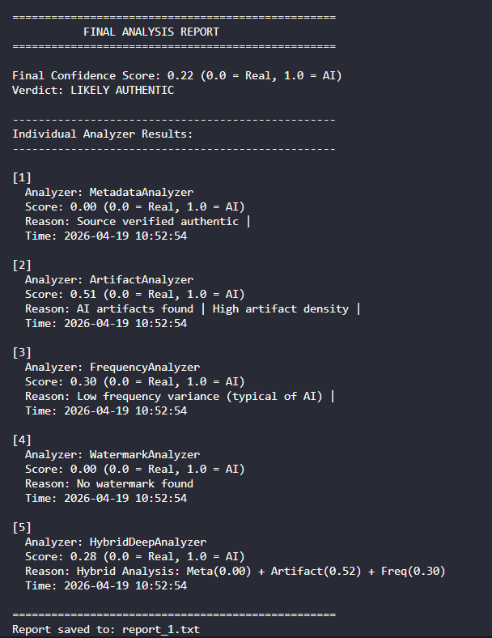

Key Features:
Plugin-Based Architecture
- Add/remove analyzers dynamically
- Extensible framework for new analysis methods
- Each analyzer operates independently
Multi-Technique Analysis
- Metadata examination
- Visual artifact detection
- Frequency domain analysis
- Watermark verification
- Hybrid ensemble approach
Comprehensive Reporting
- Individual analyzer scores
- Final confidence verdict
- Detailed reasoning per analyzer
- Timestamp tracking
- File-based result storage
Object-Oriented Design
- Abstract base classes
- Interface Implementation(ILoggable)
- Proper encapsulation and access control
- Smart memory management with destructors
Operator Overloading
- Array access: image[index]
- Comparison: result1 < result2
- Stream output: cout << result
- Increment: result++ 6. Activity Logging
- All operations logged via ILoggable
- Timestamps for audit
- Hierarchical logging (analyzer-level and system-level)

Limitations:
- Stimulating processing.
- Current is based on random image data
- No real image Implementing libraries like OpenCV, EXIF for image processing

Future Enhancement:
In future it can also be integrated with different image detection libraries to actually load and process image array data libraries which we integrated into is :

OpenCV ( to Load image and process real image)

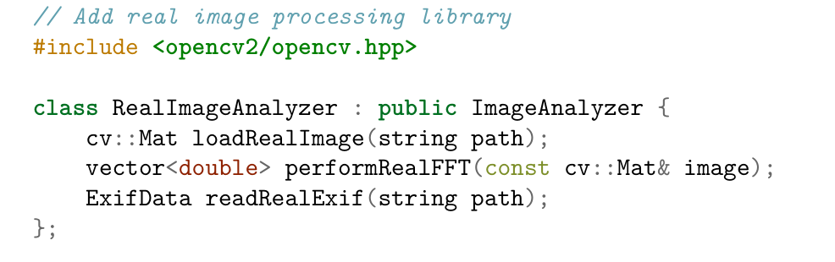

Machine Learning integration TensorFlow:

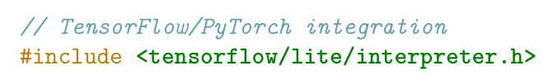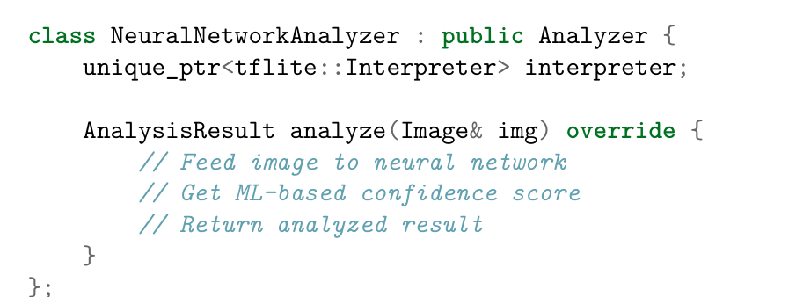
Deep learning model detects images with higher up to 95% accuracy

Data base integration:

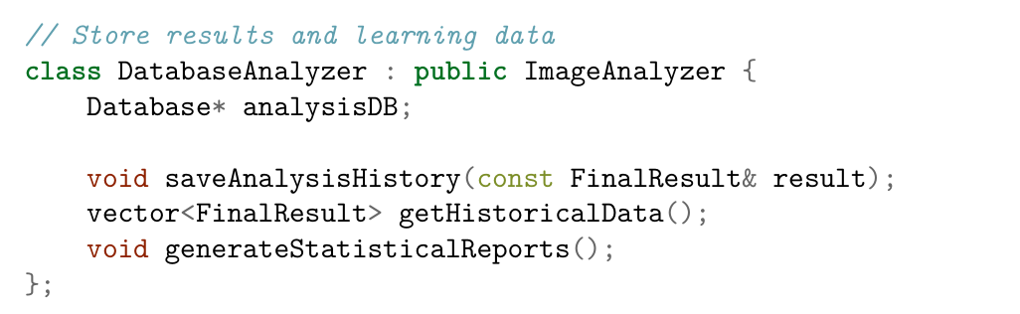
It uses to Historical tracking- Statistical analysis- Pattern recognition Dataset for model training.

Conclusion:
This AI image detection Model provides a comprehensive approach to implementing in C++ via strict OOP Principles with different parameters analysis.
- Meta data
- Frequency spectral
- Artifact approach
- Water mark
- Hybrid Analysis
Which helps to achieve a confidence score for determining an image analysis.

Project Strengths:

1. Robust Architecture - Plugin-based design allows easy analyzer addition
2. Comprehensive Analysis- Multiple independent verification methods
3. Maintainable Code - Clear OOP structure with proper encapsulation
4. Extendable Framework - Easy to add new analyzers
5. Production-Ready - Proper error handling and validation.

References:
- C++ standard : ISO/IEC 14882:2020 (C++20) https://cppreference.com/
- Design Patterns: Gang of Four: Design Patterns - C++ Design Patterns handbook- Martin Fowler’s Pattern Database

Class Diagram:

