DOCUMENTATION
FAST UNIVERSITY | OOP-A1-SPRING 26
PAK WHEEL
K250899 Muhammad Anas
Table of Contents
1. Introduction 2
2. Feature 1 – Car Listings Display 2
(A) Website Screenshot 2
(B) Observed Functionality 3
(C) Implementation 3
(D) Design Reasoning 4
3. Feature 2 – User Roles (Buyer / Seller / Admin) 4
(A) Website Screenshot 4
(B) Observed Functionality 5
(C) Implementation 5
(D) Design Reasoning 6
4. Feature 3 – Add to Favorites 6
(A) Website Screenshot 6
(B) Observed Functionality 7
(C) Our Implementation 7
(D) Design Reasoning 8
5. Feature 4 – Messaging System 8
(A) Website Screenshot 8
(B) Observed Functionality 8
(C) Implementation 8
(D) Design Reasoning 9
6. Feature 5 – Admin Listing Management 9
(A) Website Screenshot 9
10
(B) Observed Functionality 10
(C) Implementation 10
(D) Design Reasoning 10
7. UML Diagram Explanation 11
8. OOP Concepts Applied 12
9. Challenges Faced 12
10. Conclusion 13

1. Introduction
This project replicates selected core functionalities of PakWheels using Object-Oriented Programming in C++. The website was analyzed to identify major components such as vehicle listings, user roles, favorites, and messaging. These features were then modeled using classes, relationships, and modular architecture.
The objective was not to copy the website interface but to replicate its functionality using proper OOP design principles including encapsulation, inheritance, composition, and aggregation.

2. Feature 1 – Car Listings Display

(A) Website Screenshot
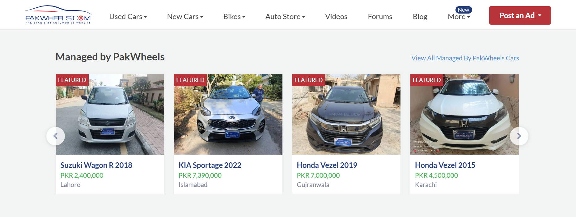
Used Cars listing page from PakWheels showing:
- Car title
- Price
- City
- Model year
- Vehicle specifications

(B) Observed Functionality
On the website:
- Multiple cars are displayed in a list format.
- Each listing contains structured information.
- Listings are managed centrally by the platform.
- Users can browse available vehicles.
Each car behaves like a separate entity with its own properties.

(C) Implementation
class Listing {
private:
static int totalListings;
int listingId;
Vehicle car;
CarSpecification specs;
double price;
string city;
bool isApproved;

public:
void publish();
void display() const;
};
Inside system controller:
class MarketplaceSystem {
private:
Listing* allListings[20];
int count;

public:
void addListing(Listing l);
void showListings();
};

(D) Design Reasoning
Each car card shown on the website is modeled as a Listing object.
- Encapsulation is used to protect listing data.
- Composition is applied because Listing contains Vehicle and CarSpecification objects.
- Static member totalListings tracks total listings globally, similar to a real marketplace.
- MarketplaceSystem owns listings, representing strong ownership (composition).
Pointer-based storage was used to avoid object slicing and copy-assignment issues, ensuring scalability and flexibility.

3. Feature 2 – User Roles (Buyer / Seller / Admin)

(A) Website Screenshot
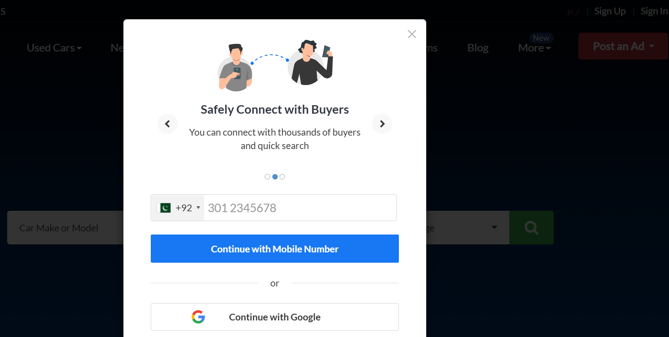
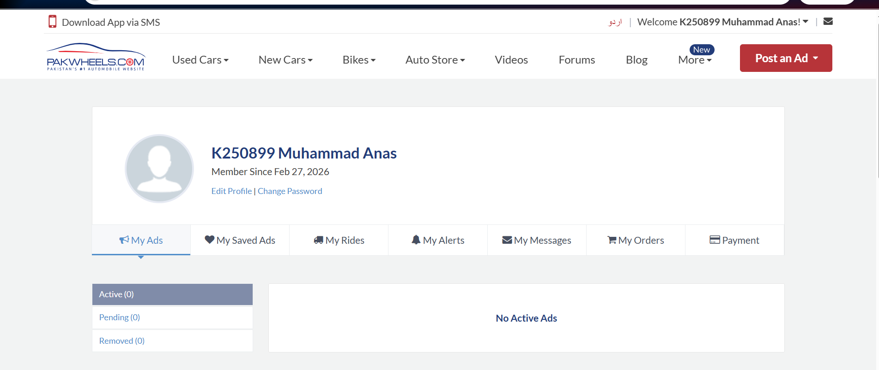Login page and seller dashboard from PakWheels.

(B) Observed Functionality
The website has multiple user roles:
- Buyers browse listings.
- Sellers post advertisements.
- Admin manages marketplace.
Different roles have different permissions.

(C) Implementation
class User {
protected:
string userId;
string name;
string city;

public:
virtual void login() = 0;
};

class Buyer : public User { };
class Seller : public User { };
class Admin : public User { };

(D) Design Reasoning
Inheritance was used to represent real-world hierarchy.
- User is the base class containing common attributes.
- Buyer, Seller, and Admin inherit shared properties.
- This reduces redundancy and increases maintainability.
- Virtual functions allow polymorphic behavior.
This structure directly mirrors how the website separates user responsibilities.

4. Feature 3 – Add to Favorites
(A) Website Screenshot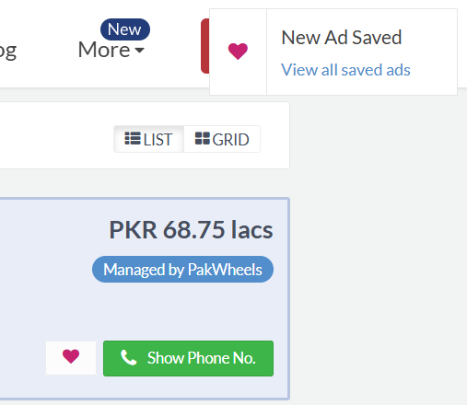
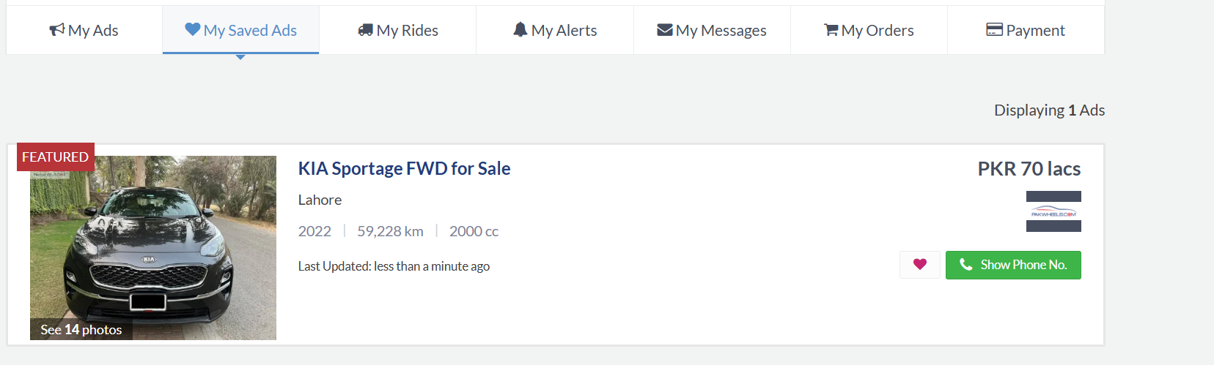
“Save Ad” button on listing.

(B) Observed Functionality
Users can save listings for later viewing.
The saved listing remains in the system independently of the buyer.

(C) Our Implementation
class FavoriteList {
private:
Listing* savedListings[20];
int count;
const int MAX_FAVORITES;

public:
void addFavorite(Listing* listing);
void viewFavorites() const;
};
Inside Buyer:
class Buyer : public User {
private:
FavoriteList favorites;
};

(D) Design Reasoning
Aggregation relationship was implemented between Buyer and Listing.
- Buyer does not own the listing.
- Listing exists independently of favorites.
- Pointer-based referencing ensures no duplication.
A separate FavoriteList class improves modularity and keeps Buyer class clean.

5. Feature 4 – Messaging System

(A) Website Screenshot
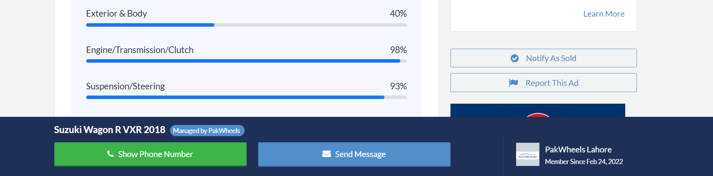
“Contact Seller” section from listing page.

(B) Observed Functionality
Buyers can send messages to sellers regarding a listing.
Messages contain:
- Sender
- Receiver
- Message content

(C) Implementation
class Message {
private:
string senderId;
string receiverId;
string content;
bool isRead;

public:
void send();
void display() const;
};

(D) Design Reasoning
Messaging is modeled as an independent entity.
- Represents association between users.
- Keeps communication logic separate from listing logic.
- Promotes scalability if message history or inbox is extended.

6. Feature 5 – Admin Listing Management

(A) Website Screenshot
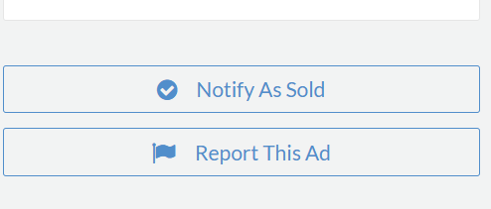
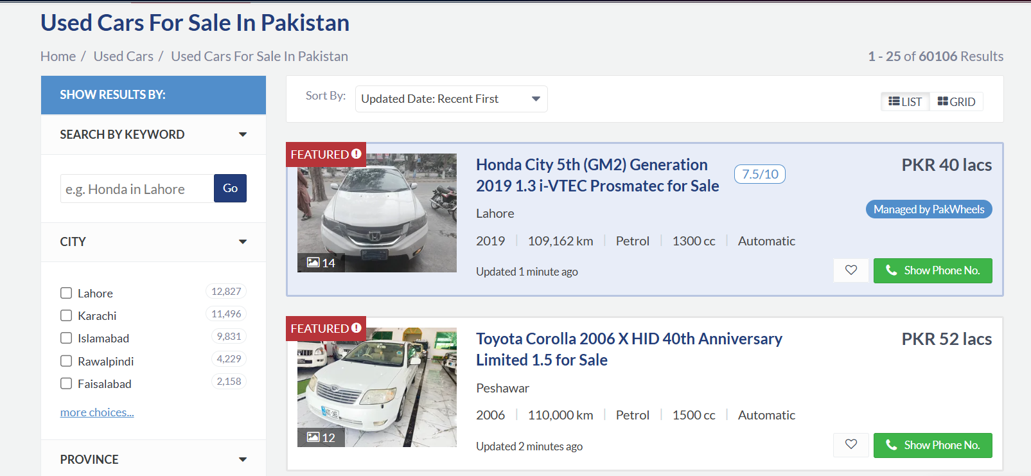
Admin moderation / approval system.

(B) Observed Functionality
Marketplace platforms control listings through approval or removal mechanisms.

(C) Implementation
class Admin : public User {
public:
void approveListing(Listing& l);
};

(D) Design Reasoning
Admin inherits from User but has additional control methods.
This models role-based access control and maintains clear separation of authority.

7. UML Diagram Explanation
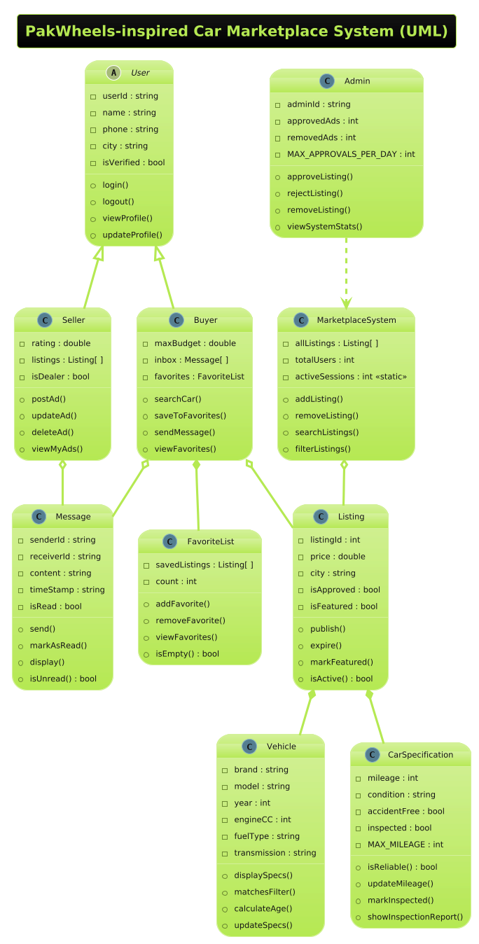
Explain:
- Inheritance: User → Buyer, Seller, Admin
- Composition: MarketplaceSystem → Listing
- Aggregation: Buyer → Listing
- Association: Message ↔ Users
The UML ensures that system design matches implementation structure.

8. OOP Concepts Applied
Concept | Implementation
Encapsulation | Private data members
Inheritance | User hierarchy
Polymorphism | Virtual functions
Composition | Listing contains Vehicle
Aggregation | Buyer references Listing
Static Members | totalListings counter
Const Members | MAX_FAVORITES

9. Challenges Faced
- Managing header include paths
- Copy assignment errors due to const members
- Pointer management and memory handling
- Maintaining modular file structure
These challenges improved understanding of practical OOP development.

10. Conclusion
The project successfully replicates essential functionalities of PakWheels using structured OOP design.
The implementation demonstrates:
- Proper class hierarchy
- Real-world modeling
- Modular architecture
- Clear separation of responsibilities
The system can be extended in future with file handling, database integration, and graphical interface.

