Online Car Marketplace System (PakWheels Simulation)

Subject: Object Oriented Programming (CS1004)
Student Name: Muhammad Anas
Student ID: K250899
Date: March 1, 2026

Table of Contents
1. Introduction 1
2. System Features & Implementation 1
Feature 1: Car Listings Display 1
Feature 2: User Roles (Inheritance) 4
Feature 3: Add to Favorites (Aggregation) 8
Feature 4: Messaging System (Association) 10
3. OOP Concepts Applied 13
Class diagram: 14
5. Final Output & Execution 15
How to Compile: 15
Expected Output: 15

GitHub Repository: muhammadanas20/oop-a1-pak_wheel_system

1. Introduction
This project is a console-based simulation of an online car marketplace inspired by PakWheels. The system implements core marketplace behaviors such as listing management, user roles, and buyer-seller interaction using advanced C++ Object-Oriented Programming principles.

2. System Features & Implementation

Feature 1: Car Listings Display
- Observed Functionality: Multiple cars are displayed with structured information like price, city, and specifications.
- Design Reasoning: Each car is modeled as a Listing object. Composition is used because a Listing cannot exist without a Vehicle and CarSpecification.
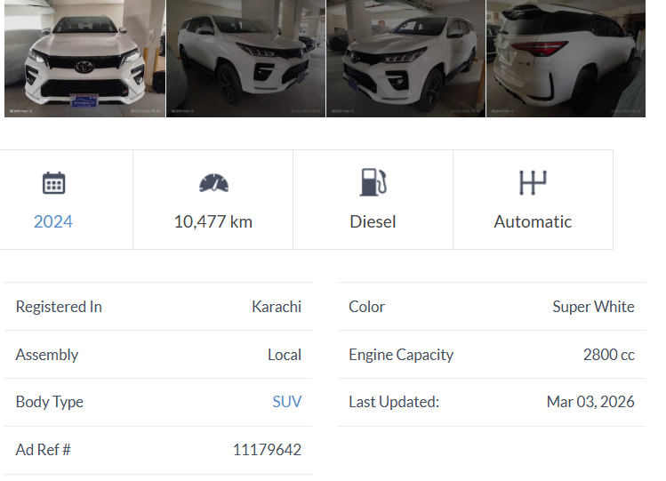
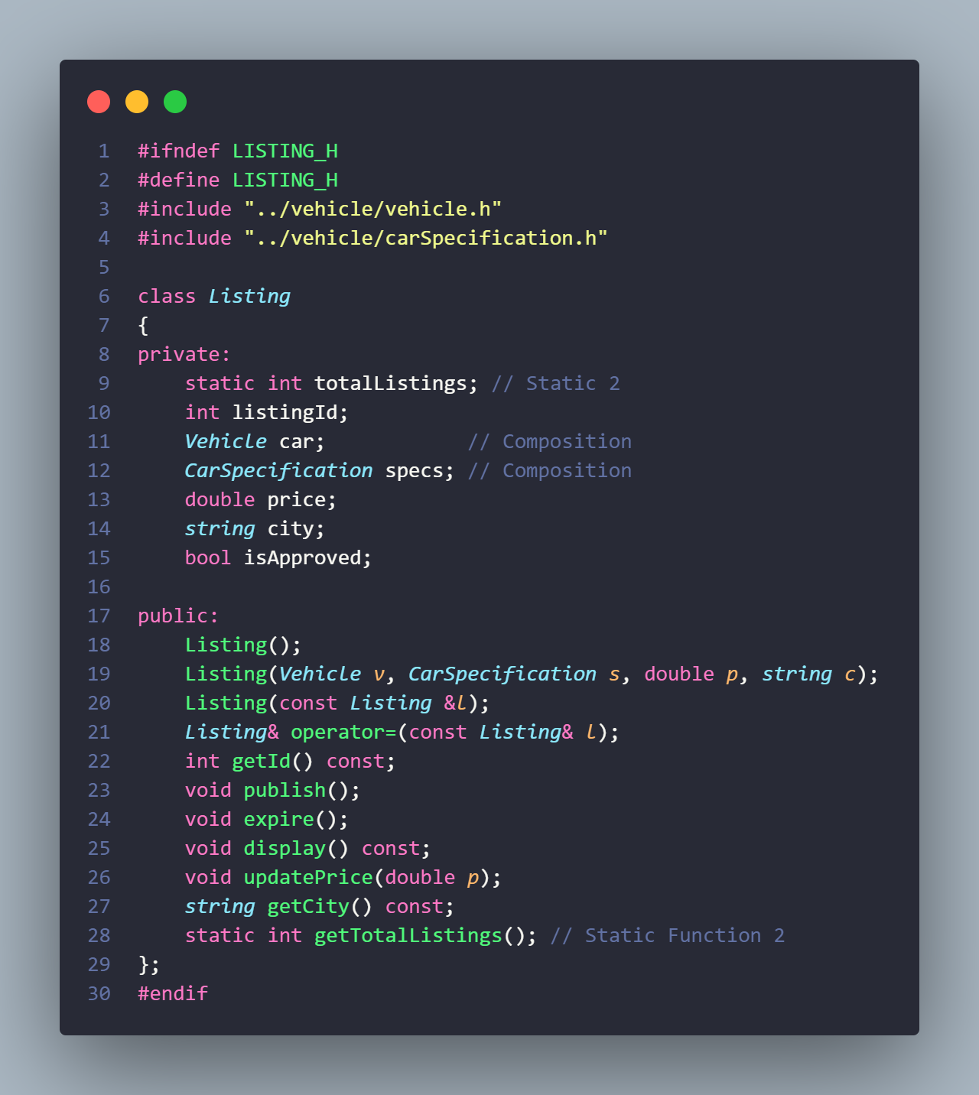
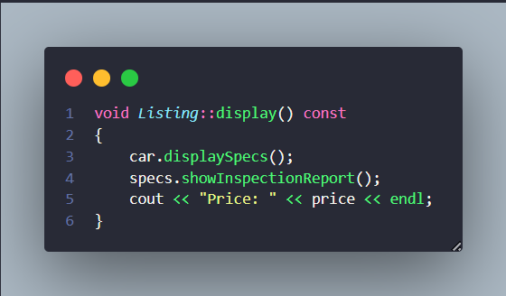

Feature 2: User Roles (Inheritance)
- Observed Functionality: The system separates permissions for Buyers, Sellers, and Admins.
- Design Reasoning: Inheritance represents the real-world hierarchy. User is an abstract base class, and polymorphism is used for login() and logout() behaviors.
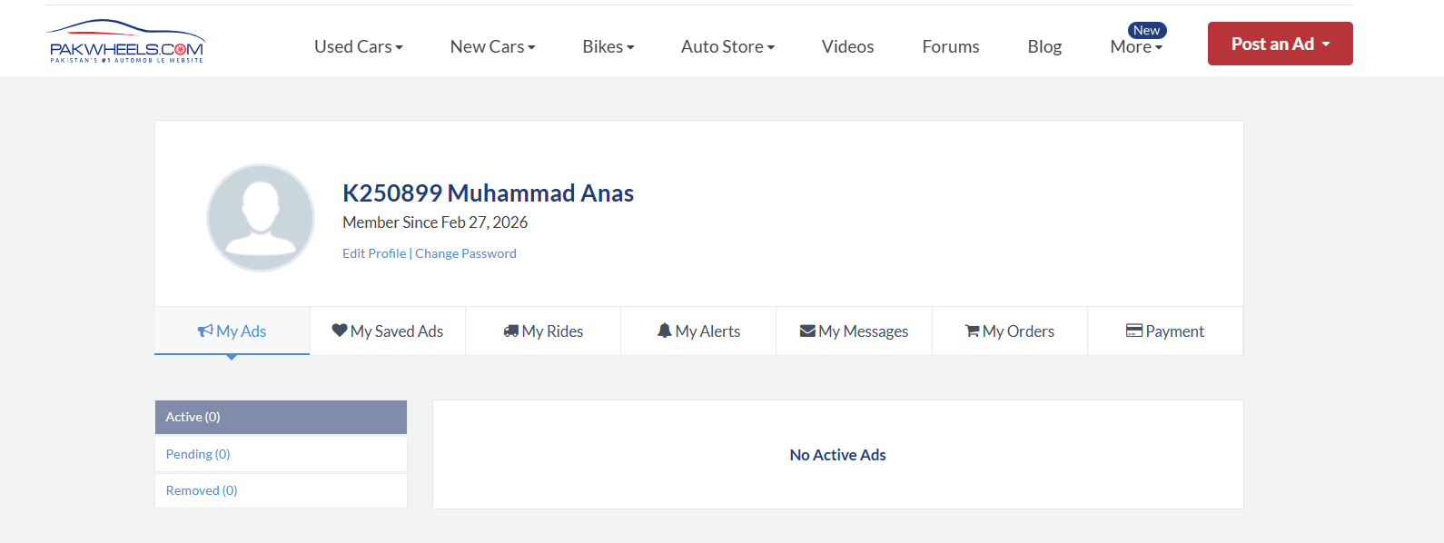
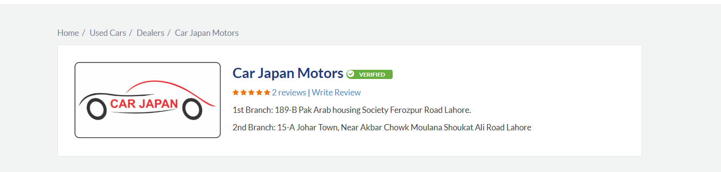
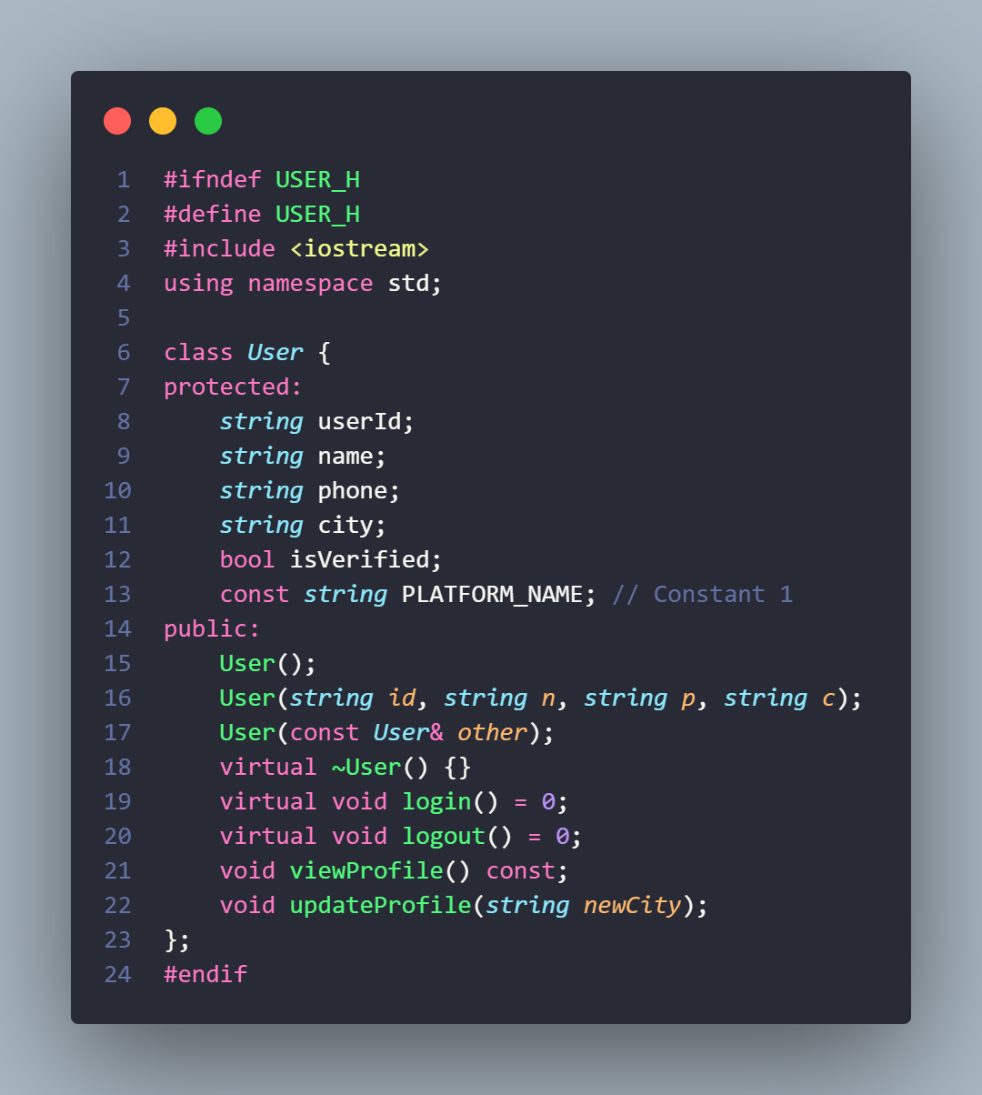
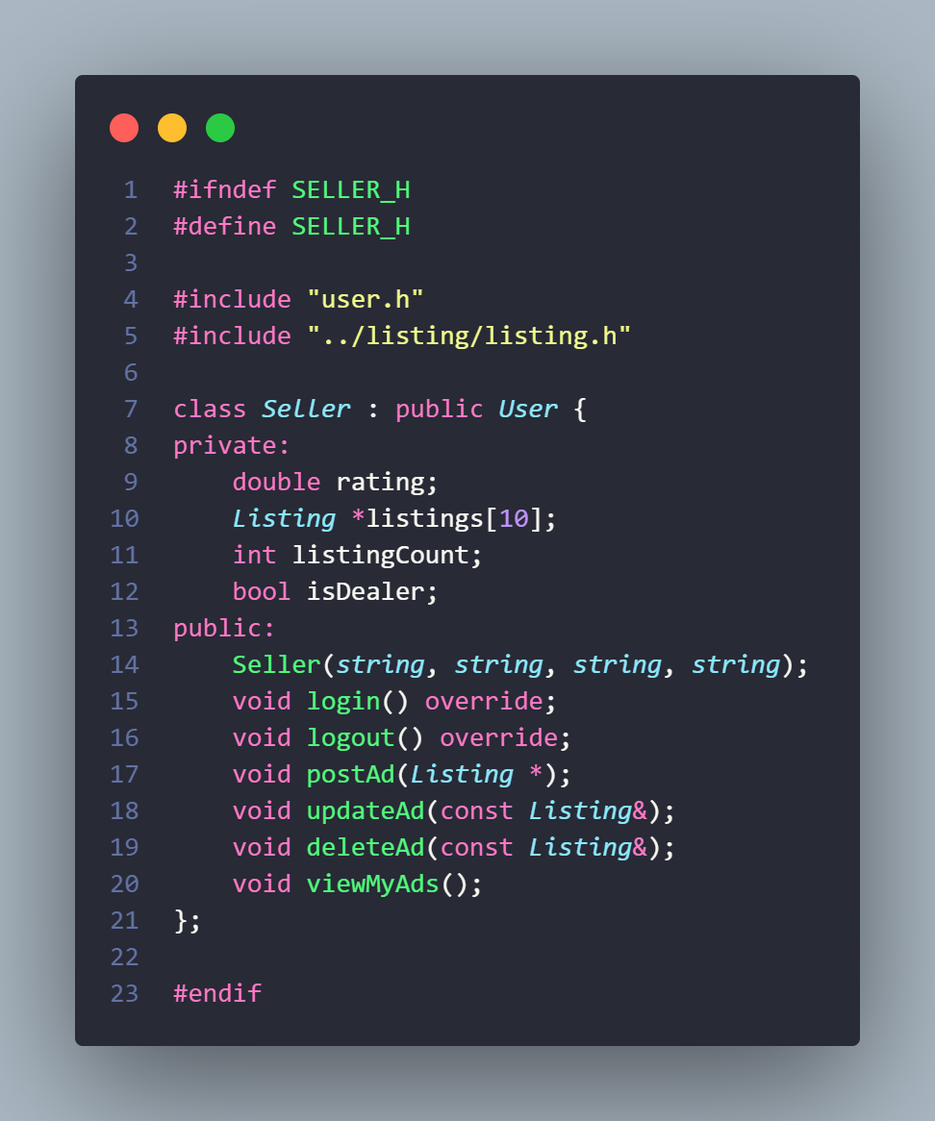
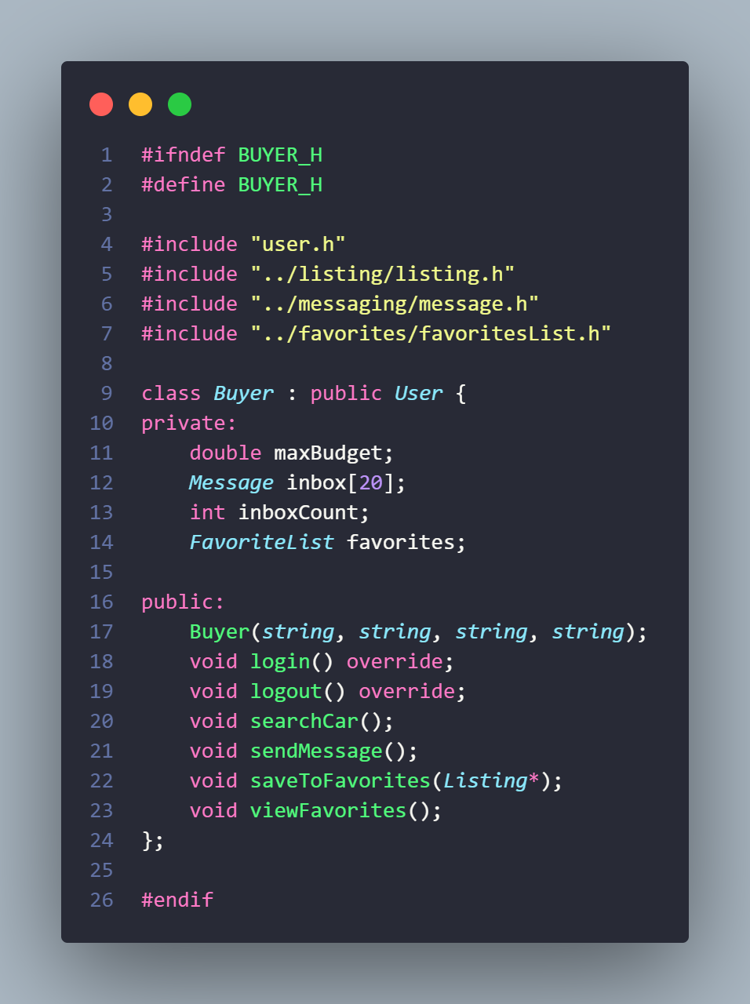
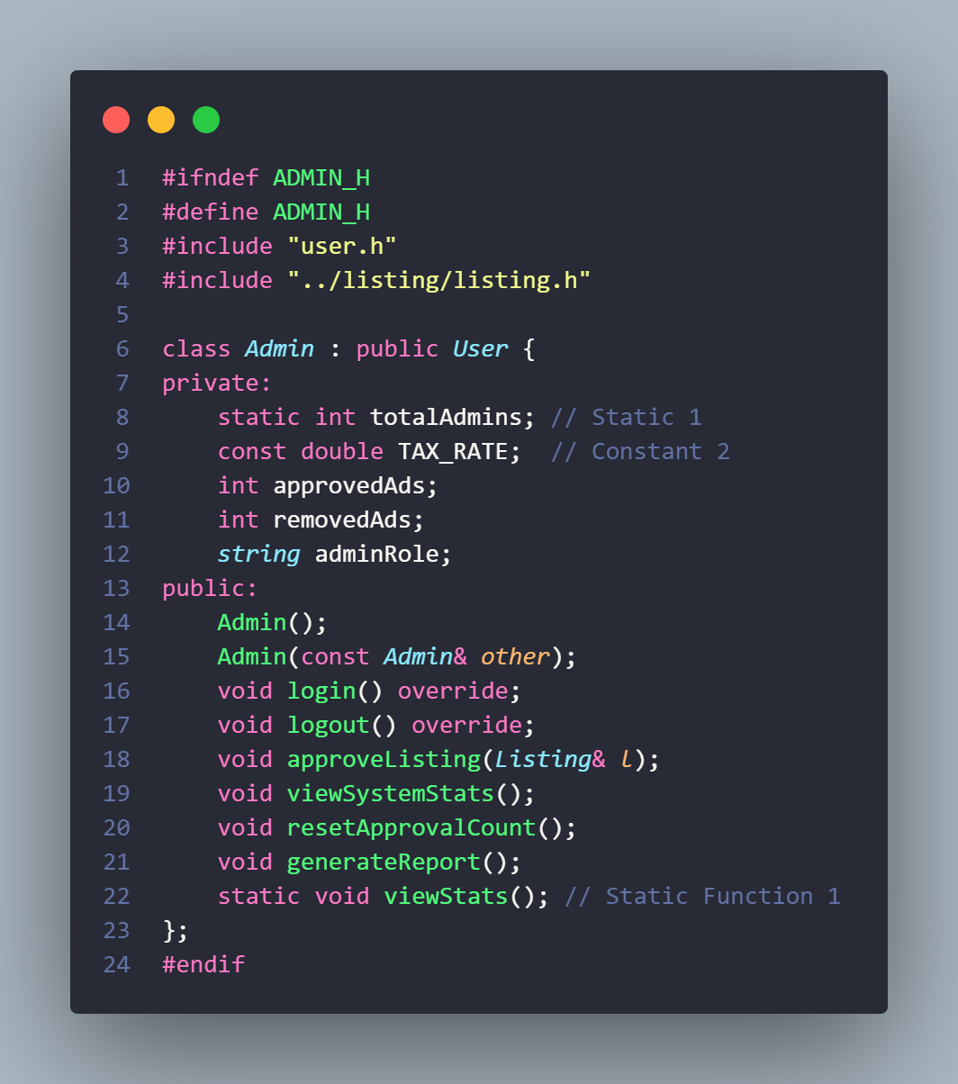

Feature 3: Add to Favorites (Aggregation)
- Observed Functionality: Buyers can save ads to a list that exists independently of the main marketplace.
- Design Reasoning: This is an aggregation relationship. The Buyer has a FavoriteList, but the Listing objects themselves are owned by the system, not the buyer.
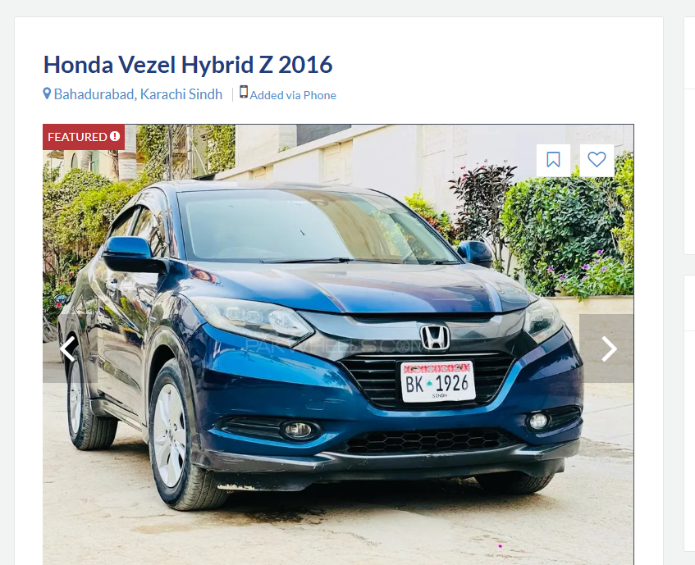
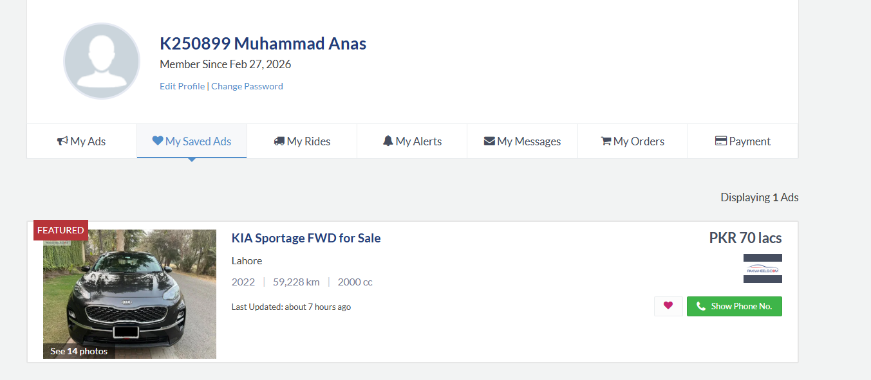
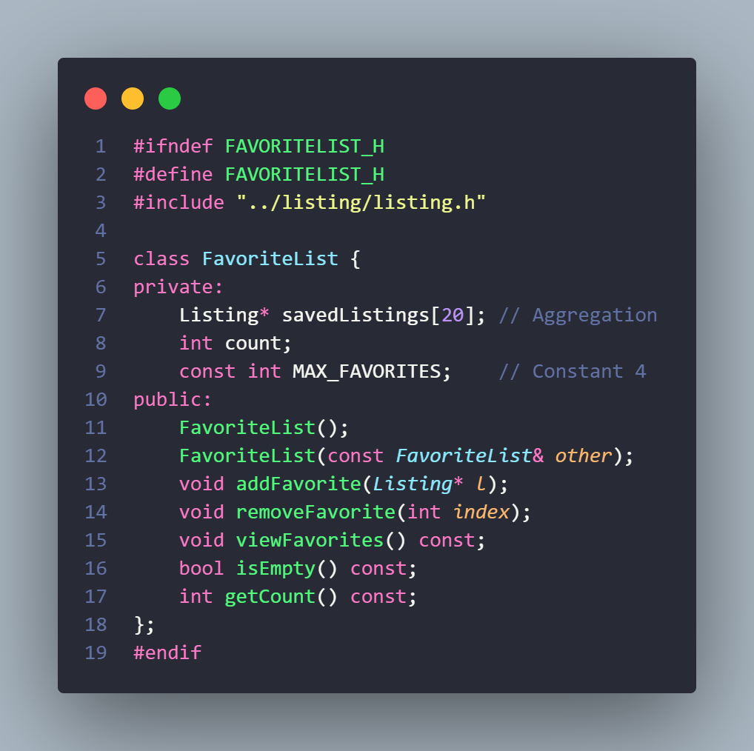

Feature 4: Messaging System (Association)
- Observed Functionality: Buyers can contact sellers directly through the platform.
- Design Reasoning: Modeled as an association between users, where a Message object stores sender and receiver IDs.
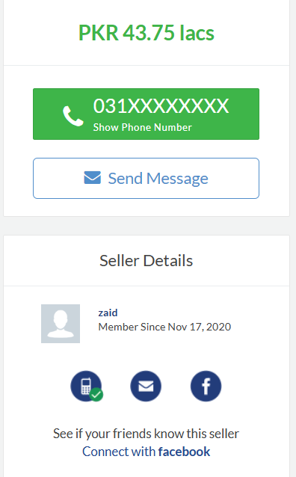
- 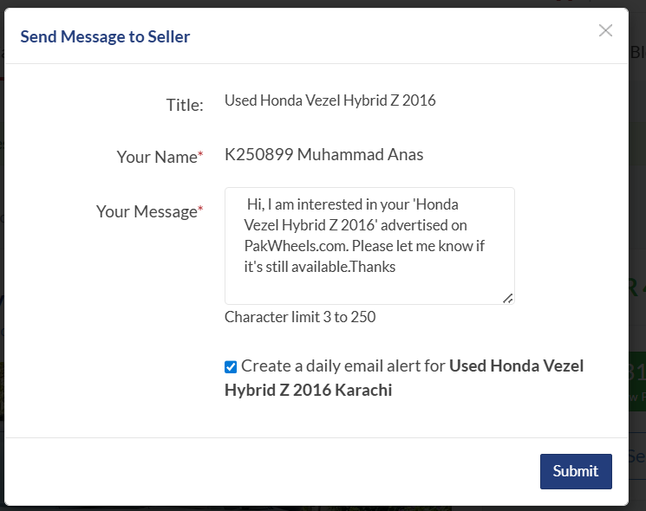
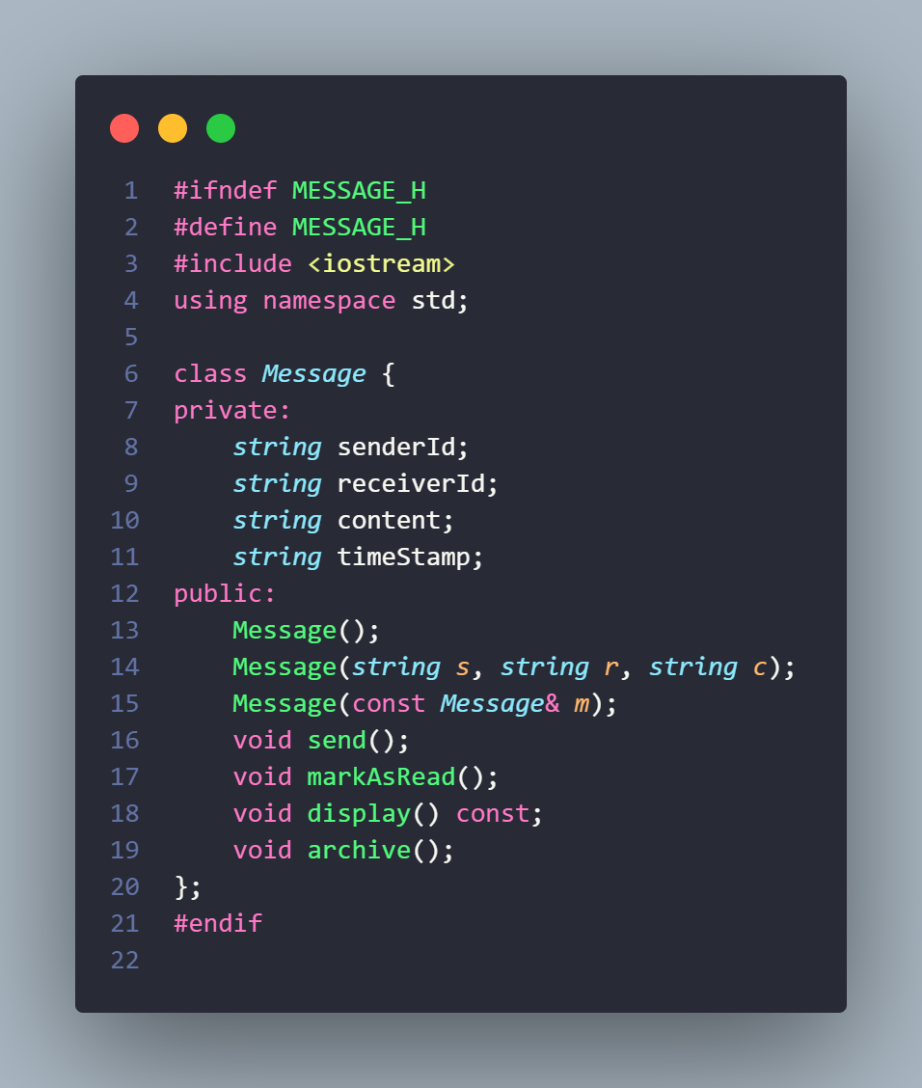

3. OOP Concepts Applied
Concept | Implementation Details
10 Classes | User, Buyer, Seller, Admin, Listing, Vehicle, CarSpecification, FavoriteList, Message, MarketplaceSystem.
Constructors | Default, parameterized, and copy constructors are used in Vehicle and Listing to handle object creation and cloning.
Constants | 5 constants used: PLATFORM_NAME (User), TAX_RATE (Admin), MAX_CAPACITY (Marketplace), MAX_FAVORITES (FavoriteList), MAX_MILEAGE (Specs).
Static Members | totalListings in Listing and totalAdmins in Admin track global system state.
Composition | Listing class contains Vehicle and CarSpecification objects.
Aggregation | FavoriteList holds an array of Listing* pointers.
Array of Objects | Used in MarketplaceSystem for all listings and Buyer for inbox messages.
Class diagram:
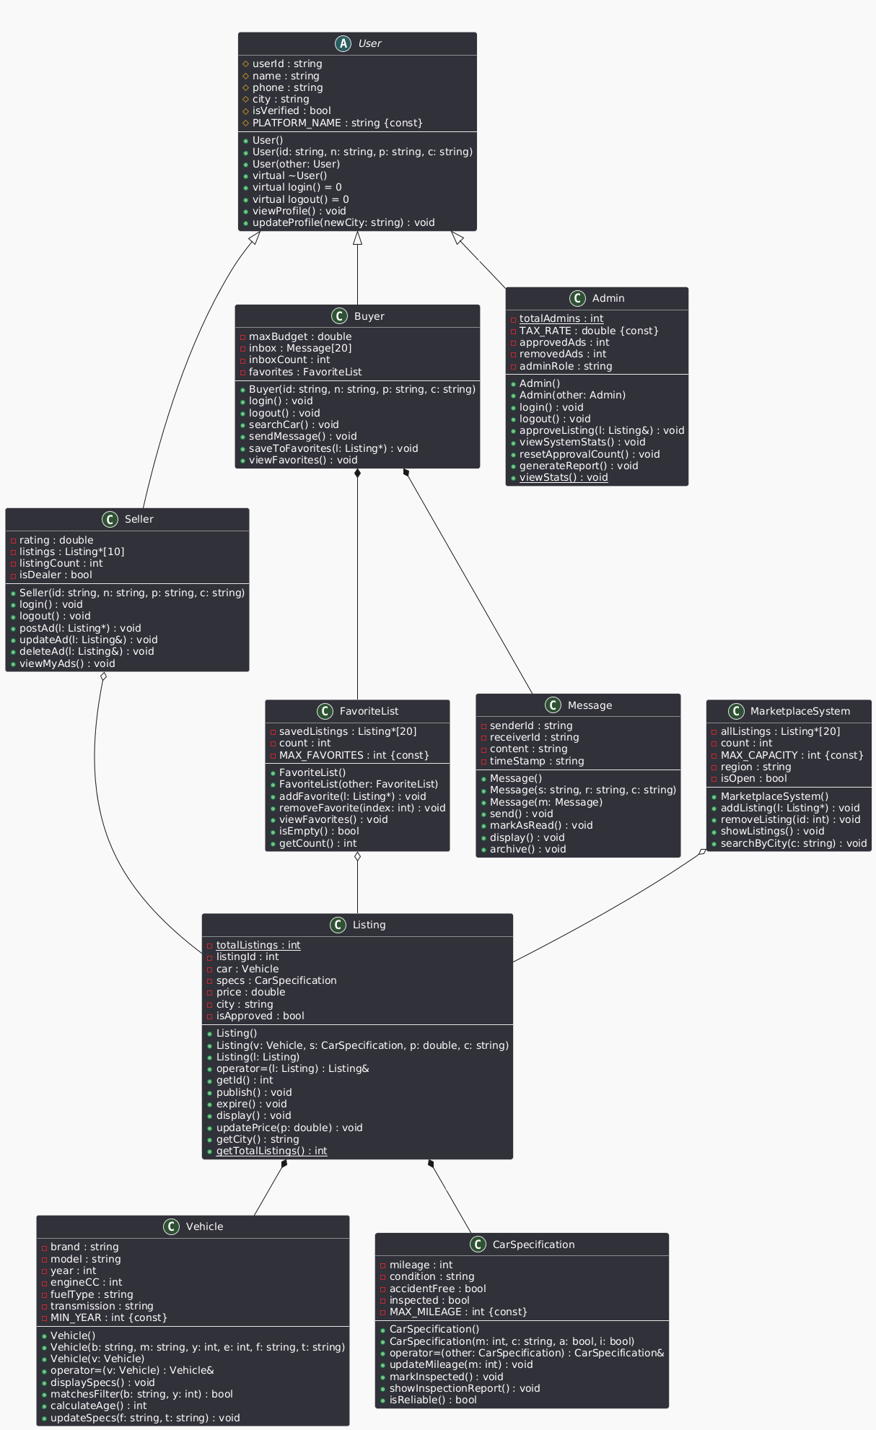

5. Final Output & Execution

How to Compile:
g++ main.cpp favorites/*.cpp listing/*.cpp messaging/*.cpp system/*.cpp user/*.cpp vehicle/*.cpp -o marketplaceSystem
./marketplaceSystem

Expected Output:
The system will simulate a Seller logging in and posting an ad, an Admin approving the ad, and a Buyer adding that ad to their favorites before displaying the final marketplace state.
