National University of Computer and Emerging Sciences, Karachi
FAST School of Computing
Project Report
Project Name | Smart Shopping Machine
Course and  Instructor: | Digital Logic Design (DLD)  Miss Seema Hashwani
Date | 5 May 2026
Semester | 2026 Spring
Members | Muhammad Anas(Leader) (25k-0899)  Syed Alyan Hussain (25k-0648)


Table of Contents
1. Project Overview 3
Project Objectives 3
2. Circuit Components & Logic Explanation 4
2.1 Encoding Logic for Product Prices 4
2.2 Adder Circuit (4-bit Addition) 5
2.3 Register for Storage 5
2.4 Clock Triggering & Synchronization 6
2.5 Add & Reset Functionality 7
2.6 Comparator Circuit (Threshold Detection at >10) 9
2.7 Subtractor IC (4-bit Subtraction) 10
2.8 BCD to 7-Segment Decoder/Driver 10
2.9 Tens and Units Display Function 12
2.10 Subtractor Function in Detail 12
3. Implementation & Demo Results 14
3.1 System Integration Overview 14
3.5 Reset Demonstration 15
4. Restrictions & Limitations 17
5. Future Enhancements 18
6. Use Cases & Applications 19
7. Conclusion 20

1. Project Overview
The Smart Shopping Machine is a digital logic circuit designed to simulate an automated shopping system that handles product selection, price calculation, comparison, and display. This project integrates multiple digital logic components including encoders, adders, comparators, subtractors, multiplexers, and display drivers to create a complete functional system.

Project Objectives
- Implement encoding logic to process product selection (P1, P2, P3)
- Calculate total price using 4-bit adder circuits with register storage
- Compare prices using comparator IC for threshold detection (>10)
- Perform arithmetic subtraction using subtractor IC
- Display results on 7-segment displays with tens and units separation
- Demonstrate practical application of sequential and combinational circuits

2. Circuit Components & Logic Explanation

2.1 Encoding Logic for Product Prices
The encoding logic converts product selection into binary price representation. The Smart Shopping Machine contains three products, each with a unique 4-bit binary code representing its price. P1 (Price: 2, Code: 0010), P2 (Price: 3, Code: 0011), and P3 (Price: 5, Code: 0101) are encoded using combinational logic circuits. When a product is selected via input lines, the corresponding price bits (P1, P2, P3) are generated and fed to subsequent arithmetic circuits for processing.
Encoding Truth Table:
Product | Price (Binary)
P1 | 0010 (2)
P2 | 0011 (3)
P3 | 0101 (5)

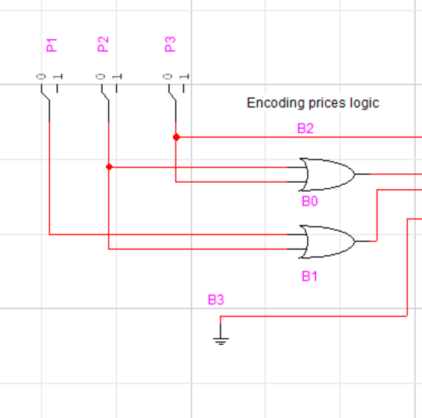

2.2 Adder Circuit (4-bit Addition)
The 4-bit adder circuit performs arithmetic addition of binary numbers with carry propagation. Input lines A0-A3 and B0-B3 represent the two 4-bit numbers to be added. The adder outputs S0-S3 represent the sum, while the Carry Out (CO) represents the carry generated from the most significant bit. This circuit is essential for accumulating prices when multiple products are selected sequentially.
✓ Inputs (A0-A3, B0-B3): 8-bit total representing two 4-bit binary numbers
✓ Outputs (S0-S3): 4-bit sum result representing the addition output
✓ Carry In (CI): Initial carry input (typically 0)
✓ Carry Out (CO): Overflow bit generated if sum exceeds 15
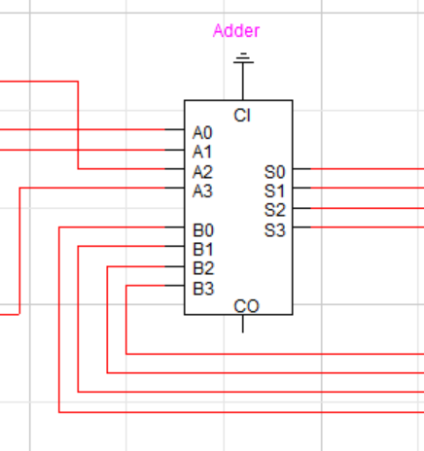

2.3 Register for Storage
The register circuit stores the output of the adder temporarily using D-type flip-flops (4 flip-flops for 4-bit storage). The register has inputs D0-D3 (data inputs from adder outputs), clock (CLK) input for synchronization, and clear (CLR) input for resetting. When a clock pulse arrives, the current data on D inputs is captured and held at Q outputs, providing stable values for subsequent processing stages.
✓ Data Inputs (D0-D3): Receives 4-bit sum from adder outputs
✓ Clock (CLK): Synchronizes data capture on rising/falling edge
✓ Clear (CLR): Asynchronous reset that clears all flip-flops to 0
✓ Outputs (Q0-Q3): Stable stored value available for next stage

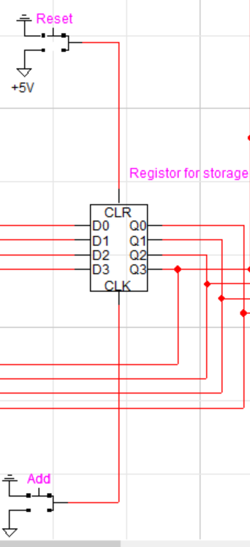

2.4 Clock Triggering & Synchronization
The clock signal provides temporal synchronization for the entire system. When the Add button is pressed (logic HIGH), the clock pulse triggers the register to capture the adder output. The clock ensures that all flip-flops update simultaneously, preventing metastability and timing errors. The active-high Add signal determines whether data is captured on the next clock pulse, allowing manual control over when accumulation occurs.
✓ Add Signal (+5V): When HIGH, enables clock pulse to capture adder sum
✓ Clock Pulse: Periodic signal driving state changes in flip-flops
✓ Synchronization: All outputs update simultaneously on clock edge
✓ Manual Control: Add button provides user control over accumulation timing

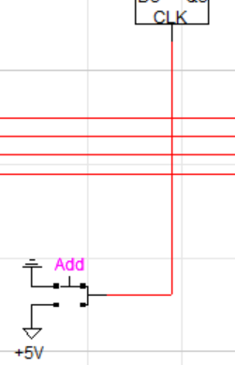

2.5 Add & Reset Functionality
The Add function allows incremental addition of product prices to the stored total. When the Add button (+5V) is activated, the current adder output is synchronized with the clock and stored in the register. The Reset function (also active-HIGH) asynchronously clears all register flip-flops, setting the stored value to 0000 (decimal 0). This enables the machine to restart calculation for a new shopping transaction without waiting for clock cycles.
✓ Add Button Operation: Triggers clock pulse to accumulate product price into register
✓ Reset Button Operation: Immediately clears register to 0, independent of clock
✓ Manual Control: Both buttons provide user interface for transaction management
✓ Logic States: Add: Logic 1 (enable), Reset: Logic 1 (active), Default: Logic 0

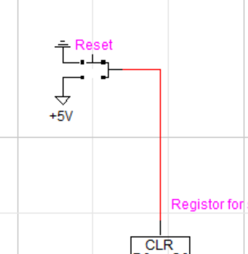

2.6 Comparator Circuit (Threshold Detection at >10)
The 4-bit magnitude comparator (IC 7485 or equivalent) compares the accumulated total price with a threshold value. The comparator has two 4-bit inputs (A3-A0 and B3-B0) and three output lines: A>B, A=B, A<B. In this application, input A receives the accumulated price from the register, while input B is set to 1010 (decimal 10). When accumulated price exceeds 10, the A>B output goes HIGH, triggering additional logic for handling high-value transactions.
✓ Input A (A3-A0): Accumulated price from register (variable)
✓ Input B (B3-B0): Threshold value = 1010 (decimal 10)
✓ Output A>B: HIGH when accumulated price > 10
✓ Cascade Inputs: A>Bin, A=Bin, A<Bin allow comparison chaining

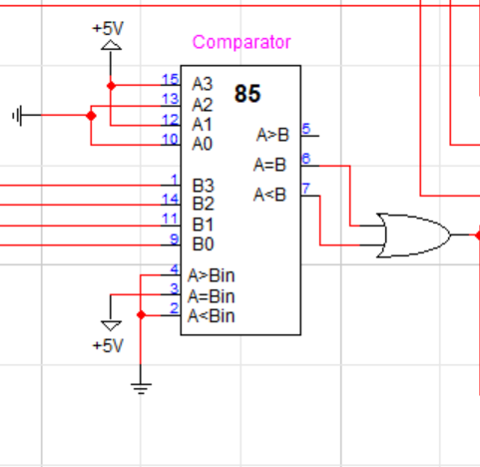

2.7 Subtractor IC (4-bit Subtraction)
The 4-bit subtractor circuit performs binary subtraction (A - B) using full subtractors in cascade. It receives the accumulated price (A3-A0) and a discount or reference value (B3-B0), producing the difference on output lines (S3-S0). The Carry In (CI) and Carry Out (CO) lines handle borrow operations. This enables discount calculations or price adjustments in the smart shopping machine application.
✓ Input A (A3-A0): Minuend - accumulated price from register
✓ Input B (B3-B0): Subtrahend - discount or reference value
✓ Carry In (CI): Initial borrow from previous stage (typically 0)
✓ Outputs (S3-S0): Result of subtraction (A - B)

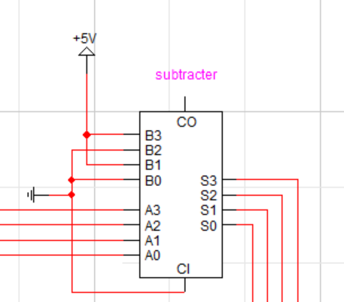

2.8 BCD to 7-Segment Decoder/Driver
The BCD-to-7-segment decoder (IC 7448 or 4511) converts 4-bit binary coded decimal (BCD) into 7-segment display signals (a-g). Each 4-bit input represents a single decimal digit (0-9). The decoder outputs control the seven LED segments (a, b, c, d, e, f, g) of the display, forming the digit shape. Two decoders are used: one for tens place and one for units place, enabling display of values from 00 to 99.
✓ Inputs (A-D or D3-D0): 4-bit BCD value representing digit 0-9
✓ Outputs (a-g): Seven signals controlling individual LED segments
✓ RBO (Ripple Blank Out): Suppresses leading zeros in multi-digit displays
✓ LT (Lamp Test): When HIGH, illuminates all segments for testing

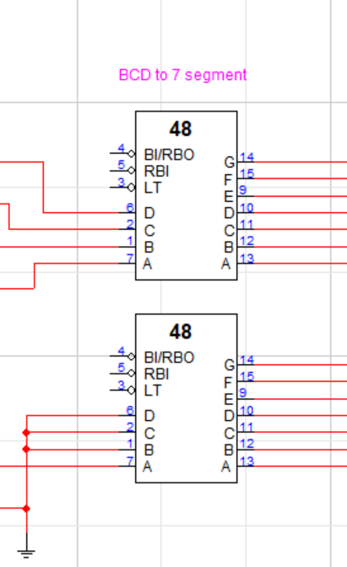

2.9 Tens and Units Display Function
The display system separates the total price into tens and units digits for clear visual representation. A 4:1 multiplexer selects which 4 bits (upper 4 bits for tens, lower 4 bits for units) feed the BCD decoder. The tens display shows values 0-1 (since max is 15), while the units display cycles through 0-9. For example, price 13 displays as '1' on tens place and '3' on units place. The decimal point (dot) on each display can indicate currency or transaction status.
✓ Tens Place Extraction: Upper 4 bits (Q3-Q2-Q1-Q0) from register
✓ Units Place Extraction: Lower 4 bits processed through multiplexer
✓ Multiplexer Control: Select lines (S0-S1) route correct bits to decoder
✓ Display Range: Shows values 0-15 using both digit positions

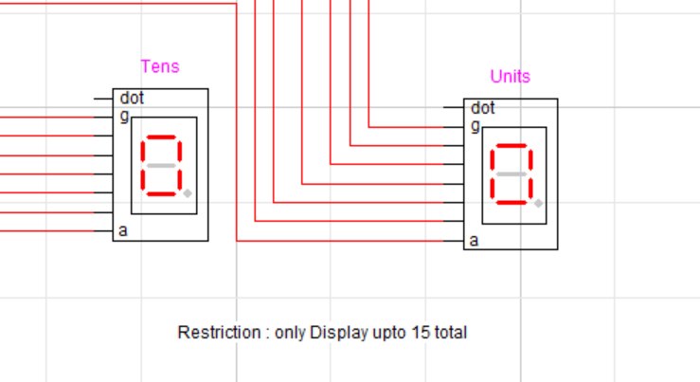

2.10 Subtractor Function in Detail
The subtractor processes the output from the multiplexer, performing final arithmetic operations for discount or change calculations. It takes the selected value (either tens or units) and subtracts a reference value, producing output for final display. The borrow logic (CI/CO) handles cases where the minuend is smaller than the subtrahend, properly representing negative or underflow conditions through carry propagation.
✓ Input Selection via MUX: Multiplexer routes tens or units to subtractor
✓ Subtraction Operation: Performs A - B with automatic borrow handling
✓ Result Routing: Output feeds back to display decoders for visualization
✓ Borrow Handling: CO signal indicates if result is negative/underflow
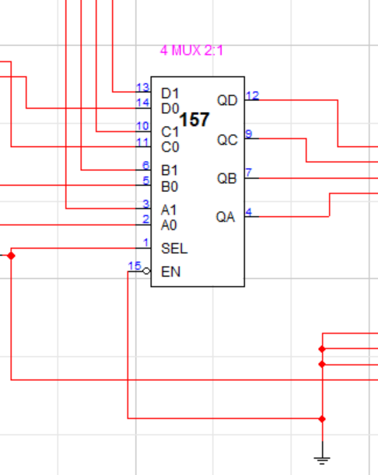

3. Implementation & Demo Results

3.1 System Integration Overview
The complete Smart Shopping Machine integrates all components through careful signal routing and control logic. Product prices flow from encoding logic through the adder, are stored in the register, compared against thresholds, and finally displayed. The system operates in cycles: product selection → price encoding → accumulation → comparison → display. Multiple iterations accumulate prices until reset.

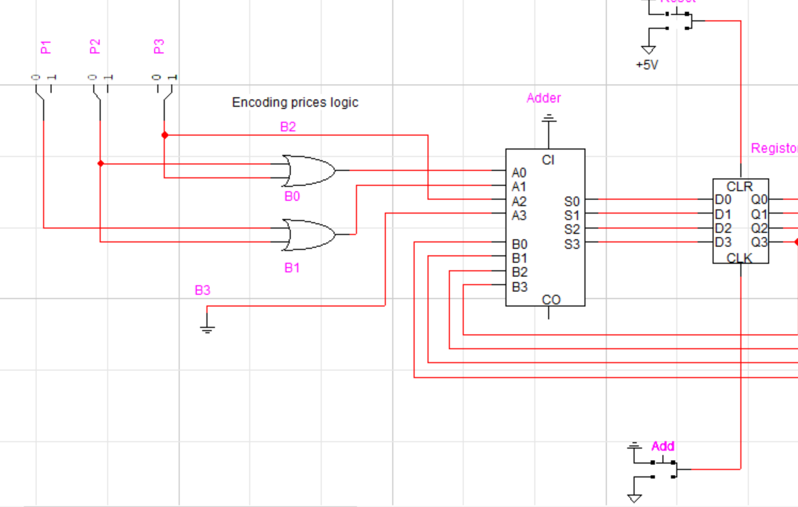
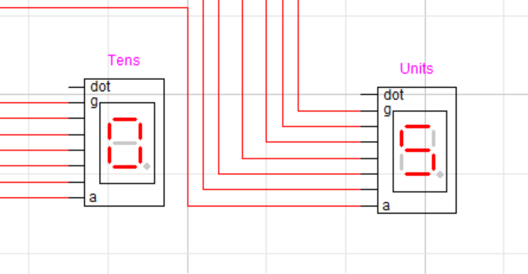

3.5 Reset Demonstration
Scenario: After transaction, customer initiates new transaction
• Previous State: Register = 1100 (12)
• Reset Button: Pressed (Logic HIGH)
• Immediate Result: All flip-flops clear asynchronously
• Register Output: 0000 (all Q outputs = 0)
• Display: Shows "0" on both tens and units displays
• Status: System ready for new product selection and accumulation

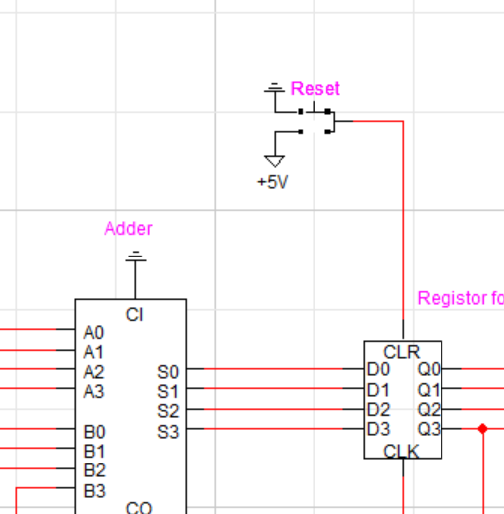
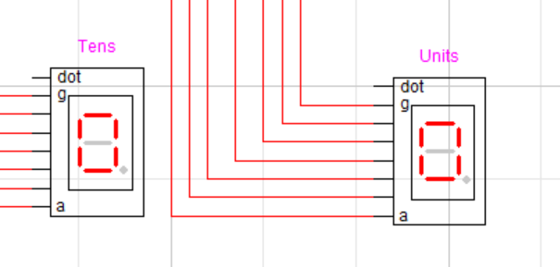

4. Restrictions & Limitations
• Maximum Display Value: Limited to 15 (binary 1111) due to 4-bit storage. Prices exceeding 15 cannot be accurately displayed or stored without additional bit capacity.
• Three Product Limit: System supports only three predefined products (P1, P2, P3). Adding new products requires circuit redesign or reconfiguration of encoding logic.
• Binary Price Encoding: Prices must be representable as 4-bit binary integers. Fractional prices (e.g., 2.50) cannot be directly encoded without decimal point handling.
• Single Currency Limitation: Display shows only whole number values. Cents or decimal precision requires additional decoder circuits and display lines.
• Synchronous Operation: All state changes require clock pulses. Manual control is limited to Add and Reset buttons; intermediate values cannot be arbitrarily inserted.
• No User Input Validation: System does not detect invalid inputs or prevent erroneous price selections. Incorrect encoding can propagate through the system.
• Limited Comparison Operations: Comparator only checks A>B against fixed threshold (10). Comparison with variable values would require additional multiplexing.
• Adder Overflow Handling: When sum exceeds 15, Carry Out generates but is not displayed. Overflow detection requires additional logic for user notification.

5. Future Enhancements
→ 8-Bit Architecture: Expand to 8-bit registers and adders to support prices up to 255, enabling wider product range and higher transaction values. Requires additional flip-flops and logic gates.
→ Decimal Price Support: Add binary-coded decimal (BCD) multiplier and separate display decoders for cents. Would display prices like 12.95 with four 7-segment displays.
→ Discount Calculation Logic: Integrate automatic discount engine that calculates percentage-based or fixed discounts when total exceeds threshold. Could apply senior/student discounts programmatically.
→ Keypad Interface: Replace fixed product buttons with numeric keypad for flexible price input. Allow manual price entry and custom product selection beyond P1/P2/P3.
→ Error Detection & Correction: Implement parity bits and checksums to detect circuit malfunctions or data corruption, with automatic correction or alert mechanisms.

6. Use Cases & Applications
✓ Retail Checkout System: Deploy in small retail stores (convenience stores) for automated price calculation and display. Reduces checkout time and eliminates manual price entry errors.
✓ Vending Machine Integration: Incorporate into automated vending machines to manage multiple product selections with automatic price calculation and payment validation before dispensing.
✓ Fast-Food Ordering System: Integrate into quick-service restaurant ordering terminals where customers select multiple items and system automatically calculates bill with applicable discounts/taxes.
✓ Warehouse Management: Deploy in warehouse inventory systems to track item quantities and values. Price accumulation helps calculate total shipment value and inventory worth in real-time.
✓ Educational Laboratory: Use as teaching tool in digital electronics courses to demonstrate combinational and sequential circuit integration, practical application of logic gates and ICs.
✓ Billing Terminals: Integrate into pharmacy or medical supply counter systems to rapidly calculate medicine/product costs for multiple customer items simultaneously.

7. Conclusion
The Smart Shopping Machine project successfully demonstrates the integration of fundamental digital logic components into a practical, real-world application. By combining encoders, adders, registers, comparators, subtractors, and display drivers, we created a functional system that performs price calculation, threshold detection, and real-time display operations.
This project illustrates how combinational circuits (adders, subtractors, comparators) work in conjunction with sequential circuits (registers, flip-flops) to create systems capable of storing state and performing complex operations.
Through this project, we have gained hands-on understanding of circuit design principles, digital logic optimization, and the importance of proper signal synchronization and data flow management in complex systems.

