**Assignment # 2**

**PHP**

**Difference between high level and low-level language**

Low level language is machine readable form of program. Whereas the high level language will be in human readable form. Low level language are difficult to write and compile but high level languages are easy to write as well as compile.

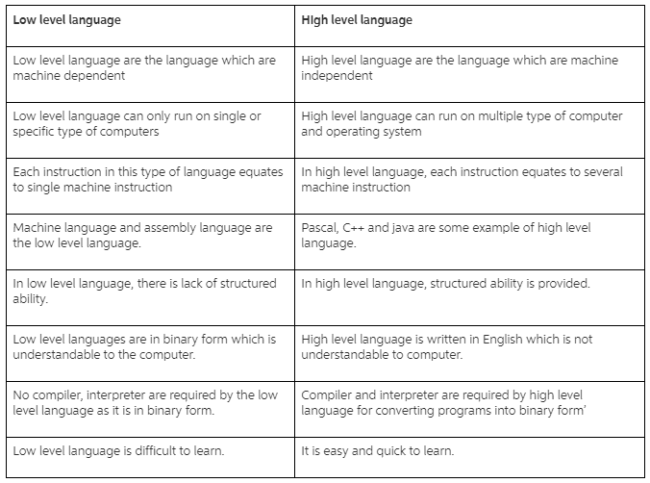

**What is PHP?**

PHP is a server scripting language, and a powerful tool for making dynamic and interactive Web pages. PHP is a widely-used, free, and efficient alternative to competitors such as Microsoft's ASP.

**Scope of Variables in PHP**

There are three types of variables in PHP

* Local
* Global
* Static