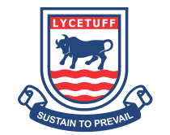




































کن الئسیٹفیامر
جونیئر اینڈ اپر سکول

االسایمت : رپہچ
ــ ــــــــــــــــ :احلص رکدہ ربمن

امجع : او ل(Jan) اسالہن ہس امہ2025
ـ ــ ــ ـــــــــ ـــــــــــــــــــ:انم

/ | ۵۰ |  | : لک ربمن |  | ــ ــــــــــ:اترخی ــــــــــــــــــ
 | 10 |  | )(ہّصح انرظہ
/ | / | 6 | 3 / |  | 1.رتسب رپ ےنٹیل ےک دعب یک داع ۔
 |  |  | 3 / |  | 2.وس رک اےنھٹ ےک دعب یک داع ۔
 |  |  | 4 / |  | یطلغ رپ اعمیف یک داع ۔ |  |  |  |  |  |  |  |  |  | 3.
 |  |  | )(ہّصح رتہیب
 |  |  | 2 / |  | ۔ االخق ےک ابرے ںیم وضحر ےن ایک رفامای؟ |  |  |  |  |  |  |  | س1
 |  |  | 2 / | س2۔ وادلنی ےک اسھت اقلعتت ےک قلعتم وکیئ نیت آداب اتبںیئ؟
 | 10 |  | / 2 |  | ۔ بج مہ وخش وہں وت ںیمہ ایک رکان اچےیہ؟ س3
 |  |  | ہّصح اصنب ) (
 |  |  | )(رعمویض رطز
 |  |  | اگلیئ ۔ |  | اشنن | ) ک | ✖ اسےنم ( | کے غل | اور | ) | ( ۔ درتس ےلمج ےک اسےنم✔ |  |  | س۱
 |  |  | چس وبےنل ےس ہشیمہ زعت یتلم ےہ۔ |  |  |  |  |  |  |  |  | 1.
 |  |  | رضحت دمحم بس ےس ےچس ااسنن ےھت۔ |  |  |  |  |  |  |  |  | 2.
 |  |  | السم رکےن ےس سیب ایکینں یتلم ںیہ۔ |  |  |  |  |  |  |  |  | 3.
 |  |  | روزے امہ رحمم ںیم رےھک اجےت ںیہ۔ |  |  |  |  |  |  |  |  | 4.
5.رہ املسمن رپ روزہ رفض ےہ۔
وترتی رضحت ومیس رپ انزل وہیئ۔ 6.
اہلل اعتٰلی ےن دس آامسین اتکںیب انزل رفامںیئ۔ 7.
8.زوبر رضحت یسیع ی ؑ رپ انزل وہیئ۔
چس وبانل یکین ےہ۔ 9.
وھجٹ وبےنل ےس بس رفنت رکےت ںیہ۔ . 10











































6 / |  | ب | اخیل ہگج رپ رکںی۔ | وسال۲ ۔
/ | 4 |  | چس وبےنل ےس ہشیمہ ________ یتلم ےہ۔ |  | 1.
 |  |  | ________ رکےن ےس آسپ ںیم تبحم ڑبیتھ ےہ۔ |  | 2.
 |  |  | روزہ رپ ________ رفض ےہ۔ |  | 3.
 |  |  | روزہ اکی ________ ابعدت ےہ۔ |  | 4.
 |  |  | اہلل اعتٰلی ےن ________ اتکںیب انزل رفامںیئ۔ |  | 5.
 |  |  | رقآن دیجم ________ آامسین اتکب ےہ۔ |  | 6.
 |  |  | آسپ ںیم کمل المںیئ۔ | وسال۳ -
 |  |  | ال
 |  | ؑرضحت داود | وترتی
ؑرضحت ومسی زوبر
رضحت دمحم ﷺ ایجن
ؑرضحت یسیع رقآن دیجم
) ( ااشنہیئ رطز
/ | 10 | درج ذلی وساولں ےک وجاب درج رکںی۔ | : | وسال۴
 |  | چس وبانل ایک ےہ؟ ۱ ۔
_________________________________________________________
بج املسمن آسپ ںیم ےتلم ںیہ وت ایک ےتہک ںیہ؟ ۲ ۔
_________________________________________________________
روزہ ےسک ےتہک ںیہ؟ ۔ ۳
_________________________________________________________





































روزے سک ےنیہم ںیم رےھک اجےت ںیہ؟ ۔ ۴
_________________________________________________________
اہلل اعتٰیل ےن ہی اتکںیب نک ولوگں رپ انزل رفامںیئ؟ ۔ ۵
_________________________________________________________
/ 4 | )(ہصح االسیم اہکاینں | ؑ رضحت امیلسن | ۶۔
 | یک وافت ےک دعب ینب ارسالیئ ک ایک احل وہا؟
_________________________________________________________
ب اہکں ںیہ؟ | ؑرضحت یسیع ی ا | ۷۔
_________________________________________________________

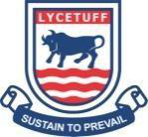







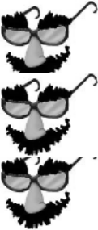




















































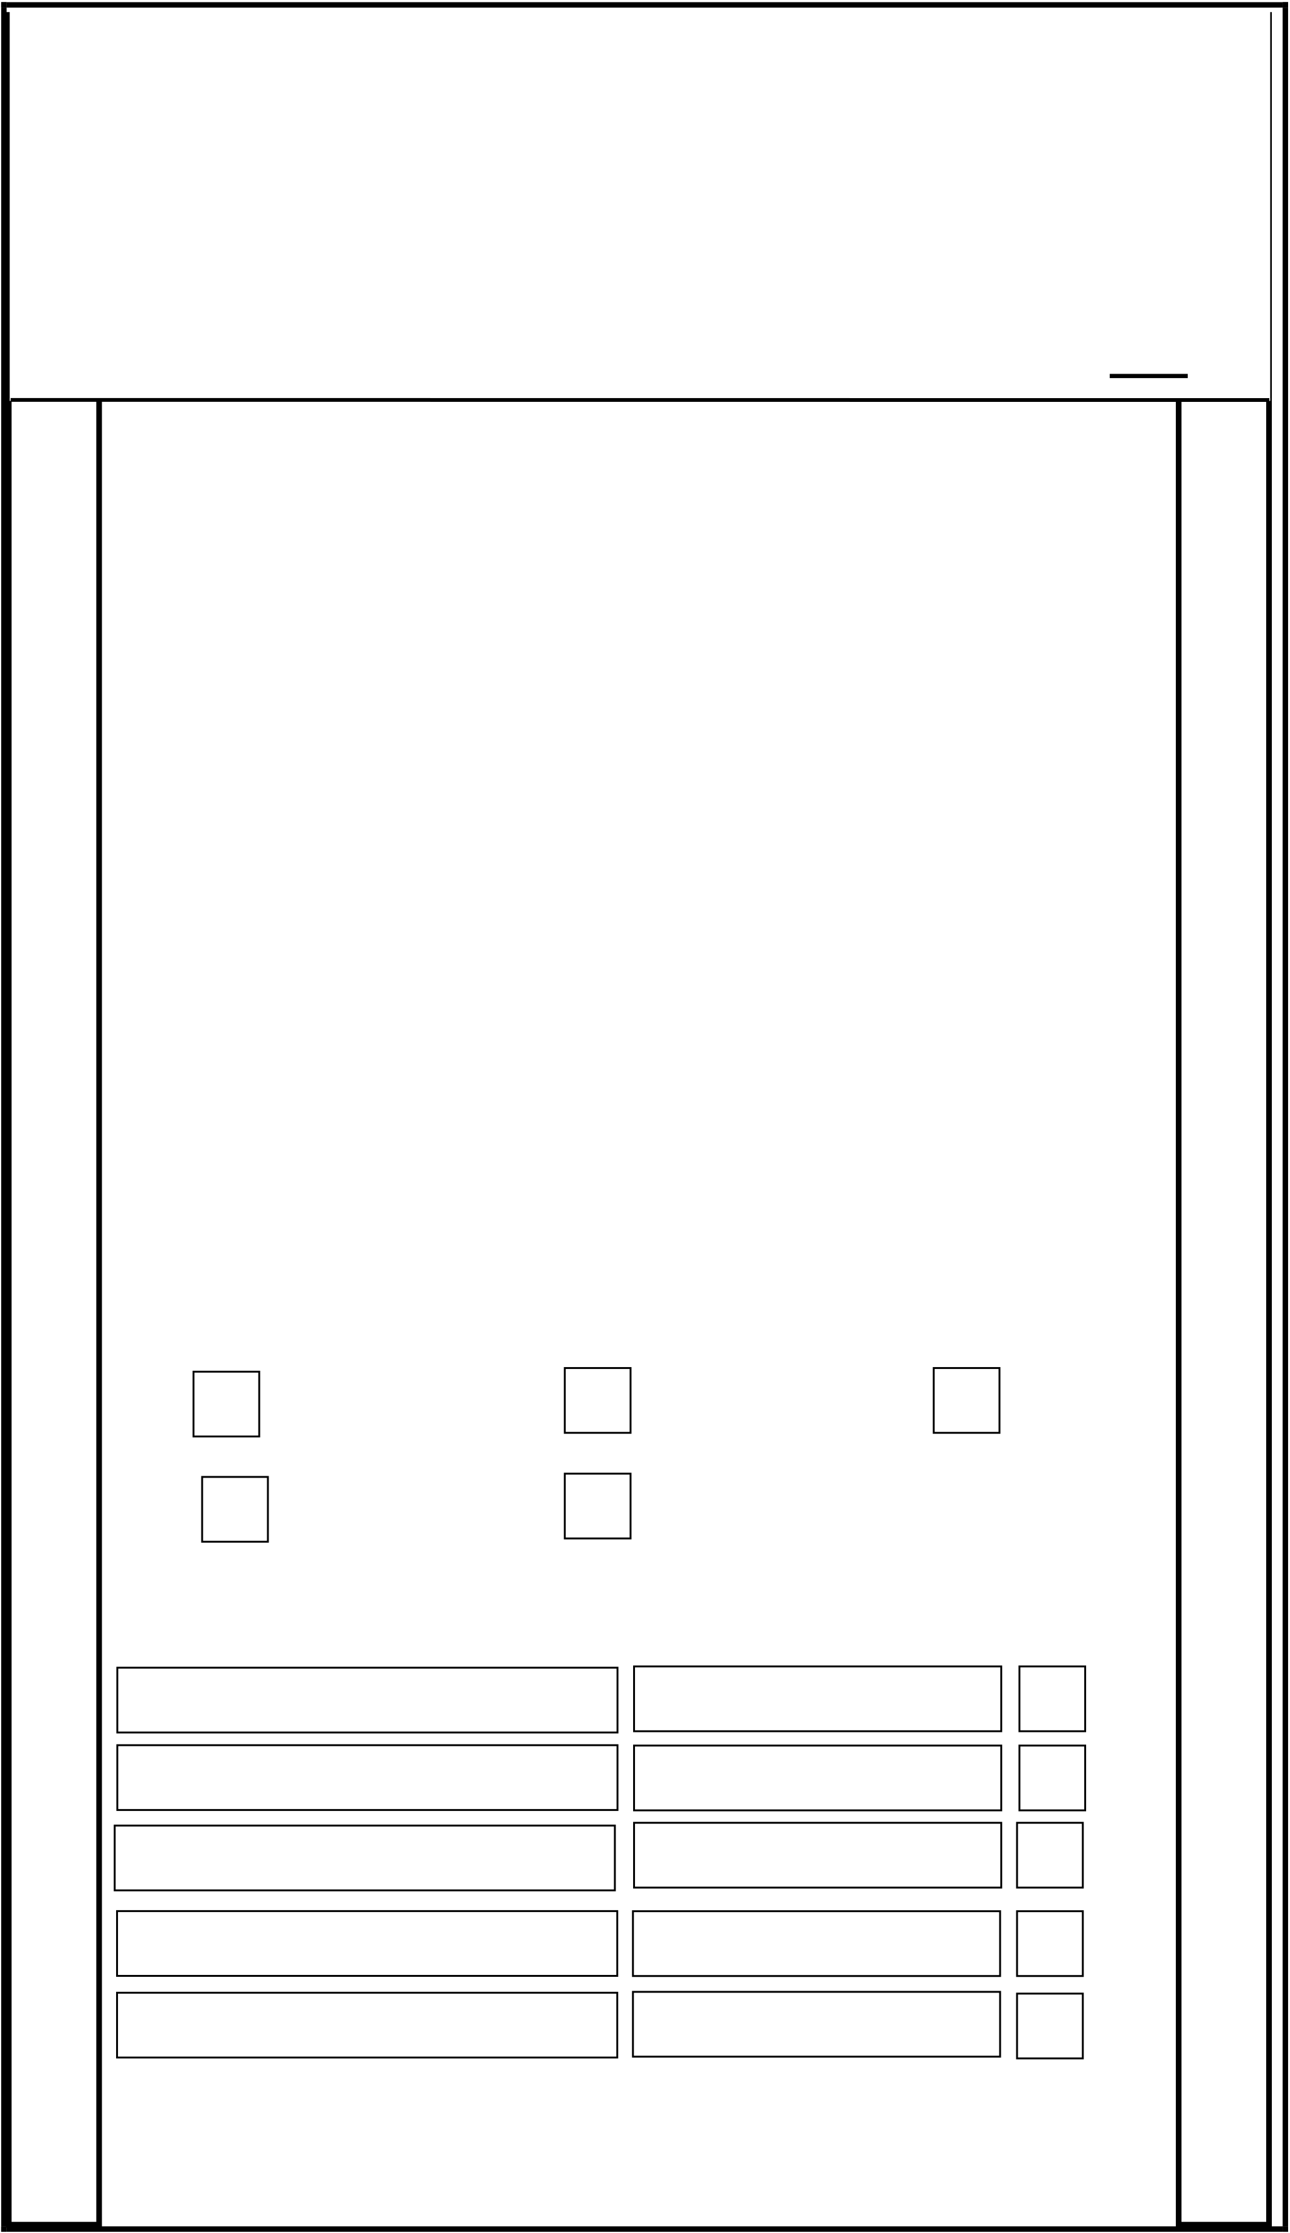
AMERICAN LYCETUFF Junior & Upper School
Final Assessment, 2025 Class: I (Jan) Subject: Mathematics

Name: _________________ Date: __________________

Marks Obtained:______ Total Marks: __ 100___

Q1. Fill in the space with suitable answers. /10 1. 4 groups of 2 are ______________.
2. 5 groups of 2 are ______________.
3. 44 cats have _____________ eyes.
4. 3 tigers have _____________ ears.
5. There are _____________ wheels of 3 tricycles. 6. There are _____________ wheels of 2 bicycles. 7. 12 divided by 2 equal ______________.
8. ______________ has four sides and four corners. 9. ______________ has no corners.
10. ______________ has 3 corners.
(b) Use ≤, ≥ or = to solve these sums. /5 36 26 28 18 21 21 85
85 81 | 61 20 | 3 x 2 | /5
(c) Fill in the empty boxes.
2 +2 +2
5 x 2
3 +3 +3 +3 4 x 3
3 x 3
4 x 5

Q2. (a) Join the sums with correct answers. / 8
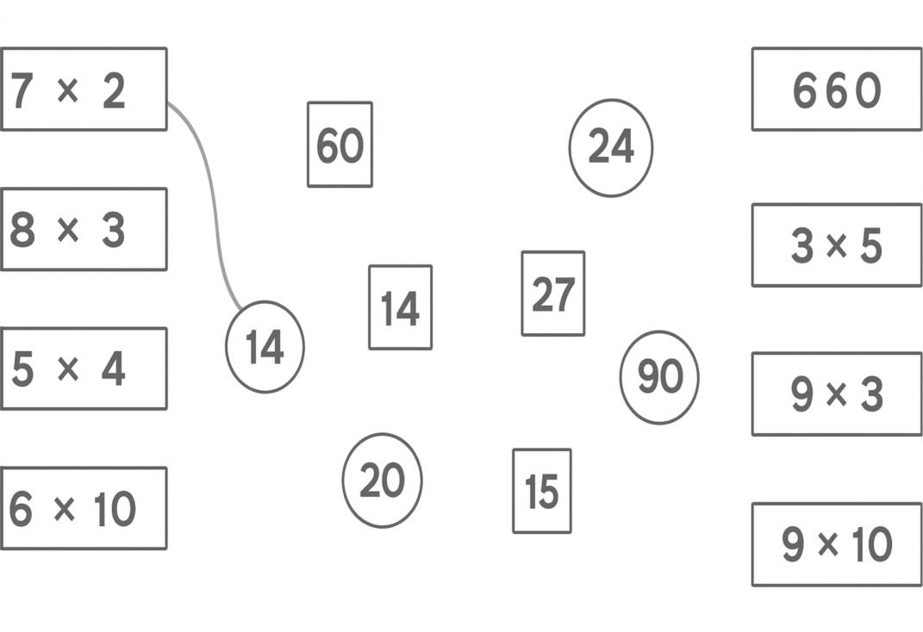
(b) Write the missing numbers. |  |  |  |  |  |  |  |  | / 10
4 x 3 8 x 2 |  |  |  |  |  | 0 x 4
10 x 3 |  |  | 3 x 3 |  |  | 16 ÷ 4
12 ÷ 3 |  |  | 25 ÷ 5 |  |  | 30 ÷ 3
9 ÷ 3
Q3. (a) Join the things which have similar shapes and colour it. Write their names in the box. /5
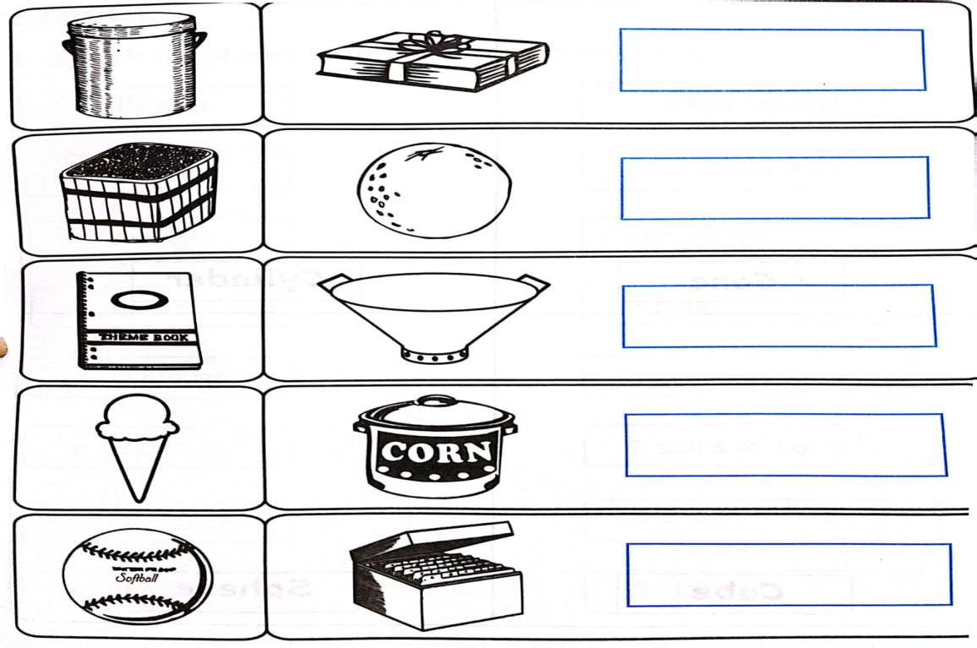
                                                         |  |                                                             

(b) Name one object which look like the same as
the given shape. |  | / 6 Sphere
Cuboid | Cylinder
Q4. (a) Write the time of each clock on the given block. / 6

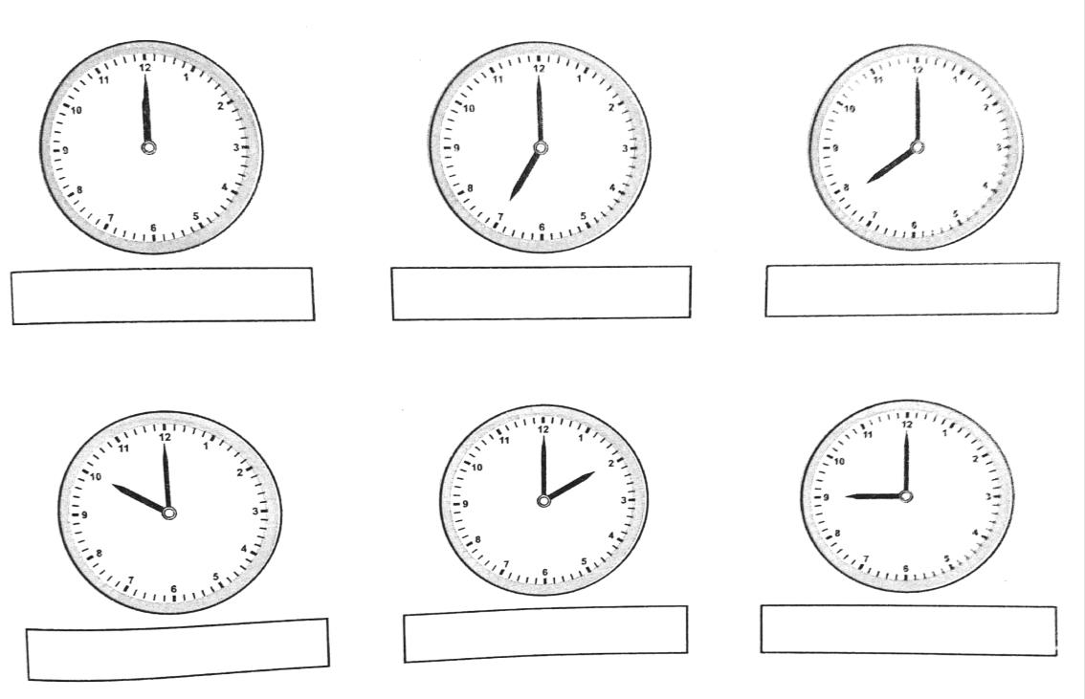
(b) Draw hands on the clock to show the given time. / 6
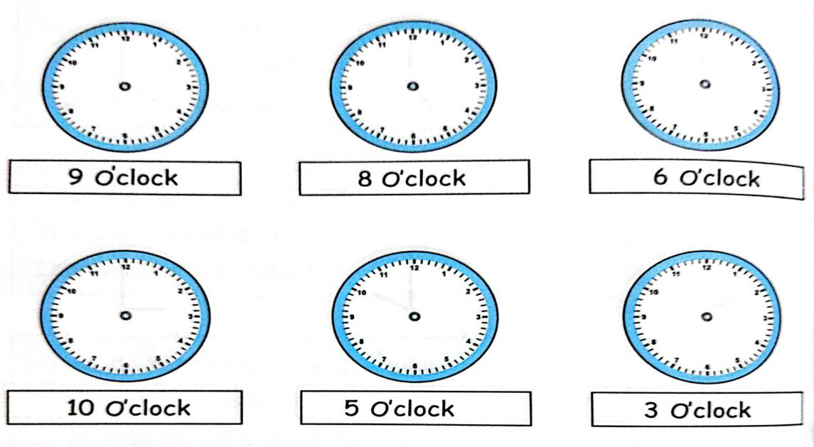
Q5. Count in fours and fill in the missing
numbers. /12 1. 0,______, 8, ______, 16, _______, 24
2. 12, ______, 20, 24, _______, 32
3. 4, ______, 12, _______, 20, ______, 28
4. 16, _______, ________, 28, _______, _______
                                                         |  |                                                             

Q6. Solve these sums. /10 a) 2 children each hold 2 balls. How many balls are there altogether?
_______________
_______________
b) 4 crows are on a tree. How many wings are there altogether?
_______________
_______________
Q7. Write the table of 5. | /10

Q8. Solve these word problems. | / 2
i) How many jumps of 2 can be made from 20?
20  ÷ | =
ii) How many jumps of 2 can be made from 16?
 | ÷ | 2 | =

                                                         |  |                                                             

Q9. Solve these sums. |  | ii) | 5 | 8 | / 5
i)
3 | 9
+ | 0 |  | + 0 | 0
ii) |  | iv) | 9 | 9
2 5
– | 0 |  | – 0 | 7

                                                         |  |                                                             


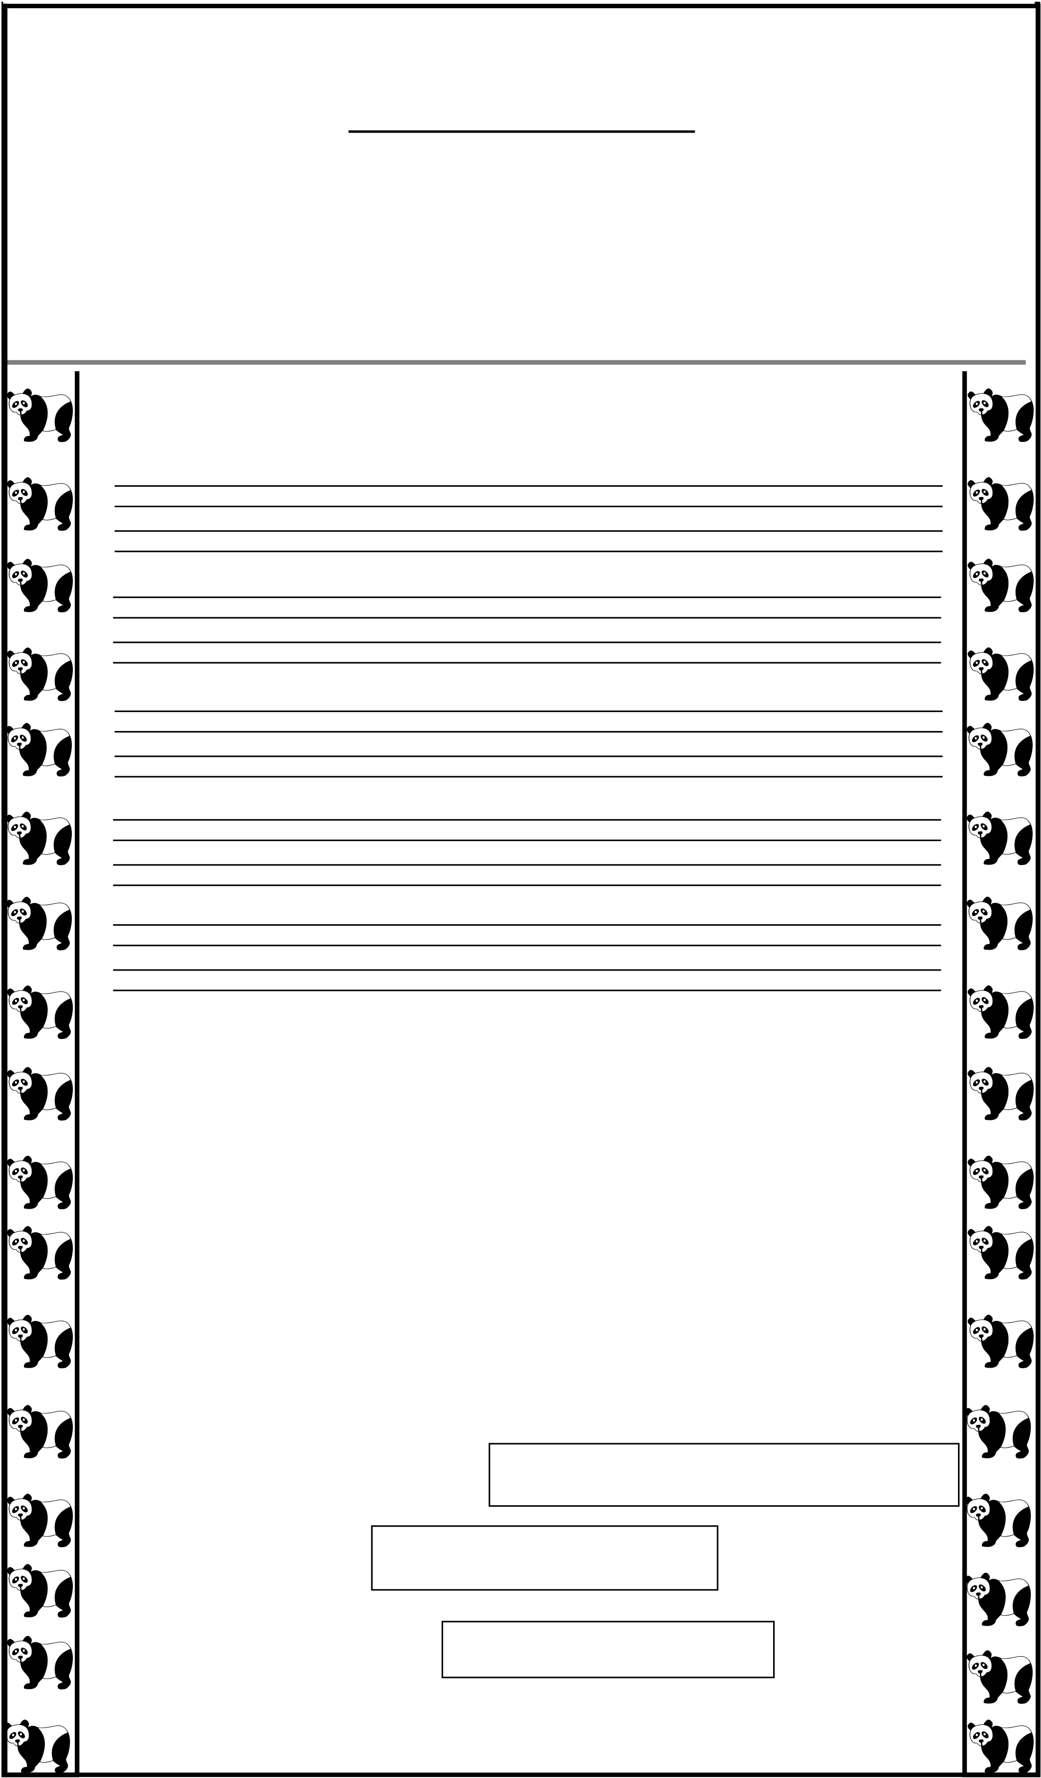
AMERICAN LYCETUFF Junior & Upper School
Final Assessment, 2025

Class: I (Jan)
Name: _________________ Date: __________________

Subject: English
Marks Obtained:_______ Total Marks: 100

Q1. (a) Reading. / 5
b) Dictation. / 5
Q2. (a) Tick the sentence if it is true, cross if it is
not true. / 5

i. The pancake is small.
ii. It runs away.
iii. A cat sees the pancake. iv. The pancake sees a river. v. It can swim.

________
________
________
________
________

(b) Circle the correct words. / 5

1. Dadi is the children’s

Mother, father, grandmother

2. She cannot very well. See hear smell
3. Sara offers her a Cow drink tree

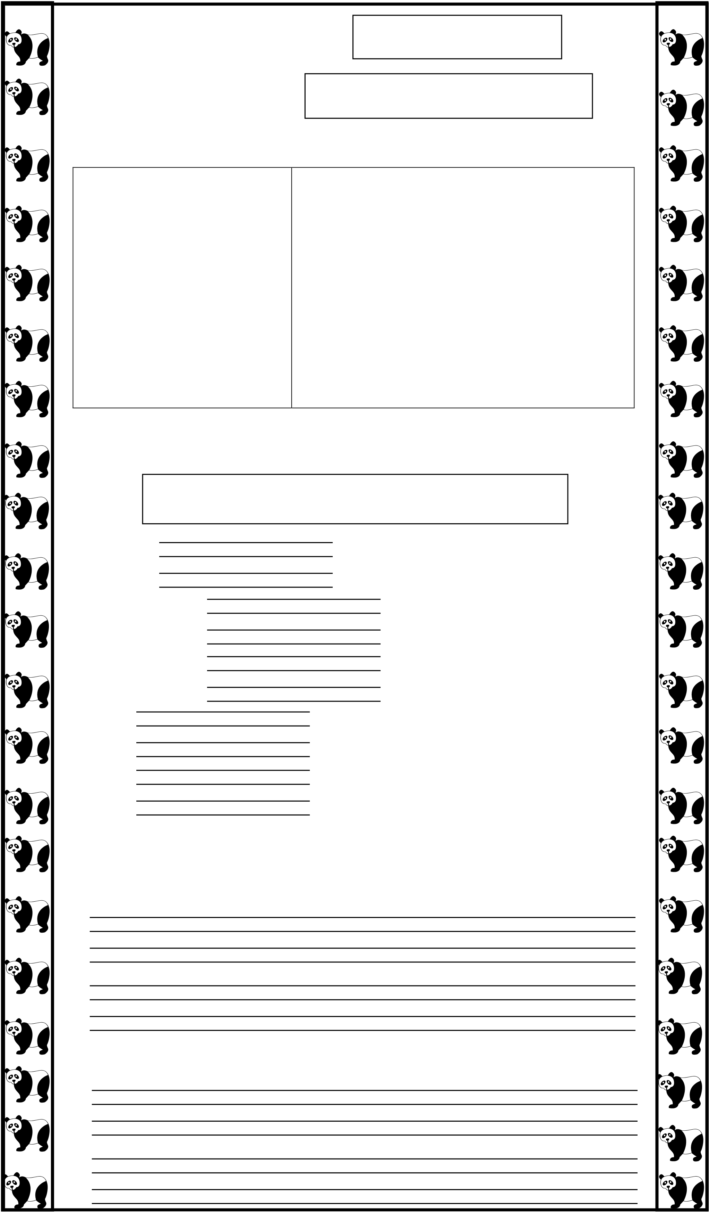

4. Ali offers her a cup of

Tea coffee meat

5. Dadi wants some | Tea water tea and water | / 5
Q3. (a) Match.

1. On Monday
2. On Tuesday
3. On Wednesday 4. On Thursday
5. On Friday

They give it snails and it flies away.
They give it nuts and seeds. Ali and Adam help a little crow. The put plastic bags in the bin. They give it flies and spiders.

(b) Complete the sentences using the words in
the box. /5
Played got went ran walked
1. They the piano, trumpet, cymbals
2. and drum .

3. Mr. Majid

out of his shop.

4. He on a train.
5. He into a big field.
Q4. Write answers of the following questions. /10
1. Did Mr. Majid have a music shop?
2. Did the cows go quack?

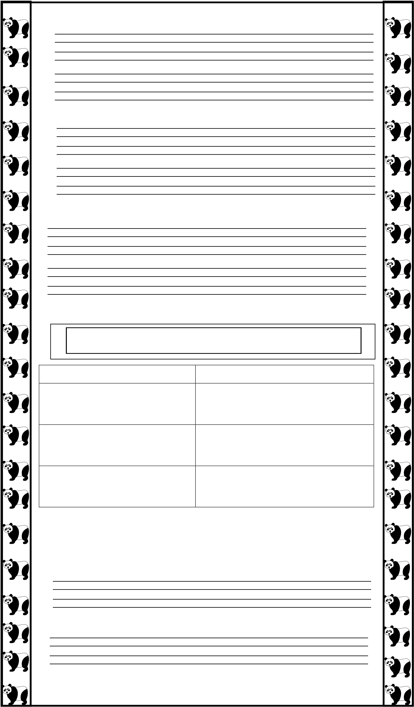
3. Did a woman play the piano?
4. Did Mr.Majid lie the noise?
5. Did he like the quiet field at the end?
Q5. Wrote the words in the correct columns. / 10
Cakes mangoes beans eggs ice cream meat

Sweet food

Salty food

Q6. Rewrite the sentences by putting in the
missing capital letters and full stop. /10 1. owl can see in the dark
2. pandas have black ears

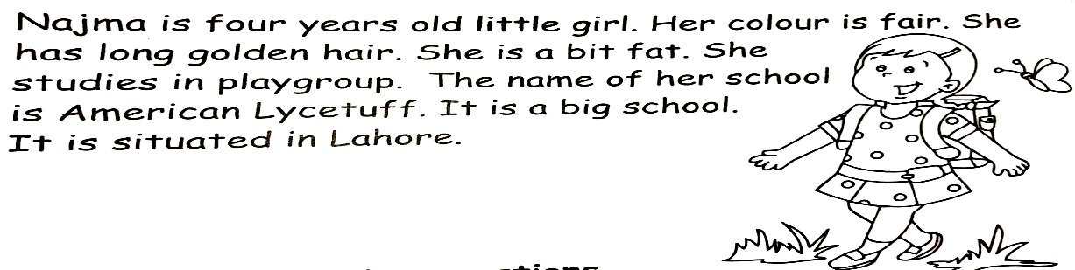
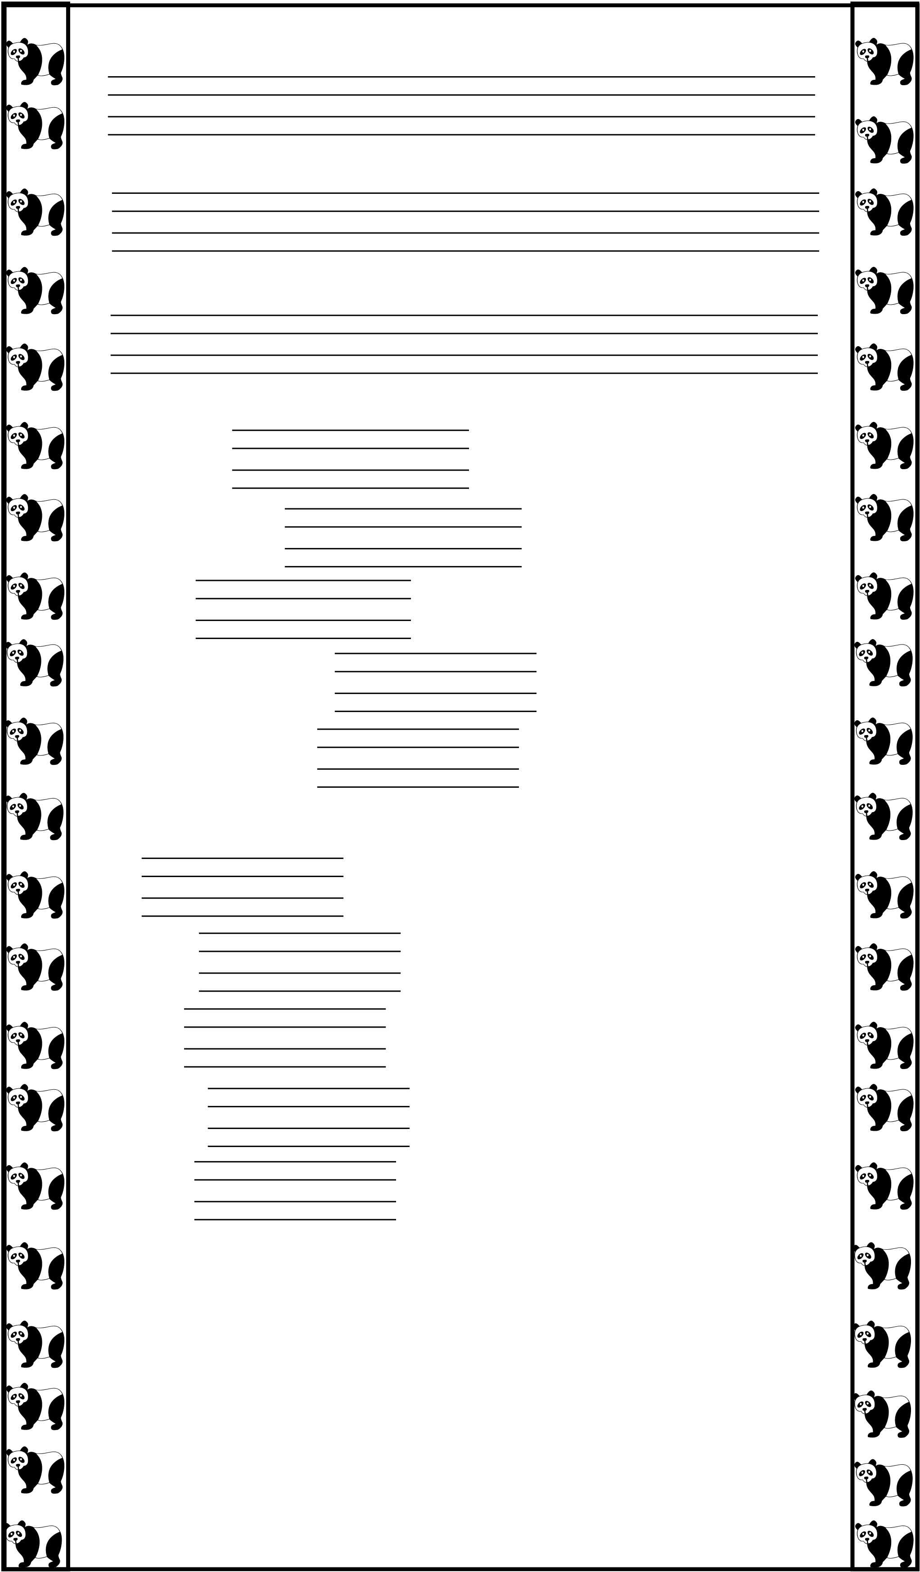
3. sheep live in a farm
4. they will grow big and tall
5. wardah is an intelligent girl
Q7. (a) Fill each space with ‘is’ and ‘are’. / 5
i. These apples.
ii. This apple red.
iii. This a yellow balloon.
iv. These houses old.
v. The oranges sweet.
(b) Fill each space with has or have. / 5
i. I a brother and a sister.
ii. She temperature.
iii. We a new car.
iv. They three children.
v. You a beautiful children.
Q8. Read the passage carefully and answer the
questions. /10

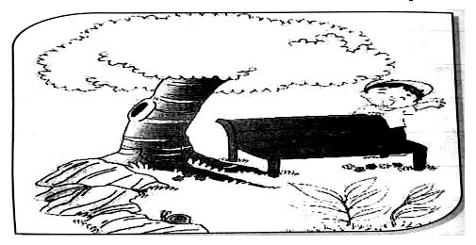
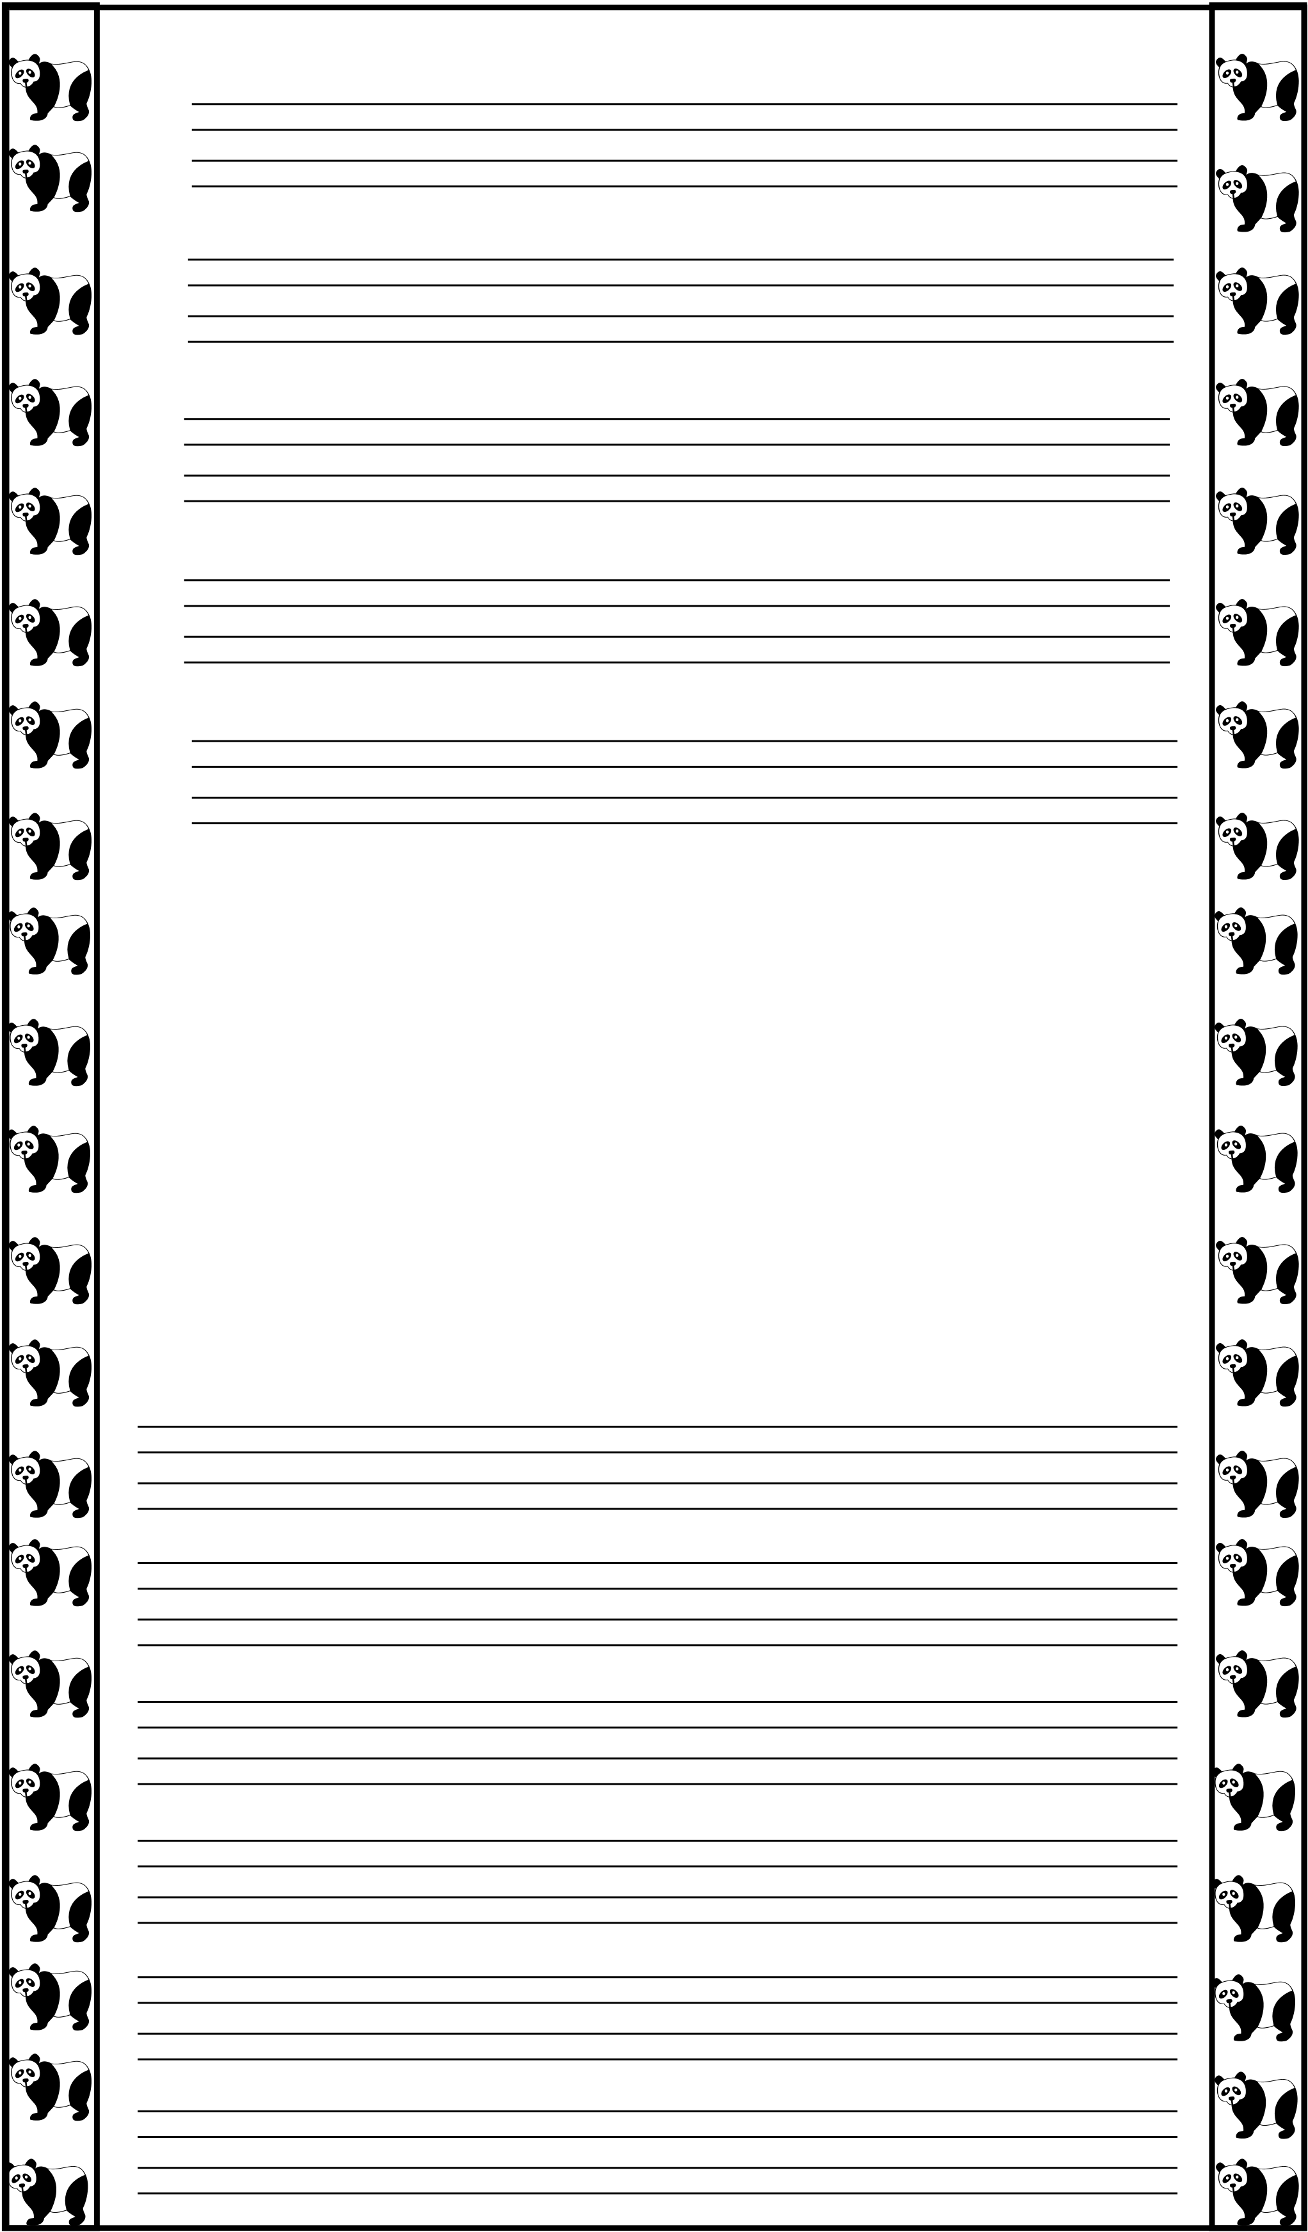
1. How old is Najma?
2. What is the colour of her hair?
3. Is she a fat girl?
4. What is the name of her school?
5. Where school is situated?
Q9. Write few lines to describe this picture. /10

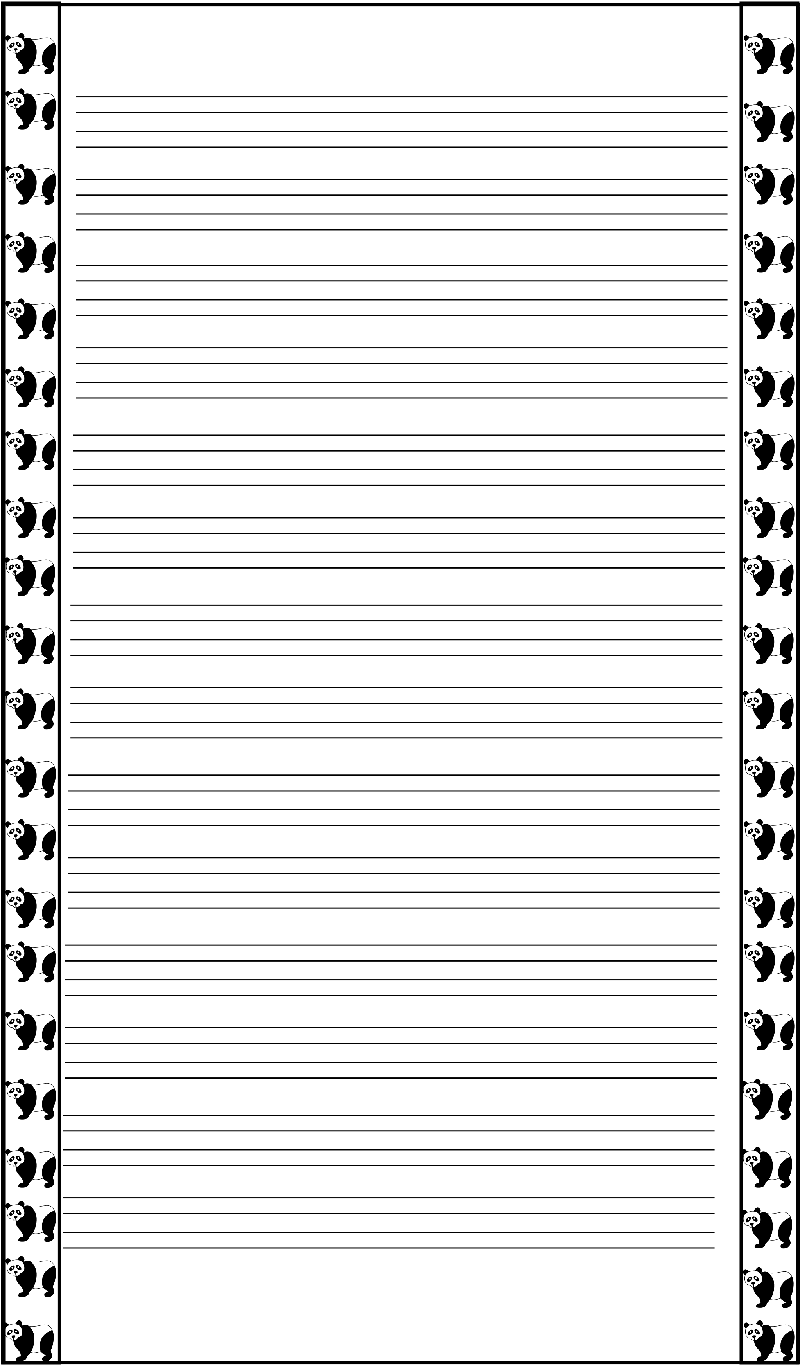
Q10. Write on ‘My Mother’. / 10


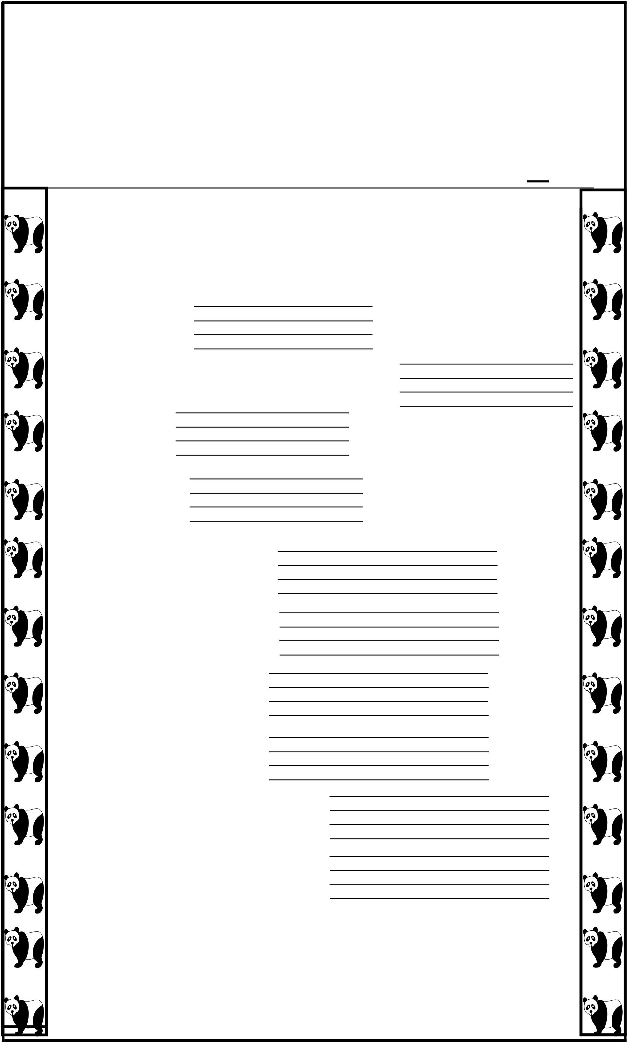
AMERICAN LYCETUFF
Junior & Upper School
Final Assessment, 2025
Class: I (Jan) Subject: World Around Us
Name: _____________________ Marks Obtained:________
Date: ______________________ Total Marks: ____50______
Q1. Fill in the blanks. / 10
(i) We need to protect ourselves.
(ii) We wear light cotton clothes in .

(iii) We get
(iv) We wear

from cotton plants. and woolen clothes

in winter.
(v) We get wool from | . | .
(vi) We get meat from | .
(vii) We get milk from | .
(viii) We get rice from | .
(ix) We prepare butter from
(x) We prepare curds from |  | .

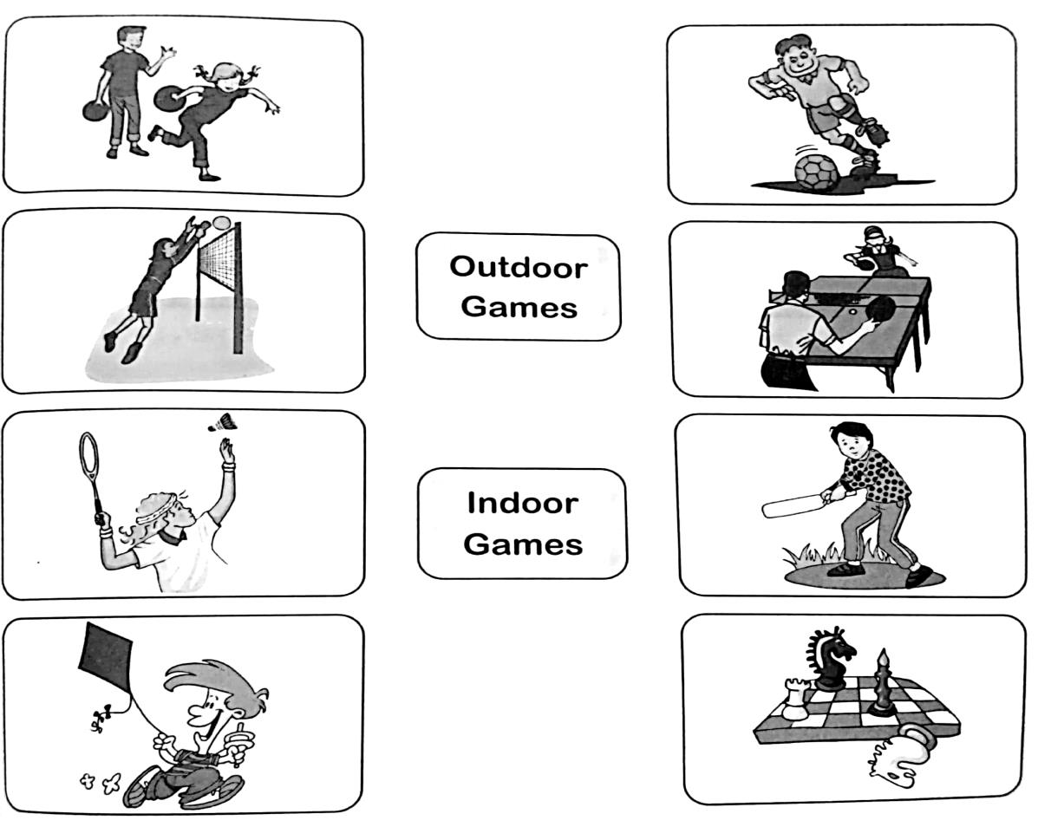
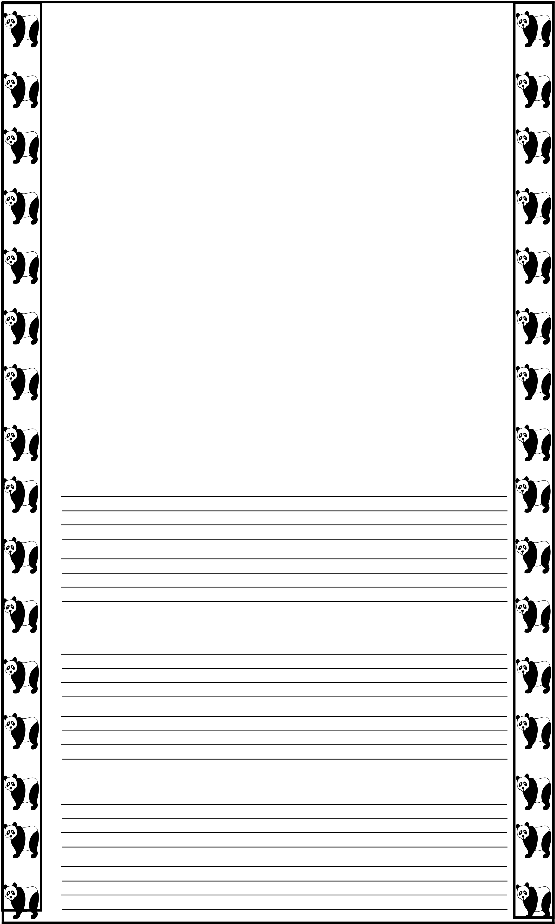
Q2. Draw lines to join the games with correct
names. / 5
Q3. Answers these Questions. / 23
1. Write five major parts of a plant. / 5
2. How many colours are there in rainbow? Name them.
/ 7
3. What is wind? / 2

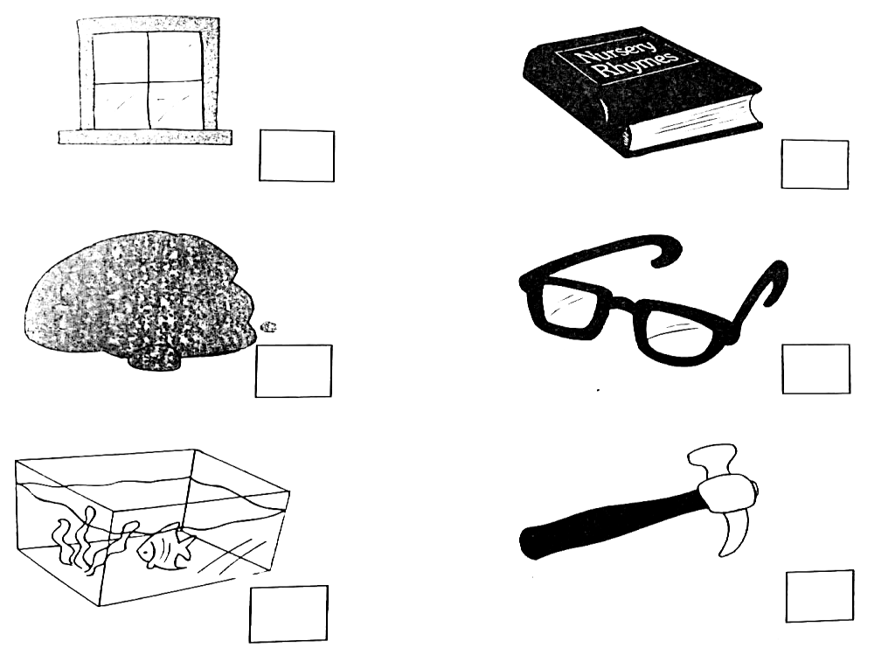
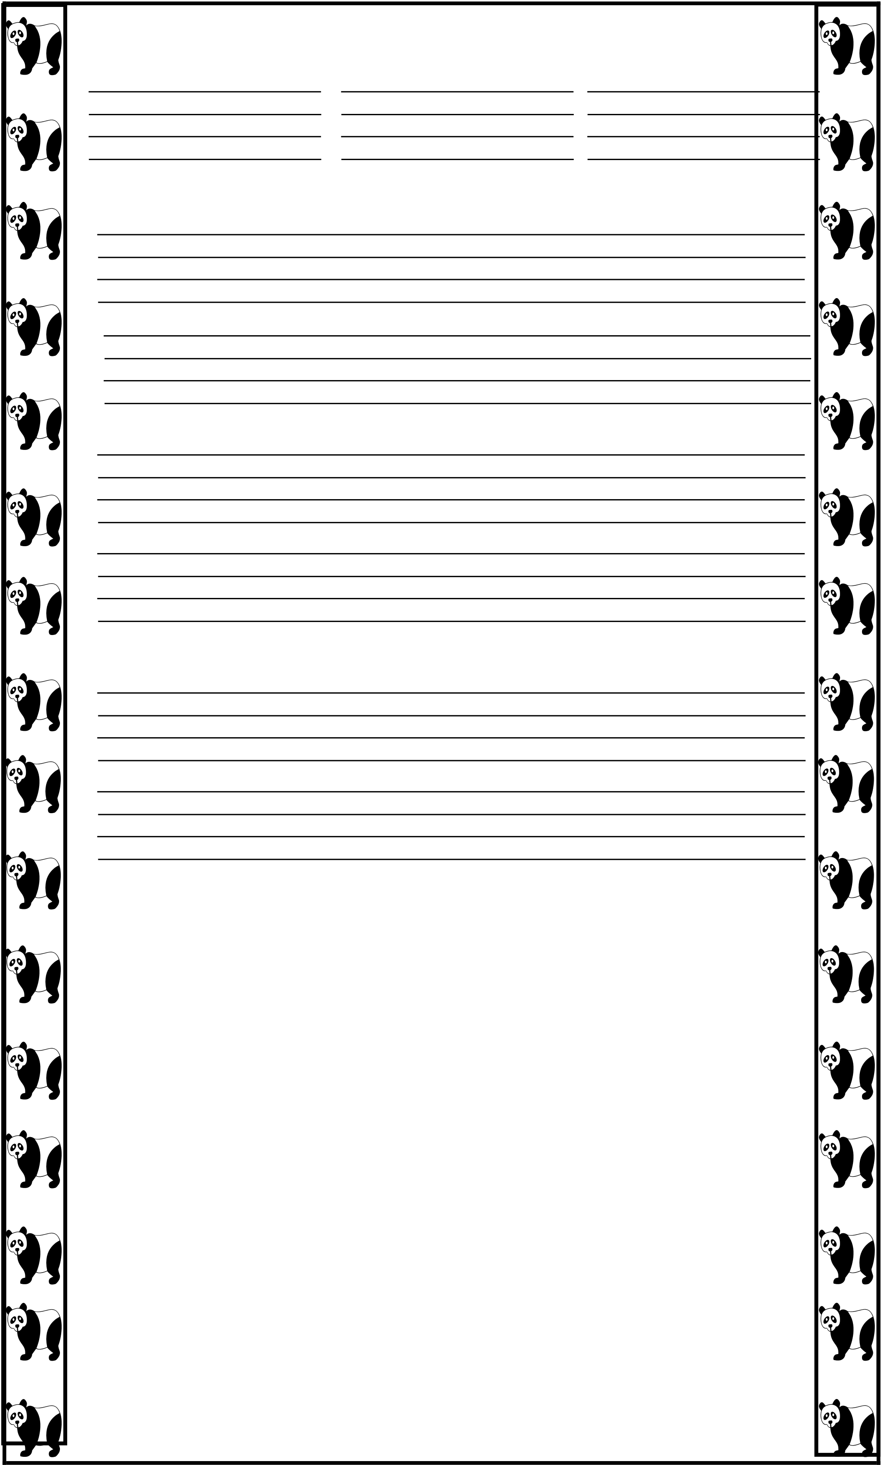
4. Write any three sources of light? / 3
5. Why do we need clothes? / 2
6. What are out door games? / 2
7. Name four indoor games? / 2
Q4: Which things allow light to pass through them?
Put a tick. Which things do not do so?
Put a cross. / 2.5

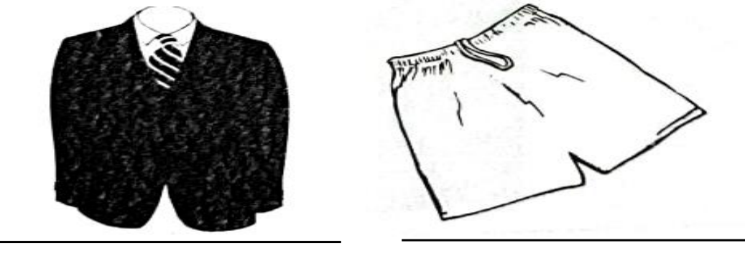
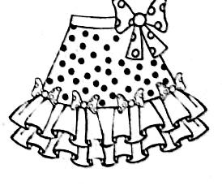
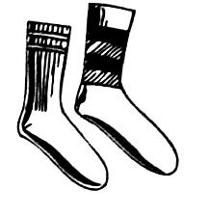
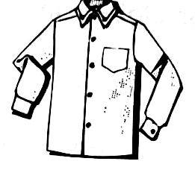
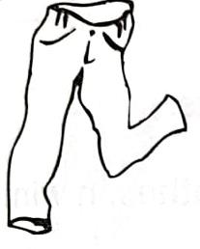
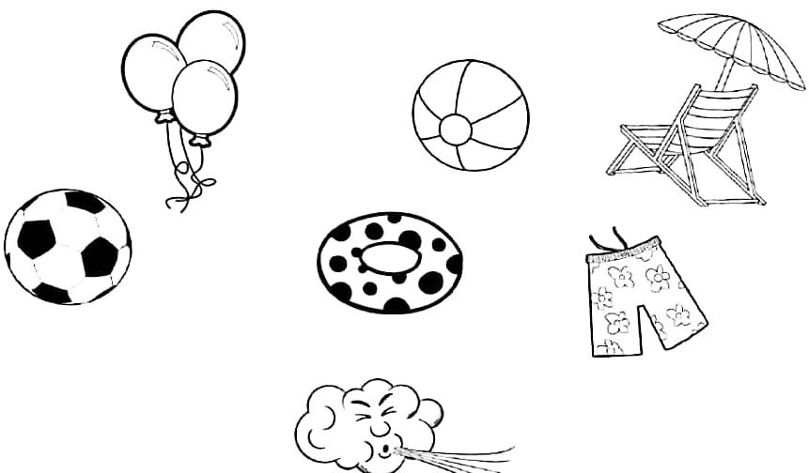
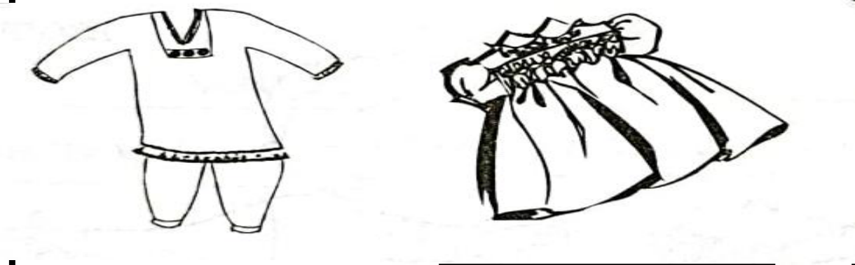
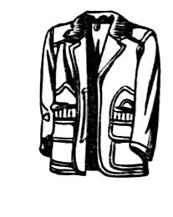
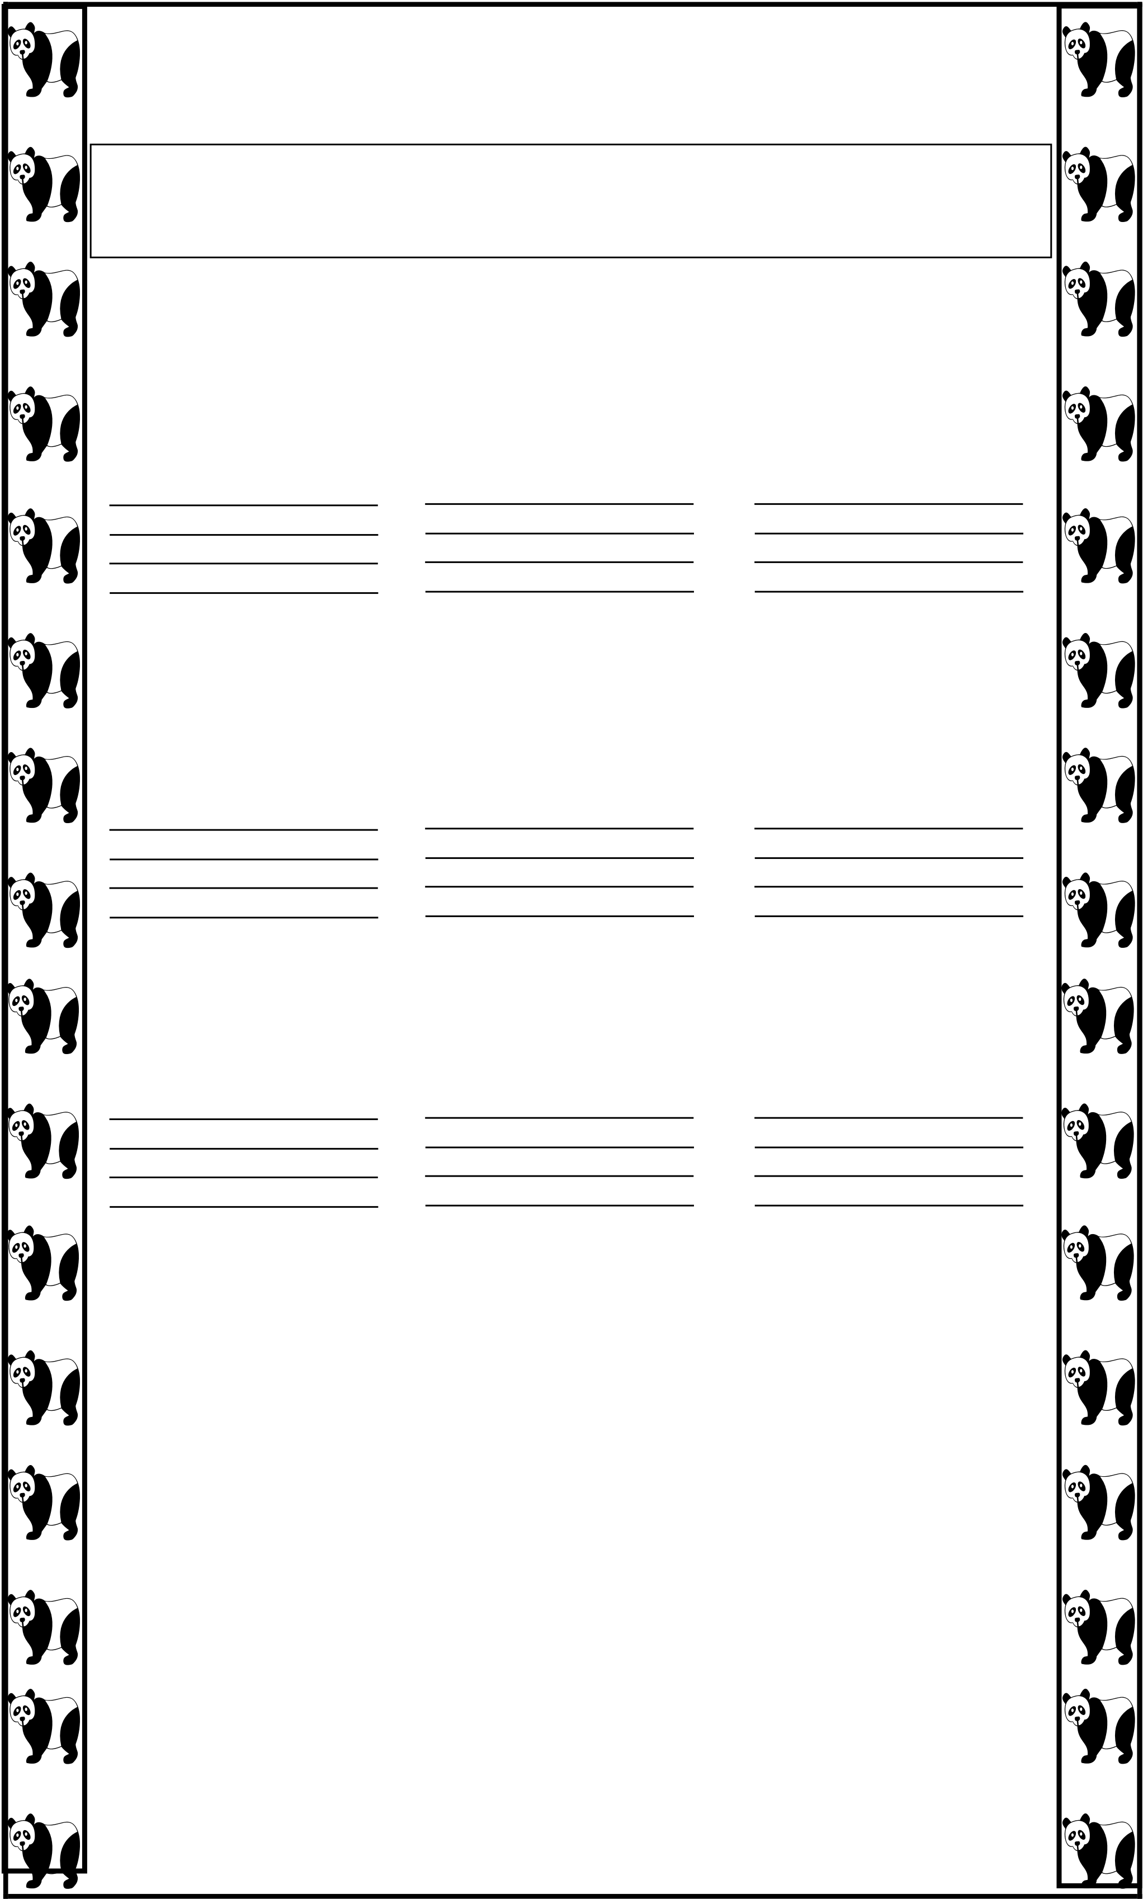
Q5: Choose a word from the box and write it at
proper place. / 4.5
S5hirt, frock, trousers, shalwar kameez,

socks, short,

jacket, coat

Q6: Which things filled with air? Colour it. / 5















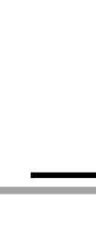















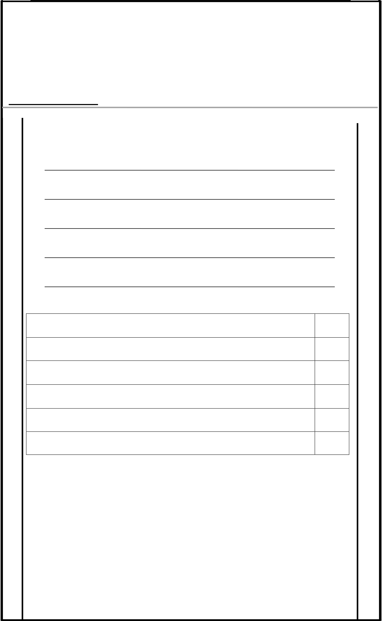
ــ ــــــــــــ |  |  | اردو | : رپہچ | کن الئسیٹف | یامر
 |  |  |  |  | جونیئر اینڈ اپر سکول
 |  |  |  |  | :امجتع او ل(Jan) |  | ۲۰۲۵ ہس امہ |  |  |  |  |  |  | اسالہن
 |  |  | ــــ :احلص رکدہ ربمن |  | ـ ــ ــ ـــــــــ ـــــــــــــــــــ |  |  |  |  |  |  |  |  |  | :انم
۱۰ ۰ |  |  | لک ربمن: |  | ــ ــــــــــ |  | :اترخی ــــــــــــــــــ
/ |  | ۵ |  |  | ڑپاھیئ |  |  |  | )(ا |  |  | نمبر۱: | وسال
/ |  | ۵ |  |  | ںیھکل۔ |  |  | االمء |  | )(ب
/ | 10 |  |  |  | ےلمج انبیئ: |  |  |  |  |  | وسال ربمن۲ :
جملے ا افلظ
گھر
پ ا ن
ا وکسل
وھپل
اتکب
5 / :وسا ل: رحو ف وجڑ رک ڑ وگنں ےک پا م ںیھکل وسال ربمن۳ :
_________________________ ڑ + س ب +-1

_________________________

ا+ ل+ ي+ ب 2۔

_________________________ | ا+ ڑ+ ہ | 3۔

_________________________

۔ ي+ ں+ م+ ا+ ج 4

_________________________ | ا+ ل+ ا+ ک ۔ | 5




































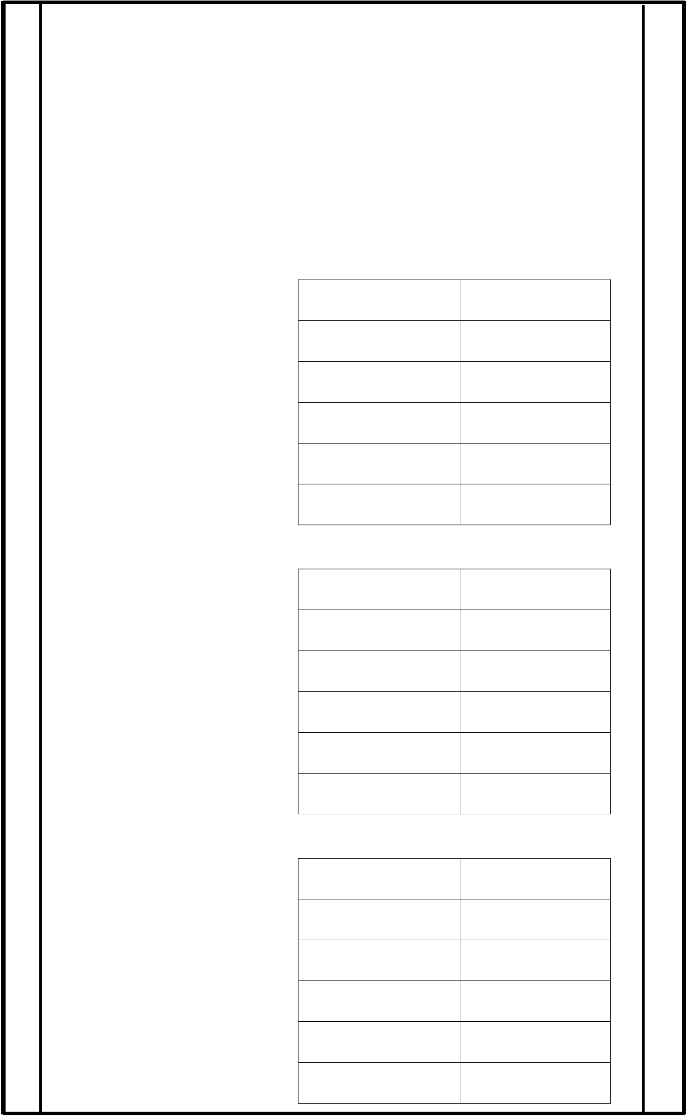
5 / |  | رحوف اگل رکںی- |  | نمبر۴ : | وسال
_____ _____ _____ ۔ ڑبا | 2 | _____ _____ _____ _____ |  | 1۔ رونش
_____ _____ _____ ۔ ب ِکتا 4 |  | _____ _____ _____ |  | پیڑ ۔ |  | 3
 |  | _____ _____ _____ |  | ۔ رمکا |  | 5
5 /
 |  | ا افلظ یک دض ںیھکل ۔ |  | نمبر۵ : | وسال
 |  | ضد | ا افلظ
ا دنڑ
سفید
وسپ ا
وخس
5 / | ا اھچ  ذمرک ومن ث ںیھکل ۔ )(افل ؤمن ث ذمرک | نمبر۶ : | وسال
د ا د ا
ومڑ
رماغ
ڑلاک
رکبي
5 / | ا و ا ڑ ی | حیحص ا و ا ڑ و ں ےس مالےیئ- | )(ب
 |  | زیچی
 | رترت | بجلی
 | فر فر | پ ا د ل
 | رکرک | ڈنیمک
 | مھج مھج | وھچکا
پ ا ن رگرگ































5 / | در ج ذلی وسا الت ےک وجاابت رحتری رکںی۔ |  | نمبر۷ : | وسال
 | ا ہلل اعتیٰل یک انبیئ وہیئ وکیئ یس پ ا چن زیچو ں ےک پا م ںیھکل ۔ | )(افل | س

__________________________ __________________________

__________________________ __________________________

__________________________
2 / وکں ایپسا اھت ؟ س )(ب
______________________________________________________________وجاب:
______________________________________________________________
2 / وکے وک ا اچپک ایک رظن ا پ ا ؟ س : ( ج )
______________________________________________________________وجاب:
______________________________________________________________
2 / وکے ےن ےکٹم ںیم ایک ڈاانل رشوع رک دای ؟ )س: (د
______________________________________________________________وجاب:
2 / وکے ےن اپین ےنیپ ےک دعب ایک ایک ؟ ( :س ر)
______________________________________________________________وجاب:
5 / اخیل ہگج رُپ رکںی۔ )(افل نمبر۸ : وسال
1۔ دودھ اک رگن _________________ وہات ےہ۔
2۔ ےچب اور _________________ دودھ وشق ےس ےتیپ ںیہ۔
۔ دہ _________________ ےس یتنب ےہ۔ 3
4۔ دودھ ےنیپ ےس _________________ وبضمط وہیت ںیہ۔
۔ دودھ ےنیپ واےل ےچب _________________ دےتی ںیہ۔ 5
4 / اافلظ ںیھکل ۔ " )(ب " ےک آ
____________ __________ _________ __________آاپ

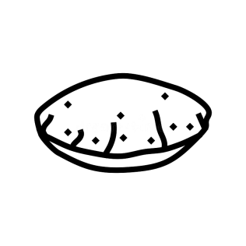
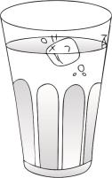



































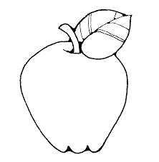
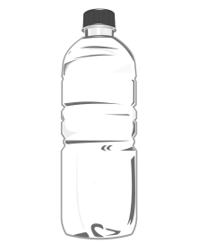
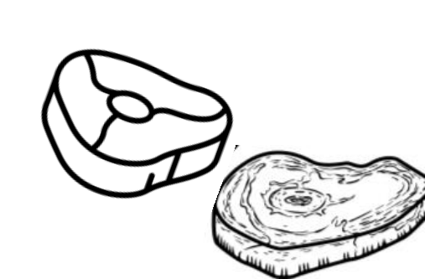
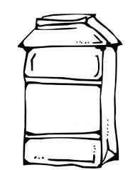
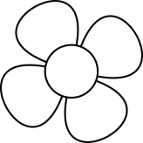

3 / | ھکل رک اافلظ انبےیئ ۔ |  | )(افل یٹ |  |  | نمبر۹: | وسال
__________ رو | ___________ م | ___________ ب
5 / | ان زیچوں ںیم رگن رھبںی وج امون وک دنسپ ںیہ ۔ |  |  | )(ب
5 / | اافلظ وک رتبیت دے رک درتس رک ےک ںیھکل ۔ |  |  |  | ج ) (

______________ یک اخ ۴۔
______________ دار وہا ۵۔

________________ وصرت وخب :۱ ۔
___________________ چن اپ ۲۔
___________________ ۳۔ ونں امہم

5 / درتس ظفل نچ رک اخونں ںیم ںیھکل ۔ ( د )
ن___________ ص_________ _____________ ہ/ح 1
___________________ چن _____________ ق / ک ۲ ۔
___________________ ان ا _____________ / ک ک ۔ ۳
____________________ وادار _____________ ہ / ح ۔ ۴
____________________ م _____________ ہ / ح ۔ ۵
5 / ) 16 – ( یظفل اور دنہیس ےیھکل۔20 )(ر
16
17
18
19
20































/ | 10 | یقیلخت اھکلیئ | : | ۱۰ نمبر | وسال
ریما اعترف
_________________________________________________________________ _________________________________________________________________ _________________________________________________________________ _________________________________________________________________ _________________________________________________________________ _________________________________________________________________ _________________________________________________________________ _________________________________________________________________ _________________________________________________________________ _________________________________________________________________ _________________________________________________________________ _________________________________________________________________ _________________________________________________________________ _________________________________________________________________ _________________________________________________________________ _________________________________________________________________ _________________________________________________________________ _________________________________________________________________ _________________________________________________________________





































_________________________________________________________________ _________________________________________________________________ _________________________________________________________________ _________________________________________________________________


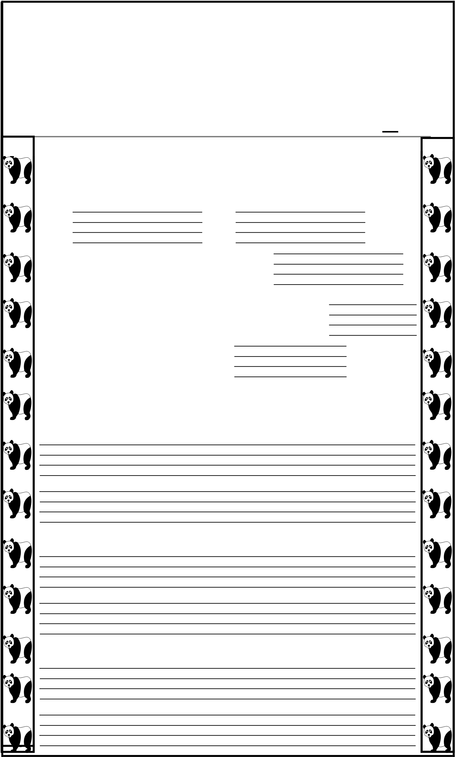
AMERICAN LYCETUFF Junior & Upper School
Final Assessment, 2025
Class: I (Jan) Subject: Robotics
Name: _____________________ Marks Obtained:________ Date: ______________________ Total Marks: ____50______
Q1. (a) Fill in the blanks. / 5
1. Scratch is a program where you make
and .
2. In Scratch, we use colourful
to give instructions.
3. The characters in Scratch are called | . | .
4. Scratch helps us learn |  | / 20
Q2. Answer these questions.
1. What do we connect in Scratch to give instructions?
2. What is a robot?
3. Do robots have feelings like people?

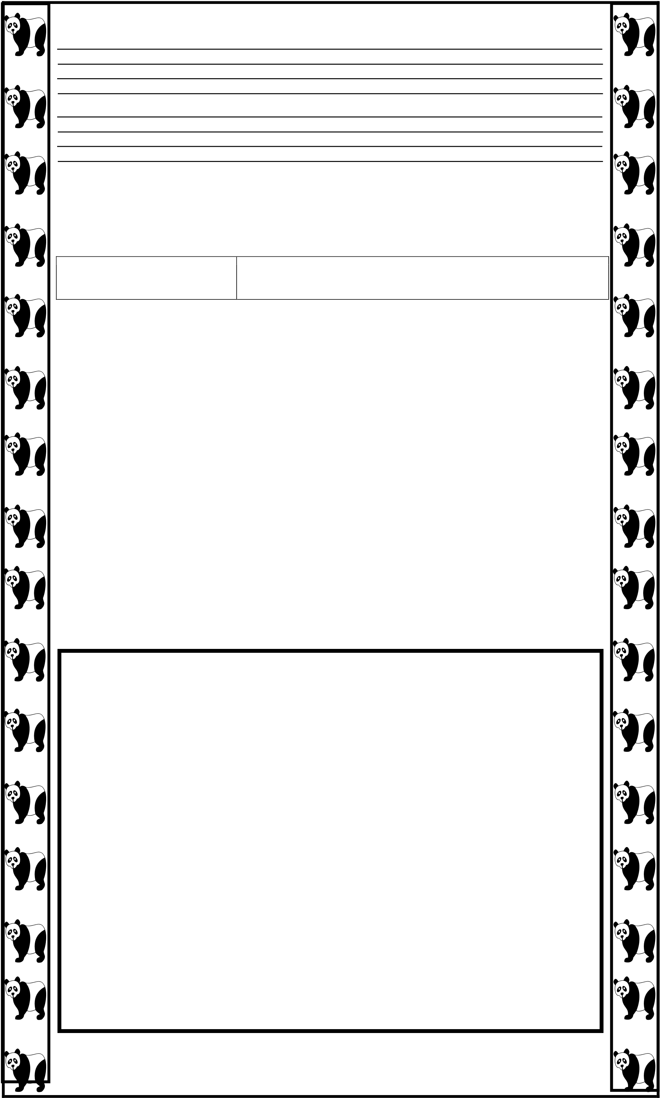
4. What can a robot help you with?
Q3. Draw a line to match each robot part to its
function. Parts  arms  buttons  lights  wheels  screen | / 5 Functions  helps the robot move  helps the robot pick things up used to give instructions to the robot  shows what the robot is doing helps the robot see in the dark
Q4: Draw and colour your robot and name it. / 5

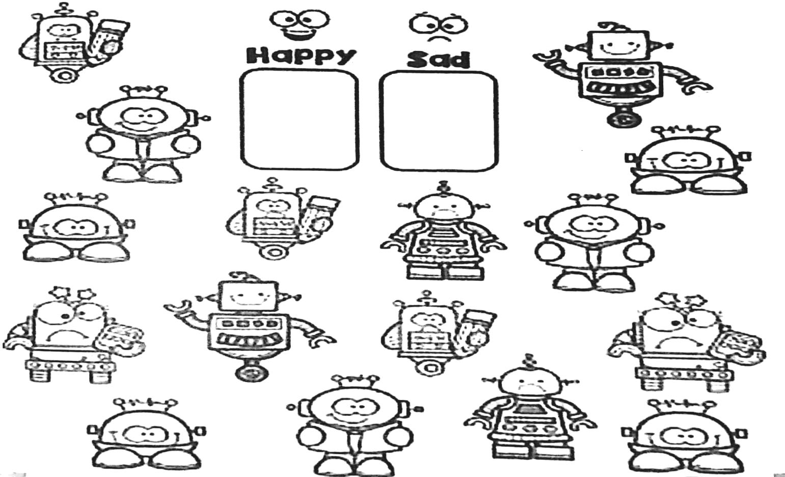
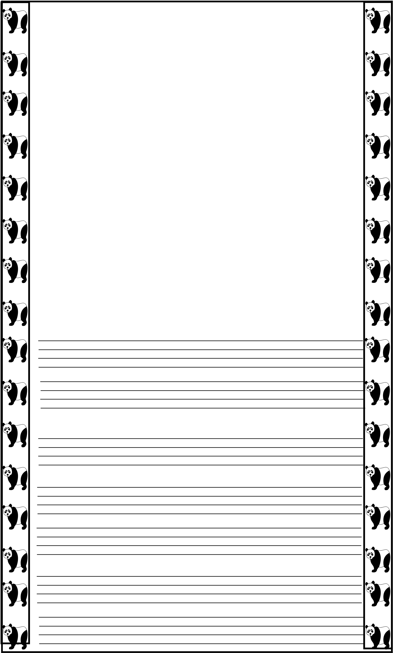
Q5: Count and colour the robots with each
emotion. Record the numbers. / 5
Q 6: Viva Questions. / 10 1. What does AI stand for?
2. Name one example of AI in daily life.
3. What helps a robot think smart?
4. Can robot get tired?

