# Heap Smash v1
PWN
Description
Read the challenge prompt and requirements.
Heap exploitation warmup: the flag is loaded into memory and freed at startup. Reclaim the uninitialized memory to leak the flag. Connect to the service on port 1337 and use the provided commands to allocate, write, read, and delete notes. Commands: - `A ` allocate - `W ` write - `R ` read - `D ` delete - `E` exit
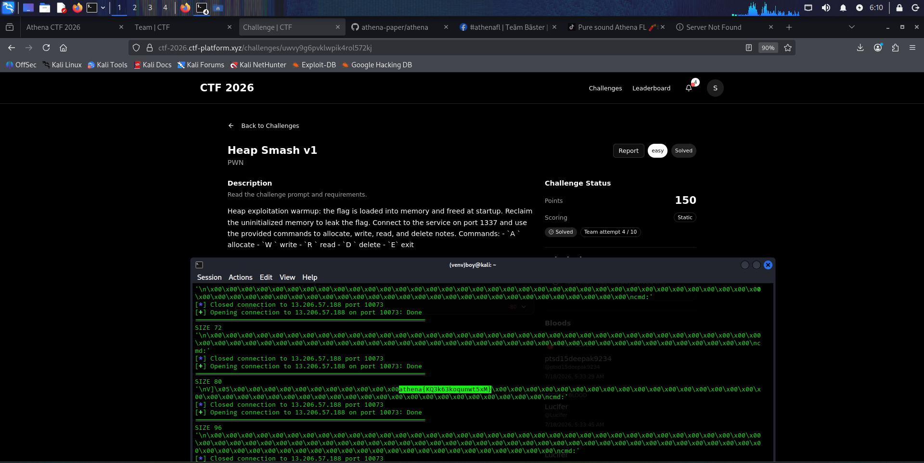
# Net MITM TLS
INFRA
Description
Read the challenge prompt and requirements.
A background service in the target environment periodically transmits a secret flag over TLS to https://net-mitm.local:4443/submit. Connect to the shell service, set up a rogue TLS server with a forged certificate matching the expected domain hostname, and intercept the secret.

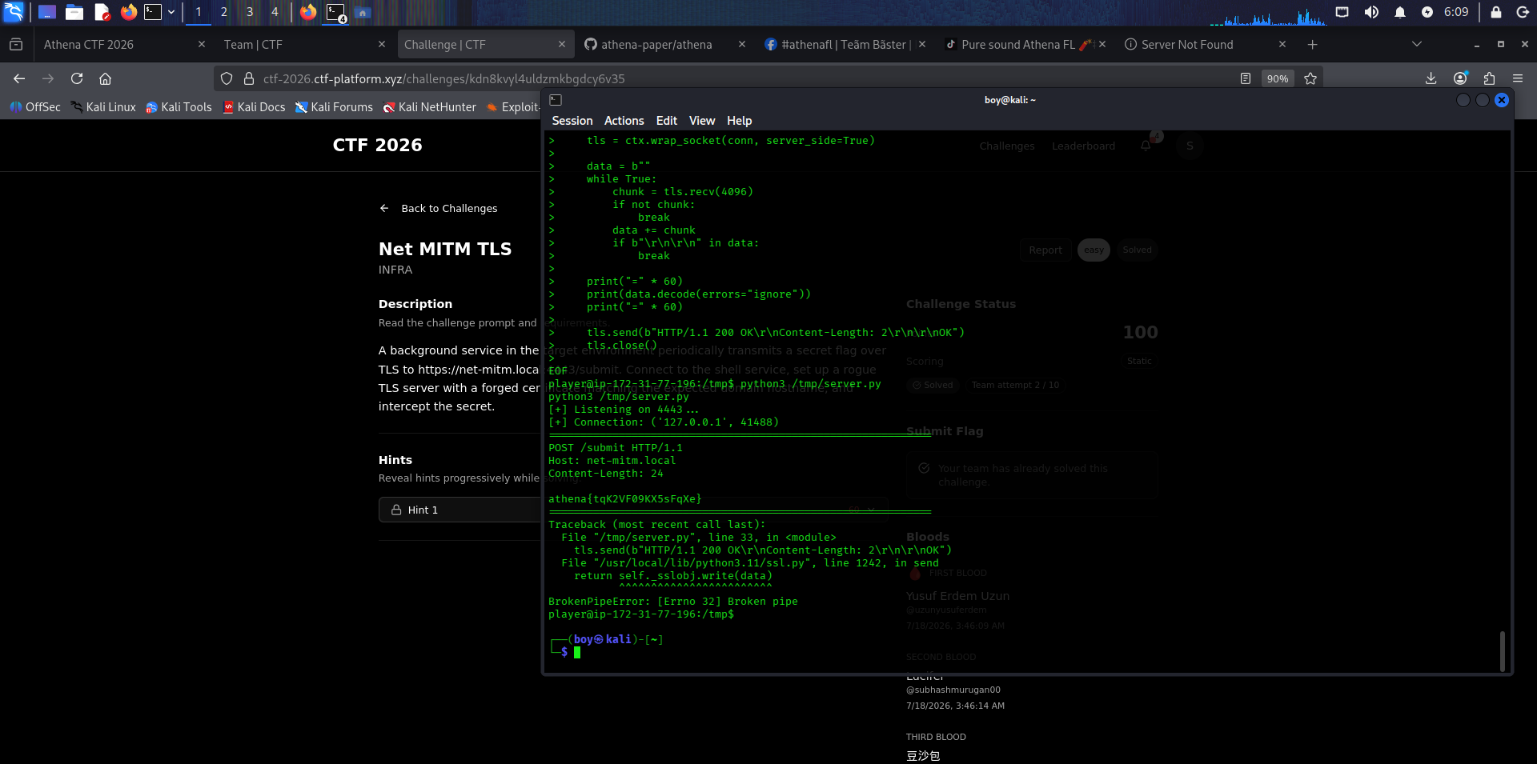

# Tiny ECC Tweak
CRYPTO
Description
Read the challenge prompt and requirements. A whistleblower inside the **Cipher Syndicate** managed to exfiltrate a single log file before going dark.The file contains two authenticated transmissions signed by the Syndicate's central command node, along with an encrypted payload believed to hold the access code to their next operation.Intelligence suggests the signing system suffered a silent flaw: a broken random number generator. Anyone who spots the anomaly in the signature data can work backwards to the signing secret, and from there, crack open the payload.The log is pub.txt. Everything you need is inside.

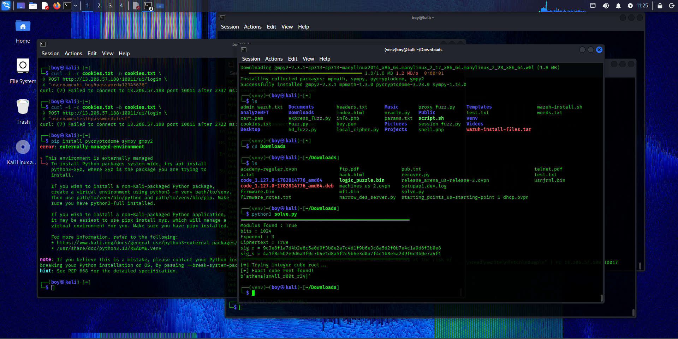

# Triplet Tweak
CRYPTO
Description
Read the challenge prompt and requirements.
A rogue archivist inside the Athena Vault grew paranoid. Before going dark, they locked the same message three times—each lock forged by a different hand, yet all three sharing a single hidden master key.Three sealed envelopes were left behind. Each bears a different lock, but the locksmith was lazy—or sloppy—and the same secret runs through all three. The envelopes are yours now. Find what ties them together.
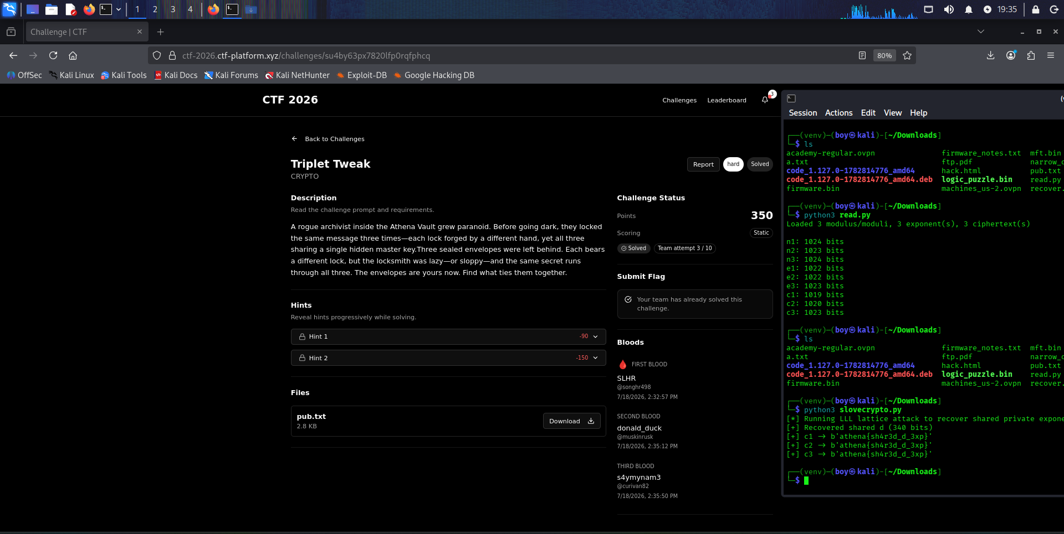

# Upload Lantern
INFRA
Description
Read the challenge prompt and requirements.
A file upload feature was exported from a staging branch after a sanitization change. A live instance of the staging service is provided: preview stored uploads via `GET /view?name=`. Get the flag.
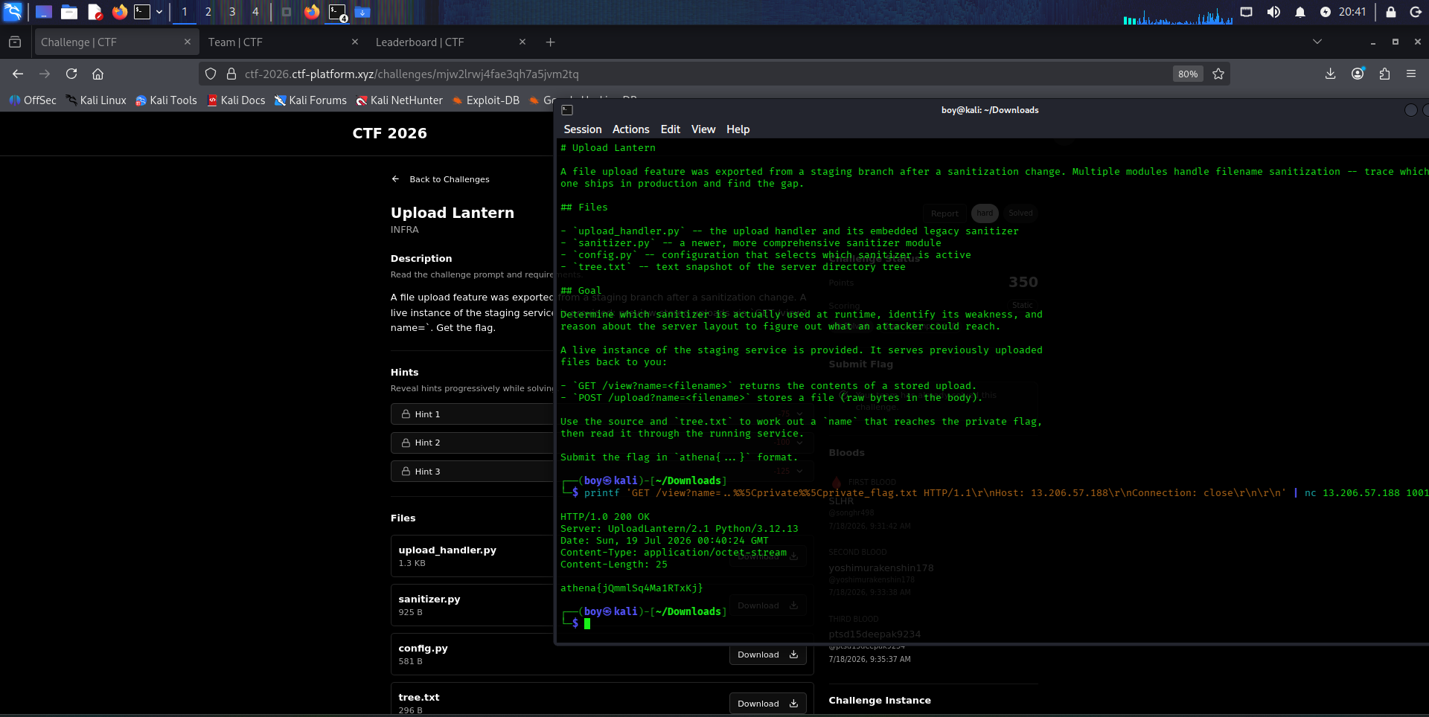

# Net Custom Protocol
INFRA
Description
Read the challenge prompt and requirements.
Reverse the custom echo protocol(ECHO|k|foo) over tcp and find a way to leak the secret. A player-facing transcript is provided; the service and secret are organizer-only.
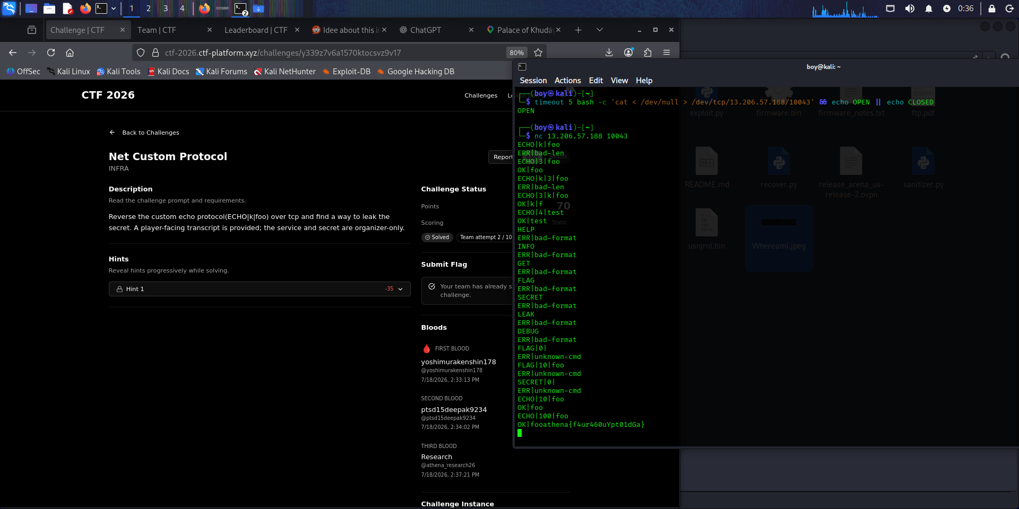

# Table Stakes
REV
Description
Read the challenge prompt and requirements.
A small binary was recovered from a compromised endpoint. It checks a candidate flag and reports whether it is correct: ``` ./challenge.bin 'athena{...}' ``` It will not reveal the flag on its own — the answer is only ever verified, never printed. Reverse engineer to recover the embedded payload.
