ENCRYPTION COMMANDS :
OPENSSL:
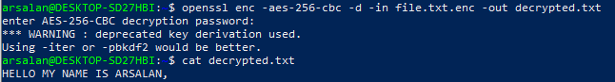
GPG:
Encrypt file : gpg –c file.txt,
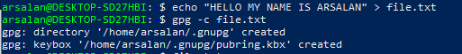
Type | Name | Used For | Requires
Symmetric | One key | Quick personal file protection | A password
-c = symmetric encryption

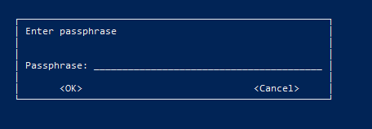

Decrypt the file : gpg file.txt.gpg
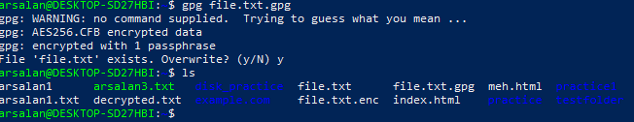
Viewing the decrypted content

ENCFS:
Creating 2 folders
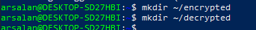
Initializing encryption
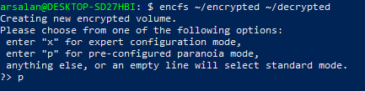
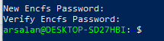
Not uses the encfs , and stop working further more, wsl not supported encfs.

SERVICE MANAGEMENT
For save practice using cron, is harmless background scheduler staring / stopping will not break anything.
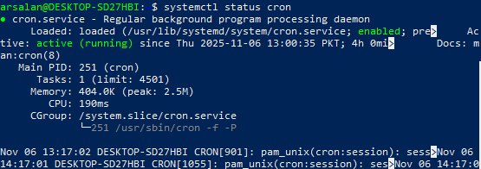

Showing process by memory sorting , pressing M list memory usage by highest first
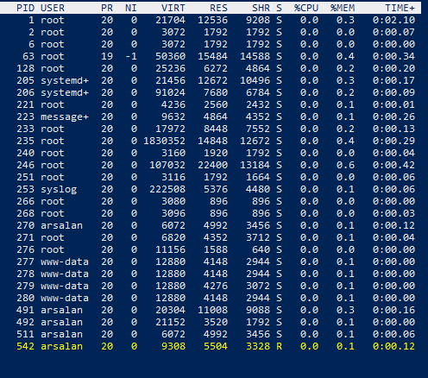

PID 246 root uses more memory,
