Step 1: Launch an EC2 Instance (Free Tier)
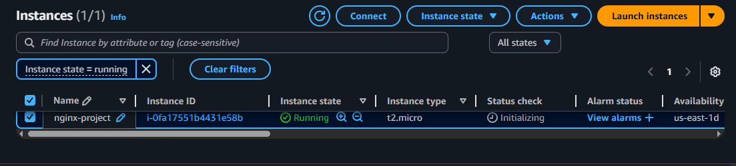
Step 2: Connect to EC2 (SSH)
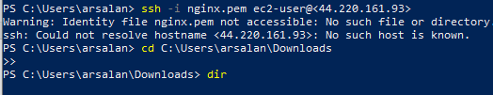
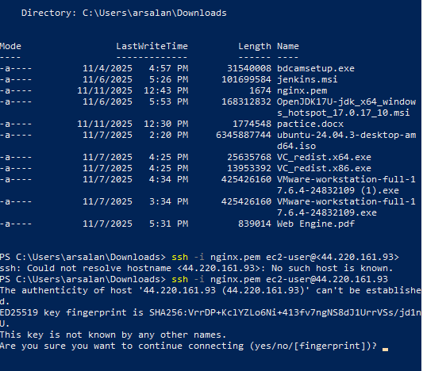
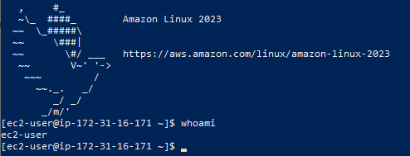
Step 3: Install NGINX
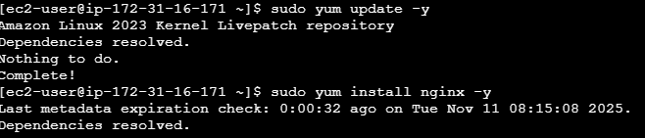
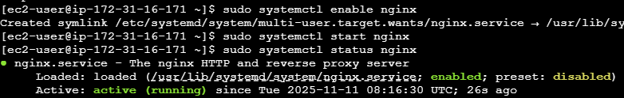
Step 4: Open in Browser
On your computer browser visit:
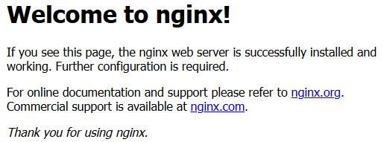

Step 5: Create Your Project Folder and Page
Create index page:
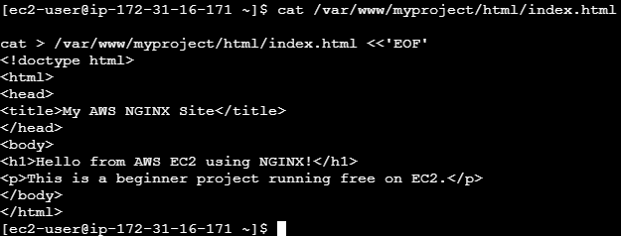
Step 6: Create Server Block (Virtual Host)
Paste in the file:
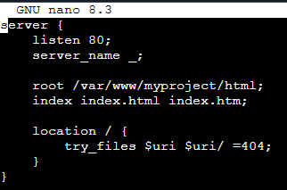
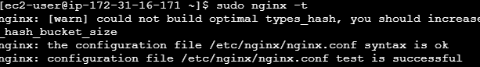

Creating main config file:
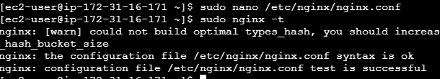
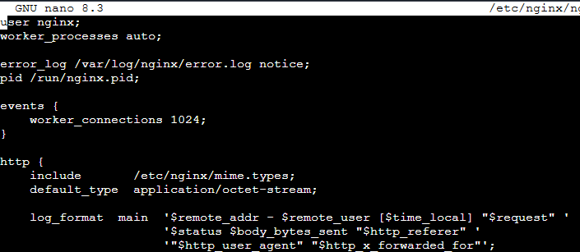

Step 7: Test and Reload NGINX
Step 8: Test in Browser
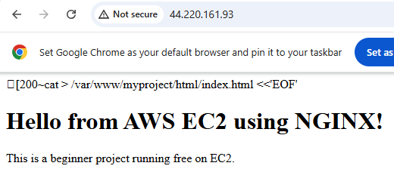

What we Learned
- How to launch and connect to EC2
- Install and manage NGINX service
- Create project directories and serve HTML
- Configure a server block
- Verify config and reload service

Fix 2: Now Enable HTTPS (SSL)
Since your domain is working, we now install Certbot:
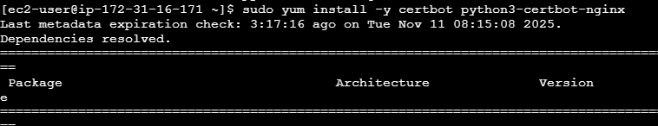
Run SSL setup:
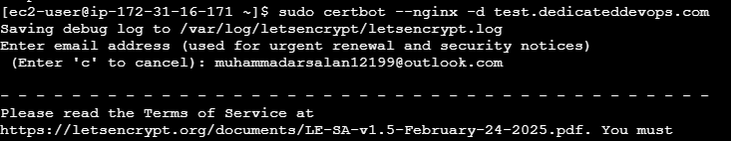
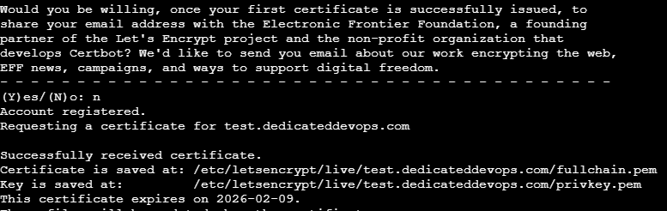

website was not loading earlier because two important steps were missing:
- NGINX configuration was still pointing to a static HTML setup and it did not include domain name. When NGINX does not know which domain it should respond to, it will not serve the correct website. Once updated the server_name in the NGINX config to actual domain test.dedicateddevops.com, NGINX was able to serve the correct site.
- AWS EC2 Security Group did not have the HTTPS (port 443) rule enabled. Without this rule, the server was receiving requests but was not allowed to respond securely. Adding the HTTPS rule allowed secure traffic to reach server, which fixed the browser access issue.
So the main problems were:
- Missing server_name in the NGINX project configuration.
- Missing HTTPS inbound rule in the EC2 security group.
Once corrected both, the site started working correctly.

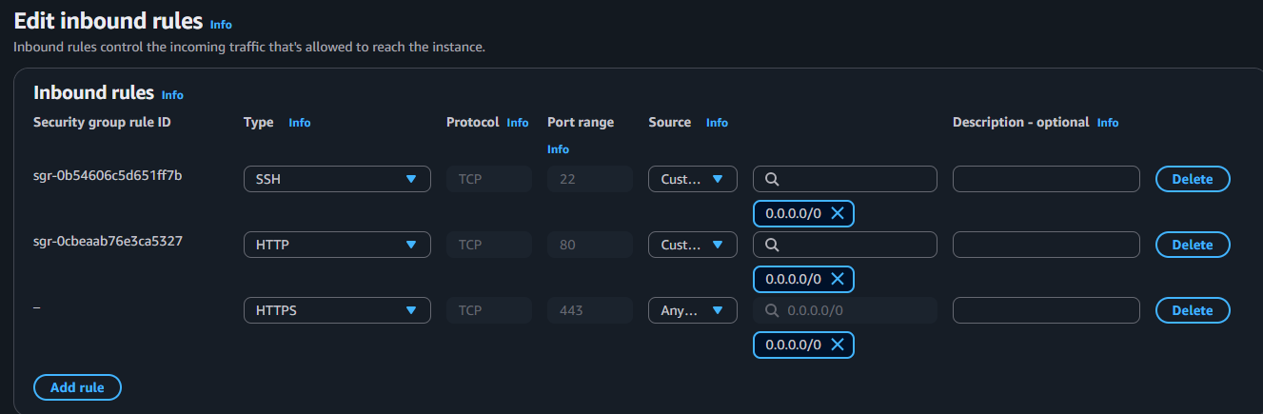
Finally after ssl certificate its not showing more not secure on wesite starts.
