PAKISTAN STOCK EXCHANGE
Real-Time AI-Powered Market Intelligence System
Week 1 Implementation Progress Report

Subject | Big Data Analytics
Submitted To | Sir Zeeshan Hussain Chuhan
Submitted By | Syeda Maria Batool (L1F23BSAI0115)  Semal Fatima (L1F23BSAI0088)  M. Aryan (L1F23BSAI0019)
Project Phase | Week 1 - Foundation Setup and Streaming Pipeline
Report Date | 06 May 2026
Overall Status: Week 1 foundation work is completed and verified for local development.

Executive Summary
This document reports the Week 1 implementation progress for the PSX Real-Time AI-Powered Market Intelligence System. The objective of Week 1 was to prepare the local development foundation, configure the streaming infrastructure, create a sample PSX data flow, and connect PySpark with the Kafka-based market tick pipeline.
The Week 1 milestone has been achieved at the foundation level. Docker and Docker Compose are available, Kafka and Zookeeper are defined in Docker Compose, sample PSX stock data has been added, a Kafka producer and consumer have been implemented, and the PySpark stream processor can start successfully with Spark 4.1.1. A unit test for tick generation also passes when the project root is included in PYTHONPATH.
Important note: this is not the final complete system. RAG, sentiment analysis, multi-agent decision logic, and the Flask dashboard are present as project modules/placeholders but are planned for Week 2 and later phases.

Direct Answer: Is Week 1 Work Completed?
Yes. The Week 1 foundation work is completed. The system now has a working base for local streaming development: Docker/Kafka configuration, sample PSX data, Kafka producer/consumer code, PySpark stream processing code, Windows Hadoop support files, dependency setup, and verification evidence.
For submission, it should be described as: Week 1 completed for infrastructure and streaming foundation; advanced AI features and dashboard integration are next milestones.
Area | Status | Evidence
Docker installation | Verified | Docker version 29.4.1 detected on the system.
Docker Compose | Verified | Docker Compose v5.1.3 detected; compose file includes zookeeper and kafka services.
Kafka configuration | Complete | docker-compose.yml defines Confluent Zookeeper and Kafka on localhost:9092.
Sample PSX data | Complete | data/sample_psx_data.csv contains sample symbols HBL, UBL, MCB, LUCK, and ENGRO.
Kafka producer | Complete | kafka_layer/producer.py generates simulated live market ticks and publishes JSON.
Kafka consumer | Complete | kafka_layer/consumer.py subscribes to the configured topic and deserializes JSON.
PySpark integration | Verified | spark_layer/stream_processor.py creates Spark session and reads Kafka streams; smoke test reports Spark 4.1.1.
Testing | Passed | $env:PYTHONPATH=(Get-Location).Path; pytest -q returned 1 passed.
Official PSX dataset | In progress | Dataset request email was sent to PSX and a reply was received; formal data access/integration remains the next step.

Week 1 Implemented Pipeline
The following diagram shows the implemented Week 1 streaming path. It starts from local sample PSX stock data, passes through Kafka, and is then consumed by PySpark for schema-based parsing.
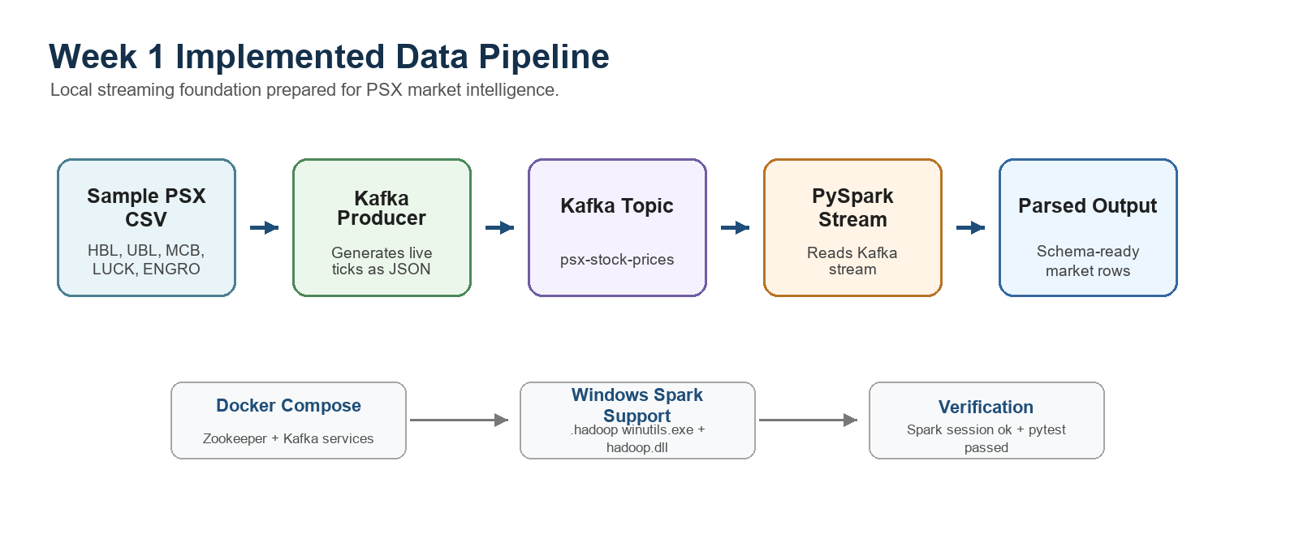

System Architecture Status
The complete project architecture includes real-time data ingestion, big data processing, RAG, sentiment analysis, multi-agent decision-making, and dashboard visualization. In Week 1, the streaming and processing foundation was prioritized.
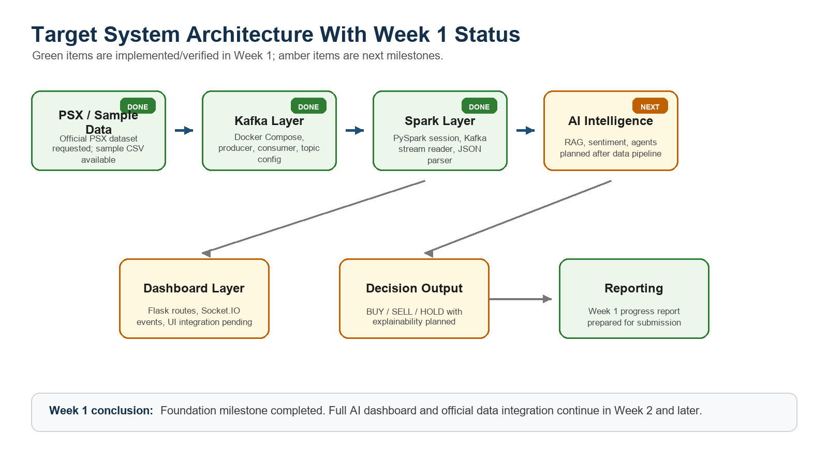

Week 1 Timeline
This timeline summarizes the main activities completed during the first implementation week.
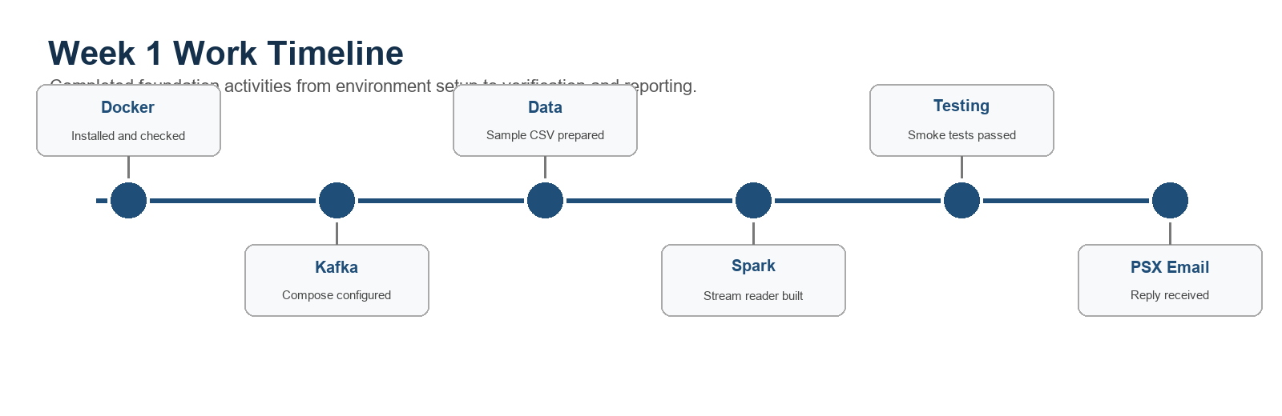

Detailed Work Completed

1. Docker and Kafka Setup
Docker was installed and verified on the development machine. Docker Compose was used to define the streaming infrastructure required by the system.
- Docker version verified: Docker version 29.4.1.
- Docker Compose version verified: v5.1.3.
- docker-compose.yml defines two services: zookeeper and kafka.
- Kafka is advertised locally through PLAINTEXT://localhost:9092.
- Kafka offset topic replication factor is configured as 1 for local single-broker development.

2. Project Environment and Dependencies
The Python environment dependencies required for Week 1 streaming work were defined in requirements.txt.
- pandas for reading sample CSV market data.
- kafka-python for Kafka producer and consumer integration.
- python-dotenv for environment variable loading from .env.
- pyspark for stream processing.
- pytest for automated verification.
The local .env file contains KAFKA_BOOTSTRAP_SERVERS=localhost:9092, which keeps Kafka connection settings separate from code.

3. Sample PSX Dataset
A sample dataset was created for development before official PSX data access is finalized. This allows the Kafka and Spark pipeline to be built and tested without waiting for production data.
Symbol | Price | Volume | High | Low
HBL | 142.50 | 12000 | 145.00 | 140.20
UBL | 188.30 | 18000 | 190.00 | 185.50
MCB | 225.75 | 9000 | 228.00 | 222.10
LUCK | 740.20 | 15000 | 750.00 | 735.00
ENGRO | 310.40 | 11000 | 315.00 | 305.50

4. Kafka Producer
The Kafka producer reads a random row from the sample PSX dataset and converts it into a simulated live market tick. It slightly changes the price and volume so the stream behaves like real-time data.
- Main file: kafka_layer/producer.py.
- Function generate_live_tick(row) creates symbol, price, volume, high, low, and timestamp.
- Messages are serialized as JSON and sent to the configured Kafka topic.
- The default topic is psx-stock-prices.

5. Kafka Consumer
A Kafka consumer was implemented to subscribe to the PSX topic and read the JSON messages. This helps verify that the producer is publishing correctly and that the topic can be consumed by downstream systems.
- Main file: kafka_layer/consumer.py.
- Consumer group: psx-consumer-group.
- JSON messages are deserialized into Python dictionaries.
- Includes broker availability error handling for local development.

6. PySpark Stream Processor
The Spark layer was connected to the Kafka stream. The processor creates a Spark session, loads the Kafka connector, reads messages from Kafka, parses JSON values into a typed schema, and writes parsed rows to the console for verification.
- Main file: spark_layer/stream_processor.py.
- Spark application name: PSX Kafka Stream Processor.
- Spark version verified locally: 4.1.1.
- Kafka connector package is selected based on Spark/Scala version.
- Windows Hadoop support is configured through local .hadoop files.
- The stream schema includes symbol, price, volume, high, low, and timestamp.

7. Windows Hadoop Support
Because the project is running on Windows, Spark requires supporting Hadoop utilities. A local .hadoop folder was prepared with winutils.exe, hadoop.dll, and core-site.xml. The Spark processor checks this folder and sets HADOOP_HOME, HADOOP_CONF_DIR, and PATH where needed.

8. Spark Runner
A helper runner file was added so the stream processor can be started directly through Python instead of requiring a manual spark-submit command.
- Main file: run_spark_stream.py.
- Checks whether PySpark is installed before running.
- Imports and starts spark_layer.stream_processor.main().
- Handles Ctrl+C and error messages for easier local execution.

Technical Data Contract
The Week 1 pipeline uses a simple but clear market tick contract. This contract is important because Kafka, Spark, RAG, sentiment, agents, and dashboard modules will all depend on consistent data fields.
Field | Type | Purpose
symbol | String | PSX stock/company symbol such as HBL or UBL.
price | Double | Latest simulated trading price.
volume | Long | Simulated traded volume.
high | Double | Day or sample high price.
low | Double | Day or sample low price.
timestamp | String | ISO timestamp showing when the tick was generated.

Setup and Run Steps
The following steps document how the Week 1 work can be reproduced on the local machine.
- Open PowerShell in the project directory: C:\Users\malik\Desktop\PSX-Intelligence-System.
- Install Python dependencies using requirements.txt.
- Verify Docker and Docker Compose installation.
- Start Kafka and Zookeeper through Docker Compose when running the live demo.
- Run the Kafka producer to generate sample live PSX ticks.
- Optionally run the Kafka consumer to verify messages.
- Run the PySpark stream processor to read and parse Kafka messages.
- Run pytest with PYTHONPATH set to verify the current unit test.
python -m pip install -r requirements.txt
docker --version
docker compose version
docker compose up -d
python kafka_layer/producer.py
python kafka_layer/consumer.py
python run_spark_stream.py
$env:PYTHONPATH=(Get-Location).Path; pytest -q

Verification Evidence
Check | Result | Output / Notes
Docker version | Verified | Docker version 29.4.1, build 055a478.
Docker Compose version | Verified | Docker Compose version v5.1.3.
Compose services | Verified | docker compose config --services returned zookeeper and kafka.
Python version | Verified | Python 3.12.3.
PySpark version | Verified | PySpark 4.1.1.
Pandas version | Verified | Pandas 2.3.3 available.
Spark smoke test | Passed | create_spark_session() started successfully and reported Spark 4.1.1.
Pytest | Passed | $env:PYTHONPATH=(Get-Location).Path; pytest -q returned 1 passed.

PSX Dataset Communication
The team also started the official data acquisition process. An email was sent to Pakistan Stock Exchange (PSX) requesting access to the required dataset. A reply was received from PSX, which confirms that the communication process has started.
Current status: official dataset access and integration are still in progress. Until the final dataset is received or access rules are confirmed, the project uses a small sample CSV file for development and testing.
Recommended submission note: Attach or show the PSX email reply separately if the supervisor asks for proof of communication, because the exact email content is outside the project repository.

Current Limitations
- The current market data is simulated from a sample CSV, not yet the official PSX production dataset.
- RAG files are present as module placeholders but retrieval and vector database integration are not implemented yet.
- Sentiment analysis files are present as placeholders and are planned for a later milestone.
- Multi-agent files are present as placeholders and will be connected after the streaming/data layer becomes stable.
- Dashboard files are present as placeholders; real-time dashboard routes, services, and socket events are planned for the next implementation phase.
- Before a live demo, Kafka and Zookeeper should be started with docker compose up -d.

Week 2 Planned Work
- Integrate official PSX dataset if access is provided, or convert the received dataset into the current market tick schema.
- Add Spark transformations for cleaning, aggregation, and trend detection.
- Persist processed Spark output to a local store or dashboard service layer.
- Start implementing dashboard routes, services, and Socket.IO events for real-time display.
- Begin RAG/news layer implementation using PSX news or financial news CSV data.
- Expand automated tests for Spark parsing, Kafka tick generation, and future dashboard services.

Repository Evidence
File / Folder | Purpose
docker-compose.yml | Defines local Zookeeper and Kafka services.
requirements.txt | Lists Python dependencies for Week 1 work.
.env | Stores Kafka bootstrap server configuration.
data/sample_psx_data.csv | Provides sample PSX symbols and prices for local development.
kafka_layer/producer.py | Generates and publishes simulated market ticks.
kafka_layer/consumer.py | Reads market ticks from Kafka.
config/kafka_config.py | Loads Kafka bootstrap server and topic name.
spark_layer/stream_processor.py | Creates Spark session and parses Kafka stream data.
run_spark_stream.py | Starts the Spark stream processor through Python.
tests/test_kafka.py | Tests the live tick generation function.
dashboard/* | Dashboard placeholders for future Flask/Socket.IO implementation.
rag_layer/* | RAG placeholders for future retrieval and embeddings work.
agents/* | Multi-agent system placeholders for future AI decision layer.

Conclusion
Week 1 successfully completed the foundation milestone for the PSX Real-Time AI-Powered Market Intelligence System. The local development environment is ready, Docker/Kafka configuration exists, sample data can be streamed through Kafka, PySpark is connected and verified, and the project now has a defendable base for Week 2 implementation.
The correct academic status is: Week 1 completed for setup, streaming foundation, and Spark integration; remaining AI intelligence, official dataset integration, dashboard, and advanced analytics are planned for upcoming weeks.

