Data:

The data required to analyze the different options would be the following:

1. Location data labeling each neighborhood in the city in the form of a shape file which could be rendered as a map.
2. Foursquare data summarizing the venues by location, rating, likes. One api would be used to find all the food venues near the chosen location. Second API call would be used to rate each venue to determine which neighborhood would be more lucrative.

For the first data set, we could leverage the open datasets available using https://gis.ucla.edu/apps/click2shp/ and subsequently https://mygeodata.cloud/converter/shp-to-csv webservice to arrive at the following csv file:

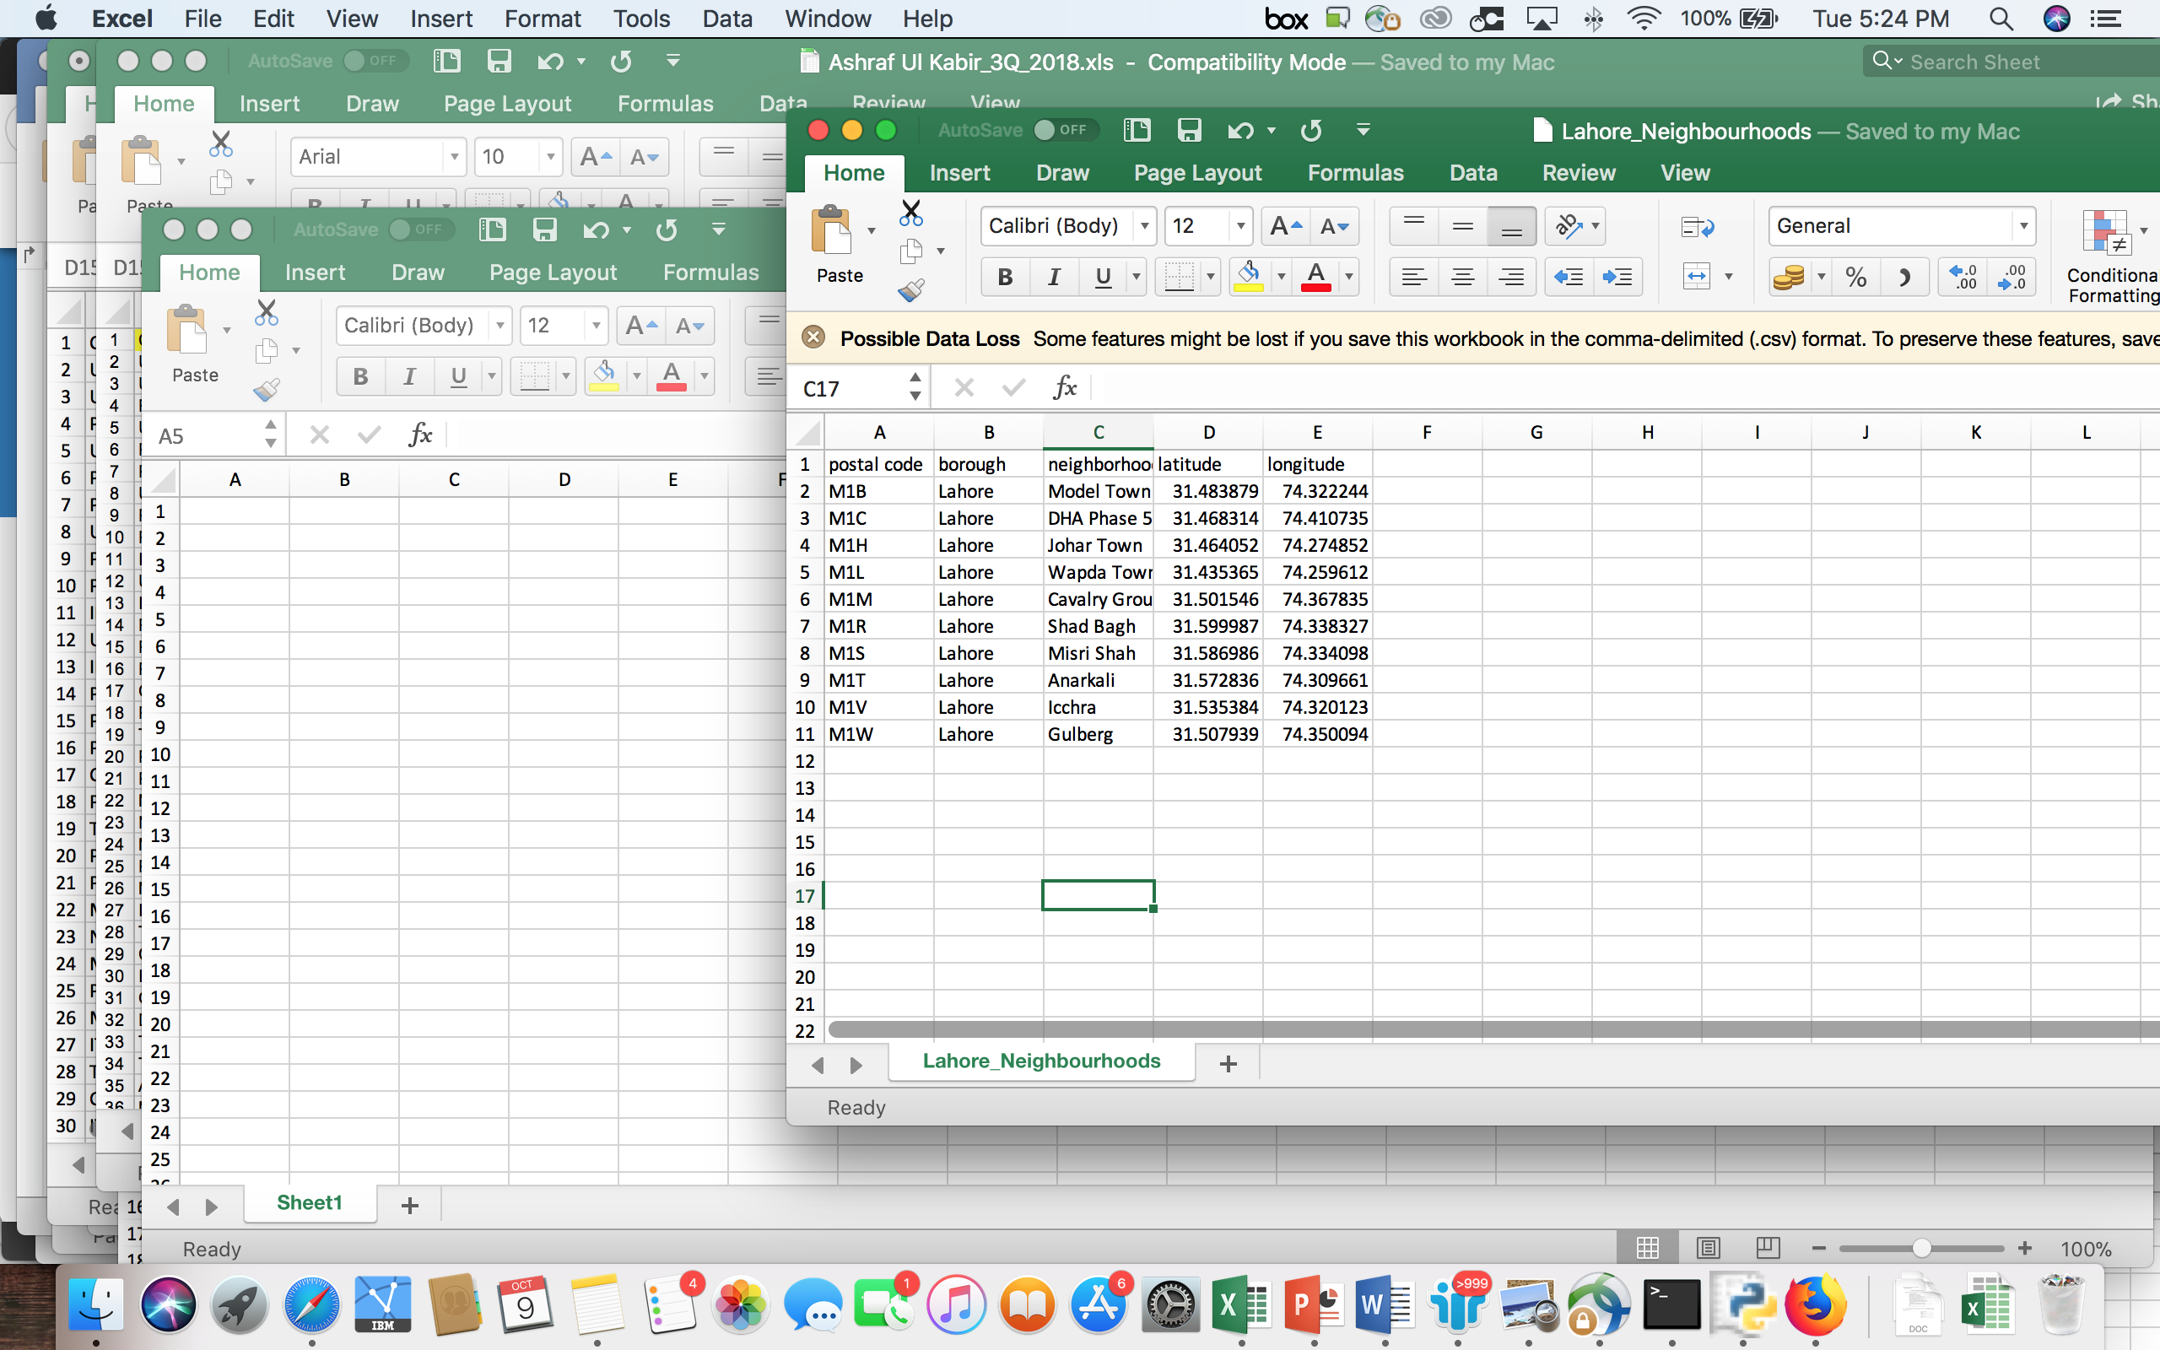

Analyzing a particular neighborhood using Foursquare API endpoint explore in Karachi yields the following result:

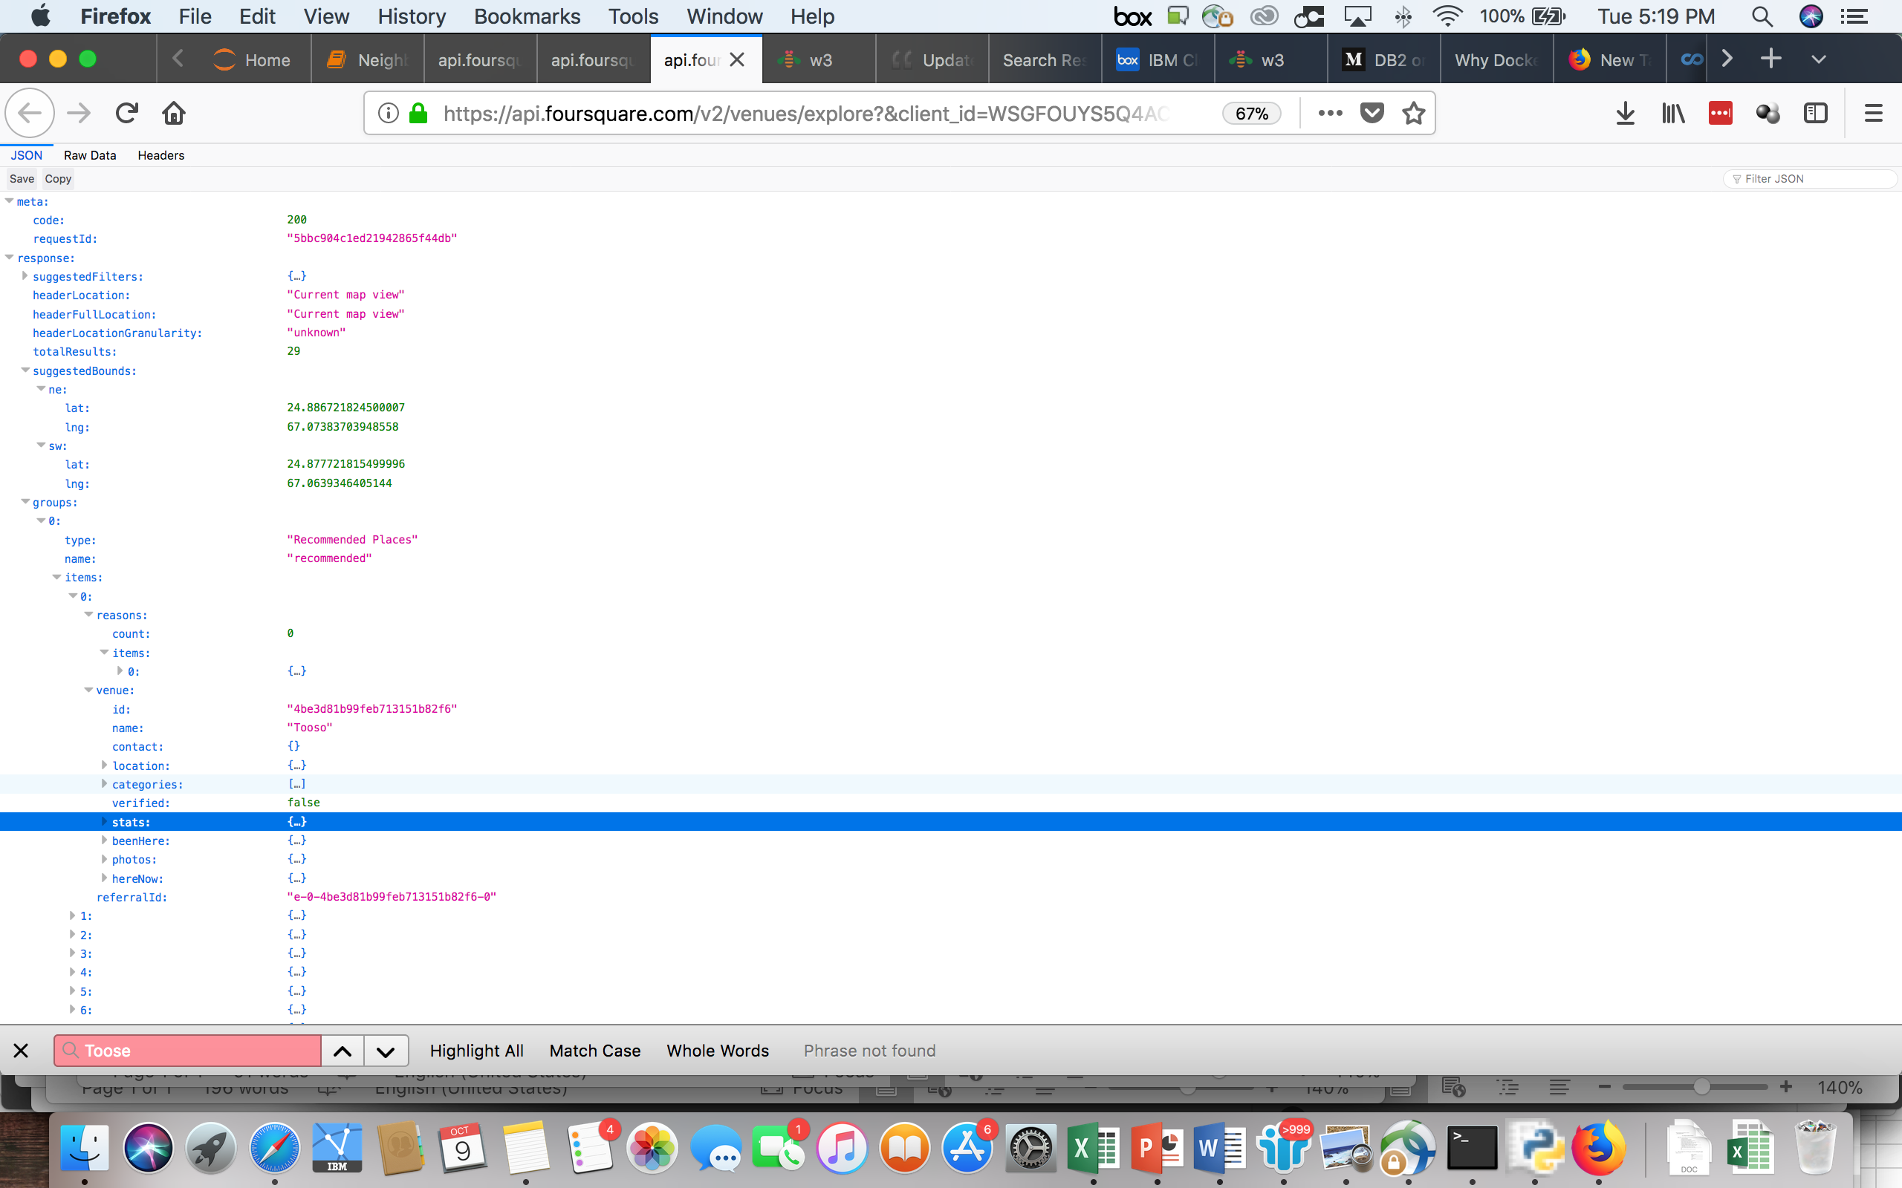

This shows that there are a number of restaurants listed in items and we need to analyze each venue using the venue endpoint like follows:

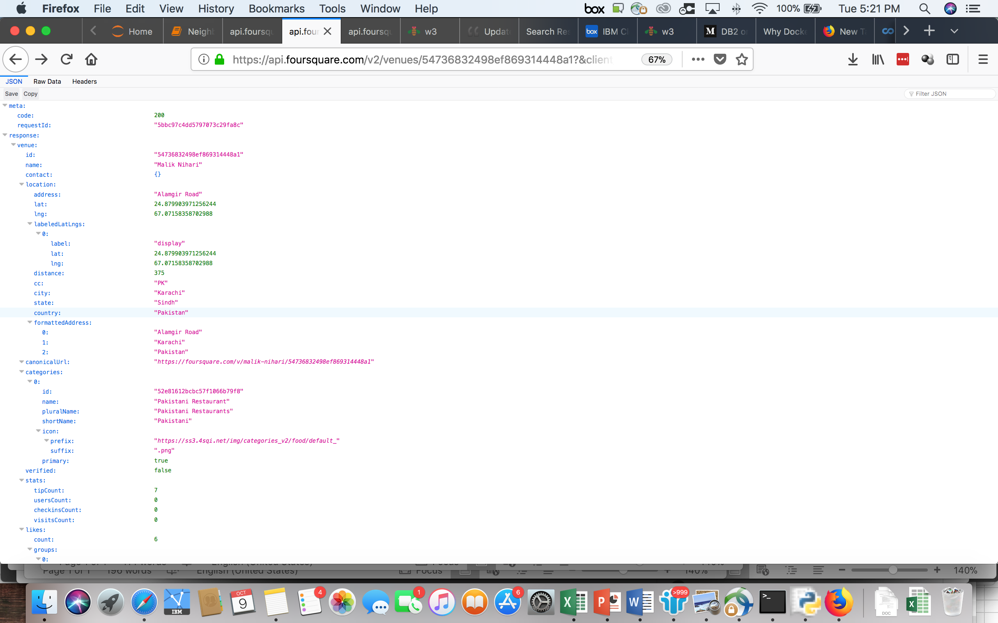

This gives a picture of each venue, how likable it is in terms of the number of likes, rating etc.

These datasets would then be rated and the most likable venues would determine the behavior of that particular neighborhood, so for instance if the likes are more, it is a representation of more people visiting and then liking the food outlets in that neighborhood. Since a small percentage of the population is savvy enough to use the internet and the mobile device for social media interaction, it also shows an indication of the likelihood to spend by that population.

This data would then be compared between the cities to arrive at the best available location.