Siresoft RAG
Overall Architecture and Design

Architectural style, component and data-model design, the design patterns applied in the codebase, the runtime/deployment architecture, and the non-functional design decisions and trade-offs behind them.

1. Purpose and Scope
This document describes the architecture of Siresoft RAG at the design level: the architectural style chosen and why, how responsibility is split across components, the design patterns applied and where, the data model and the reasoning behind its key structural choices, the runtime and deployment topology, and the non-functional trade-offs made along the way. It complements the project plan document (structure, step-by-step data flow, and production-readiness checklist) by going one level deeper into the *why* behind the design, not just the *what* and *how*.

2. Architectural Style
Siresoft RAG is built as a modular monolith: one deployable Django application, internally split into independent apps with clear boundaries, backed by a single PostgreSQL instance that serves as both the relational store and the vector store. This is a deliberate choice, not a default.

2.1 Why a modular monolith, not microservices
Consideration | Reasoning
Team/operational size | One team, one deployable to version and roll back, one set of logs to correlate -- microservices trade this simplicity for independent scaling this system doesn't yet need.
Data locality | Retrieval needs relational metadata (document status, chunk ownership) and vector similarity in the same query path. Keeping both in one PostgreSQL instance avoids a distributed join or a second network hop for every single retrieval.
Failure domain | A single well-tested deployable has one failure mode to reason about (the process is up or it isn't) instead of N services each with their own partial-failure and retry semantics.
Natural service boundaries already exist | The Django app boundaries (documents / rag / chat / core) already draw the seams a future service split would follow -- so the option isn't foreclosed, just not exercised until there's a concrete reason (e.g. the reranker genuinely needs its own GPU fleet).

2.2 Layering within the monolith
Each Django app follows the same internal layering: HTTP/serialization (views.py, serializers.py) does not contain business logic; it delegates to a services/domain layer (services.py in chat, the top-level modules in rag) which in turn talks to models.py for persistence. This keeps the same retrieval and generation logic reusable from both the HTTP layer and the management-command layer (manage.py prove_retrieval) without duplicating it.
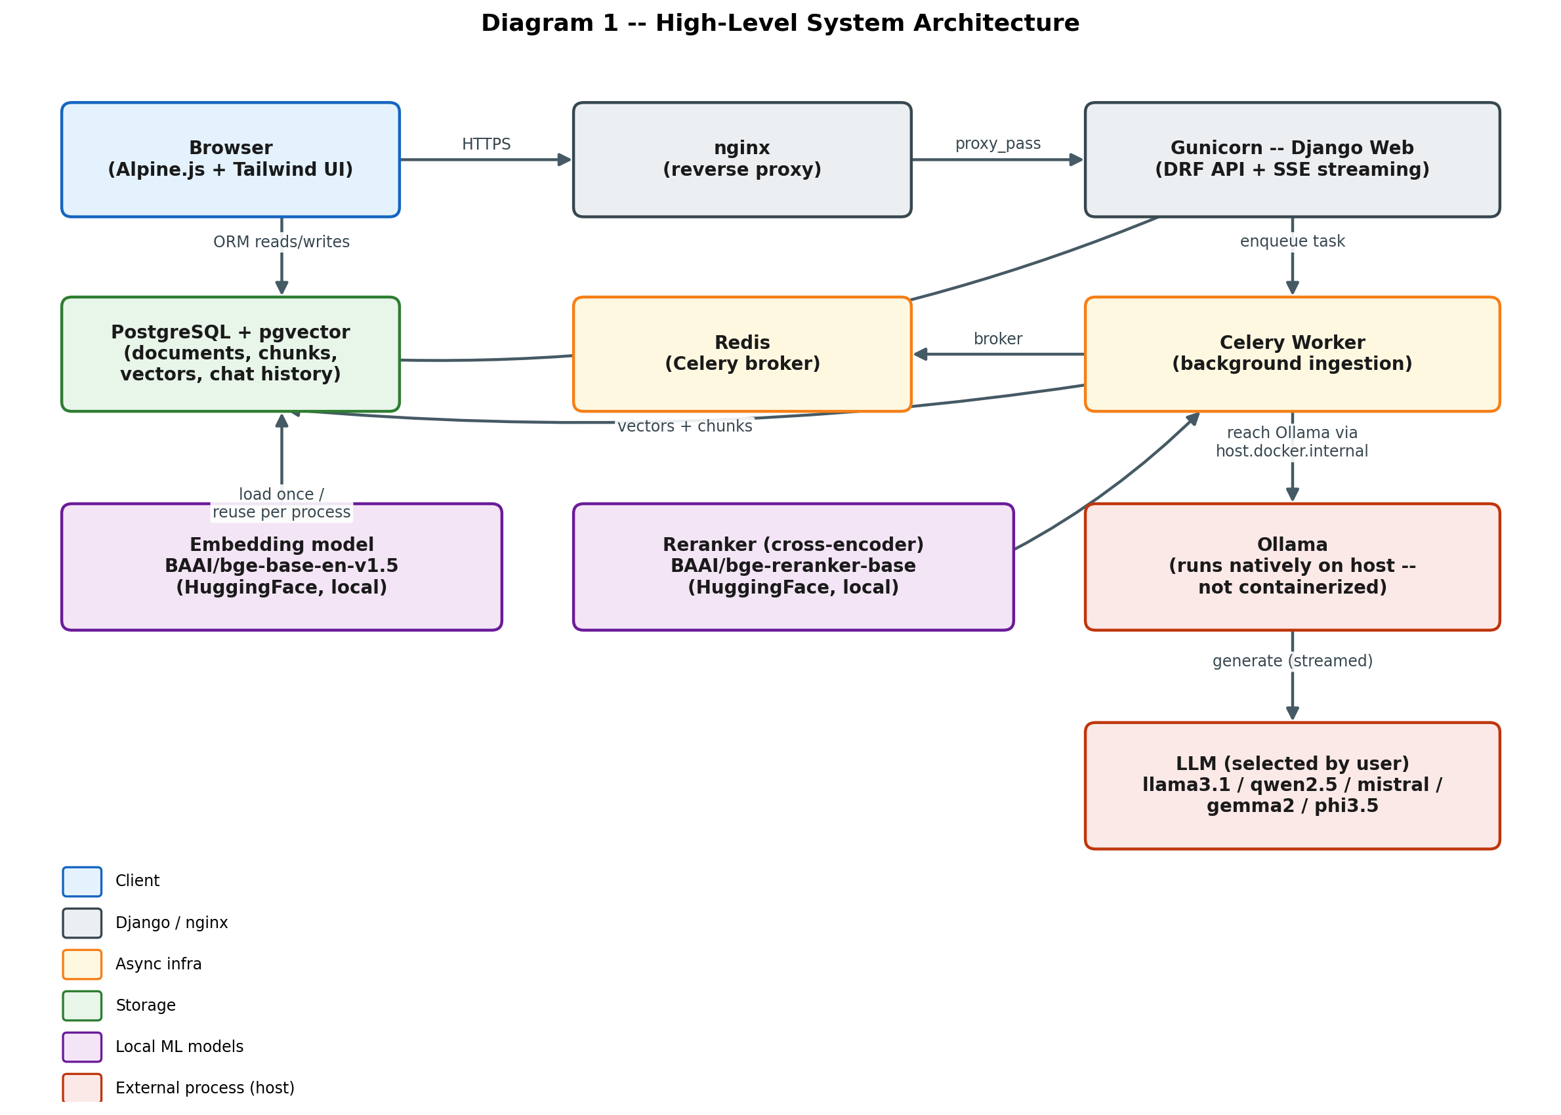
Figure 1 -- Component architecture: every major building block and how they connect.

3. Component Responsibilities
Component | Responsibility | Depends on
config/ | Composition root: settings, URL routing, WSGI/ASGI entry points, Celery app wiring | All apps (imports/registers them)
core/ | Cross-cutting concerns: abstract base models, custom exception types, the Ollama-availability check, the SPA shell view | Nothing app-specific (deliberately the lowest layer)
documents/ | Upload intake, validation, SHA-256 dedup, document lifecycle (queued -> ... -> indexed/failed), the Celery ingestion task | rag/ (loaders, chunking, embedding)
rag/ | The retrieval/generation engine: loaders, splitter, embeddings, hybrid retrieval, reranking, the LCEL generation chain | core/ only -- deliberately app-agnostic so both documents/ and chat/ can call it
chat/ | Conversation state, turn orchestration (rewrite -> retrieve -> generate -> persist), SSE streaming endpoint | rag/ (for retrieval + generation)
templates/ + static/ | The single-page UI shell: state, dropdowns, SSE consumption, chunk viewer | The chat/ and documents/ HTTP APIs only, via fetch/EventSource
Celery worker | Executes ingestion asynchronously, isolated from the request/response cycle | documents/, rag/ (same codebase, different process)
Ollama (external process) | LLM inference, addressed only through the ChatOllama adapter in rag/generation.py | Nothing in this codebase -- a boundary, not a dependency

The dependency direction is intentionally one-way: rag/ never imports from documents/ or chat/. This is what makes rag/ reusable from three different callers (the ingestion task, the chat turn, and the standalone prove_retrieval command) without any of them coupling to each other.

4. Design Patterns Applied in the Codebase
These are not applied for their own sake -- each one solves a concrete problem the codebase actually has.
Pattern | Where used | Problem it solves
Strategy | rag/loaders.py (one loader per source_type: PDF, DOCX, text/Markdown, URL); EMBEDDING_PROFILE switch between bge-base and minilm | Adding a new file type or embedding profile means adding a new strategy, not branching deeper into existing code.
Adapter | rag/generation.py wraps LangChain's ChatOllama; rag/reranker.py wraps sentence-transformers' CrossEncoder | The rest of the codebase depends on a small, stable interface ("stream tokens for a prompt", "score these pairs"), not on the third-party library's own API shape -- either can be swapped without touching callers.
Pipeline / Chain of Responsibility | The LCEL chain in rag/generation.py (prompt -> model -> parser), and the chat turn itself (rewrite -> retrieve -> rerank -> gate -> generate -> persist) | Each stage is independently testable and independently replaceable (e.g. swapping the prompt for SUMMARY_PROMPT re-uses every other stage unchanged).
Repository (via Django ORM / QuerySet functions) | rag/retrieval.py's retrieve() and get_all_chunks() return plain RetrievedChunk value objects, not QuerySets, to their callers | Callers (chat/services.py) work against a stable, simple return type regardless of how the underlying hybrid-search SQL evolves.
Gate / guard clause | The relevance-threshold check in the chat turn -- generation is never invoked unless retrieval clears RETRIEVAL_SIMILARITY_THRESHOLD | Structurally prevents the single most common RAG failure mode (answering from empty/irrelevant context) rather than relying on prompt instructions alone.
Producer/consumer via SSE | chat/views.py streams tokens as they're produced by the LCEL chain directly to the HTTP response | The browser starts rendering the answer immediately instead of waiting for the full generation to finish -- no polling, no websockets needed for a one-directional stream.
Idempotent intake | Document upload hashes the file (SHA-256) before creating a new Document row | Re-uploading the same file is a safe no-op instead of silently duplicating storage and index entries.

5. Data Model and Design
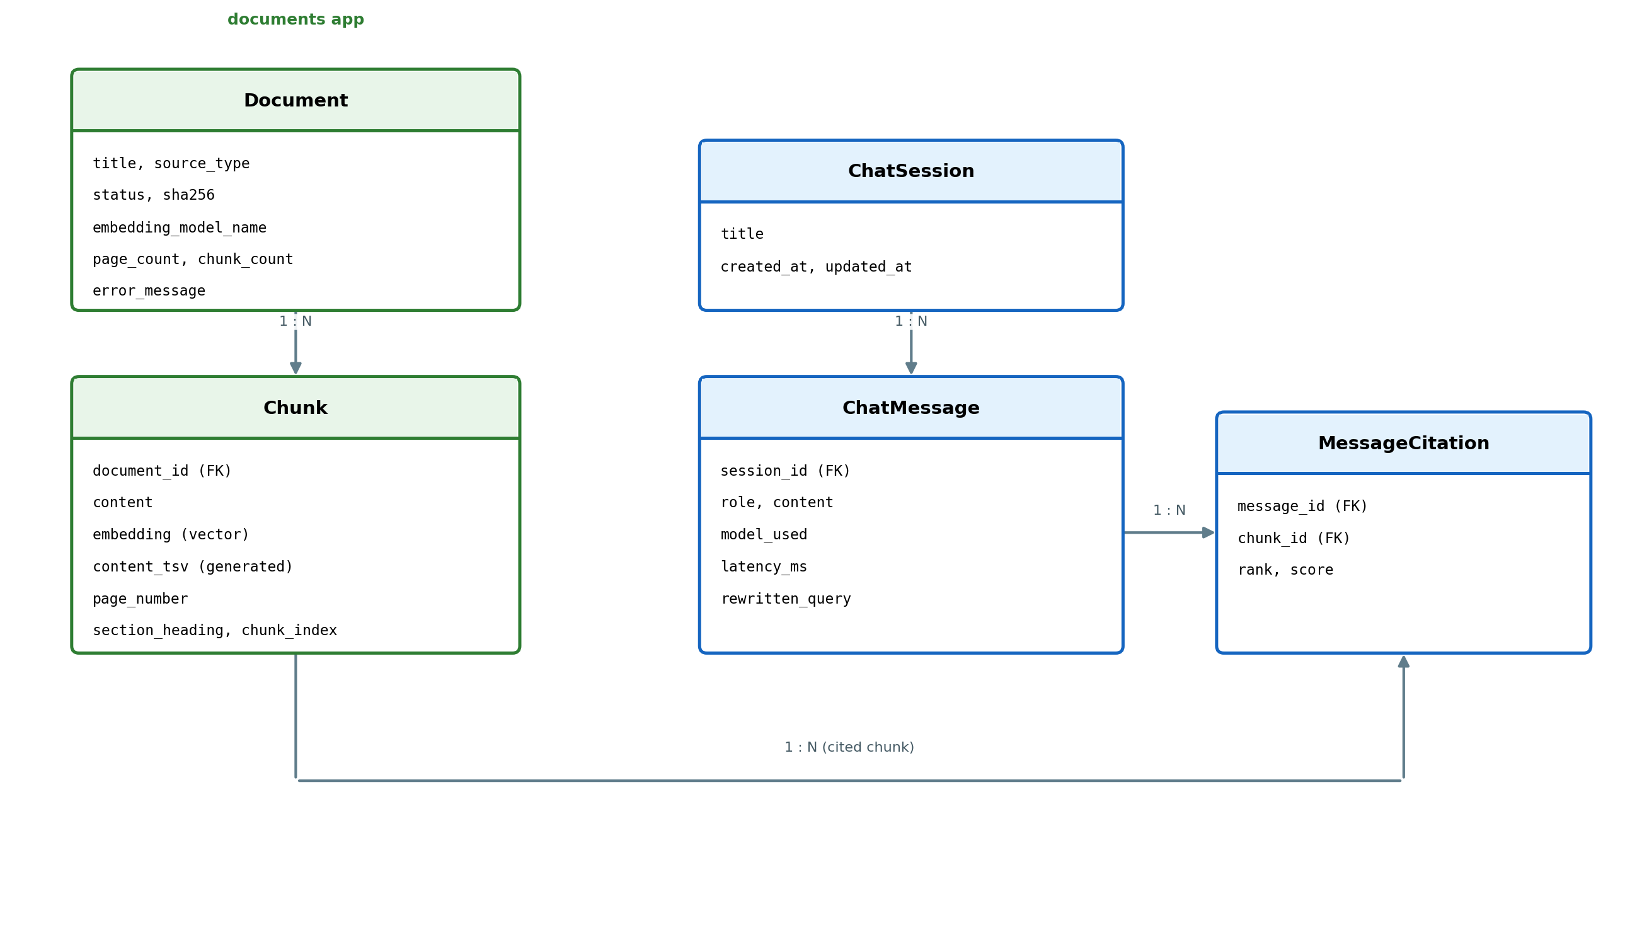
Figure 2 -- Entity-relationship diagram: the five core tables and how they relate.

5.1 Key structural decisions
Decision | Rationale
Vectors live in the same table as the content they came from (Chunk.embedding), not a separate vector-store service | Every retrieval query needs both the vector distance and the relational metadata (document, page, section) in one result row -- pgvector inside PostgreSQL makes that a single SQL query with one HNSW index, instead of a fan-out to a second system and a join in application code.
content_tsv is a PostgreSQL GENERATED column, not maintained by application code | A generated column can never drift out of sync with content -- there's no code path that updates one and forgets the other, which is a real class of bug in hand-maintained search-index columns.
MessageCitation is its own table, not a JSON array on ChatMessage | Citations need to be queried on their own terms (which chunks get cited most, by which model) and hold structured per-citation data (rank, score) -- a proper FK table supports that; a JSON blob would not be indexable or queryable the same way.
Document.embedding_model_name is stored per document, not read from global config | Config can change (a reranker or embedding profile swap) after documents are already indexed. Recording the model actually used per document makes an inconsistent index a detectable, explicit state rather than a silent mismatch discovered only as bad retrieval results.
Document.status is an explicit state machine (queued -> parsing -> chunking -> embedding -> indexed / failed), not a boolean | The sidebar can show real ingestion progress, and a failure at any stage is captured with its own error_message instead of collapsing every failure mode into one generic "failed" flag.

5.2 Normalization stance
The schema is normalized to third normal form with one deliberate exception: Document carries denormalized page_count and chunk_count counters, updated at the end of ingestion. These are read on every sidebar render; computing them with a COUNT/aggregate query per document on every request would be wasted work for numbers that only change once, when ingestion completes.

6. Runtime and Deployment Architecture
The design draws a hard boundary between the containerized application stack and the host-native LLM runtime, and treats the HTTP request/response cycle and the background ingestion cycle as two separate process types that scale independently.
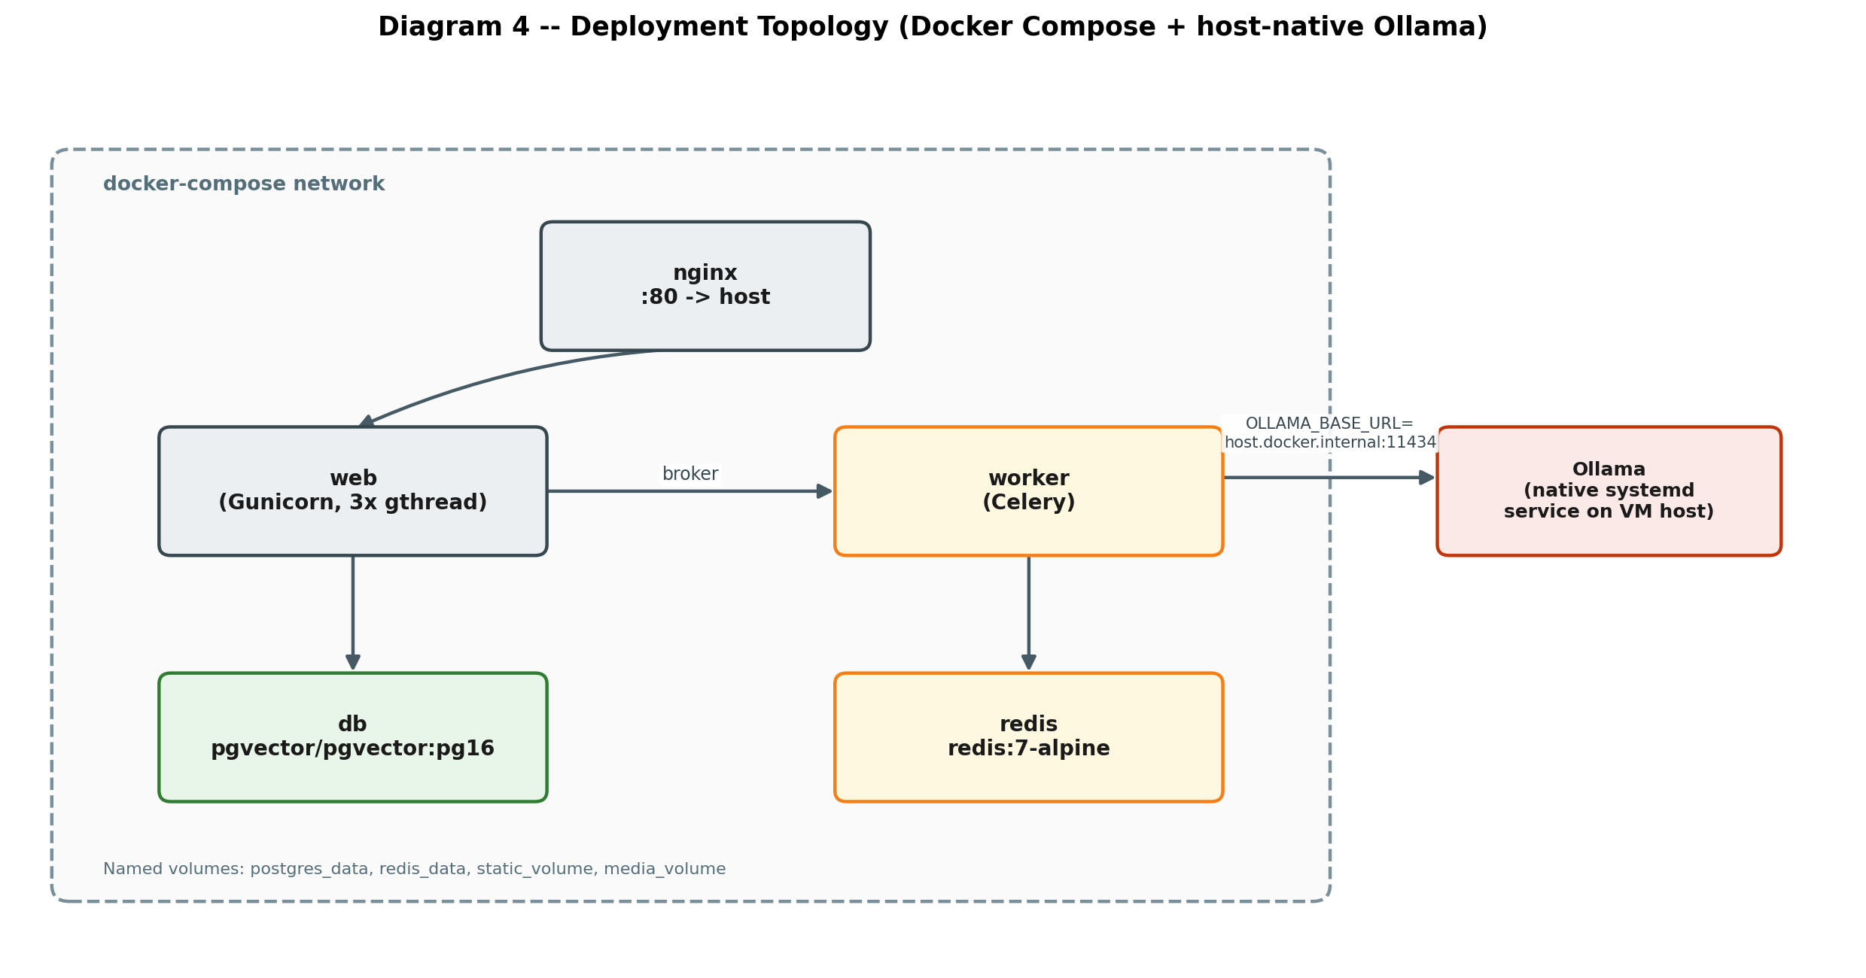
Figure 3 -- Deployment topology and process boundaries.

Boundary | Design decision
Request-serving vs. background work | gunicorn (web) and celery worker are separate processes/containers from the same image. A slow or stuck ingestion job cannot block chat requests, and vice versa -- they don't share a process, only a database and a queue.
Application containers vs. host-native Ollama | LLM inference is the one component deliberately kept out of the container boundary -- it's the most resource-intensive piece, benefits from direct hardware access, and runs under its own systemd supervision independent of docker compose's lifecycle.
Reverse proxy as the only public-facing surface | nginx is the sole container with a published host port; web, worker, db, and redis are only reachable inside the compose network -- reduces the attack surface to one process whose only job is proxying and static-file serving.
Stateless web/worker containers | All durable state lives in PostgreSQL (and the media volume for original files) -- web and worker containers can be stopped, rebuilt, and restarted without any data loss, which is what makes docker compose up -d --build a safe, repeatable deploy step.

7. Non-Functional Design Decisions
Concern | Design decision | Trade-off accepted
Scalability | Stateless web/worker containers behind nginx; Postgres/pgvector benchmarked for millions of vectors on one instance | Vertical scaling of one Postgres instance has a ceiling -- acceptable because this design targets 100+ documents / 100k+ chunks, well under that ceiling.
Availability | restart: unless-stopped on every container; Ollama under systemd with Restart=on-failure; healthchecks gate service startup order | No multi-node failover -- a single VM's hardware failure is still a full outage. Accepted for a single-VM deployment; the mitigation is fast, scripted redeploy, not live failover.
Performance (latency) | Hybrid retrieval + reranking adds latency vs. embeddings alone, but is kept off the critical path for the first token via SSE streaming -- the user sees generation start immediately after retrieval completes | Total tokens-per-second is bounded by CPU inference speed on Ollama; the design optimizes perceived latency (time-to-first-token), not raw throughput.
Consistency | Ingestion status transitions are the single source of truth (Document.status) rather than inferring readiness from the presence of chunks | A document mid-re-index briefly shows as not-fully-indexed rather than serving a mixed old/new result set -- correctness over availability of stale data.
Security | Secrets only in .env (never committed); upload validation on type/size before disk write; no public port on db/redis | No authentication on API endpoints in the current build -- an explicit, documented gap (see plan doc §7.5), acceptable only for a trusted-network deployment.
Observability | Every chat turn logs question, retrieved chunk IDs, model used, latency; ingestion failures captured as structured error_message | No centralized log aggregation/metrics dashboard yet -- logs are read per-container (docker compose logs); fine at current scale, a real gap past a handful of concurrent users.
Maintainability | One-way dependency direction (rag/ has no knowledge of documents/ or chat/); adapters isolate third-party library APIs | Slightly more indirection (a thin wrapper around ChatOllama/CrossEncoder) than calling the library directly -- paid back the first time a model swap only touched one file.
Cost | Every model (LLM, embeddings, reranker) runs self-hosted; no per-token or per-call third-party API cost | Fixed infrastructure cost (CPU/RAM/disk for local inference) instead of variable API cost -- favors predictable internal usage over bursty, low-volume usage where a paid API would be cheaper.

8. Technology Selection Rationale
Technology | Alternatives considered | Why this one
Django + DRF | FastAPI, Flask | Batteries-included ORM, migrations, and admin meant less custom infrastructure code for a data-heavy app; DRF's serializers map cleanly onto the existing model layer.
PostgreSQL + pgvector | A dedicated vector database (e.g. Milvus, Qdrant, Pinecone) | Avoids running and operating a second stateful system. pgvector's HNSW index is proven at the scale this project targets, and keeping vectors + relational metadata in one engine removes an entire class of cross-system consistency bugs.
LangChain (LCEL) | Hand-rolled prompt/chain code | LCEL's declarative composition (prompt | model | parser) gives streaming and swappable stages for free; hand-rolled code would reimplement the same plumbing with less scrutiny behind it.
Celery + Redis | Django-Q, RQ, a simple background thread | Mature retry/visibility semantics and the ecosystem's operational familiarity outweighed the extra moving part (Redis) for a task -- document ingestion -- that must not silently fail.
Ollama | A hosted LLM API (OpenAI, Anthropic, etc.), vLLM/TGI self-hosted serving | Meets the hard requirement that nothing in the pipeline calls a paid third-party API; simpler operational model than a dedicated inference server for a single-node, moderate-throughput deployment.
Cross-encoder reranking (sentence-transformers) | Skipping reranking; using the LLM itself to rerank | A dedicated cross-encoder is far cheaper per query than an LLM call, and scores the actual query-passage pair -- measurably better precision than trusting embedding similarity alone (see plan doc §4.1).
Alpine.js + Django templates | A separate SPA framework (React/Vue) with its own build and API-only backend | One deployable, no separate frontend build/CI pipeline, no CORS/auth-token surface between two apps -- proportionate to the UI's actual complexity (one page, a handful of interactive components).

9. Known Architectural Trade-offs and Risks
Documented deliberately, so they are decisions on record rather than gaps discovered later under pressure.
Risk | Why it was accepted anyway | Mitigation path if it becomes a real problem
Single PostgreSQL instance is a structural single point of failure for all durable state | Simplicity and consistency guarantees outweigh this at current scale; a distributed data layer is unjustified complexity for the target corpus size | Standard PostgreSQL HA (streaming replication + failover) if uptime requirements tighten -- doesn't require a schema or application change
Ollama running outside the container boundary couples the app to whatever host it's deployed on | Direct hardware access for inference outweighs the deployment-portability loss; still supervised the same way (systemd, restart policy) as everything else | Containerize Ollama with GPU passthrough if the deployment target changes to something less host-controlled (e.g. a managed Kubernetes cluster)
No authentication on API endpoints | Correct for the current trusted-network/internal deployment; adding it speculatively would be unused complexity today | Add session or token auth (DRF supports both natively) before any deployment reachable by untrusted users -- flagged explicitly in §7.5 of the plan doc as a pre-condition, not an afterthought
Modular-monolith coupling means the whole app redeploys together | One deployable is simpler to reason about and version at this team size; the internal app boundaries already mark where a future split would occur | Extract rag/ as its own service first if the reranker/embedding workload ever needs independent (e.g. GPU) scaling -- it already has no dependency on documents/ or chat/

