Siresoft RAG
Project Structure, Data-Flow Pipeline & Production Readiness Plan

A self-hosted Retrieval-Augmented Generation system -- Django + LangChain + PostgreSQL/pgvector + Celery + Ollama -- covering architecture, the complete request pipeline from user query to LLM answer, and the operational practices this project has actually needed in real deployment.

1. Project Overview
Siresoft RAG lets a user upload PDFs, DOCX, plain text/Markdown files, or web page URLs; ask natural-language questions in a chat interface; and receive answers grounded strictly in the uploaded material, with citations back to the source document and page/section. Every model in the stack -- the LLM, the embedding model, and the reranker -- runs locally. Nothing in the pipeline calls a paid third-party API.
Layer | Technology | Role
Backend framework | Django + Django REST Framework | HTTP API, admin, ORM, migrations
RAG orchestration | LangChain (LCEL) | Prompt templates, chains, streaming
Database | PostgreSQL 16 | Relational data + vector store (one instance)
Vector store | pgvector (HNSW index) | Dense similarity search, in the same Postgres
Keyword search | Postgres full-text (GIN + tsvector) | Exact terms, codes, numbers dense search misses
Task queue | Celery + Redis | Background document ingestion
LLM serving | Ollama (ChatOllama) | Local inference, 5 selectable models
Embeddings | sentence-transformers / HuggingFace | BAAI/bge-base-en-v1.5, self-hosted
Reranking | Cross-encoder (HuggingFace) | Reorders fused candidates before generation
Frontend | Django templates + Alpine.js + Tailwind | Single deployable, no separate frontend build

2. Project Structure
The codebase is split into four Django apps, each with one clear responsibility, plus the project config package and a self-contained frontend (Django templates, no separate SPA build).
App / Path | Responsibility
config/ | Django settings, URL routing, WSGI/ASGI entry points, Celery app definition
core/ | Shared abstract models, custom exceptions, the Ollama-availability helper, the app-shell view
documents/ | Upload endpoints, validation (type/size/SHA-256 dedup), the Celery ingestion task, document CRUD
rag/ | Loaders, chunking/splitting, embeddings, hybrid retrieval, reranking, the LangChain generation chain, the retrieval-quality proof command
chat/ | Chat sessions, messages, the SSE streaming endpoint, turn orchestration (rewrite -> retrieve -> generate -> persist)
templates/ + static/ | Single-page app shell (Alpine.js + Tailwind), compiled CSS, self-hosted fonts/JS -- no CDN dependency at runtime
docker/ + Dockerfile + docker-compose.yml | Containerized deployment: nginx, Django (web), Celery (worker), Postgres, Redis

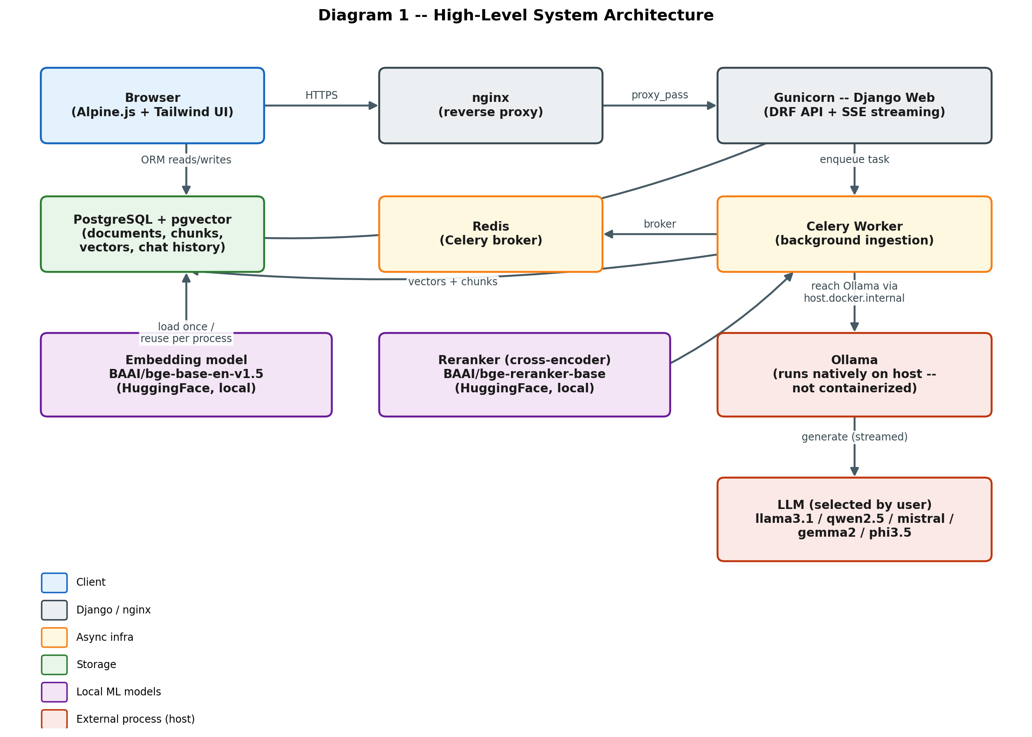
Figure 1 -- High-level system architecture: every component and how they connect.

2.1 Core Data Models
Model | App | Key fields
Document | documents | title, source_type, status (queued/parsing/chunking/embedding/indexed/failed), sha256, embedding_model_name, error_message
Chunk | rag | document (FK), content, embedding (vector), content_tsv (generated column), page_number, section_heading, chunk_index
ChatSession | chat | title, created_at, updated_at
ChatMessage | chat | session (FK), role, content, model_used, latency_ms, rewritten_query
MessageCitation | chat | message (FK), chunk (FK), rank, score -- links an answer to the exact chunks it was grounded in

3. Data Flow -- Document Ingestion
Uploading a file never blocks the HTTP request. Validation and SHA-256 deduplication happen synchronously (fast); everything from parsing onward runs in a Celery worker, with live status polled from the sidebar.
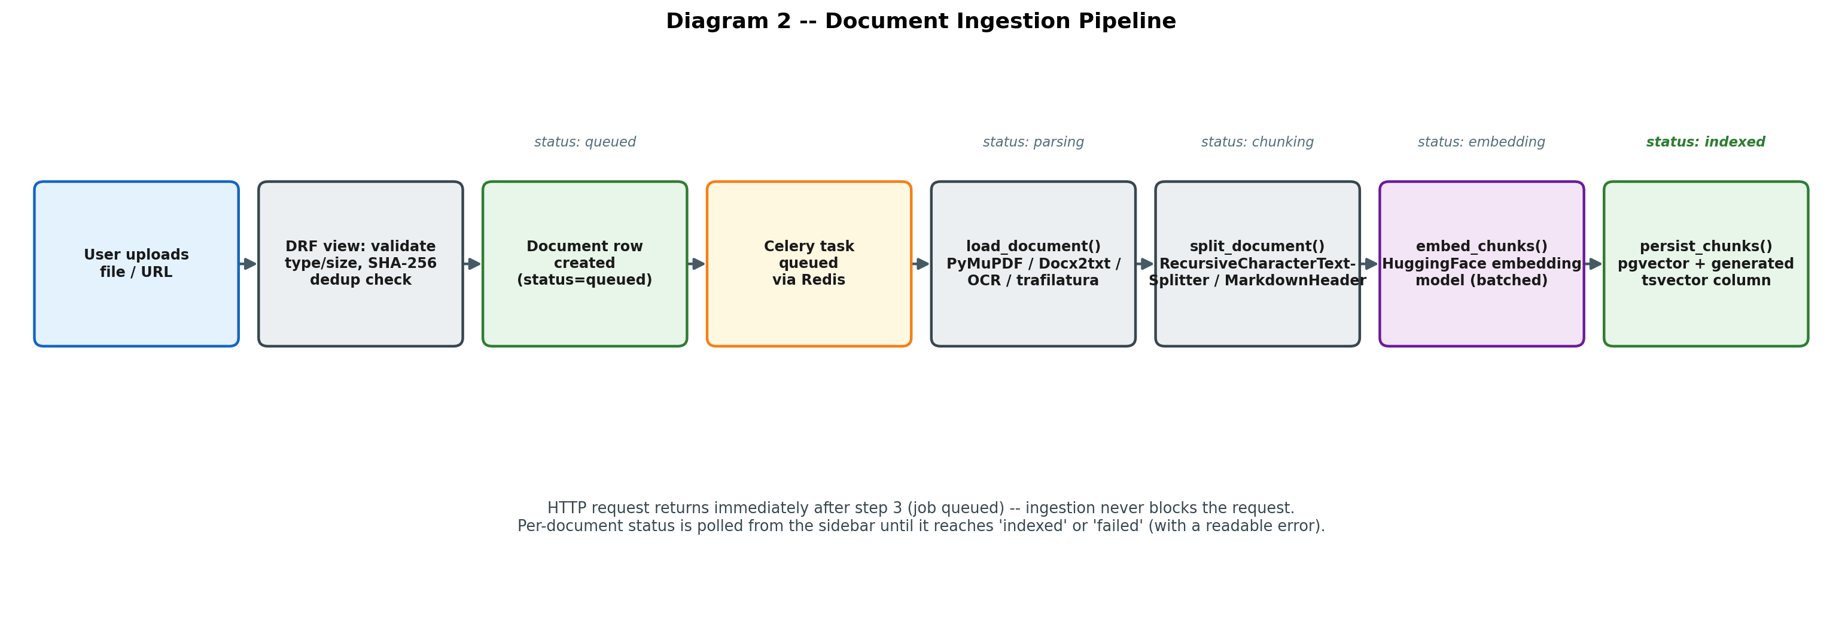
Figure 2 -- Document ingestion pipeline, from upload to a queryable, indexed chunk.

Notable engineering decisions: PyMuPDF is used for text PDFs, with an automatic OCR fallback (Tesseract) triggered when a page yields near-zero extractable text -- a scanned PDF is never silently indexed as empty. Markdown files are split header-aware first (so a chunk never crosses a section boundary), then size-capped. Every chunk's embedding model is recorded on its parent Document, so switching embedding models later is a detectable, explicit re-index rather than a silent inconsistency.

4. Data Flow -- User Query to LLM Answer
This is the core interactive path: a chat message goes through history-aware query rewriting, hybrid retrieval, relevance gating, and streamed generation -- all inside one Server-Sent-Events response, so the browser sees the answer appear token-by-token rather than waiting for the whole thing.
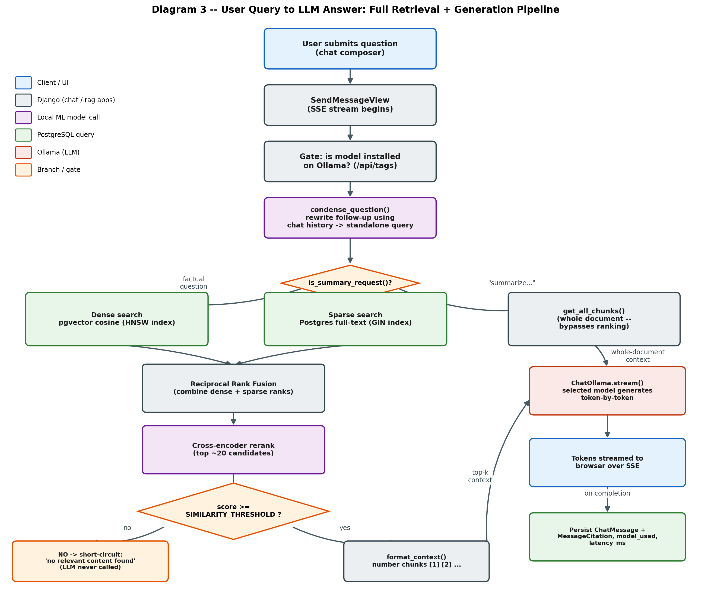
Figure 3 -- Complete request pipeline from a submitted question to a streamed, cited answer.

4.1 Why hybrid retrieval, not just embeddings
Dense (embedding) search alone misses exact error codes, product names, and numbers -- semantic similarity doesn't reliably surface a literal string like "E-4471". Sparse (keyword) search alone misses paraphrased or conceptually-related questions. The two are fused with Reciprocal Rank Fusion, and the fused candidates are then reranked with a cross-encoder, which evaluates the actual query-passage pair rather than comparing precomputed vectors -- this is the single biggest lever on answer quality in the whole pipeline.

4.2 The relevance gate
If nothing clears RETRIEVAL_SIMILARITY_THRESHOLD, the system returns "no relevant content found" without ever calling the LLM. This is deliberate: generating from empty or irrelevant context is exactly how a RAG system starts inventing facts.
Lesson learned: this threshold is not a universal constant -- it is calibrated against one specific reranker model's score distribution. Swapping the reranker model (e.g. for better accuracy on short "who/what is the name" style questions) changes the score scale by orders of magnitude and requires recalibrating the threshold from real queries against real documents, not by guessing.

4.3 Summarization is a different code path
A request like "summarize this document" is detected up front and routed around ranked retrieval entirely -- it pulls every chunk of the document in reading order instead of a relevance-ranked top-k, because a summary needs the whole document, not whatever best matches a vague query embedding.

5. Deployment Architecture
The application (Django + Celery) is fully containerized via Docker Compose. Ollama runs natively on the host rather than in a container -- LLM inference is CPU/GPU-bound work where container virtualization overhead is unwanted, and a native systemd service is already the simplest way to guarantee it survives reboots and terminal disconnects.
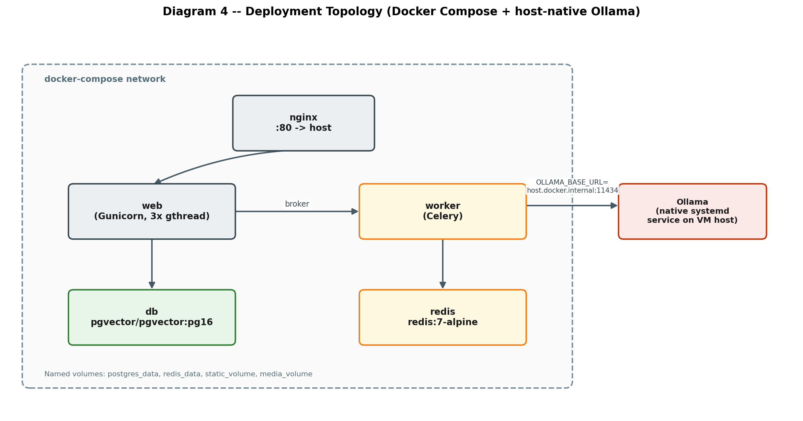
Figure 4 -- Deployment topology: containerized app stack, host-native Ollama.

Concern | How it's handled
Long-lived streaming requests | Gunicorn runs gthread workers, not sync -- a sync worker would block on one chat stream for its entire duration, starving every other request
nginx buffering | Explicitly disabled on the chat streaming route -- otherwise nginx waits for the full SSE response before forwarding anything, defeating streaming
Container survives disconnect/reboot | docker compose up -d (detached) + restart: unless-stopped on every service
Ollama survives disconnect/reboot | Installed as a systemd service (system-level on a dedicated VM, user-level via systemctl --user on a shared desktop), enabled to start on boot/login
Postgres port isolation | The db/redis services expose no host port -- only reachable from inside the compose network, avoiding collisions with any native Postgres already on the host

6. Configuration Reference
Every tunable is an environment variable (.env), never hardcoded mid-function.
Setting | Purpose
EMBEDDING_PROFILE | bge-base (768-dim, default) or minilm (384-dim, low-RAM). Changing this invalidates the existing index.
CHUNK_SIZE / CHUNK_OVERLAP | Token-based (tiktoken), not character-based. Default 800/120.
RETRIEVAL_TOP_K / RETRIEVAL_CANDIDATE_POOL | How many chunks reach the LLM vs. how many reach the reranker.
RETRIEVAL_SIMILARITY_THRESHOLD | Paired to the specific reranker model in use -- recalibrate on change (see 4.2).
RERANKER_MODEL | Swappable; e.g. bge-reranker-base (fast, ~1.1GB) vs. bge-reranker-v2-m3 (better on short/meta questions, ~2.2GB, needs more RAM/disk).
OLLAMA_MODELS / OLLAMA_DEFAULT_MODEL | The model roster shown in the dropdown; the UI disables any not actually pulled.
MAX_UPLOAD_SIZE_MB / ALLOWED_UPLOAD_EXTENSIONS | Upload validation limits.

7. Additional Considerations for an Industrial-Grade Deployment
Beyond the pipeline itself, the following are the practices that separate a working demo from something safe to run unattended for real users -- several of these were learned directly from issues hit while standing this project up, not just general best practice.

7.1 Resource planning
The embedding model, reranker, and each Celery worker process all hold their own copy of the ML models in memory. A Celery worker started with high --concurrency multiplies that memory cost directly -- size it to actual CPU/RAM, not reflexively. Budget disk for the HuggingFace model cache (multiple GB) separately from application data; a reranker model swap alone can need an additional 1-2GB. On a VM, confirm the storage backend Docker actually writes to (see 7.4) has room for this -- "disk full" during a model download fails silently as a generic error unless the logs are read carefully.

7.2 Process supervision
Every long-running process needs an explicit restart policy, not just "start it and leave the terminal open": Docker services need restart: unless-stopped; anything running natively on the host (Ollama) needs a real systemd unit (or systemd --user unit where root isn't available), enabled to start automatically -- a process started with nohup in a terminal session does not reliably survive a reboot or session teardown.

7.3 Observability
Every chat turn already logs the question, the chunk IDs retrieved, the model used, and latency in milliseconds -- this is what makes a bad answer debuggable after the fact instead of unreproducible. The same discipline should extend to ingestion failures (already captured as a human-readable Document.error_message, not a raw traceback) and to periodic checks that the HNSW index is actually being used (EXPLAIN ANALYZE) rather than degrading to a sequential scan as the corpus grows past the six-figure chunk count this system is designed for.

7.4 Infrastructure surprises worth planning for
Issue | Why it matters
Docker's actual storage backend | Modern Docker installs often use containerd's own snapshotter, which has a storage root independent of Docker's own data-root setting -- moving one without the other silently leaves the real data on the original (possibly small) disk.
A reranker's score scale is model-specific | Sigmoid-normalized scores from different cross-encoder models are not comparable -- a threshold tuned for one model can silently reject everything, or accept everything, on another.
Framework-level directive misuse can look like a data bug | A frontend loop directive applied to the wrong element rendered only one list item instead of many -- from the outside this looked identical to a backend/API problem until the actual markup was inspected.
CPU-only vs GPU package builds | An unpinned ML dependency can silently resolve to a multi-gigabyte GPU build in a fresh container even when the host has no GPU -- pin the CPU wheel index explicitly.

7.5 Security baseline
Secrets (DJANGO_SECRET_KEY, DB credentials) live only in .env, never committed. Uploads are validated on both file type and size before touching disk. In the current build, API endpoints are open (no authentication) -- acceptable for an internal/trusted-network deployment, but a real production rollout facing untrusted users needs authentication on both the upload and chat endpoints, plus rate limiting on the LLM-calling routes specifically (generation is the expensive, abusable operation, not the CRUD endpoints).

7.6 Testing strategy
Unit tests mock the ML/LLM boundary (embedding model, reranker, Ollama) so the suite runs in under a second with no GPU and no downloaded models -- what's under test is this project's own logic (chunking, RRF math, status transitions, citation persistence), not the correctness of third-party libraries. Retrieval quality itself is separately verified against a live corpus and live models via a dedicated management command, producing a real, re-runnable before/after comparison rather than a one-time manual check.

7.7 Backup and recovery
All durable state -- documents, chunks, embeddings, chat history -- lives in one PostgreSQL instance, which simplifies backup to a single pg_dump / continuous-archiving strategy. Original uploaded files are kept separately (media volume); losing them doesn't lose searchability (the extracted chunks remain), but re-ingestion after a restore requires them, so both should be backed up together.

7.8 Scaling path, if usage grows
For a genuinely large corpus (well beyond the 100+ documents / 100k+ chunks this design targets), the next levers are, in order of how cheap they are to pull: increasing Gunicorn/Celery worker counts (near-zero engineering cost), moving the embedding/reranker models to a GPU host, and only then reaching for infrastructure this project deliberately did not need -- a distributed storage/processing system (e.g. Hadoop/Spark) has no role here since PostgreSQL with pgvector is explicitly built and benchmarked for millions of vectors on a single instance; that kind of cluster infrastructure would add operational cost without solving a problem this system actually has.

