ALBERTO / ATELIER

Design Document
Website design, structure and implementation


Project | Alberto Atelier — Luxury Watch Website
Submitted by | Muhammad Awais | Student ID: 1733752
Course | Aptech E-Project | Frontend web development

DOCUMENT MAP

Contents
This guide follows the actual screens and files in the submitted project.
01 Project brief — purpose, target users and scope
02 Requirements — what each page needs to do
03 Site structure — navigation and file organisation
04 Visual direction — typography, colour and layout
05 Page designs — home, collection and supporting pages
06 Cart and orders — local storage and request journey
07 Account and theme — frontend-only login and appearance
08 Offline behaviour — what works and under which conditions
09 Testing and handover — realistic checks and limitations

Project team
Member | Student ID
Muhammad Awais | 1733752
Haider Shah | 1733014
Habib Alam | 1733025
Hassan | 1729113

Faculty: Muhammad Arkam Tariq |

01 / PROJECT OVERVIEW

Project brief
A responsive watch-catalogue website built as an Aptech E-Project.
Alberto Atelier is a front-end project presenting a catalogue of watches through a luxury-inspired visual design. Visitors can browse collections, place watches in a shopping bag, and prepare a request using a customer-details form. The website also includes account demonstration pages and a day/night appearance switch.

Why the website was made
A watch website needs more than photographs. Visitors should be able to move between the brand story, product selection and contact details without losing their place. For this project, the aim was to practise a complete multi-page interface while keeping interactions clear enough to demonstrate in class.

Scope of the E-Project
- Responsive pages for Home, About, Collection, Services, Contact, Login/Register and Shopping Bag.
- A JavaScript product catalogue with filters, sorting, quantity controls and local cart storage.
- Order-request form with a locally saved reference and an optional email hand-off.
- Day/Night presentation modes and animated offline/404 page designs.
PROJECT BOUNDARY The project is not connected to a store database or payment gateway. Accounts and saved order requests are browser-local demonstrations, not live customer transactions.

02 / FUNCTIONAL REQUIREMENTS

Requirements
The features below are taken from the supplied website rather than added as future promises.
Area | Required behaviour
Navigation | Visitors can reach the principal pages from a shared menu.
Catalogue | Product images, names, categories and demo prices are shown as cards.
Filters and sorting | Visitors can narrow or reorder the product display.
Shopping Bag | Add items, adjust quantities, remove selections and view a summary.
Order request | Enter contact and delivery details; save a local request reference.
Account demo | Register, sign in, view account state and sign out in the browser.
Theme | Switch between dark and light appearances; remember the preference.
Offline | Use cached offline assets after a successful installation where supported.

Non-functional requirements
- Pages should remain readable on desktop and phone screens.
- Controls need a visible hover, focus or confirmation state.
- Image paths, CSS links and JavaScript files must remain valid after extraction.
- The navigation and colour scheme should look consistent across the site.

03 / ARCHITECTURE

Website structure
The site is made of separate HTML pages and shared front-end assets.
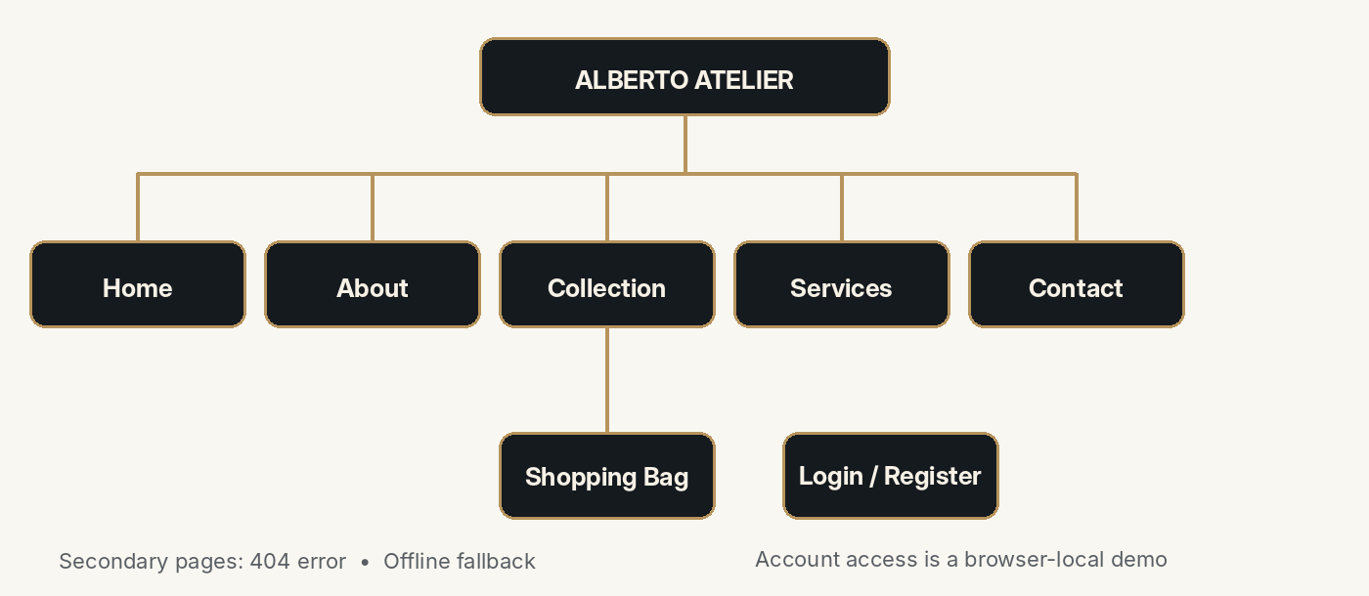
Simplified sitemap based on the project navigation and the account/cart shortcuts.

Folder arrangement
Location | Purpose
index.html | Main landing page
pages/ | About, Product, Services, Contact, Cart, Login and Register pages
css/ | Dedicated stylesheets for page layouts and effects
js/ | Catalogue, cart, account, order, theme and navigation scripts
images/ | Watch imagery and other supplied photographs
sw.js + offline.html | Service Worker and cached offline screen

SUBMISSION NOTE No Python or Node.js server is required by the submitted site. Use a development web server such as the VS Code Live Server extension to preview relative paths and browser storage correctly.

04 / DESIGN SYSTEM

Visual direction
The interface uses restrained dark surfaces and champagne-gold details.
The main visual language is charcoal, warm gold and large watch photography. Serif headings carry the editorial feel, while a simpler sans-serif face keeps navigation, labels and forms readable. The hierarchy is deliberately clear: brand statement first, call-to-action second, supporting details after that.
Element | Design choice | Reason
Background | Charcoal / near-black | Keeps attention on photography
Accent | Champagne gold | Connects primary links and controls
Headings | Editorial serif style | Helps headings stand apart from body text
Body copy | Readable sans-serif | Works well in forms and cards
Cards | Subtle borders and modest shadows | Separates products without clutter
Movement | Short transitions and entrance effects | Makes actions feel responsive


Home screen showing the watch-led hero, navigation and primary collection action.

05 / PAGE COMPOSITION

Home and supporting pages
Each page has a specific job rather than repeating the home screen.

Home
The landing page introduces Alberto Atelier with the “Beyond Time” heading, a large watch image and a route into the collection. The header stays familiar when moving to inner pages.

About
About presents the brand story and the design values used across the site. Its copy and visual sections are intended to be read in sequence rather than treated as product cards.

Services and Contact
Services explains the website’s service offering. Contact provides information and an enquiry route. They support browsing by giving visitors a place to ask questions before preparing an order request.
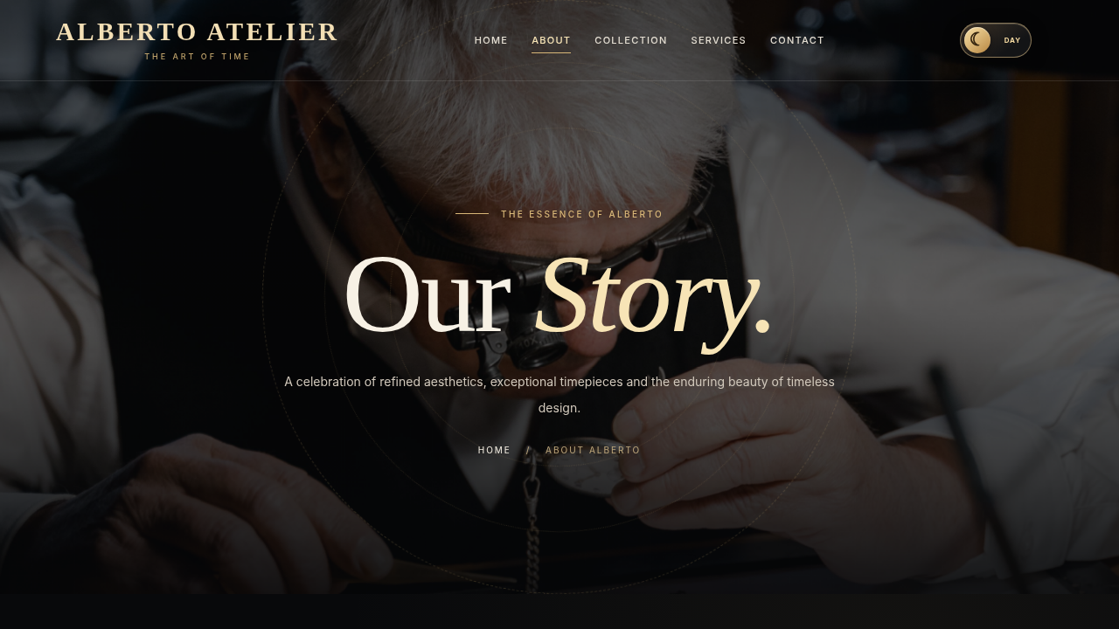
About page, retaining the same navigation rhythm as the landing page.

06 / CATALOGUE

Collection page
The catalogue is handled by JavaScript rather than duplicated static product cards.
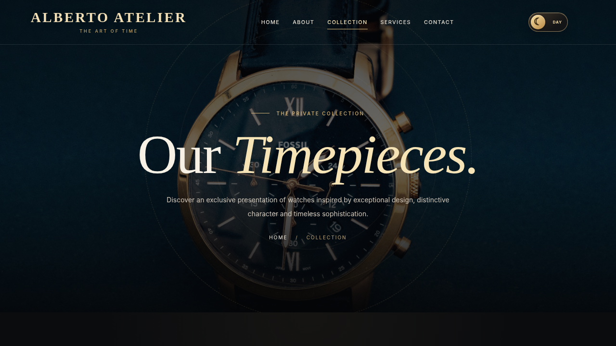
Collection hero and entry point to the product cards.

Product information
Product records are supplied by js/product-catalog.js. Each watch has an identifier, name, category, sample PKR price, image path and short description. The page script renders the cards and connects the filter, sort and Add to Cart controls.

Selection feedback
After Add to Cart, the shopping-bag quantity changes. A short box-and-trolley animation provides visual feedback. It is an interface confirmation only; it does not place an online order.

07 / CART INTERACTION

Shopping Bag
The bag combines product selections with quantity and price controls.
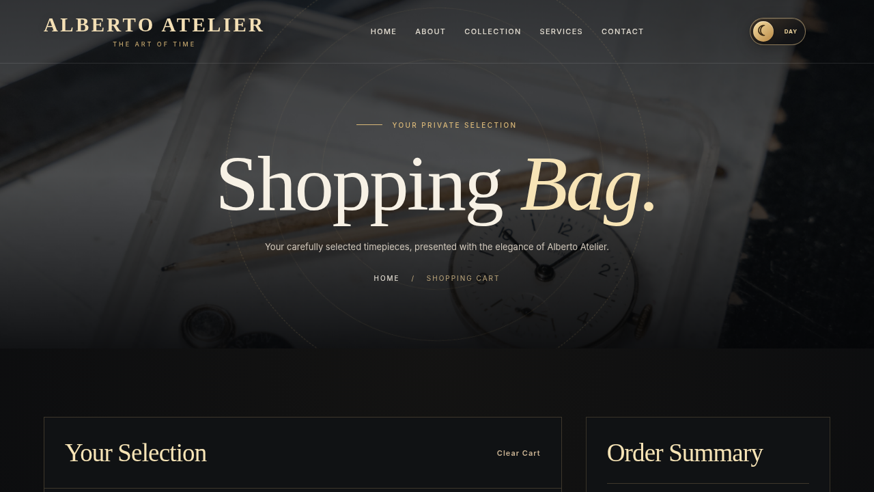
Shopping Bag screen: selected watches and an order summary.

Storage and recalculation
The cart is stored in localStorage under alberto_atelier_cart_v1. Product and bag scripts read the same key, so the selection remains available when changing pages in the same browser. Updating a quantity changes the displayed subtotal; removing a product updates the total and item count.

Typical user path
- Open Collection and select a watch.
- Press Add to Cart and verify that the bag count increases.
- Open Shopping Bag; change quantity or remove an item.
- Check the summary before choosing Request This Order.

08 / ORDER FORM

Request an order
The process is a saved enquiry, not an automatic checkout.
The order button opens a form requiring the customer’s name, phone, email, address and city. Postal code and additional instructions are optional. The user can review the selected items and subtotal before saving.
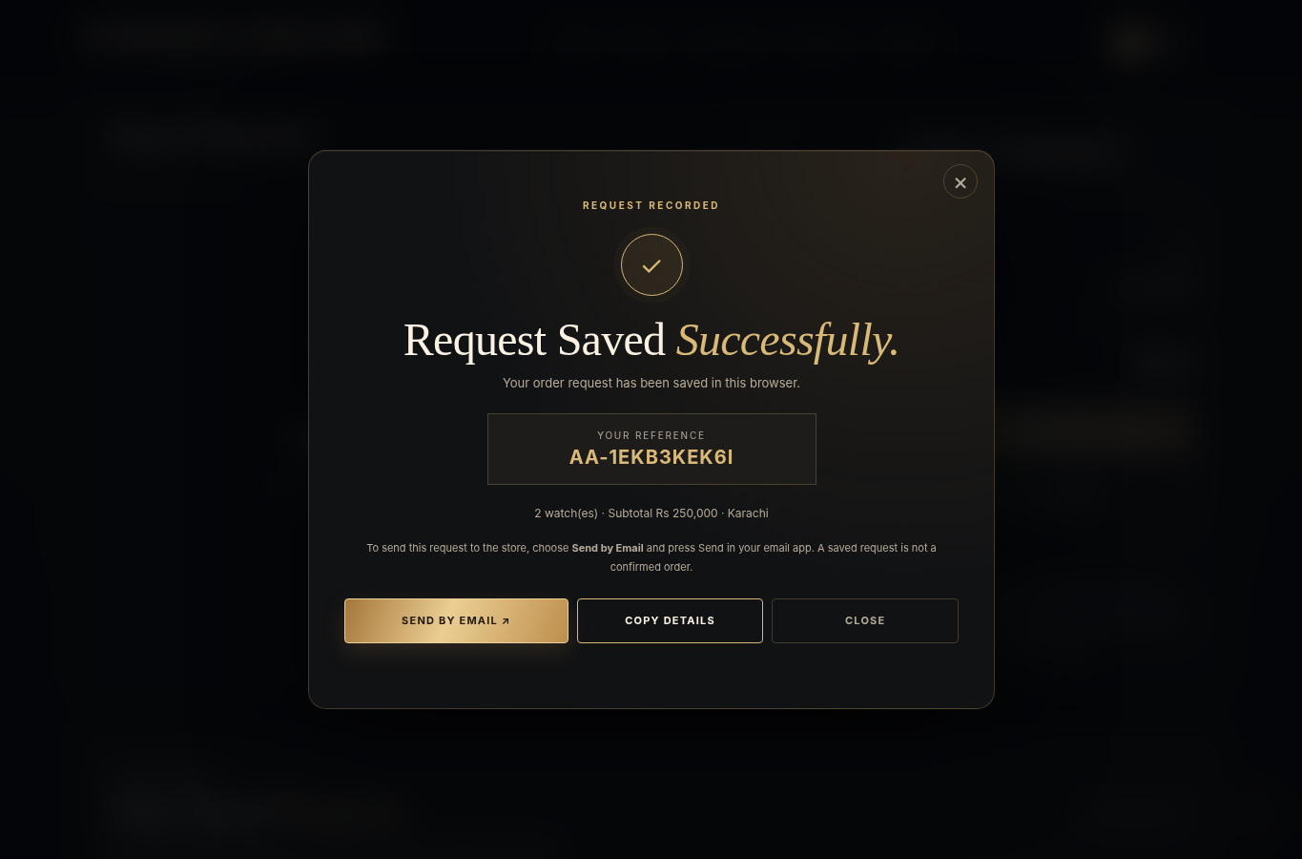
Confirmation view after the request is saved in the current browser.

How confirmation works
On submit, the page writes a request record to localStorage using alberto_atelier_order_requests_v1 and generates a reference. The confirmation modal displays that reference. A separate Send by Email option lets the visitor open a prepared email, but the visitor must send it in their own email application.
DO NOT CONFUSE “Request Saved Successfully” means the browser saved a demo request. It does not mean a shop has accepted or received an order.

09 / ACCOUNT & APPEARANCE

Account and theme
Both features are implemented within the browser.

Account demonstration
The Register and Sign In pages allow visitors to create and use a local demo account. js/account-store.js stores a salted password verifier and uses sessionStorage for the active demo session. The account is not available on another device and is not a production identity system.

Day / Night
The display preference is saved under alberto_atelier_theme. The dark mode retains the original charcoal-and-gold style; the light mode changes the main surfaces to warm ivory while keeping gold as an accent. A header toggle lets visitors switch modes without leaving the page.
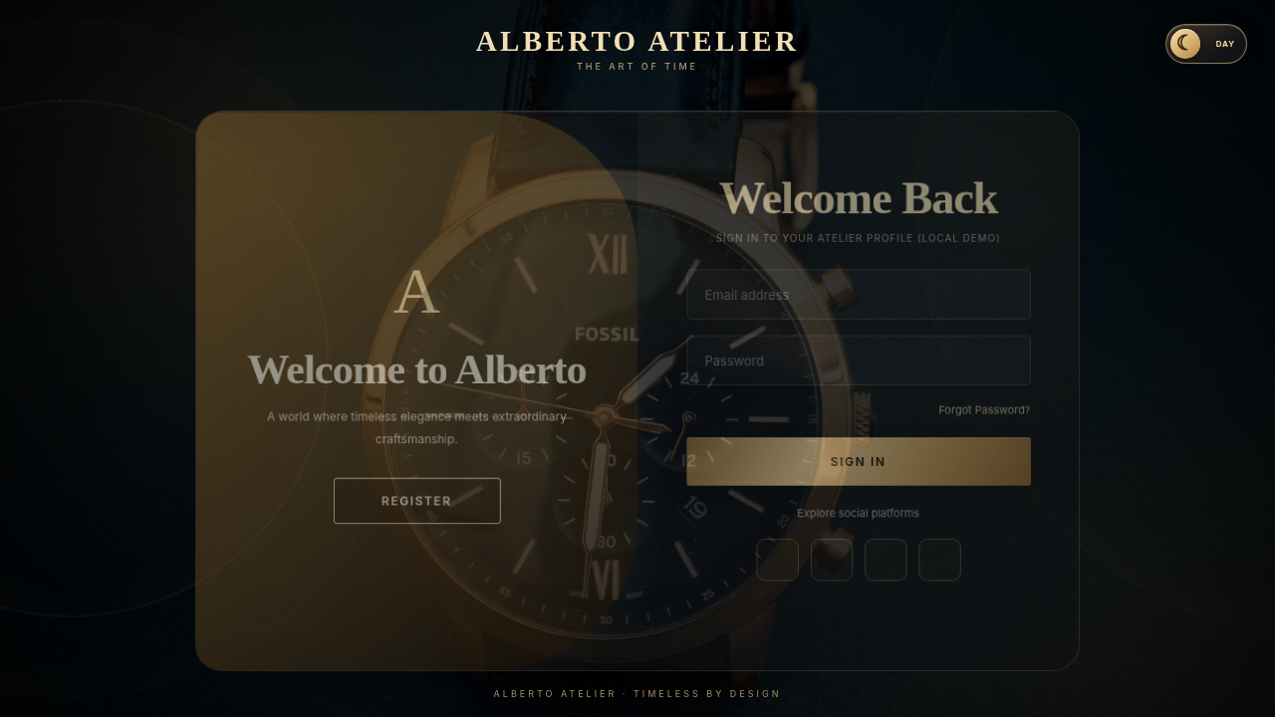
Account screen in the supplied website build.

10 / RESILIENCE

Offline and error pages
The project includes artwork for two different browser situations.

Connection lost
js/network-guard.js registers sw.js where the browser supports Service Workers. The worker caches offline.html and its separate style/script files. Once that cache exists, a failed navigation can show the animated offline screen. A first visit with no connection cannot be expected to do this.

Page not found
A separate 404 page exists, but whether it appears automatically for an unknown URL depends on the host or development server. The static page alone cannot replace every browser or server error message.
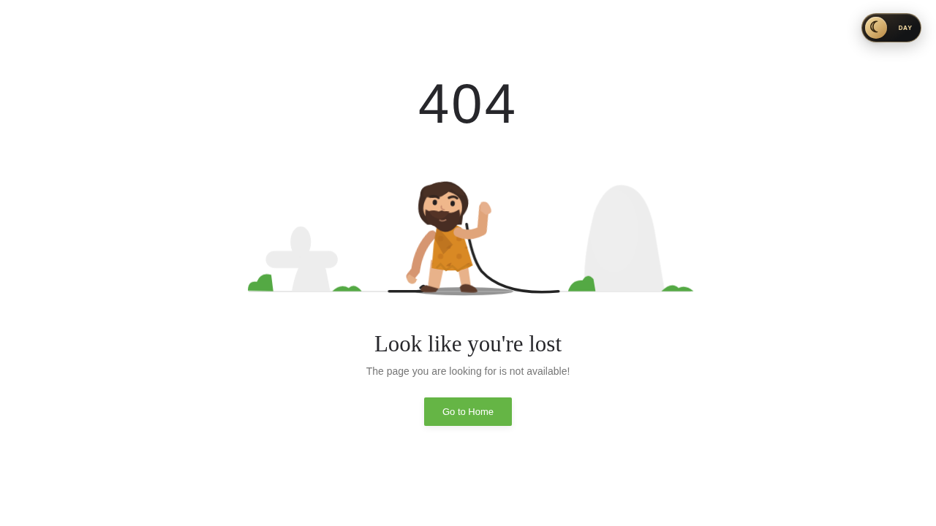
Included animated 404 illustration (shown here as a still frame).
TESTING CONDITION VS Code Live Server and real hosting can handle unavailable URLs differently. Offline testing should be done after allowing the Service Worker to cache its files.

11 / VERIFICATION

Testing and review
Checks to perform on the submission laptop before presenting.
Test | Action | Expected result
01 | Open main navigation links | Correct page opens and styles load
02 | Filter the collection | Visible product list responds
03 | Add a product | Bag counter and animation respond
04 | Change bag quantity | Line total and subtotal update
05 | Register a demo account | Account is saved in current browser
06 | Sign in, then sign out | Account state updates
07 | Switch Day / Night | Preference remains after refresh
08 | Save an order request | Reference and local history appear
09 | Reconnect after going offline | Cached offline screen is available where supported

Known limitations
Prices are examples; stock and delivery are not checked. There is no payment capture, shared customer database, automatic seller notification or shipment tracking. Browser storage can be cleared by the user. External Bootstrap/jQuery/CDN resources may require an internet connection.

12 / SUBMISSION

Handover notes
A simple checklist for presenting the project accurately.
- Extract the complete project; keep the existing css/, js/, images/ and pages/ directories together.
- Open the extracted folder in Visual Studio Code and run index.html through Live Server.
- Check pages and images before class. Internet is needed for any libraries loaded through CDN links.
- Use sample details—not personal passwords—when demonstrating Login and Register.
- Show catalogue → Add to Cart → Shopping Bag → Request This Order in that order.
- Explain that the request reference is saved locally and email sending is a separate step.

Technologies used
HTML5 is used for structure, CSS3 for the visual design and responsive layout, JavaScript for interactivity and browser storage, and Bootstrap/jQuery on the pages where they are linked. No Python or Node.js application backend is included in this website package.

Closing note
This project demonstrates a connected front-end shopping journey: finding a watch, managing a bag, entering details and seeing a request reference. A future version would need a secured server, shared database and order processing before it could be used as a live store.

