ALBERTO / ATELIER

User Guide
How to use the website, from browsing to request saving


Project | Alberto Atelier — Luxury Watch Website
Submitted by | Muhammad Awais | Student ID: 1733752
Course | Aptech E-Project | Frontend web development

DOCUMENT MAP

Contents
This guide follows the actual screens and files in the submitted project.
01 Getting started — open the site correctly
02 Navigation — menu, account and shopping bag
03 Home and About — meet the brand
04 Collection — find watches and use filters
05 Add to Cart — watch the counter and feedback
06 Shopping Bag — adjust selections
07 Request form — enter customer details
08 Saved requests — read the confirmation
09 Login / Register — use a local demo account
10 Appearance and contact — Day/Night and help
11 Offline and troubleshooting — what to check if a page fails

Project team
Member | Student ID
Muhammad Awais | 1733752
Haider Shah | Not provided
Habib Alam | Not provided
Hassan | Not provided

Faculty: Muhammad Arkam Tariq |

01 / GETTING STARTED

Before you start
Keep the whole website folder together.
The Alberto Atelier website can be opened in a modern browser after serving the files with a simple local development server. For a class demonstration, open the project folder in Visual Studio Code and select “Open with Live Server” on index.html.
- Do not move index.html away from the css/, js/, images/ and pages/ folders.
- Allow localStorage in the browser so cart and demo-account features can save data.
- Keep an internet connection when loading Bootstrap/jQuery resources from a CDN.
- Use test information for the registration and order forms.
IMPORTANT This is a student front-end project. Sign-in details and order requests are stored in the browser, not in an online customer account.


Homepage as it appears in the current project.

02 / NAVIGATION

Using the main menu
A consistent header links the website sections.
Header navigation across the top of the landing page.
Menu item | What it opens
Home | Website introduction and collection shortcut
About | Brand story and design approach
Collection | Watch catalogue with category and sorting controls
Services | Service descriptions
Contact | Contact information and enquiry form
Shopping bag | Current selections and order-request action
Sign In / Account | Demo Login, Register and account state

On a small screen, use the menu icon to show the navigation links. The bag counter reflects items saved in this browser.

03 / BROWSING

Home and About
Begin with the introduction, then move to the watch collection.

About page with the Alberto Atelier brand introduction.

Home
The “Beyond Time” headline is the starting point. Use Explore Collection to go directly to the watches, or open About to read the project’s brand story. The large watch photograph is part of the website’s main identity.

About
Use the navigation menu to open About. Scroll to read the description of the brand and the presentation of watchmaking details. The page is informational; buying actions begin on Collection.

04 / COLLECTION

Finding a watch
The Collection page is the centre of the shopping demonstration.
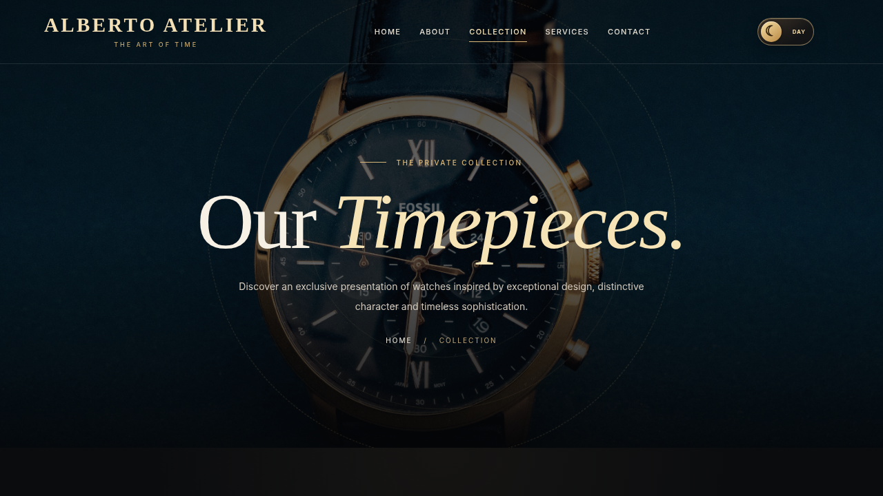
Collection page before scrolling to the product cards.
- Select Collection from the top navigation.
- Scroll down to the watch grid.
- Use the category buttons to narrow the collection.
- Use the sorting control to change the order of displayed items.
- Check the watch name, demo price and image before adding it to the bag.
The prices shown on product cards are sample PKR amounts for coursework. They are not a live stock or payment quotation.

05 / ADD TO CART

Adding products
A short animation confirms that the browser has updated the bag.

Add a watch
- Find a watch card in the product grid.
- Select Add to Cart.
- Look for the box-and-trolley animation near the right side.
- Check the shopping-bag counter in the header.
- Repeat for more watches if needed.

When the button does nothing
Reload the page once and check whether JavaScript loaded correctly. If browser storage is disabled, the bag may not be able to save changes. Use the console only if you are comfortable inspecting website errors.
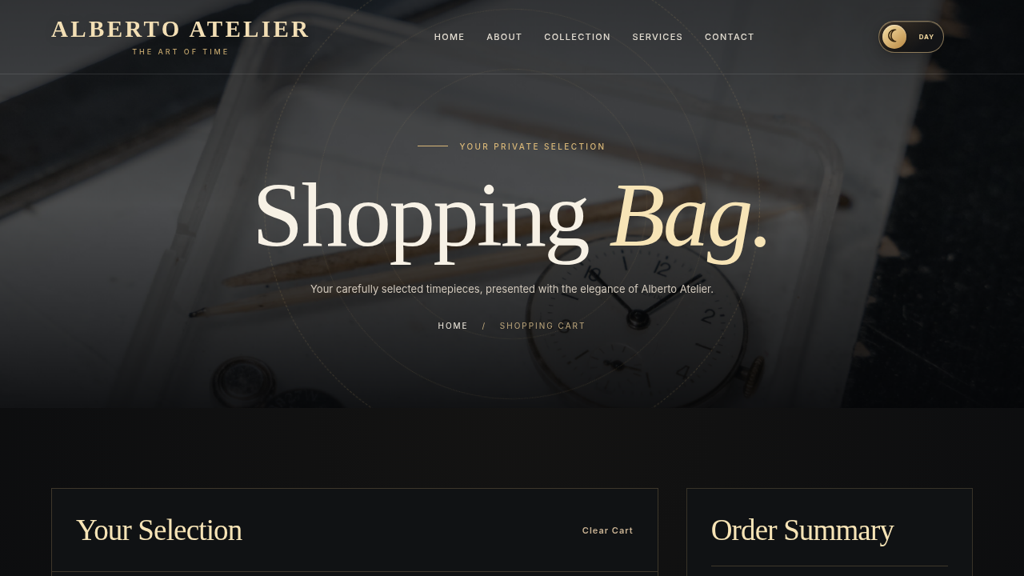
Selected items can be reviewed on the Shopping Bag page.

06 / BAG

Managing the Shopping Bag
Adjust quantities before sending a request.
Shopping Bag includes selection details and an order summary.
- Open the bag icon in the header.
- Use the plus/minus controls to change the quantity of a selected watch.
- Remove an item if it is no longer needed.
- Review the subtotal after every change.
- Choose Request This Order when the bag contains the items you want.
WHERE THE BAG IS KEPT The selection is saved in this browser. Clearing local site data or using another browser can remove it.

07 / CUSTOMER DETAILS

Completing the request form
Enter the details carefully before saving.
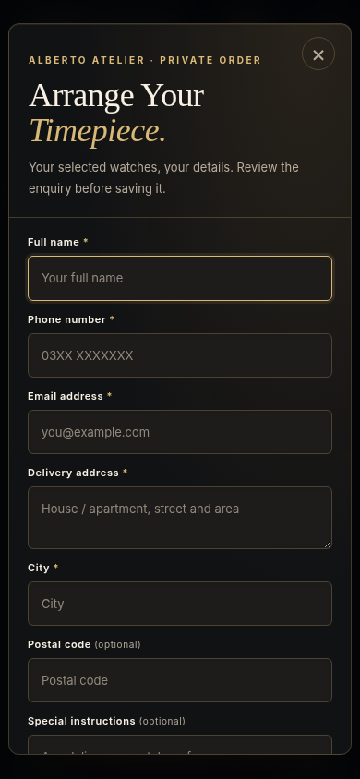
Mobile form layout used for entering customer and delivery details.

Fields in the form
The form asks for name, phone number, email address, delivery address and city. Postal code and delivery instructions may be left blank. The side or top summary shows the watch selection and amount so it can be checked before submission.
When ready, use Save Request. This saves the entry in the browser; it does not charge a card or send the order to a seller.

08 / CONFIRMATION

After saving a request
The confirmation is a local reference, not a store acceptance.
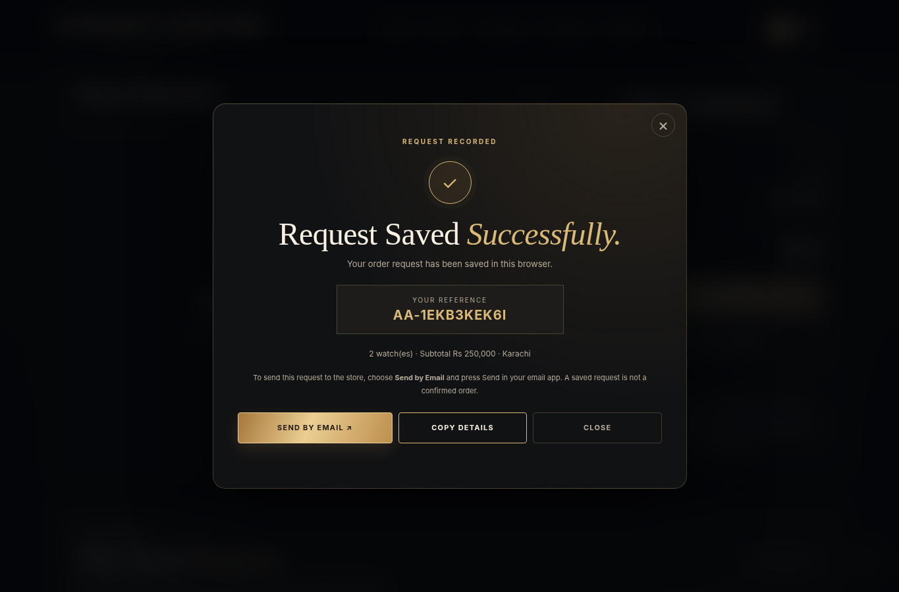
The successful local-save message with a reference number.
- Read the reference shown in the confirmation window.
- Open saved request history if you need to see it again in this browser.
- Choose Send by Email if you want an email application to open with the request details.
- Press Send yourself in the email application; the website cannot send it automatically.
REMEMBER The store has not received your request until the email has actually been sent and acknowledged. No online payment takes place here.

09 / ACCOUNT

Registering and signing in
The account feature is designed for an offline classroom demonstration.
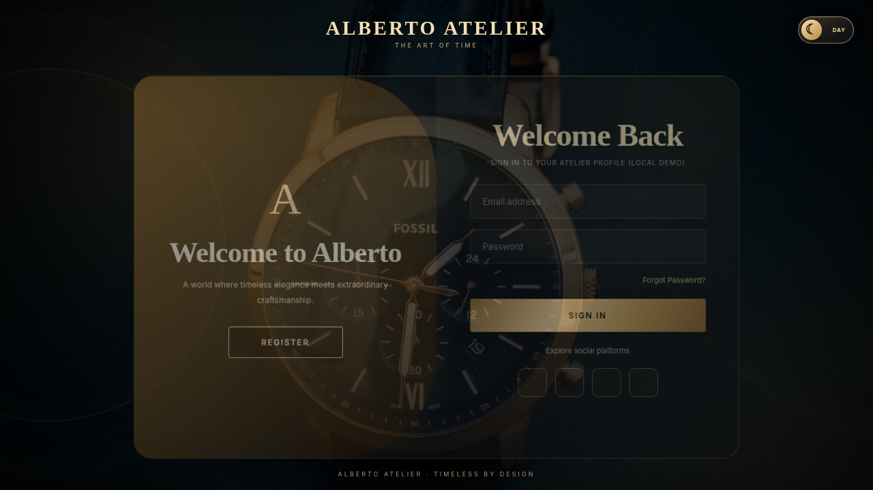
Sign In page provided with the website.

Create an account
Open Sign In and select Register. Enter a demo name, email and a password of at least eight characters. The account is saved in the current browser. Do not reuse an important personal password.

Sign In and Sign Out
Return to Sign In, enter the same demo email and password, and submit. The account area then shows the signed-in state and a Sign Out action. Accounts do not sync across different browsers or computers.

10 / PREFERENCES

Day / Night and contact
Appearance settings do not change your cart.

Changing the theme
Use the Day/Night control beside the header actions. Night mode displays the original charcoal background with gold accents. Day mode uses a lighter ivory treatment. The chosen mode is remembered in browser storage.

Services and Contact
Services explains the project’s service sections. Contact is where visitors can find the available email/phone details or prepare a general enquiry. It is separate from the shopping-bag order request.
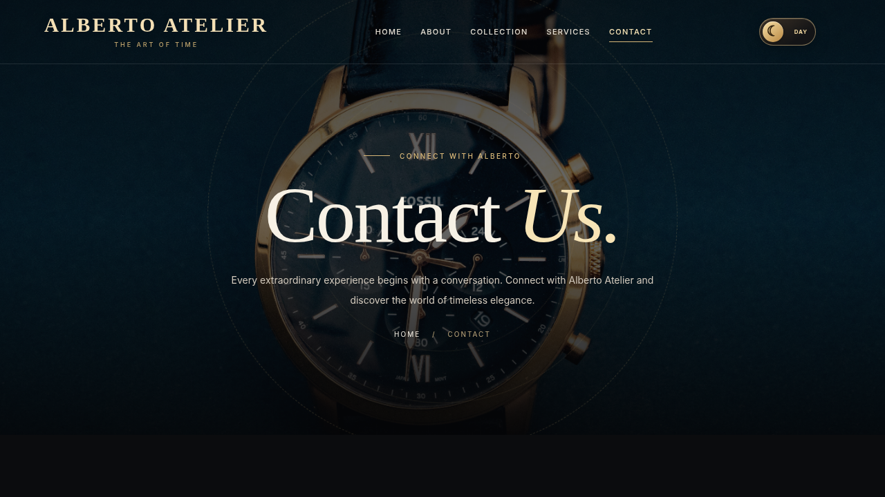
Contact page uses the same navigation system as the other sections.

11 / TROUBLESHOOTING

When something goes wrong
Most classroom issues come from missing files, blocked storage or offline resources.
Problem | Check this first
Page looks unstyled | Keep the css/ folder and ensure Live Server opened the project root.
Images are missing | Do not rename or move files inside images/.
Bag does not save | Allow localStorage and try the same browser window.
Login cannot register | Use Live Server on localhost and test in a current Chrome/Edge browser.
Theme does not stay saved | Check that site storage is not blocked or cleared.
Bootstrap/icons unavailable | Reconnect for CDN-hosted library files.
Custom 404 does not appear | The server may provide its own not-found page.
Offline page does not appear | Open online once first to allow the Service Worker to cache assets.

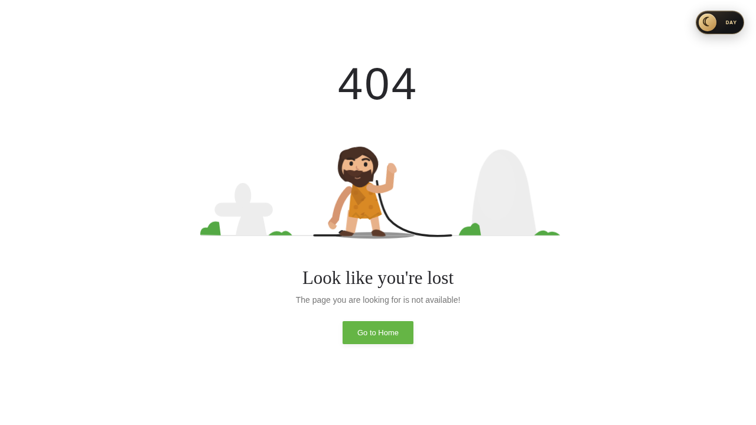
404 page artwork included in the project. Automatic routing depends on hosting.

12 / CLASSROOM WALKTHROUGH

A quick demonstration route
Useful sequence for presenting the website to the faculty.
- Launch Home and show the navigation links.
- Open About and briefly explain the brand design.
- Go to Collection; show filtering and a sample watch card.
- Add one watch and point out the bag counter and animation.
- Open Shopping Bag, increase quantity and check the subtotal.
- Open Request This Order, enter demo details and save the local request.
- Show the reference, then explain the separate Send by Email option.
- Demonstrate Sign In/Register and Day/Night mode.

Project limitations worth mentioning
This website does not contain a Python or Node.js application backend. Its shopping bag, account demo and request history are stored locally. It has no online payment, shared inventory, seller dashboard or automatic dispatch service.

End of guide
The main task for a visitor is straightforward: view the collection, select a watch, review the bag and save a request. A student demonstrating the project should be able to repeat that journey without changing the source code.

