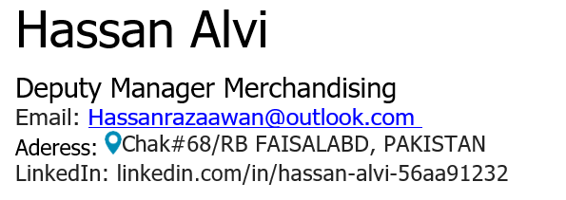
Professional Summary
Dynamic marketing & merchandising professional having 7+ years’ experience with proven success at Masood Textile Mills Ltd., excelling in apparel product development and production planning. Adept at fostering relationships with major brands, I leverage strong analytical skills and effective communication to accomplish targets. Committed to enhancing productivity and driving results in fast-paced environments.
WORK EXPERIENCE

DEPUTY MANAGER MARKETING Masood Textile Mills Ltd. | *17/08/2018 – Current*

Key Responsibilities:
Product Development & Marketing for European Brands:
- Developed and executed Development plans for high-fashion brands: (PME LEGEND, PEPE JEANS, THE STING, HUGO BOSS, MARKS & SPENCER). Sourced new leads, strengthened client relationships, and exceeded annual export targets.
- Managed styling, fabrication, finishes, and raw material selection for apparel.
Apparel Development & Team Leadership:
- Led end-to-end product development from prototyping to bulk production.
- Key tasks:
  - Created development timelines and distributed artwork for prints, yarn-dyes, and jacquards.
  - Approved embellishments (embroidery/printing) and negotiated costs with brands.
  - Settled MOQ (Minimum Order Quantity) and lead times for bulk orders.
  - Supervised PPR (Pre-Production Review) meetings to address bulk risks.
  - Ensured compliance with brand quality standards during production.
- Managed fabric database, lab dip approvals, and seasonal fabric libraries.
- Liaised with mills and overseas offices for fabric inquiries and alternatives.
Production & Planning:
- Oversaw bulk order execution, including sealer comments and testing (PERR).
- Monitored production timelines and reported to management.
- Evaluated team performance to boost productivity.

Additional Roles in Yarn & Fabric Marketing:
- Enhanced export volume by optimizing fabric marketing strategies.
- Prepared fabric specifications for the Product Development team.
- Coordinated with third-party labs for bulk testing and dye lot approvals.

Key Achievements:
- 100% KPI Award (2021): Recognized for excellence in pre-production execution.
- Streamlined cost-saving initiatives by proposing alternative materials.

Tools & Processes Managed:
- Customer Portals: Updated and maintained brand-specific platforms.
- Testing Protocols: Executed PERR (Pre-Production Evaluation Review) and bulk lab tests.
- Costing & Negotiation: Reduced production costs by 15% through material alternatives.

4. Education
- MSc Business Administration (In Progress)
National Textile University, Faisalabad | 2022–Present
Thesis: Transformational leadership’s impact on organizational performance.
- BBA (Marketing/Management)
National Textile University | 2014–2018 | Grade: B+
- HSSC (Pre-Engineering) – Al-Abbas Boys College | 2012–2014

5. Skills
- Technical: Product Development, Cost Negotiation, Fabric Sourcing, MS Office.
- Soft Skills: Strategic Planning, Team Leadership, Cross-cultural Communication.
- Languages: Urdu (Native), English (C1 Proficient).

6. Certifications & Activities
- President, Youth Entrepreneurship Society (2017–2018):
  - Founded university’s first entrepreneurship society.
- Volunteer, Better Cotton Initiative (2021):
  - Promoted child labor awareness in rural communities.

7. Hobbies & Interests
- Travel: Exploring Northern Pakistan.
- Community Development: Mentoring at-risk youth.
- Fitness: Gym, running, work-life balance advocacy.

