*OPERATING SYSTEM*

LAB NO 1

NAME: MUHAMMD AWAIS BIN MAJID

ROLL NO: BSEF17A535

**----- (BASIC COMMAN SHELL) -----**

1- “whoami” is used to display the username.

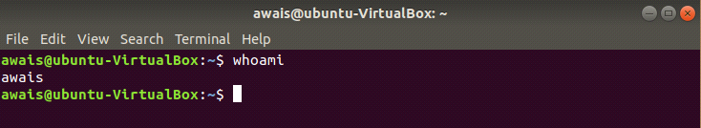

2- Creating file in tmp directory.

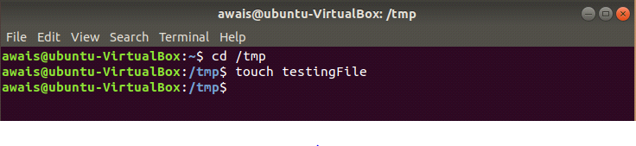

3- Checking the type and info of file.

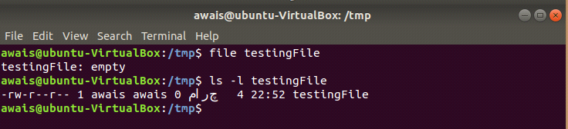

4- “rm” is used to remove /delete a file. On the other hand, “rmdir” is used to remove/delete a directory.

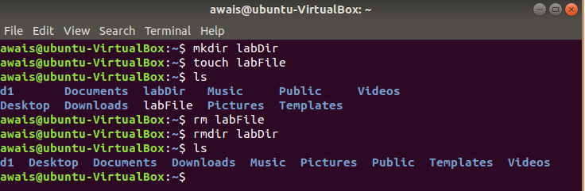

5- “cd ../ ” or cd /home commands are used to go back to home directory directly.

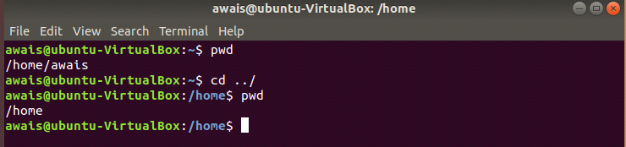

6- “mv ” command is used to rename a file.

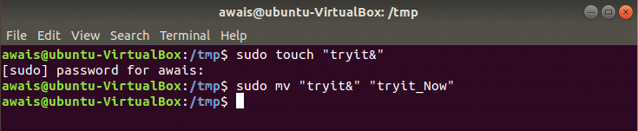

7- “alias “ command is used to assign another name to a command.

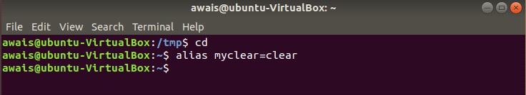

8- (part-a) Output:

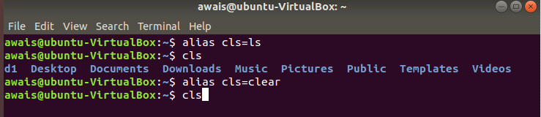

(part-b) Output:

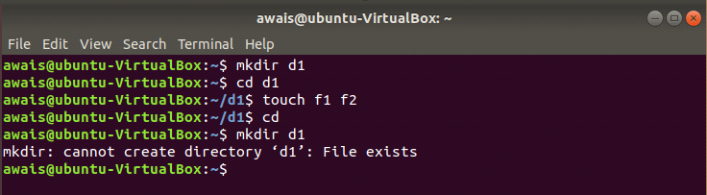

**----- (QUESTIONS) -----**

1- Single command used to make three directories:

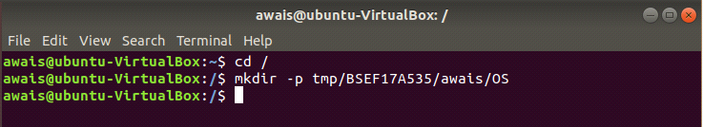

2- “ls –a “ command is used to display hidden files .

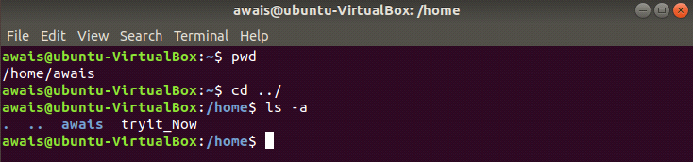

3- Method 1: rmdir /tmp/BSEF17A535/awais/Os

Method 2: step I: cd tmp

Step II: rm –r BSEF17A535

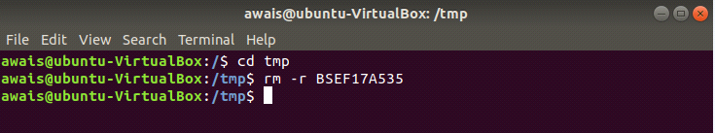

4- “ touch “ , “ gedit “ and “ cat –n “ commands are used in this case:

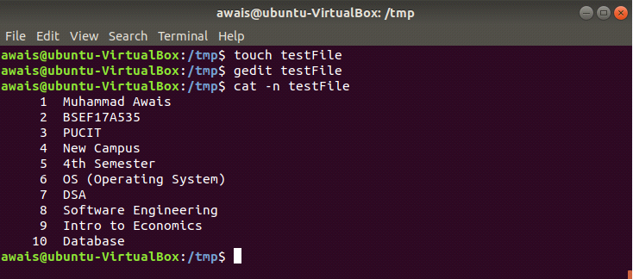

5- “ mv “ command is used to rename the file.

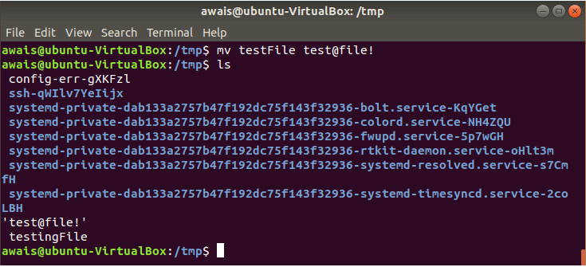

6- “ tail -2 “ command is used to display last two lines of a file.

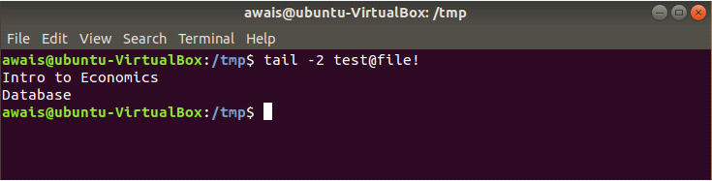

7- “ alias ” is used t assign another name to a command.

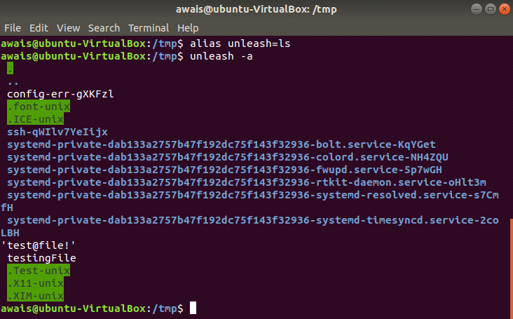

8- “ man ls “ command is used to display command details.

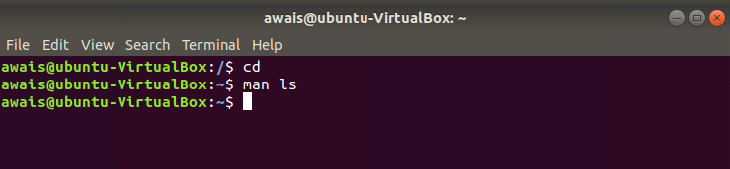

9- “ type “ is used to see whether type is an internal command or not.

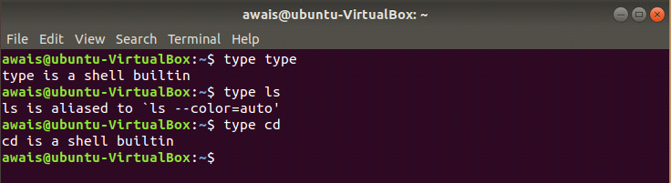

10- “ em –r “ command is used to delete/remove directory instead of rmdir command.

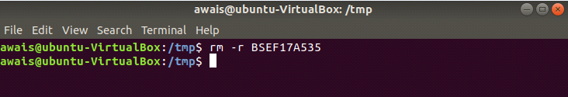

**----- (ABSOLUTE & RELATIVE PATH) -----**

1- creating reports directory in dilawar using single command:

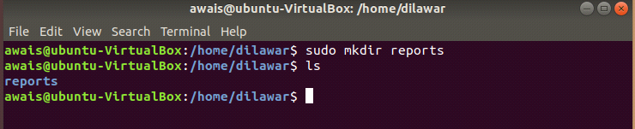

2- creating abdul directory in home:

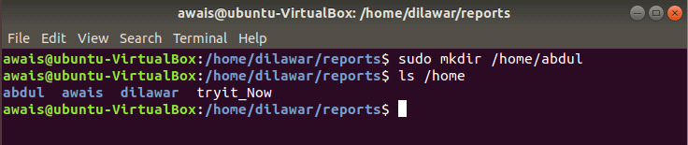

3- - Creating file “file1” in abdul using relative path (pwd reports)

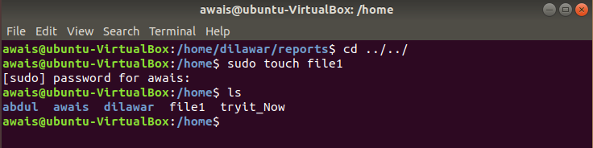

4- - Creating directory arif and rauf in staff using relative path (pwd abdul)

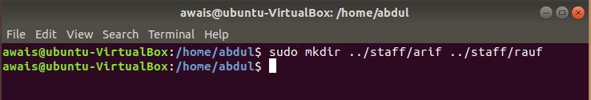

5- - Create file2 and file3 (pwd staff)

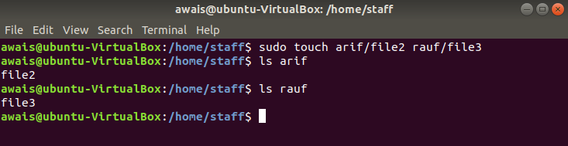

6- Coping file2 and file3 in “abdul directory” using absolute path

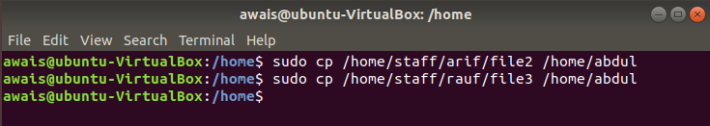

7- Copying the staff directory including its subdirectories in new directory “dilawer/newdir” (pwd abdul)”

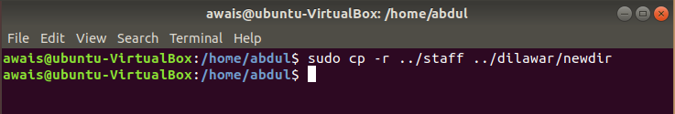

8- Removing directory staff using relative path (pwd newdir)

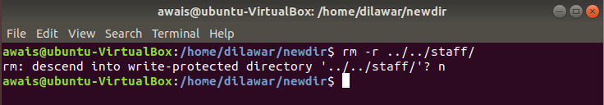

9- Renaming file2 in newdir with reFile2 (pwd newdir).

