DEEP LEARNING SEMESTER PROJECT
Traffic Sign Recognition using a Convolutional Neural Network
Classifying 43 German traffic sign classes (GTSRB) with 99.87% test accuracy, deployed as an in-browser web application
Live demo: https://traffic-sign-recognition-website.vercel.app/
Source code and model weights: https://github.com/muhammadazghan/traffic-sign-recognition
Dataset: https://www.kaggle.com/datasets/meowmeowmeowmeowmeow/gtsrb-german-traffic-sign

Abstract
Traffic sign recognition is a core component of driver-assistance systems and autonomous vehicles. This project trains a compact convolutional neural network (CNN) to classify images of traffic signs into 43 classes using the German Traffic Sign Recognition Benchmark (GTSRB), a secondary dataset downloaded from Kaggle. Images are resized to 32 x 32 pixels, scaled to the range 0 to 1, and split into stratified training, validation and test sets. The network has about 0.82 million parameters, uses batch normalization and dropout for regularization, and is trained with the Adam optimizer and light data augmentation. On the 3,921 held-out test images it reaches a test accuracy of 99.87%, with only five misclassified images. The trained weights are exported so that the model runs entirely inside the web browser, and a public website lets anyone upload a photo of a sign and see the top three predictions with confidence scores.

1. Problem Statement
Road signs communicate rules and hazards to drivers. Recognizing them automatically is difficult because real-world images vary widely in lighting, blur, scale, partial occlusion and background clutter. The task in this project is multi-class image classification: given a cropped image of a single traffic sign, predict which of 43 sign classes it belongs to.
The goals of the project are:
- to train an accurate and lightweight deep learning model on a public dataset;
- to save and publish the trained model weights together with the complete source code;
- to deploy the model in a public web application that demonstrates its predictions; and
- to document the dataset, architecture, training procedure and results.

2. Dataset Description
The project uses the German Traffic Sign Recognition Benchmark (GTSRB), a well-known secondary dataset available on Kaggle. It contains photographs of German road signs taken under realistic conditions.
Property | Value
Name | GTSRB, German Traffic Sign Recognition Benchmark
Source | Kaggle (secondary dataset), license CC0 1.0
Training images used | 39,209 images
Number of classes | 43 (for example speed limits, stop, yield, priority road, warning signs)
Image properties | Colour (RGB) photographs of varying size, lighting and sharpness
Class balance | Imbalanced: some classes have over 2,000 images, others fewer than 250

Figure 1 shows the number of images per class and Figure 2 shows random samples. The imbalance means that overall accuracy alone could hide weak performance on rare classes, so per-class precision, recall and F1-score were also examined.
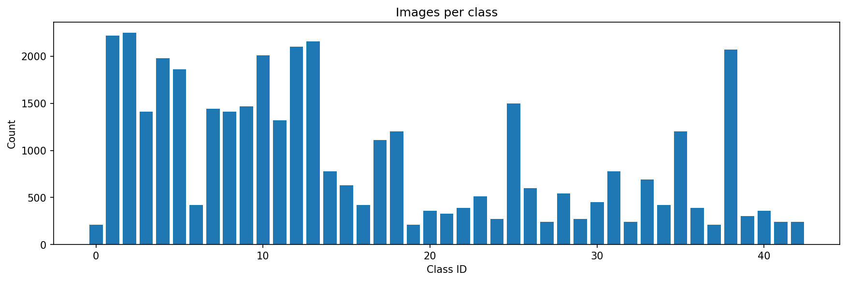
Figure 1. Number of training images per class
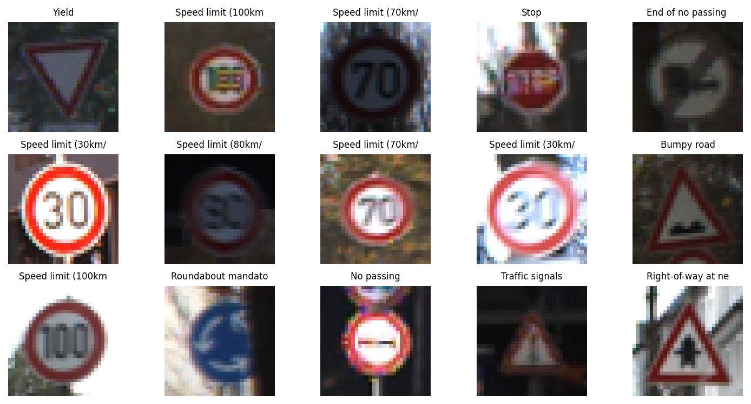
Figure 2. Random samples from the dataset

3. Preprocessing and Data Split
- Every image was converted to RGB and resized to 32 x 32 pixels.
- Pixel values were scaled from 0-255 to the range 0-1.
- The data were split with stratification (so every class appears in every split): 80% training (31,367 images), 10% validation (3,921 images) and 10% test (3,921 images). A fixed random seed of 42 was used for reproducibility.
- During training only, light augmentation was applied: random rotation (up to about 5%), zoom (10%) and translation (10%). Horizontal flipping was deliberately not used, because flipping a sign can change its meaning (for example, turn left versus turn right).

4. Model Architecture
The model is a compact CNN built from three convolutional blocks followed by a small classifier. Each block contains two 3 x 3 convolutions with ReLU activation, each followed by batch normalization, then max pooling and dropout. The number of filters doubles from block to block (32, 64, 128).
# | Layer(s) | Output shape | Notes
1 | Input | 32 x 32 x 3 | RGB image, scaled 0-1
2 | 2 x [Conv 3x3, 32 + BatchNorm] | 32 x 32 x 32 | ReLU activation
3 | MaxPool 2x2 + Dropout 0.25 | 16 x 16 x 32
4 | 2 x [Conv 3x3, 64 + BatchNorm] | 16 x 16 x 64 | ReLU activation
5 | MaxPool 2x2 + Dropout 0.25 | 8 x 8 x 64
6 | 2 x [Conv 3x3, 128 + BatchNorm] | 8 x 8 x 128 | ReLU activation
7 | MaxPool 2x2 + Dropout 0.25 | 4 x 4 x 128
8 | Flatten | 2048
9 | Dense 256 + Dropout 0.5 | 256 | ReLU activation
10 | Dense 43 | 43 | Softmax output

The network has about 824,000 parameters in total, so the saved model is only about 10 MB. This small size made it easy to store in a GitHub repository and to run directly in a web browser.

5. Training Details
Setting | Value
Framework | TensorFlow / Keras
Hardware | Google Colab, NVIDIA T4 GPU
Optimizer | Adam
Loss function | Sparse categorical cross-entropy
Batch size | 64
Maximum epochs | 25, with early stopping (patience 5 on validation accuracy, best weights restored)
Learning-rate schedule | ReduceLROnPlateau (factor 0.5, patience 2)
Regularization | Batch normalization, dropout (0.25 in conv blocks, 0.5 in dense layer), data augmentation

Training was fast: each epoch took roughly 10 seconds on the T4 GPU. Training accuracy rose above 99% and validation accuracy reached about 99.9%, as shown in Figure 3. The close agreement between the training and validation curves indicates that the model is not over-fitting.
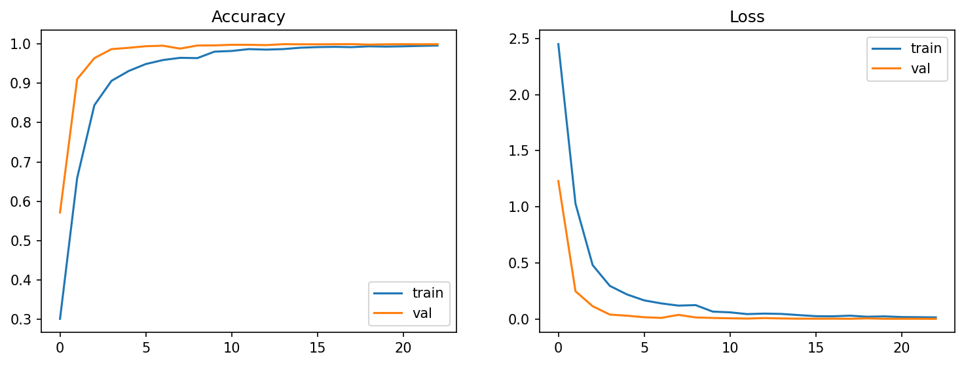
Figure 3. Training and validation accuracy and loss

6. Results and Analysis
Metric (test set, 3,921 images) | Result
Test accuracy | 99.87%
Misclassified images | 5 out of 3,921
Macro-average precision / recall / F1 | 1.00 / 1.00 / 1.00 (rounded to two decimals)
Weakest classes (by F1) | Dangerous curve to the left (0.98), Slippery road (0.98)

Almost every class reached precision and recall of 1.00. The few errors occurred on small or visually similar classes, for example warning triangles such as "Dangerous curve to the left" (only 21 test images) and "Slippery road". Figure 4 shows the confusion matrix: nearly all predictions lie on the diagonal. The complete classification report is included in the GitHub repository (results folder).
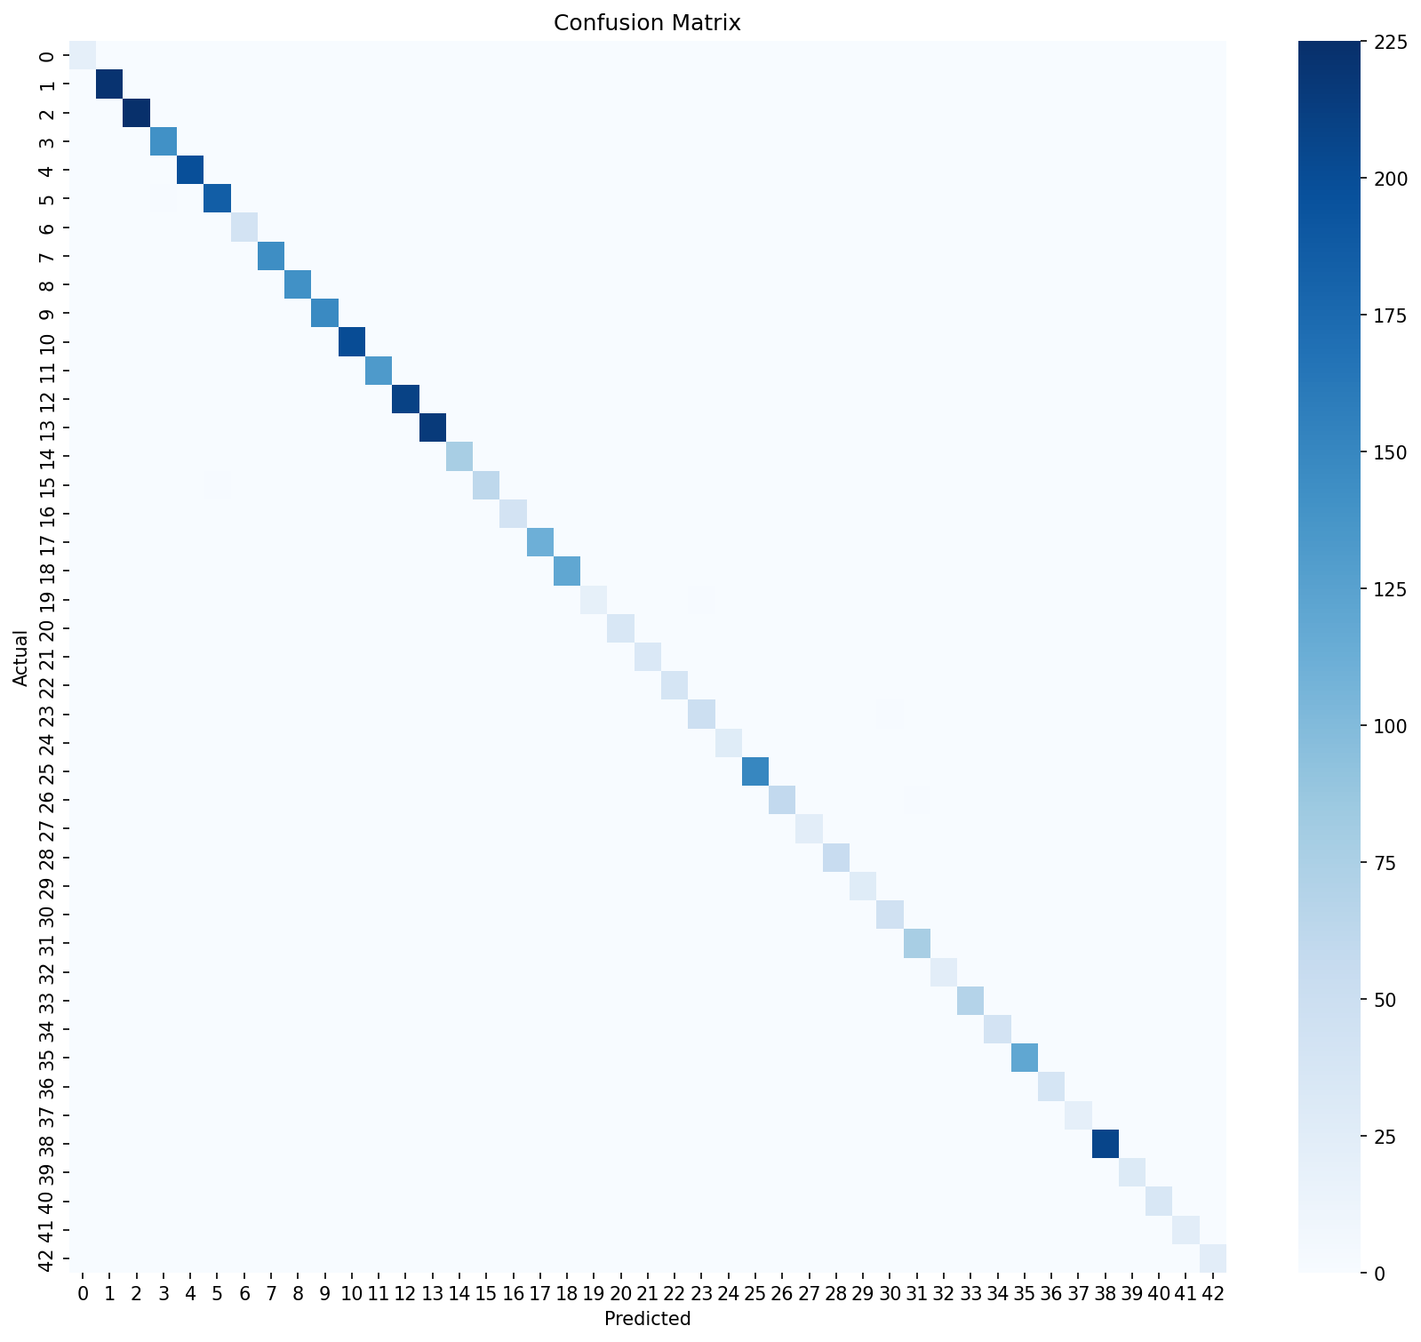
Figure 4. Confusion matrix on the test set

7. Deployment
The model was exported so it can run without any server-side Python. The network weights are saved as a binary float32 file with a small JSON description of the layers, and a short JavaScript program in the web page performs the forward pass (convolution, batch normalization, pooling and dense layers) directly in the visitor's browser. Its outputs were checked against the original Keras model and agreed to within about 0.000002.
- Website: https://traffic-sign-recognition-website.vercel.app/ (hosted on Vercel). It contains the live demo, dataset and code details, results, and project links.
- GitHub repository: https://github.com/muhammadazghan/traffic-sign-recognition (source code, training notebook, trained model weights, results and dataset link).
- Because inference happens in the browser, uploaded images never leave the user's device.
The demo takes a photo of a sign, crops it to a square, resizes it to 32 x 32 pixels, and displays the top three predicted classes with their confidence. If the top confidence is below 70% the page shows a warning that the sign may not be one of the supported classes.

8. Limitations
- The model recognizes only the 43 German (GTSRB) sign classes. Signs from other countries, or signs that are not in these classes, can be mapped to the closest known class. In testing, a UK "two-way traffic" sign was classified as "Children crossing" with only 53% confidence, which is why the website shows a low-confidence warning.
- It classifies a single, roughly centred, cropped sign. It does not detect and locate signs inside a full street scene.
- Images are reduced to 32 x 32 pixels, so very small, blurred or heavily occluded signs may be misclassified.
- The dataset contains only German road conditions and is class-imbalanced.
- The model is a learning project and must not be used for real driving decisions.

9. Future Work
- Combine several national datasets (for example from Belgium, the USA and China) to recognize signs from many countries.
- Add an object-detection model such as YOLO to find and classify signs in full images and video.
- Add an explicit "unknown sign" class or out-of-distribution detection to reject unsupported signs more reliably.
- Evaluate transfer learning with a pre-trained backbone and test robustness under night, rain and motion-blur conditions.

10. Conclusion
A small CNN with about 0.82 million parameters, trained for a few minutes on a free GPU, classified GTSRB traffic signs with 99.87% test accuracy. The model weights, code and results are published on GitHub, and a public website demonstrates the model running live in the browser. The main limitation is its restriction to the 43 German sign classes, which points to clear directions for future work such as multi-country datasets and sign detection in full scenes.

References
- Stallkamp, J., Schlipsing, M., Salmen, J. and Igel, C. (2012). Man vs. computer: Benchmarking machine learning algorithms for traffic sign recognition. Neural Networks, 32, 323-332.
- GTSRB dataset on Kaggle: https://www.kaggle.com/datasets/meowmeowmeowmeowmeow/gtsrb-german-traffic-sign
- Abadi, M. et al. TensorFlow: Large-scale machine learning on heterogeneous systems. https://www.tensorflow.org
- Kingma, D. and Ba, J. (2015). Adam: A method for stochastic optimization. ICLR.
- Ioffe, S. and Szegedy, C. (2015). Batch normalization: Accelerating deep network training by reducing internal covariate shift. ICML.
- Srivastava, N. et al. (2014). Dropout: A simple way to prevent neural networks from overfitting. Journal of Machine Learning Research, 15, 1929-1958.

