**GM Uzbekistan records growth in car production in 2017**

12 January 2018 15:16 (UTC+04:00)

898

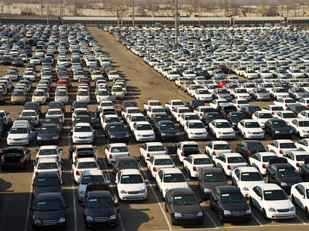

By Kamila Aliyeva

GM Uzbekistan, the former UzDaewooAuto, increased the production of passenger cars by 58.1 percent up to 135,470 units in 2017.

The production of cars in Uzbekistan rose from 85,670 units in 2016 up to 135,470 in 2017, according to the State Statistics Committee of Uzbekistan.

In particular, GM Uzbekistan increased production of Nexia cars by 7.4 percent to 34,540 units, Damas cars - to 22,490 units, as well as Spark cars - by 26.1 percent to 22,360 units in 2017.

Last year, the production volume of Gentra cars amounted to 19,160 (showing an increase by 2 times), Cobalt – 18,010 units (4.6 times), Matiz – 13,000 units (4.4 times), Captiva – 4,540 units (2.1 times), Malibu - 963 units (4.6 times) and Orlando – 388 units (15.5 percent more).

GM Uzbekistan, formerly known as UzDaewooAuto, was created in 1996 on a parity basis by Uzbekistan and South Korean Daewoo Motors.

In 2005, Uzbekistan acquired Daewoo's shares in UzDaewooAuto. In 2007, Uzavtoprom (Uzbek Association of Automotive Industry Enterprises) and the U.S.-based General Motors signed an agreement to establish the GM Uzbekistan with an authorized capital of $266.7 million.

General Motors owns 25 percent shares in the GM Uzbekistan plus one share with a possibility of increasing it to 40 percent. At the moment, 75 percent of the shares belong to the UzAvtosanoat.

Currently, 10 Chevrolet and Ravon car models are being produced at three production sites of the company.