Lume CRUD Visual and Interaction Guide
  - Version 1.0 Phone and tablet applications September 2026
This document defines how Lume creates, reads, updates and deletes records across phone and tablet applications. It includes interaction rules, responsive layouts, system states and visual references. Branding and general component standards are documented separately in the Lume Phone and Tablet Design System.
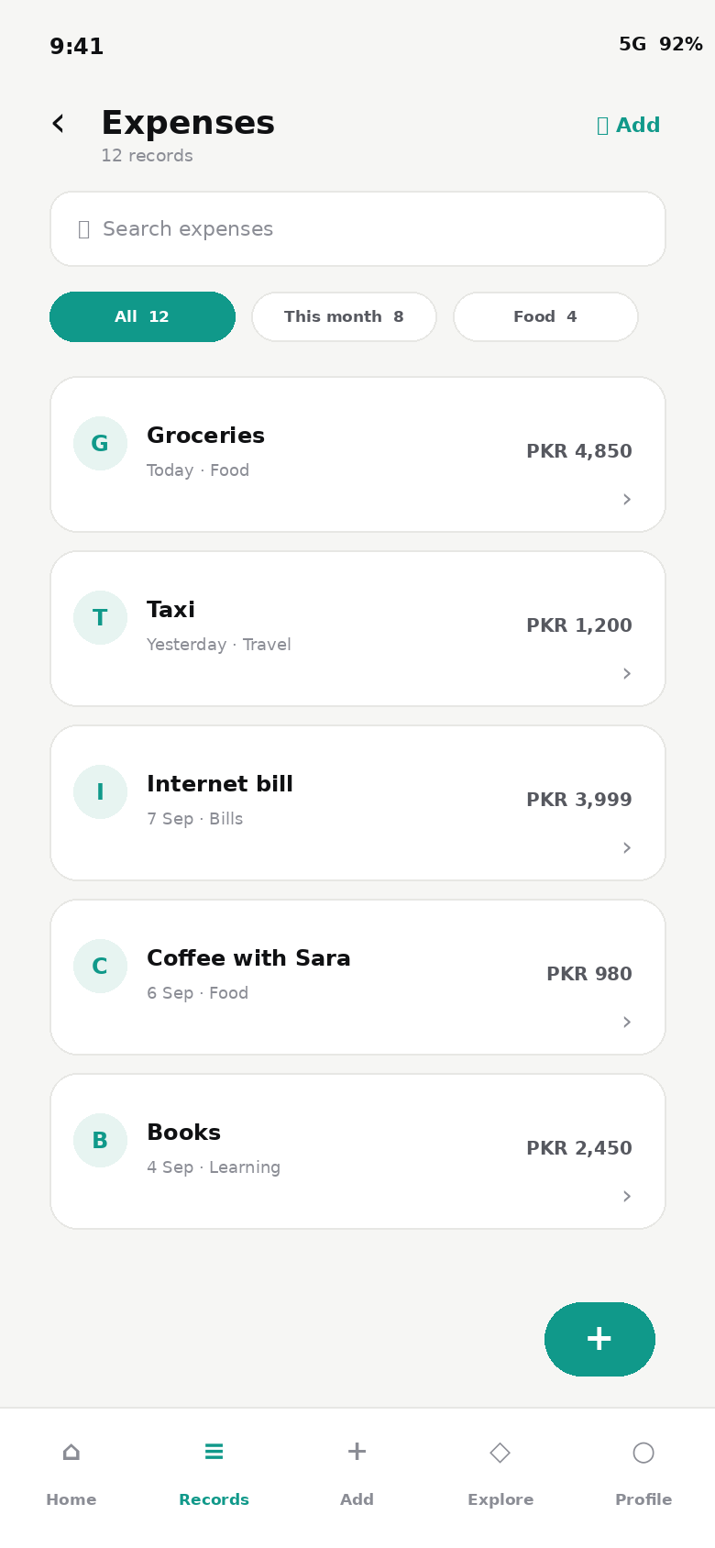

1 CRUD experience principles
CRUD includes more than four actions. Each record flow needs discoverable entry points, validation, loading, success, empty, error, offline and conflict states.
- Lists are the home of record-based tools.
- A row opens a detail view; editing starts from the detail or a clear contextual action.
- Create and Edit use focused forms.
- Delete names the record and consequence before confirmation.
- Low-risk reversible changes may update optimistically; high-consequence changes wait for server confirmation.
- Every state can be previewed without a live backend.

2 Operation and navigation model
Operation | Entry | Primary view | Completion
Create | Top action, FAB or empty-state CTA | Focused form | Detail or list plus success toast
Read list | Feature home or tab | Searchable and filterable list | Open selected detail
Read detail | Tap row or notification | Summary and grouped metadata | Edit, share or delete
Update | Edit action on detail | Pre-filled form | Return to updated detail
Delete | Overflow or danger section | Confirmation sheet or dialog | Return to list; Undo if recoverable

Phones push list, detail and form as separate screens. Expanded tablets use master-detail to reduce backtracking. Add and Edit remain visually focused even when shown beside persistent navigation.

3 Phone list and create visuals
Read list | 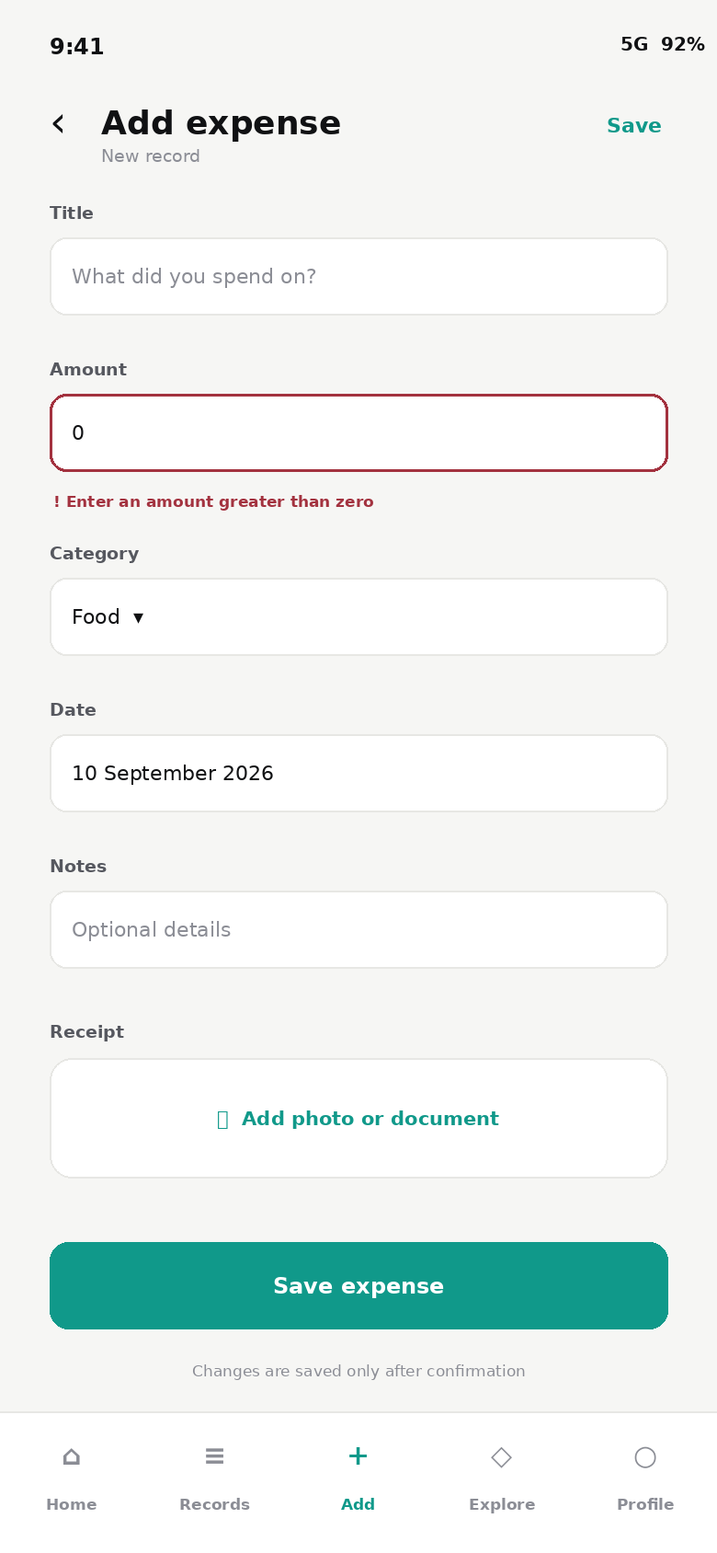  Create with validation

4 Phone detail and edit visuals
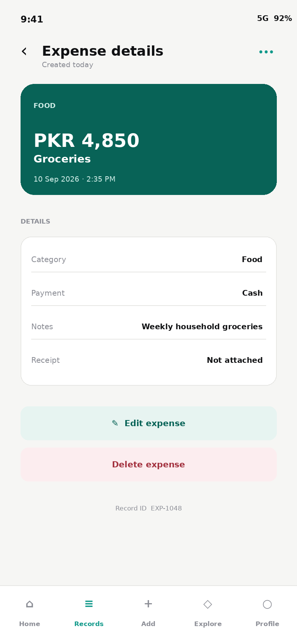  Read detail | 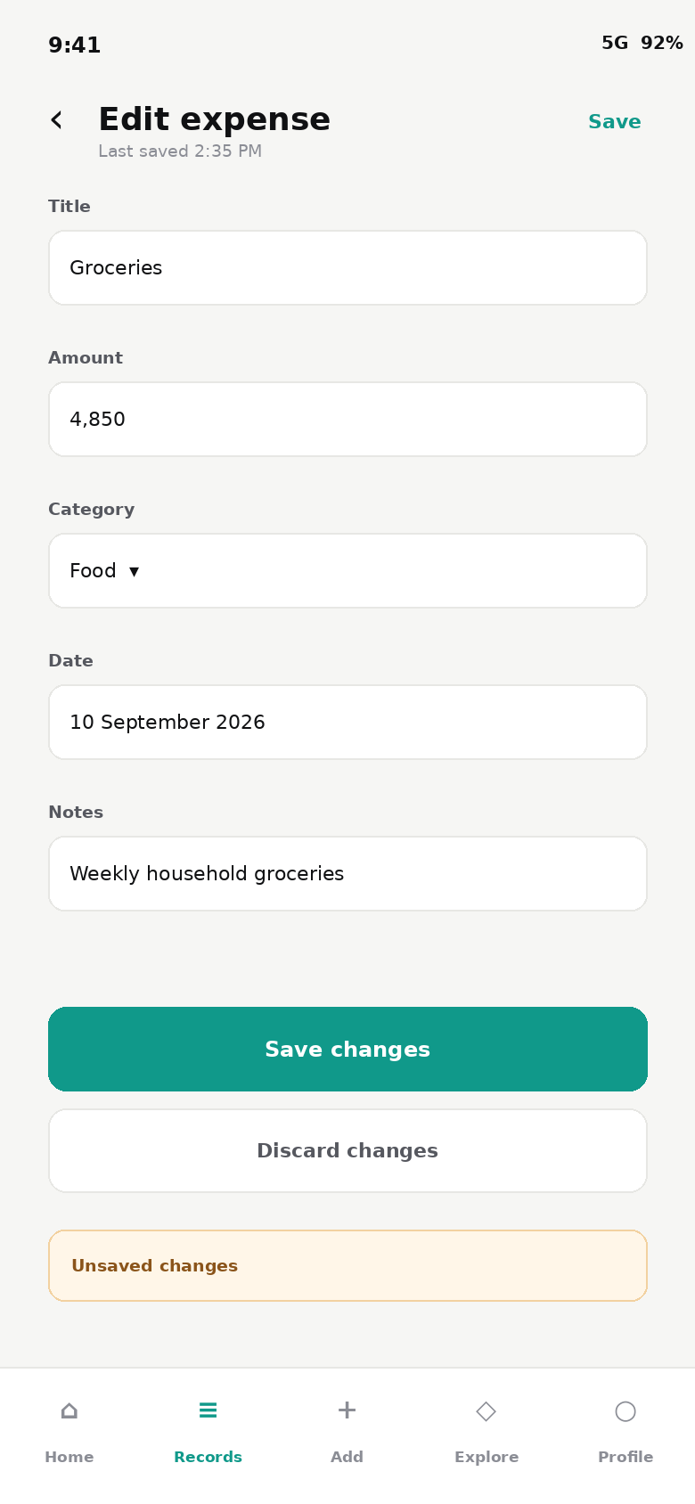  Update existing record

5 Phone delete and empty visuals
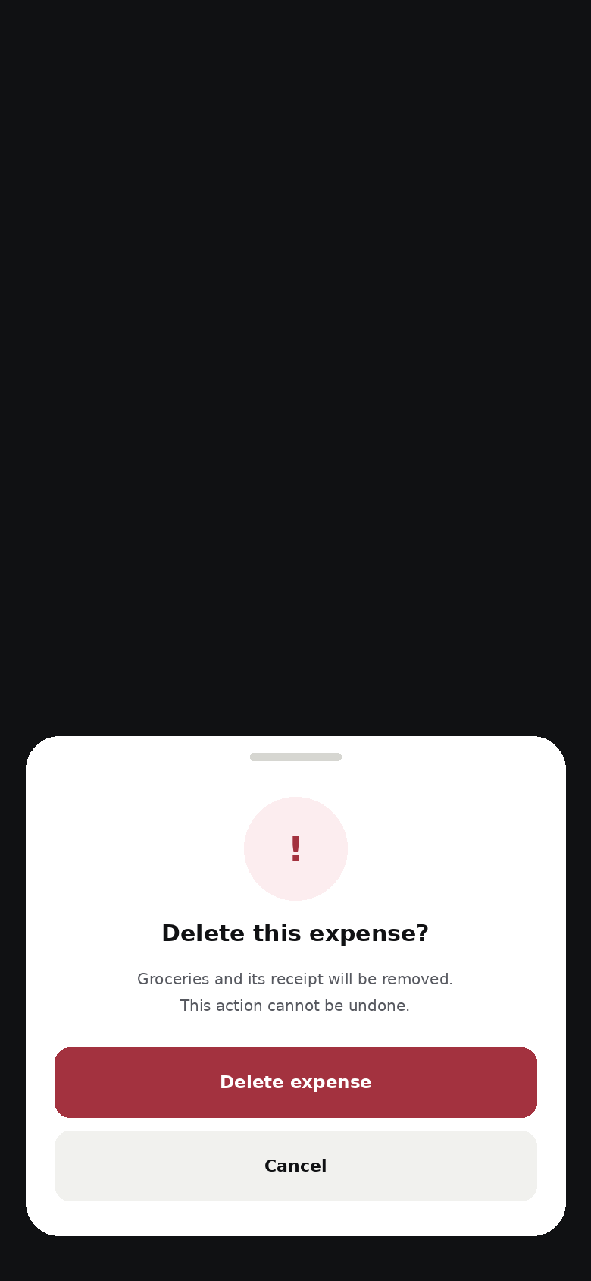  Delete confirmation | 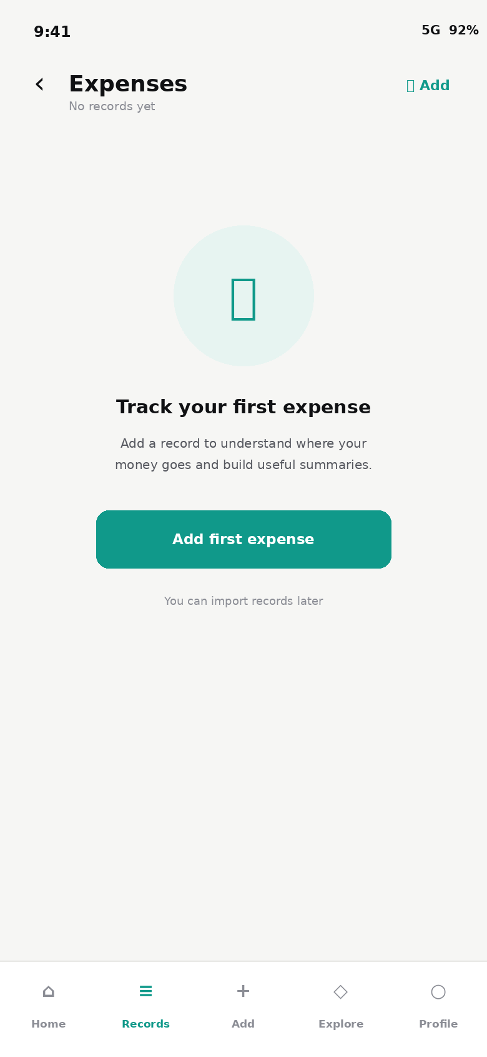  Empty collection

6 Phone loading and error visuals
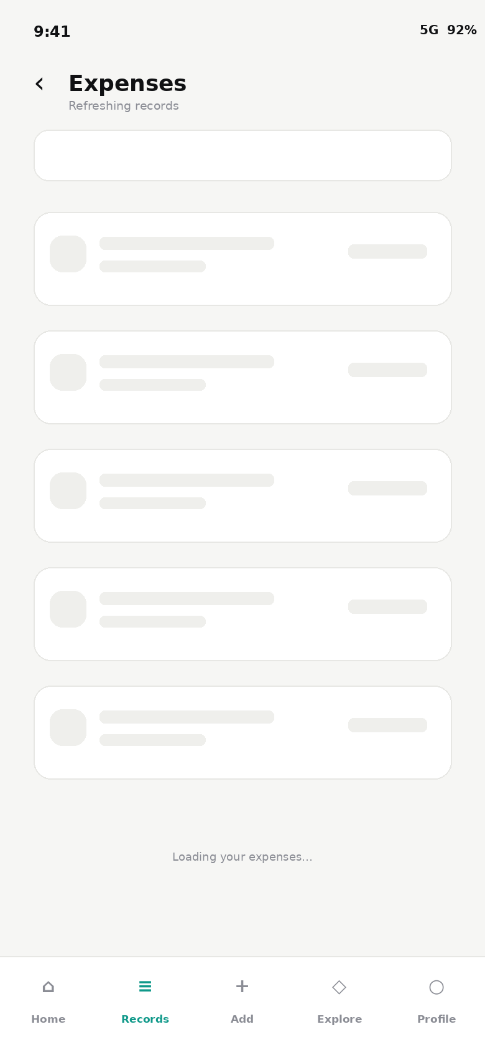  Loading skeleton | 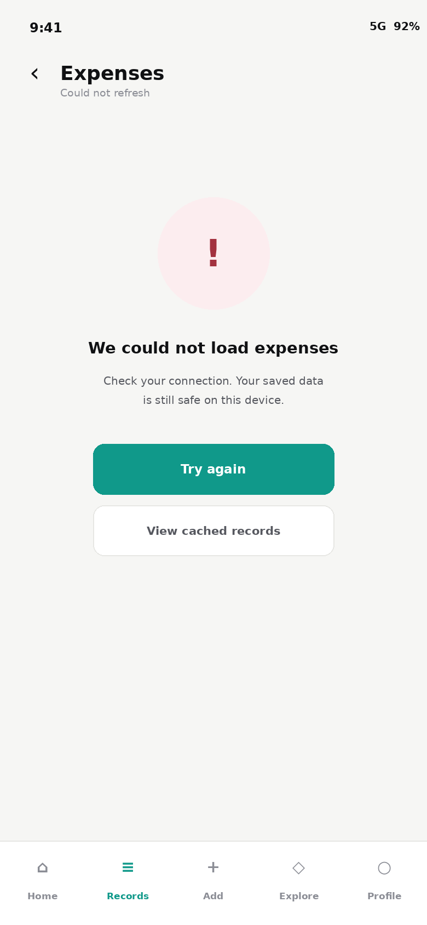  Recoverable error

7 Phone success and recovery visual
Routine completion should be confirmed without interrupting the user. Offer Undo when reversal is safe.
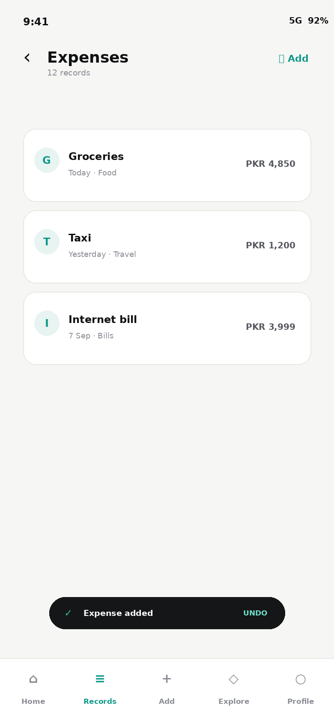

8 Tablet master detail visual
At expanded width, keep a 360-440 px list pane and a flexible detail pane. Selecting another record updates the detail pane without discarding list position or filters.
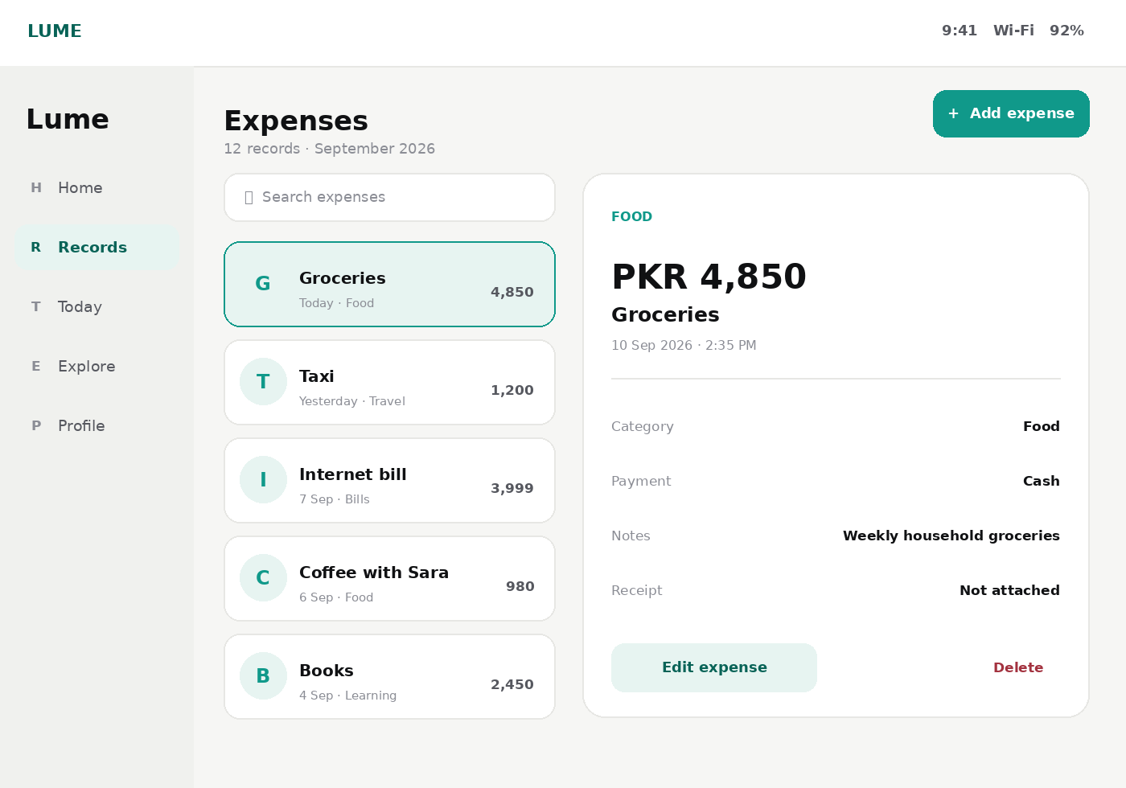

9 Tablet create and edit visual
Use two columns only for related short fields. Notes, descriptions, warnings and attachments span both columns. Collapse to one column for compact split-screen or large accessibility text.
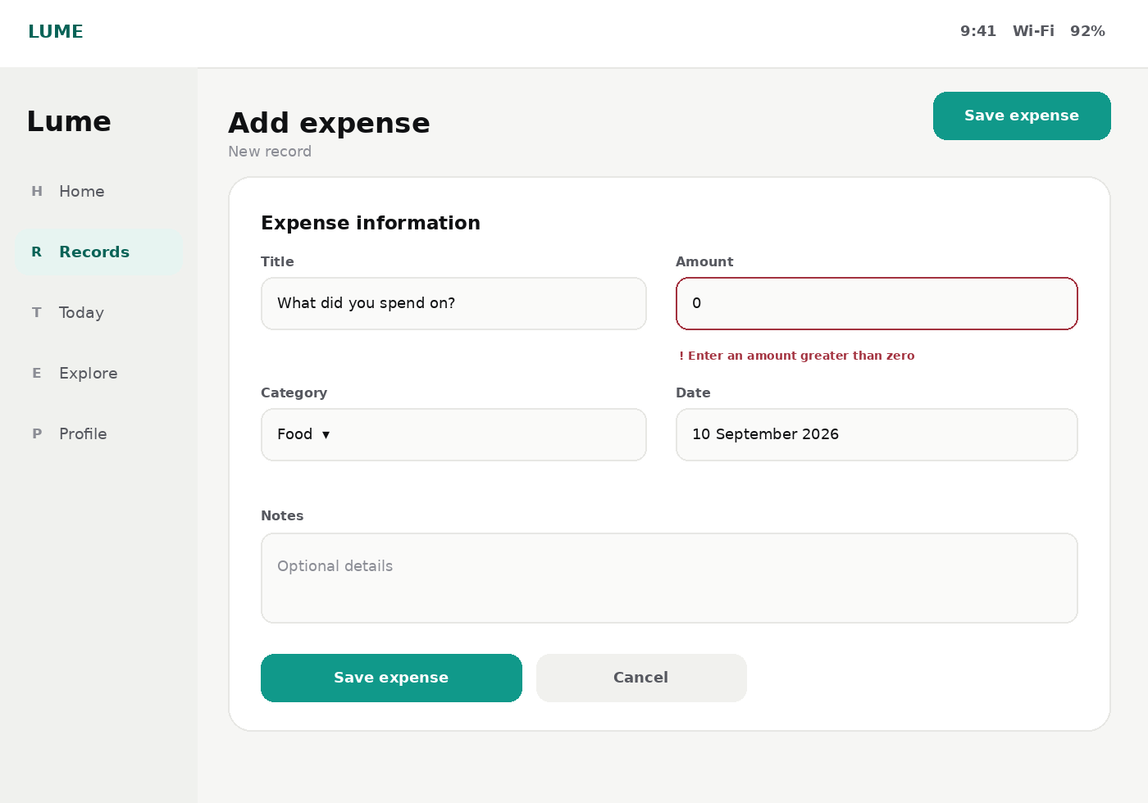

10 System state requirements
State | Show | Do not
Empty | Reason, next step and one primary CTA | Show a blank card or unexplained zero
Loading | Skeletons shaped like final content | Block the full list with a spinner
Offline | Cached records, offline label and queued status | Pretend data is current
Save success | Concise toast and safe Undo | Show a routine success modal
Save failure | Preserved input, explanation and Retry | Clear values
Delete success | Remove immediately and restore if supported | Leave a ghost row
Conflict | Explain newer version and offer Review or Reload | Silently overwrite
Permission denied | Explain need and route to Settings | Request repeatedly

Validation lifecycle
Do not validate untouched fields. Validate simple independent rules on blur and the full form on submit. Focus the first error, retain all entered values and prevent duplicate saves while a request is active.

11 Applying CRUD across Lume
Tool family | Record | List emphasis | Special consideration
Tasks and reminders | Task | Due state and completion | Undo and recurrence
Notes | Note | Title, excerpt and modified date | Autosave and conflict handling
Expenses | Transaction | Amount, category and date | Currency, receipt and privacy
Medication | Dose schedule | Next dose and adherence | Safety wording
Documents | File record | Type, expiry and lock state | Encryption and secure deletion
Health records | Measurement or report | Date, value and source | Consent and export audit
Habits and water | Daily entry | Progress and streak | Fast optimistic logging
Shopping | Item | Checked state and quantity | Confirmed bulk clear
Events and birthdays | Event | Date and recurrence | Timezone and permissions

12 Implementation and review checklist
Area | Requirement
Data state | Initial, loading, populated, empty, error, offline and conflict
Phone | Single-column list, detail and form screens
Tablet | Rail or sidebar; master-detail at expanded width
Forms | Dirty-state protection, validation and retained values
Deletion | Named object, consequence and recovery status
Feedback | Non-blocking success and actionable failure
Privacy | No sensitive detail in previews by default
Accessibility | Focus, semantics, announcements, keyboard and dynamic type
Localization | Local date, time, number, currency and RTL
Testing | Create, read, update and delete paths at all breakpoints

☐ All CRUD states are visually previewable.
☐ Create and Edit preserve input after failure.
☐ Back navigation preserves search, filters and list position.
☐ Master-detail collapses safely in compact split-screen.
☐ Delete behavior matches whether recovery is possible.
☐ Success feedback does not block the next action.

