Lume Phone and Tablet Design System
  - Version 1.0 Application interface standards September 2026
This document defines Lume branding, visual language, responsive layouts and shared components for phone and tablet applications. It is the source of truth for product design and application implementation. CRUD workflows are documented separately.
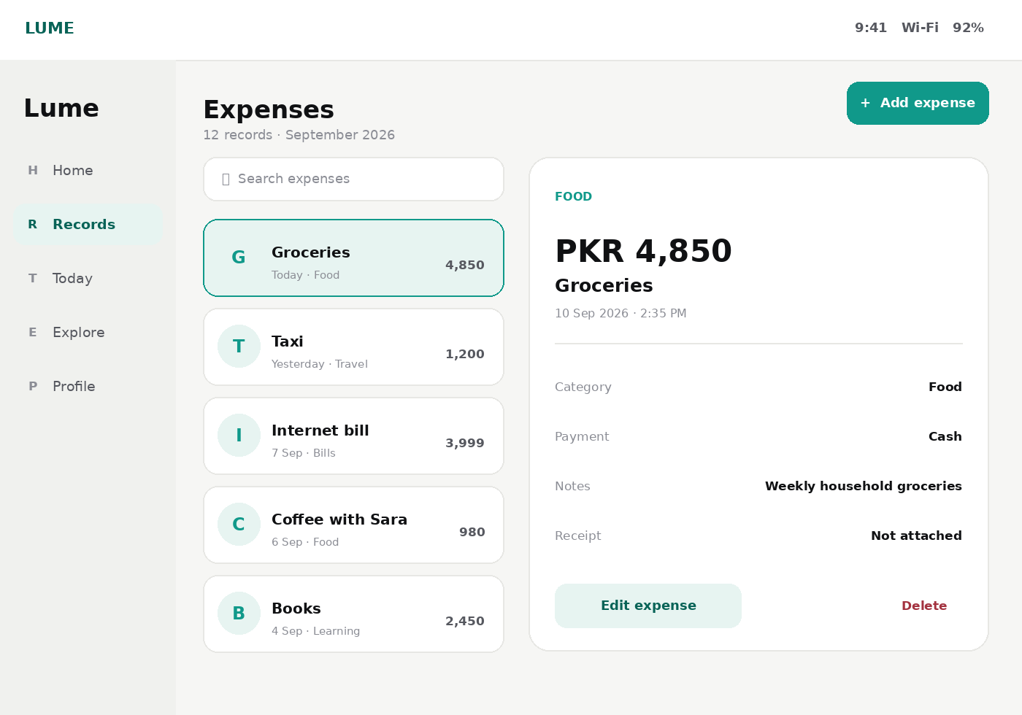

1 Scope and design principles
The system supports 320 to 1366 logical pixels, portrait, landscape and tablet split-screen. Phone reference is 390 by 844; tablet references are 768 by 1024 portrait and 1280 by 800 landscape.
- Quiet utility: information leads and decoration supports it.
- One clear primary action per screen.
- Country, language, locale, currency, units, city, interests and optional Islamic content remain independent.
- Sensitive information stays private by default.
- Every component supports dark mode, RTL, localization and dynamic type.

Responsive breakpoints
Class | Width | Default behavior
Compact | 320-599 px | Single column, bottom navigation, full-screen task flows
Medium | 600-839 px | Navigation rail, centered content, selective two-column layouts
Expanded | 840-1366 px | Sidebar, master-detail views and up to three content columns

2 Brand identity and voice
Lume is neutral, modern, global and reassuring. It should feel useful before it feels impressive. Optional Islamic functionality is personalized content, not the visual identity of the entire application.
Element | Rule
Logo clear space | At least the visual width of the mark on every side
Minimum size | 24 px mark and 72 px wordmark
Approved backgrounds | White, near-black, jade tint and approved brand gradient
Do not | Stretch, outline, recolor arbitrarily, add shadows or use on busy imagery

Interface voice
Prefer | Avoid
Add expense | Create new expense record
Could not save changes | Operation failed
Delete expense? | Are you absolutely sure?
Nothing here yet | No data available
Saved | Successfully executed operation

3 Color system
Token | Hex | Role
Jade 50 | #E9F7F4 | Soft highlight
Jade 100 | #CFEDE7 | Selected surface
Jade 400 | #34B39D | Dark-mode detail
Jade 500 | #10998A | Primary action
Jade 600 | #0B7F73 | Pressed state
Jade 700 | #086357 | Accent ink
Background | #F6F6F4 | Screen canvas
Card | #FFFFFF | Raised content
Text | #101113 | Primary copy
Text 2 | #56585F | Supporting copy
Text 3 | #8B8D95 | Metadata
Danger ink | #A3323F | Error and destructive action

Jade carries brand emphasis and primary actions. Amber means warning, rose means error or destructive action, sky means neutral information, and violet is reserved for illustration. Status color is never decoration.

Dark mode
Use #0A0A0B canvas, #141416 cards, #F3F3F4 primary text and #35CBB2 accent. Re-author gradients for dark surfaces rather than placing light gradients on black.

4 Typography
Use Plus Jakarta Sans for Latin text and numerals. Use Noto Naskh Arabic for Arabic-script reading content. Use tabular numerals for money, timers, rates and aligned statistics.
Style | Size and line height | Weight | Usage
Display | 28 / 32 px | 800 | Key value
Page title | 20 / 26 px | 700 | Screen title
Section title | 17 / 22 px | 700 | Section hierarchy
Card title | 14-15 / 20 px | 700 | Record or card name
Body | 14 / 22 px | 400-500 | Descriptions and values
Label | 12 / 16 px | 700 | Fields and actions
Metadata | 11-12 / 16 px | 500-600 | Dates and statuses
Tab label | 10 / 14 px | 700 | Phone navigation only

- Use sentence case.
- Let essential text wrap.
- Support at least 200 percent text size.
- Arabic reading passages use line height of at least 1.8.

5 Spacing shape elevation and motion
Category | Tokens | Guidance
Spacing | 4, 8, 12, 16, 20, 24, 32, 40 | 20 px phone padding; 24-32 px tablet gutters
Radius | 8, 12, 16, 20, 26, full | 12 px controls; 16 px cards; 26 px sheets
Icons | 16, 20, 24 px | 1.75 px rounded stroke
Touch target | 44 by 44 px minimum | 48 px preferred
Elevation | XS, SM, MD, LG | LG only for sheets and overlays

- Build on a 4 px base grid.
- Cap reading and form content at 680-760 px on tablets.
- Use a 360-440 px list pane in expanded master-detail layouts.
- Use 160 ms feedback, 260 ms standard transitions and 420 ms screen transitions.
- Respect reduced-motion settings.

6 Responsive application layout
Zone | Phone | Tablet
Navigation | Bottom bar, five destinations maximum | Rail at medium width; sidebar at expanded width
Content | Single column, 20 px side padding | Centered canvas or 24-32 px gutters; one to three columns
Primary action | Top action, FAB or sticky bottom action | Top action aligned with its content pane
Details | Push to a new screen | Master-detail when width allows
Forms | Single column | Centered one column or related two-column fields

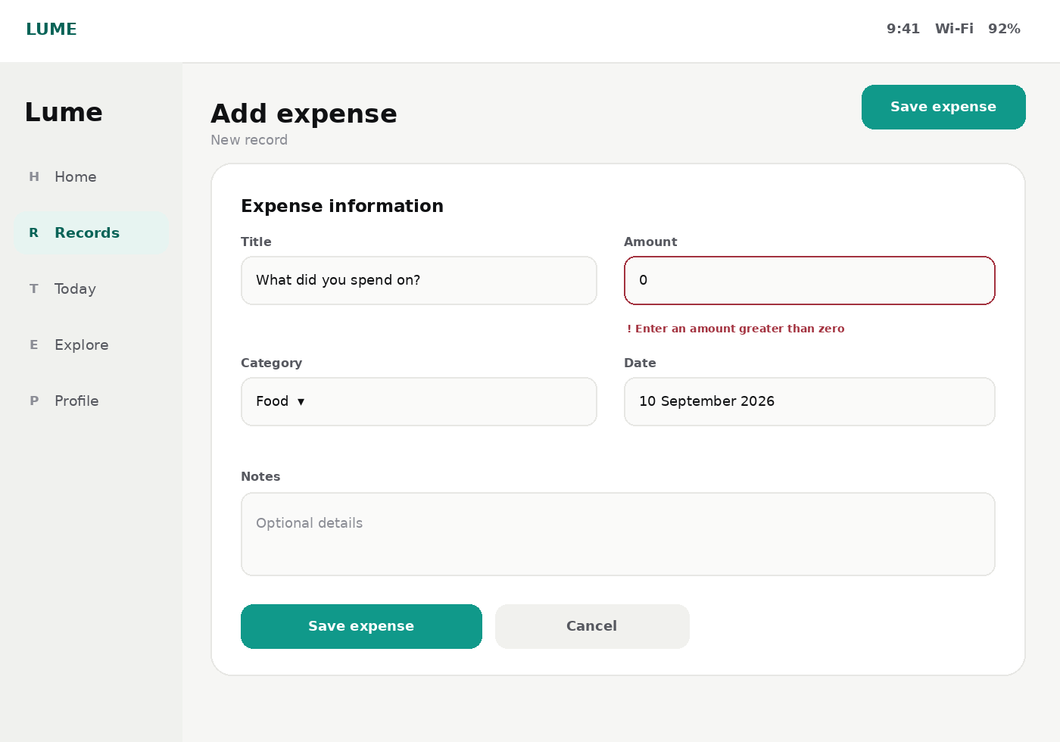

7 Core components
Component | Default specification | Required states
Top app bar | Back, title and optional contextual action | Default, scrolled, disabled action
Primary button | 46-48 px, jade, 12 px radius | Default, pressed, disabled, busy
Text field | 44-52 px, label above and helper below | Empty, focused, filled, valid, invalid, disabled
List row | Icon, body and trailing value | Default, pressed, selected, unavailable
Card | White, 16 px radius and subtle border | Default, interactive, loading
Bottom sheet | 26 px top radius and safe-area padding | Peek, open, dismissing
Toast | High-contrast pill above navigation | Success, warning, undo
Dialog | Focused decision and explicit actions | Standard and destructive
Tablet rail | Compact labeled destinations | Default, selected and focus
Tablet sidebar | Persistent expanded navigation | Default, selected and collapsed

8 Forms validation and feedback
Moment | Behavior
Before interaction | Do not judge; helper text may explain format
On focus | Jade boundary and subtle focus ring
On blur | Validate only independently judgeable rules
On submit | Validate all, focus first error and retain input
Saving | Prevent duplicate submission and show progress in the action
Success | Confirm briefly without blocking progress
Failure | Keep input, explain failure and provide Retry

- Put errors directly below their field and pair color with text or icon.
- Use appropriate mobile keyboards.
- Mark optional fields as Optional.
- Warn before leaving a dirty form.
- Collapse two-column tablet forms to one column in compact split-screen or large text.

9 Accessibility localization and privacy
Area | Requirement
Contrast | WCAG AA: 4.5 to 1 normal text and 3 to 1 large text or UI boundaries
Focus | Visible 2 px jade outline with 2 px offset
Touch | 44 by 44 logical pixels minimum
Input | Touch and keyboard support on tablets
Screen readers | Label icon-only controls and announce validation outcomes
Dynamic type | At least 200 percent without clipping
RTL | Mirror direction and layout, not numbers or media controls
Formatting | Locale-aware dates, time, currency, decimals and units
Privacy | Hide sensitive notification detail by default

10 Engineering handoff
Group | Implementation contract
Viewport | 320-1366 logical px, safe areas, portrait, landscape and split-screen
Breakpoints | Compact below 600; medium 600-839; expanded 840 and above
Theme | Central light and dark tokens; no hard-coded screen colors
Typography | Semantic styles, not per-widget declarations
Components | Shared adaptive button, field, row, rail, sidebar, sheet, toast and dialog
Accessibility | Semantics, focus order, keyboard support and dynamic type
Localization | Locale formatters, no concatenated sentences and RTL testing
Testing | Golden tests at compact, medium and expanded widths

Design review checklist
☐ One clear purpose and primary action.
☐ Correct navigation at every breakpoint.
☐ Tablet content is adapted, not stretched.
☐ Readable maximum content width.
☐ Touch, keyboard, RTL, dark mode and dynamic type verified.
☐ No one-off token or component overrides.

