Project 2 – Acme Analytics Linux Platform
Day 2 · Phase 1, Steps 1.5–1.9: ports, SSH keys, links and inodes, users and groups, Linux vs cloud NAT
Muhammad Bilal Javed · 15–16 October 2026
Project | Acme Analytics – hardened, observable and recoverable Linux platform
Phase | 1 – Network foundation: 1.5 ports and sockets · 1.6 SSH keys · 1.7 links and inodes · 1.8 users and groups · 1.9 NAT comparison
Dates | 15–16 October 2026
Hosts worked on | app01, stor01, gw01
Status | Step 1.5 ✅ · Step 1.6 ✅ – password-free SSH, remote commands and scp from gw01 to both servers · Step 1.7 ✅ – hard links, soft links, inodes · Step 1.8 ✅ – users, groups, service account · Step 1.9 ✅ – NAT comparison · Phase 1 complete, snapshot taken
Author | Muhammad Bilal Javed
How to read this report. 💡 In plain words – the idea for any reader. 🔧 Technical – the commands, with a comment on every line. 📸 Evidence – the real screenshot. Terms are explained in the glossary.

1. Objective
💡 In plain words: an IP address is the address of a building (which machine). A port is a door number inside that building (which program). Every service waits behind its own numbered door: SSH behind door 22, DNS behind door 53, a website behind door 80. Before opening new doors, I made an inventory of which doors app01 already has open – and to whom.
🔧 Technical: list all listening TCP and UDP sockets on app01 with the owning process, and interpret the result.

2. Procedure
sudo ss -tulpn # ss = socket statistics
# -t TCP sockets -u UDP sockets
# -l only listening -p show the owning process
# -n numbers, not names (memory aid: "tulpn" = tulip)
📸 Evidence:
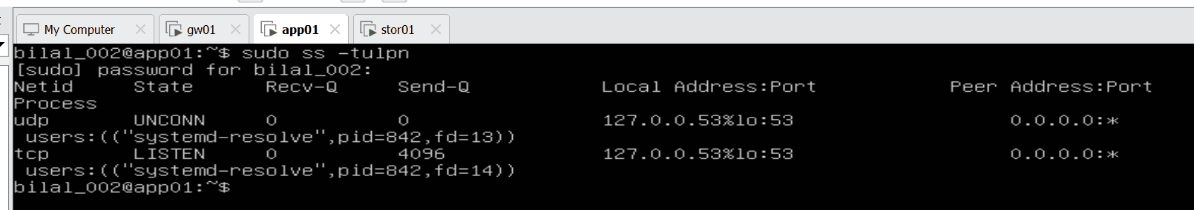
ss -tulpn on app01

3. Reading the output
Column | Technical meaning | In plain words | In my output
Netid | Protocol: TCP or UDP | TCP = a phone call (confirmed); UDP = a postcard (just sent) | udp and tcp
State | LISTEN = TCP socket waiting for connections; UNCONN = open UDP socket (UDP never connects); ESTAB = an active TCP connection | LISTEN = a door open and waiting; UNCONN = a letterbox ready for letters | UNCONN (udp), LISTEN (tcp)
Recv-Q | Bytes received but not yet read by the program | Letters that arrived but are not opened yet | 0 – nothing waiting
Send-Q | On a LISTEN socket: the maximum queue of waiting connections | How many visitors may queue at the door | 4096 on the DNS helper’s TCP socket; 0 for UDP (no queue)
Local Address:Port | IP and port on this machine where the socket listens | Building address + door number | 127.0.0.53%lo:53
Peer Address:Port | The other end of a connection | Who is visiting | 0.0.0.0:* – nobody yet, anyone may come
Process | Program name, process ID, file descriptor | Which program sits behind the door | systemd-resolve, pid 842, fd 13 (UDP) and fd 14 (TCP)
The address in detail: 127.0.0.53 % lo : 53 = the loopback address (127.x = the machine talking to itself), bound to the loopback card lo, on port 53 (DNS). Reachable only from programs inside app01.
fd (file descriptor): the number a program uses for something it has open – in Linux almost everything is a file, including network sockets. fd 13 and fd 14 are the DNS helper’s two sockets.

4. TCP and UDP – the background
 | TCP | UDP
Start | 3-way handshake: SYN → SYN-ACK → ACK (“Can you hear me?” – “Yes, can you hear me?” – “Yes”) | No handshake – it just sends
Lost data | Noticed and re-sent automatically – reliable | Lost for good – no check
Speed | Slower, but sure | Faster, no guarantee
In ss | LISTEN → ESTAB | UNCONN
Used for | SSH (22), websites (80/443) | DNS (53), video calls, games
DNS uses UDP for short questions and TCP for answers too large for one packet – that is why the DNS helper listens on both. The firewall rule ESTABLISHED,RELATED from Step 1.3 means exactly “packets belonging to a TCP conversation that already completed its handshake”.

5. Final verdict
What | Result
Open ports on app01 | 1: port 53 (DNS), UDP + TCP
Program | systemd-resolved – the local DNS helper
Reachable from the network? | ❌ No – bound to loopback only
SSH (port 22) | ❌ Not listening – the package was installed but the service was not enabled
Security view | ✅ Minimal attack surface – app01 exposes nothing to the network
Impact on the project | ⚠️ No remote administration possible: SSH keys (Step 1.6) and Ansible (Phase 7A) need SSH
Before: app01 exposed no network services at all – only the local DNS resolver on 127.0.0.53:53, reachable from inside the machine. The SSH package was installed but its service was not running, so it had to be enabled for remote administration.

6. Fix: enable SSH on app01
🔧 Commands:
sudo apt install -y openssh-server # make sure the SSH server package is installed
sudo systemctl enable --now ssh # start it now (--now) AND at every boot (enable)
sudo ss -tulpn | grep :22 # verify: is anything listening on door 22?
📸 Evidence:
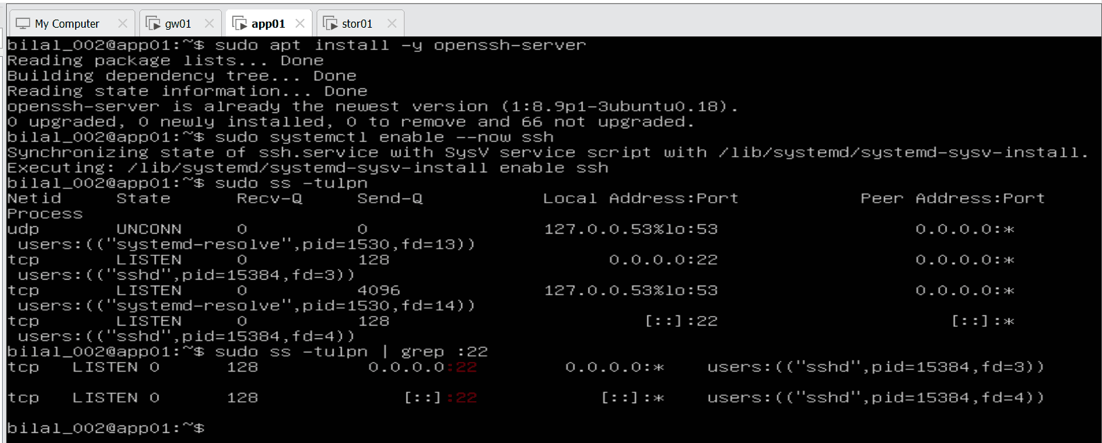
SSH enabled on app01, listening on port 22
Line | Meaning
openssh-server is already the newest version | The package was already installed – only the service was not running. enable --now started it and made it start at every boot
tcp LISTEN 0.0.0.0:22 … sshd | SSH waits on door 22 on all IPv4 addresses – reachable from gw01 and stor01
tcp LISTEN [::]:22 … sshd | The same for IPv6 ([::] = all IPv6 addresses)
Send-Q 128 | sshd’s waiting queue – up to 128 connections may queue
systemd-resolve pid 1530 (before: 842) | New process number after the VM restart – normal
Before → after: app01 went from 0 doors open to the network to 1 – SSH on port 22.

7. Testing a port: nc -zv and the binding address
💡 In plain words: ping only proves a machine is alive. To prove a service answers, you knock on its door (port). nc (netcat) does exactly that – the admin’s standard check when “ping works but the application doesn’t”.
🔧 Commands (on app01 – the machine calling itself):
nc -zv app01 22 # -z: only check the door, send no data · -v: print the result
nc -zv app01 53 # same for door 53
nc -zv 127.0.0.53 53 # door 53 at the DNS helper's own address
cat /etc/hosts # where the name "app01" points to
📸 Evidence:
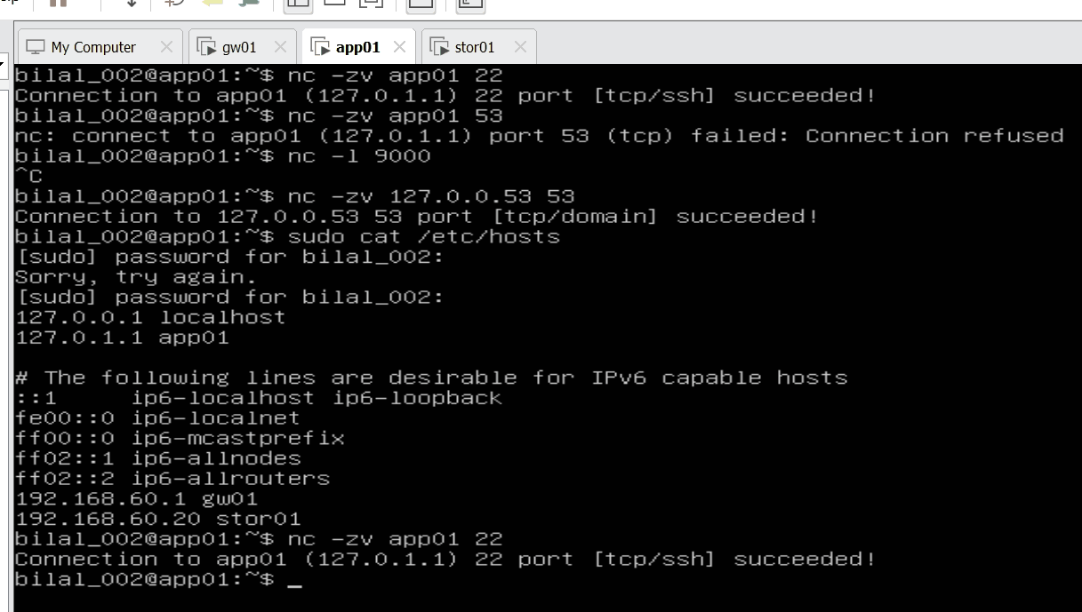
Port tests on app01 with nc -zv
Test | Result | Why
app01:22 (= 127.0.1.1) | ✅ succeeded | sshd listens on 0.0.0.0 = every address of the machine
app01:53 (= 127.0.1.1) | ❌ Connection refused | The DNS helper listens only on 127.0.0.53 – a different address
127.0.0.53:53 | ✅ succeeded | The right address – the DNS service is running
Three loopback addresses (the whole range 127.x.x.x means “this machine itself”, all on the card lo):
Address | Created by | Seen in | Purpose
127.0.0.1 | Worldwide standard | /etc/hosts → localhost | “Myself” for any program
127.0.1.1 | Ubuntu installer (hostname) | /etc/hosts → app01 | The machine finds its own name without a network
127.0.0.53 | systemd-resolved | /etc/resolv.conf → nameserver | The DNS helper’s private address
Refused vs. timeout – two different failures:
Result | What happened | Usual cause
Connection refused | The machine answered “nobody here” | Service not running, or listening on another address
Timeout | No answer at all | Firewall silently dropping, network broken, machine off
Refused points to the service; timeout points to the network or firewall.

8. Key understanding (in my own words)
Netid is the protocol, TCP or UDP. TCP starts every conversation with a 3-way handshake (SYN, SYN-ACK, ACK); after that the connection is ESTAB. UDP has no handshake – it just sends.
Every port leads directly to its own program. The port number decides which program receives the traffic: port 22 → sshd (SSH), port 53 → the DNS helper, port 80 → a web server. Traffic does not pass through the DNS helper first. A port with no program behind it is closed – nobody answers.
LISTEN = a TCP door is open and waiting. UNCONN = a UDP door is open. Recv-Q = data received but not read yet (0 = nothing waiting). Send-Q on a LISTEN socket = how many visitors may wait in the queue (4096 for the DNS helper’s TCP socket). Local address = this machine’s address and door, e.g. 127.0.0.53%lo:53 = the DNS helper on the loopback card, port 53, reachable only from inside app01. Peer address = who is visiting – 0.0.0.0:* = nobody yet; in a real connection it shows the visitor’s IP and its random port, e.g. 192.168.60.1:51234 = gw01.
A server can test itself by calling its own address – loopback (127.x.x.x). localhost (127.0.0.1) and app01 (127.0.1.1) both mean “myself”. SSH listens on all addresses (0.0.0.0), so localhost:22 and app01:22 both work. The DNS helper listens on one fixed address only, 127.0.0.53, so only 127.0.0.53:53 works – any other address gets “connection refused”. The binding address matters: 0.0.0.0 = the door is open at every entrance of the building; 127.0.0.53 = the door exists at one entrance only.
A port is a door number; a socket is a program standing at that door on a specific machine (IP + port + protocol); a connection is two sockets talking to each other.
DNS has one job: translate a name into an IP address – the phone book, not the phone line. Lookup order on app01: /etc/hosts (own contact list) → local DNS helper 127.0.0.53 (answers from its cache) → outside DNS server 1.1.1.1 / 8.8.8.8 through gw01. Once the IP is known, the real traffic goes directly to that IP and port. In a company, an internal DNS server answers internal names; in our lab /etc/hosts does that job.
Before the fix, the only open port on app01 was 53, used by the local DNS helper, and only from inside app01 – it accepted no connections from the network. Next: enable SSH so port 22 opens.

9. Step 1.5 finished – SSH reachable across the lab network
🔧 On stor01: enable SSH and test app01 from another machine (on gw01 SSH was already running; only checked):
sudo apt install -y openssh-server && sudo systemctl enable --now ssh
sudo ss -tulpn | grep :22 # LISTEN 0.0.0.0:22 = door 22 open to the network
nc -zv app01 22 # knock on app01's SSH door over the lab network
📸 Evidence – stor01: SSH listening, and app01 reached at 192.168.60.10 (not loopback):
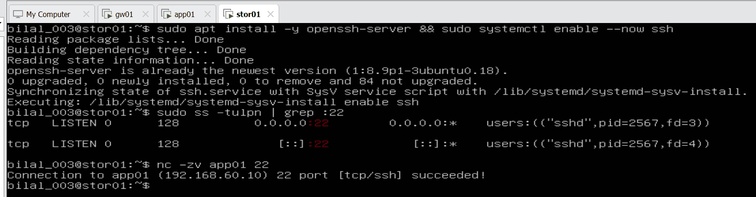
stor01: SSH enabled, nc to app01 succeeded
📸 Evidence – gw01: SSH listening, both servers reachable on port 22:
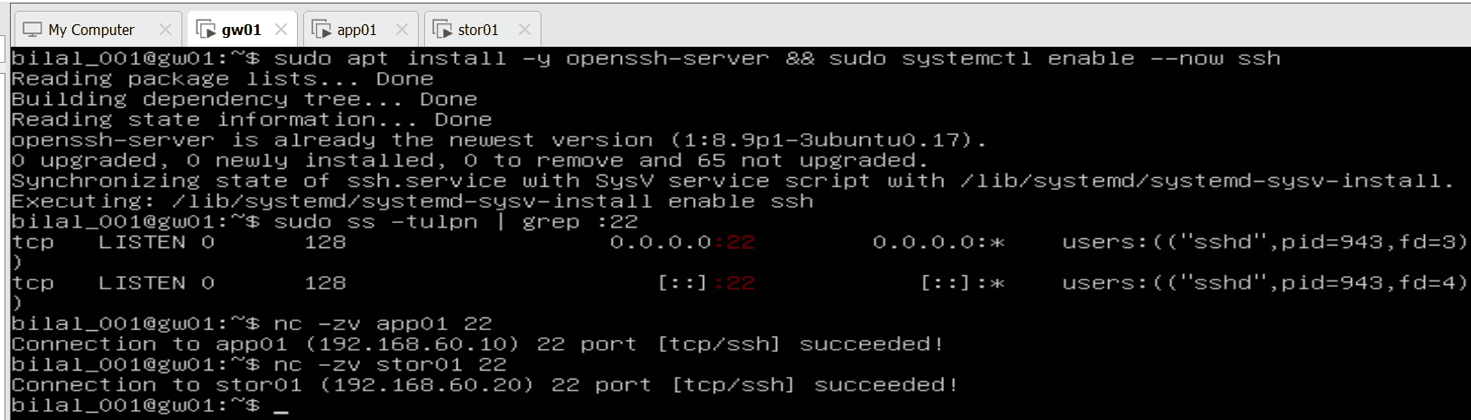
gw01: SSH listening, nc to app01 and stor01 succeeded
From | To | Result
stor01 | app01 (192.168.60.10):22 | ✅ succeeded
gw01 | app01 (192.168.60.10):22 | ✅ succeeded
gw01 | stor01 (192.168.60.20):22 | ✅ succeeded
Step 1.5 complete: every server runs SSH on port 22 (0.0.0.0 and [::]), reachable across the lab network.

10. Step 1.6 – SSH keys: log in without a password
💡 In plain words: a password is something you type; an SSH key is a pair of files – a private key that never leaves gw01 (like a house key in your pocket) and a public key that is copied to each server (like a lock fitted to the door). If the key fits the lock, the door opens – no password. gw01 needs this because it becomes the Ansible control node in Phase 7A and must reach every server automatically.
🔧 On gw01, as the normal user bilal_001 (not root):
ssh-keygen -t ed25519 -C "acme-lab" # create the key pair (Enter 3×: default path, no passphrase for the lab)
ssh-copy-id bilal_002@app01 # copy the PUBLIC key to app01 (asks the password once)
ssh-copy-id bilal_003@stor01 # same for stor01

Issue: key first created for root
📸 The first attempt ran as root – the key landed in /root/.ssh/, so password-free login would only work with sudo ssh …:
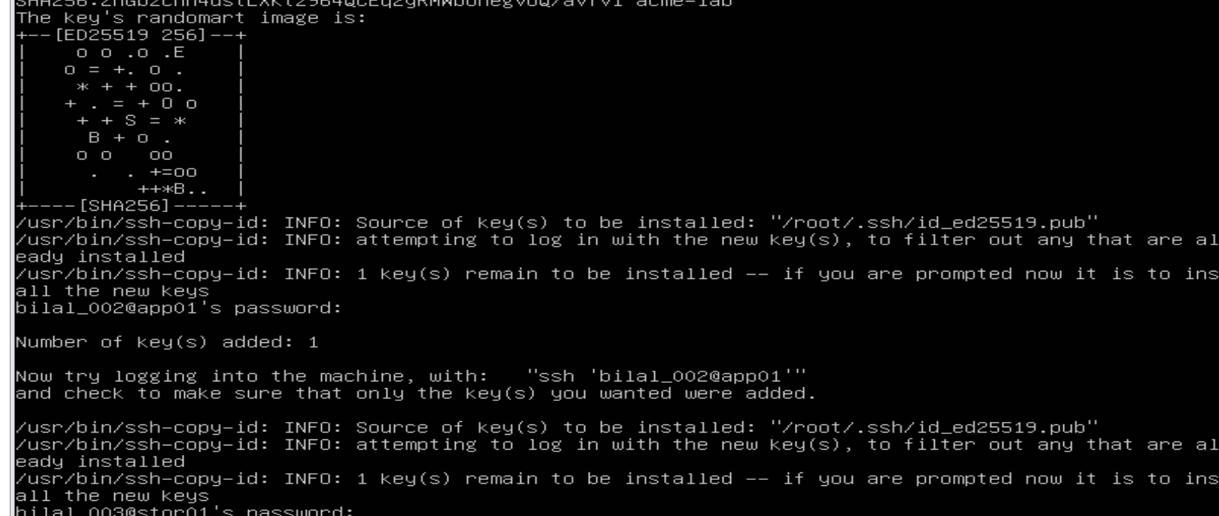
ssh-copy-id using /root/.ssh/id_ed25519.pub
Fix: repeated as bilal_001, without sudo. The key now lives in /home/bilal_001/.ssh/. (The root key copied earlier will be removed during hardening in Phase 6 – servers should not trust gw01’s root user.)
📸 Evidence – correct key for bilal_001:
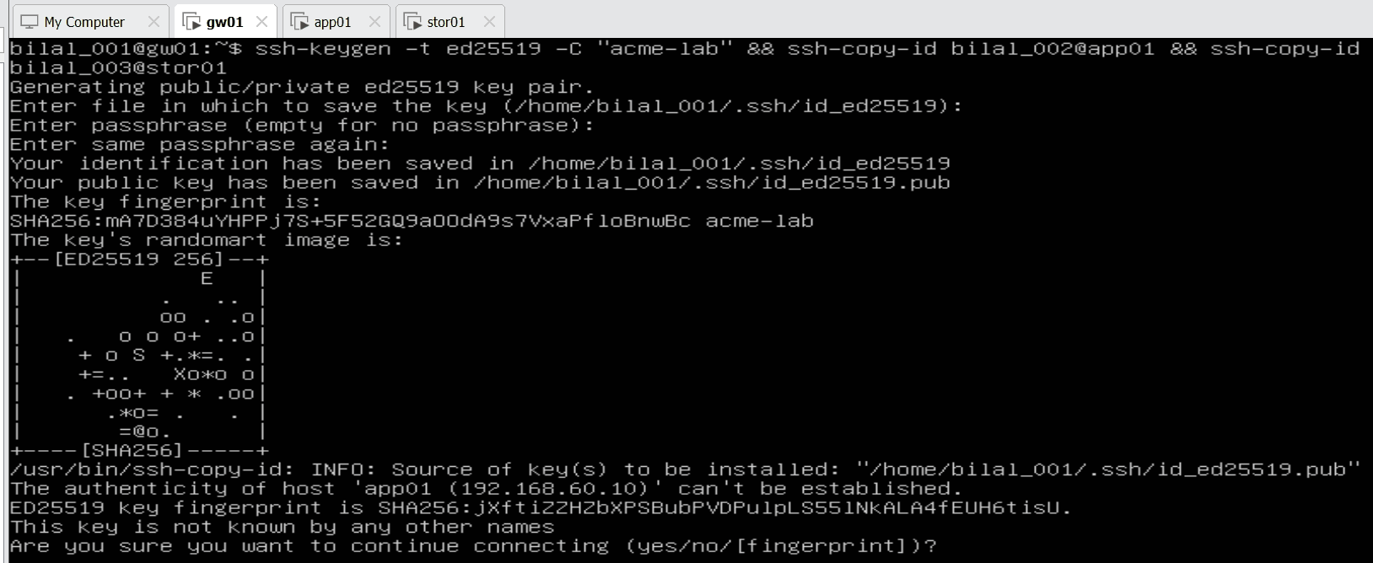
ssh-keygen as bilal_001, key in /home/bilal_001/.ssh
“The authenticity of host … can’t be established” – first visit to a server: gw01 asks whether to trust the server’s ID (fingerprint). After yes it is stored in ~/.ssh/known_hosts; if a server’s ID ever changes, SSH warns – protection against impostors.
📸 Evidence – key added to stor01 (“Number of key(s) added: 1”):
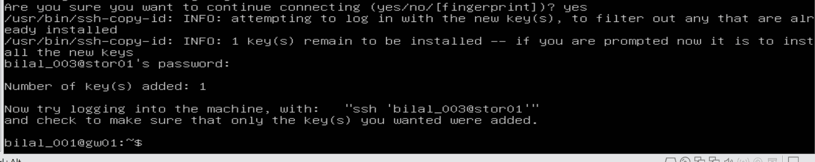
ssh-copy-id to stor01

The proof: login without a password
ssh bilal_002@app01 # log in to app01 – no password prompt
exit # close the session, back to gw01
ssh bilal_003@stor01 # log in to stor01 – no password prompt
exit # back to gw01
📸 app01 – logged in with no password; the welcome screen confirms IPv4 address for ens34: 192.168.60.10:
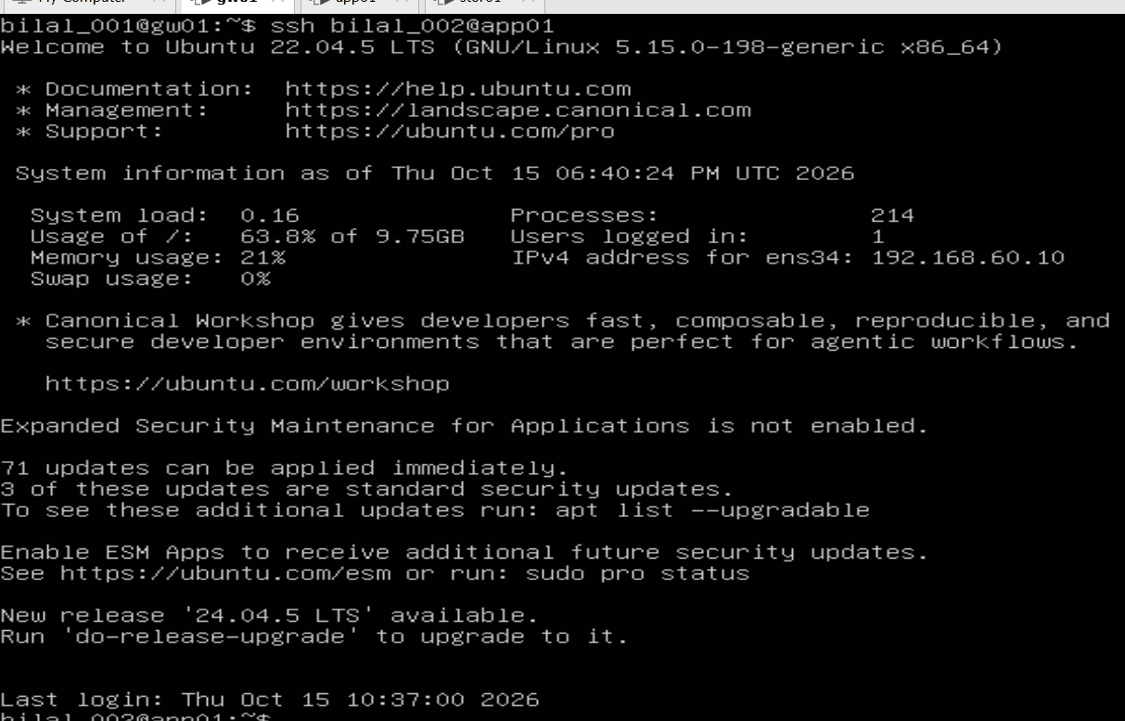
SSH login to app01 without password
📸 stor01 – same; note Last login … from 192.168.60.1 – Linux records who logged in from where (the start of an audit trail):
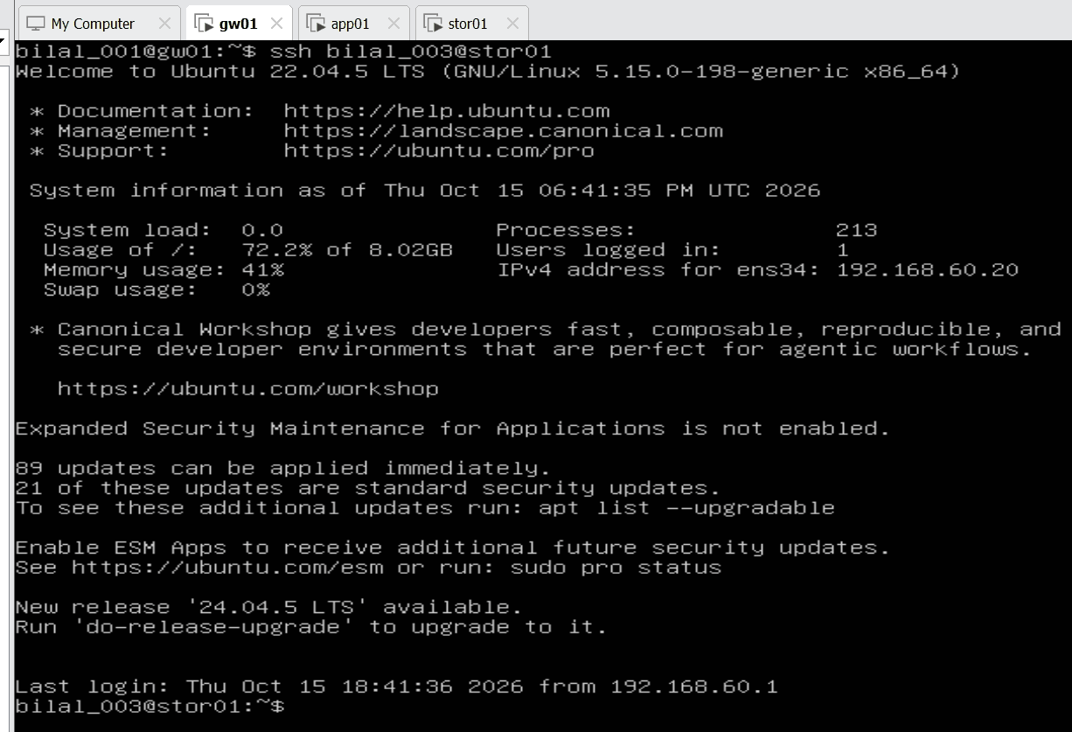
SSH login to stor01 without password
📸 exit closes the remote session – the prompt bilal_001@gw01:~$ shows I am back on gw01:
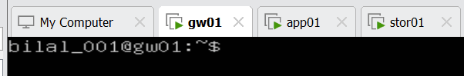
Back on gw01 after exit
Habit: always read the prompt before typing – user@host tells you which server the next command runs on.
Observed on the welcome screens | Meaning
app01 / 63.8 % of 9.75 GB · stor01 / 72.2 % of 8.02 GB | stor01’s system disk is filling – data moves to the separate LVM disks in Phase 2
71 (app01) / 89 (stor01) updates, 3 / 21 security | to be applied during hardening (Phase 6)
“New release 24.04.5 available” | deliberately not upgraded – the lab stays on 22.04

Copying a file over SSH: scp
💡 In plain words: scp (secure copy) sends a file to another server through the same encrypted SSH door – and because the key is installed, no password is needed. Instead of a throw-away test file I created a short platform runbook – the kind of handover note admins keep.
cat > Acme_Platform_Runbook.txt << 'EOF' # write the lines below into the file …
Acme Analytics - Platform Runbook
gw01 192.168.60.1 gateway, NAT, firewall
app01 192.168.60.10 application server
stor01 192.168.60.20 storage and logs
Admin access: SSH keys from gw01 only
EOF # … until the end marker EOF ("End Of File")
scp Acme_Platform_Runbook.txt bilal_002@app01:/tmp/ # copy it to app01's /tmp folder
ssh bilal_002@app01 cat /tmp/Acme_Platform_Runbook.txt # run ONE command on app01 and show the result
Heredoc (<< 'EOF'): “write everything I type until you see EOF”. The closing EOF stands alone on its line; the quotes keep the text exactly as typed. File names use underscores – spaces in Linux file names need quoting and break scripts.
📸 Evidence – file created and copied (100% 199 bytes, no password):
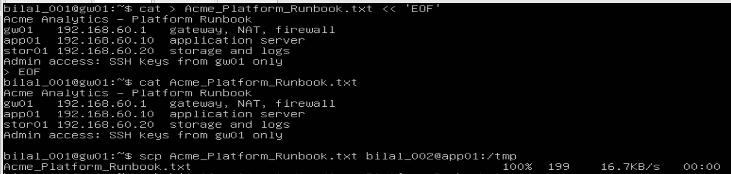
Runbook created with a heredoc and copied with scp
📸 Evidence – read back on app01 with a one-shot SSH command:
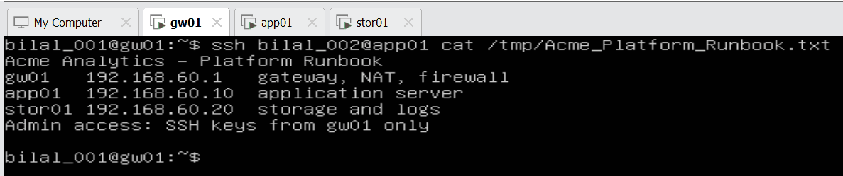
Runbook read on app01 via ssh
ssh user@host command runs a single command on the remote server and returns – the same pattern Ansible uses later.

SSH shortcuts: ~/.ssh/config
💡 In plain words: a personal address book for SSH – type ssh app01 instead of ssh bilal_002@192.168.60.10.
cat > ~/.ssh/config << 'EOF'
Host app01
HostName 192.168.60.10
User bilal_002
Host stor01
HostName 192.168.60.20
User bilal_003
EOF
chmod 600 ~/.ssh/config # only the owner may read it – SSH refuses a config others can read
ssh app01 # log in by short name – no user, no password
exit
ssh stor01
exit
📸 Evidence – the shortcut file:
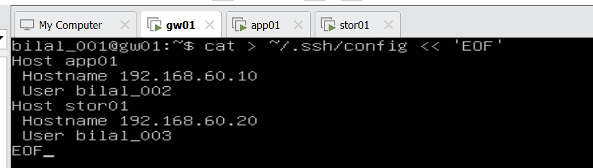
~/.ssh/config with Host entries for app01 and stor01
📸 Evidence – ssh app01 logs in as bilal_002 without a password:
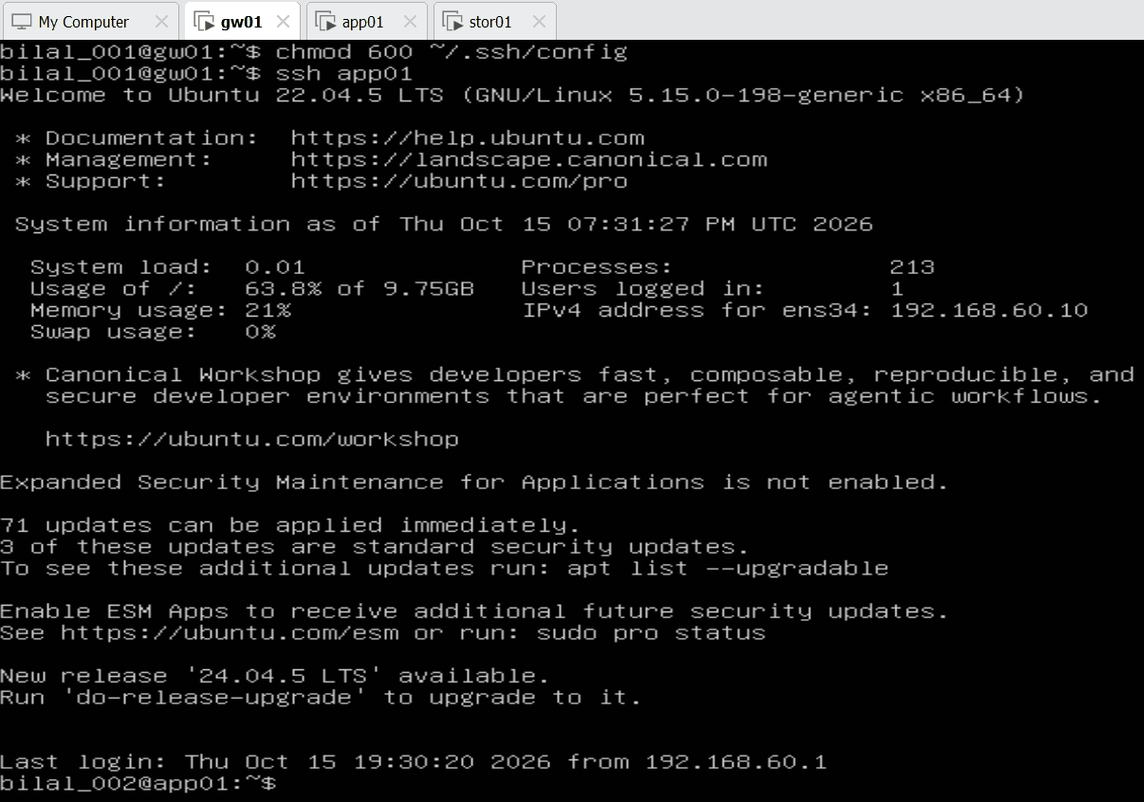
ssh app01 by alias
📸 Evidence – exit (“Connection to 192.168.60.10 closed”), then ssh stor01:
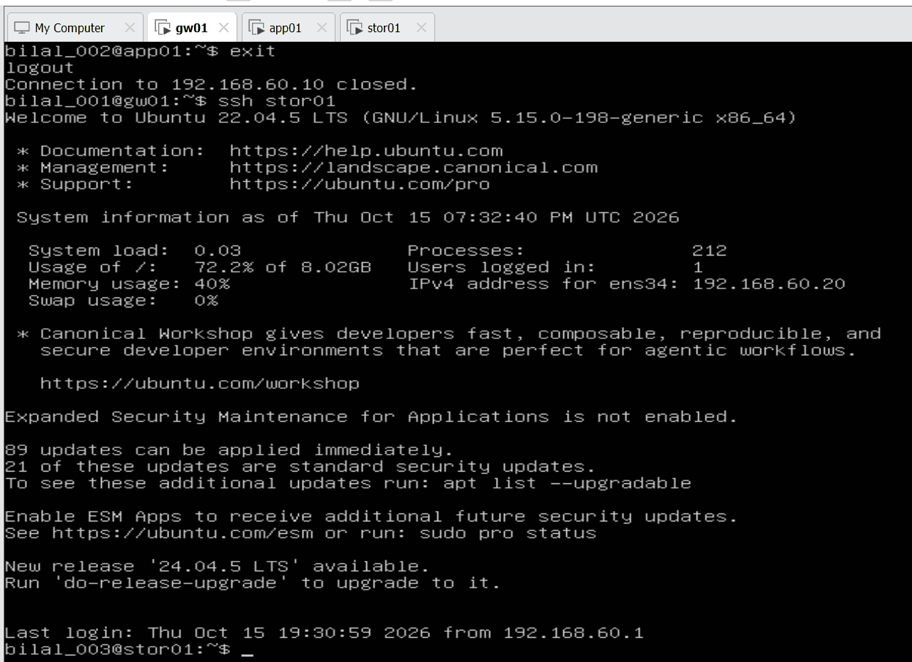
exit and ssh stor01 by alias

Interactive transfer: sftp
sftp app01 # open a file session over SSH
sftp> ls # list files in the home folder on app01
sftp> cd /tmp # change folder on app01
sftp> get Acme_Platform_Runbook.txt # download to gw01
sftp> exit
📸 Evidence – runbook downloaded from app01 to gw01 (100 %):
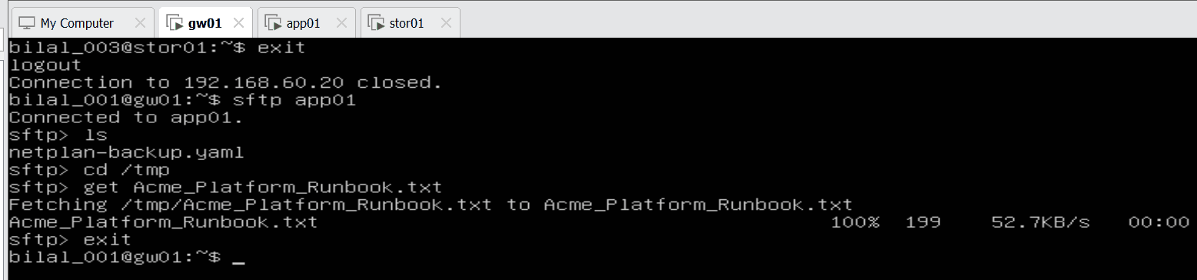
sftp session: ls, cd, get

Why not FTP?
FTP sends usernames, passwords and files in clear text – anyone listening on the network can read them. SCP and SFTP run inside SSH, so everything is encrypted, and with keys no password crosses the network at all. Companies do not use plain FTP for administration.
Tool | Use | Encrypted
scp | copy one file quickly | ✅ (SSH)
sftp | browse and transfer interactively | ✅ (SSH)
ftp | legacy file transfer | ❌ clear text
Step 1.6 complete: gw01 reaches app01 and stor01 by key and by short name, runs remote commands and copies files with scp and sftp – all encrypted, all without a password.

11. Step 1.7 – Hard links, soft links and inodes
💡 In plain words: every file has an ID card (the inode) holding its owner, permissions, size, dates and where the data sits on disk. The file name is only a label in a folder pointing to that ID card. - A hard link = a second label on the same ID card. Delete one label, the file lives on. - A soft link = a signpost with its own ID card that only says “go to that name”. Delete the original, the signpost points to nothing.
🔧 Technical: a directory is a list of name → inode number. ln adds another directory entry for the same inode (link count +1). ln -s creates a new inode of type symlink that stores a path. The inode and its data blocks are freed only when the link count reaches 0 and no process still has the file open.
Why in this project: Phase 2 backs up app data to stor01 with rsync --link-dest. Every day’s backup folder hard-links the files that did not change to yesterday’s copy, so 30 daily backups look full-size but take little extra space. A soft link /backups/latest points to the newest day and is moved each night. The same signpost idea is used by nginx (sites-enabled → sites-available) in Phase 7. This lab proves the mechanism on real files first.

Procedure (on app01, as bilal_002)
mkdir -p ~/acme && cd ~/acme
echo "APP_PORT=8080" > app.conf # an Acme config file
ln app.conf app.conf.backup # hard link: second name, same inode
ln -s app.conf current.conf # soft link: signpost holding the path "app.conf"
ls -li # first column = inode number, third = link count
echo "LOG_LEVEL=info" >> app.conf.backup # write through the hard link
cat app.conf # the change appears here too – same file
stat app.conf | head -3 # Inode and Links: 2
📸 Evidence – same inode 276722 and link count 2 for both names; the soft link has its own inode 276727; an edit via the hard link shows in the original:
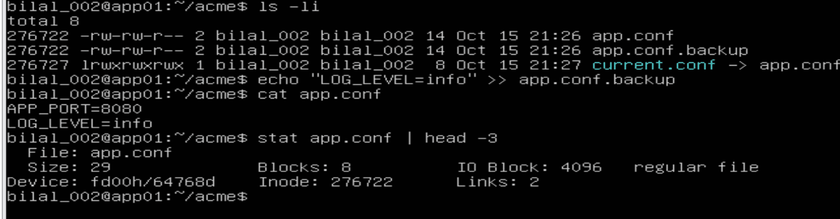
ls -li, write through the hard link, stat

The “accidental delete” test
rm app.conf # simulate a colleague deleting the file
cat app.conf.backup # data is still there
cat current.conf # "No such file or directory" – the signpost is broken
ls -li # link count of the survivor is now 1; current.conf shown in red
df -i / # inode capacity of the root file system
📸 Evidence – hard link survives, soft link broken, inode usage 19 %:
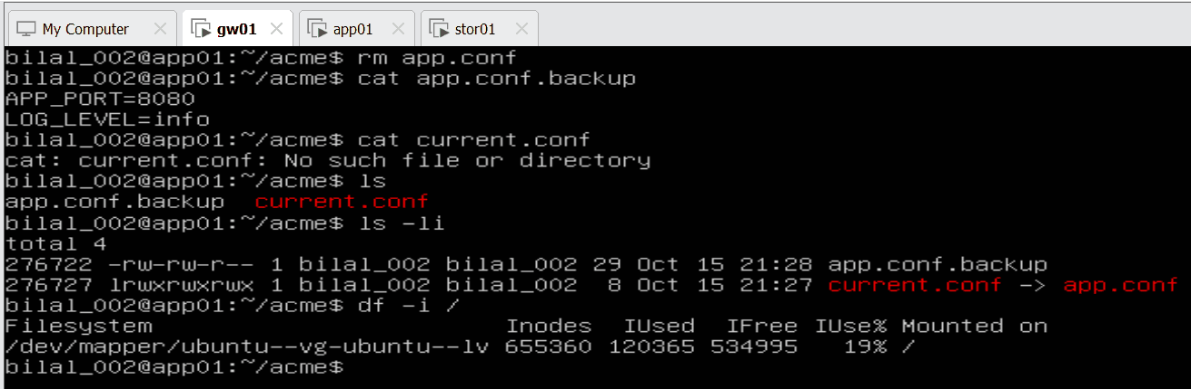
rm original, hard link survives, soft link broken, df -i

Reading the results
Observation | Meaning
276722 … 2 … app.conf and 276722 … 2 … app.conf.backup | One file, two names (link count 2)
276727 lrwxrwxrwx … current.conf -> app.conf | Separate inode; type l = symlink; size 8 = the length of the text “app.conf”
LOG_LEVEL=info appears in app.conf | A hard link is not a copy – an edit through either name changes the one file
After rm: app.conf.backup still readable, link count 1 | Data is freed only when the last name is gone
current.conf shown in red, cat fails | Dangling soft link – it points to a name that no longer exists
df -i /: 655,360 inodes, 120,365 used, 19 % | Each file uses one inode; when inodes run out you get “No space left on device” even with free GB – worth monitoring (Phase 5A)

Key understanding (in my own words)
Linux works with inode numbers; the name I type is only a label in a folder. A hard link is a second label on the same inode – deleting one name loses nothing, but it does not protect against bad edits, because it is the same file. A soft link has its own inode and only holds a path – deleting it never harms the original, but deleting the original breaks it. Hard links protect important files against accidental deletion; real protection against bad changes still needs backups (Phase 2).
Step 1.7 complete. ~/acme stays on app01 as sample data.

12. Step 1.8 – Users, groups and a service account (continued 2026-10-16)
💡 In plain words: every person gets their own account, people who do the same job share a group, and every program gets its own low-rights account that nobody can log in to. When someone leaves, their account is locked, not shared or forgotten.
Why in this project: the security questionnaire in the brief asks “who can log in, and with which rights?”. This step answers it: named users, a team group, and a no-login service account. In Phase 3 the Acme app’s systemd service runs as svc-app; in Phase 6 groups decide who may use sudo and Docker; in Phase 7A Ansible automates exactly this joiner/leaver process.

Procedure (on app01)
sudo groupadd devs # team group (it already existed)
sudo useradd -m -s /bin/bash -G devs alice # -m home folder, -s shell, -G extra group
sudo useradd -m -s /bin/bash -G devs bob
sudo useradd -r -s /usr/sbin/nologin svc-app # -r system account, nobody can log in
sudo passwd alice # give alice a password
id alice # uid, primary group, secondary groups
getent group devs # members of devs
sudo chage -l alice # password aging ("change age")
sudo usermod -L bob # lock (leaver)
sudo passwd -S bob # status: L = locked, P = password, NP = none
sudo usermod -U bob # unlock (returner)
📸 Evidence – svc-app has the shell /usr/sbin/nologin and system uid 998; alice’s password aging:
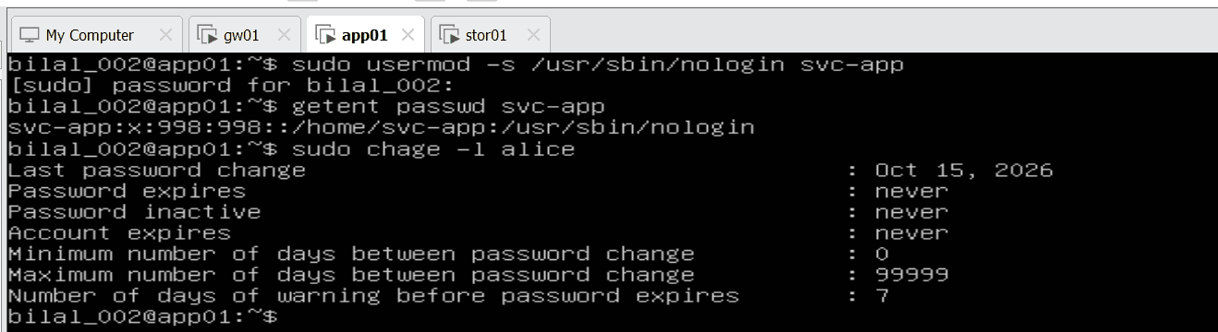
getent passwd svc-app and chage -l alice
📸 Evidence – devs = alice, bob; svc-app in its own group only; bob locked (L):
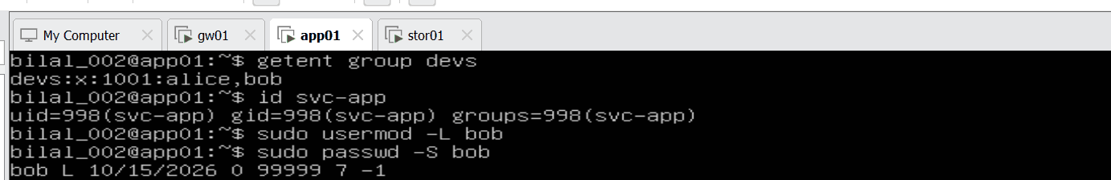
getent group devs, id svc-app, lock bob
📸 Evidence – unlock refused, because bob has no password yet:
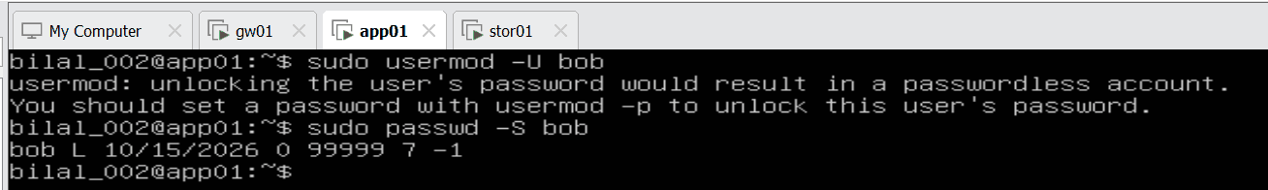
usermod -U refused: passwordless account

Reading the results
Output | Meaning
uid=1001(alice) gid=1002(alice) groups=1002(alice),1001(devs) | Primary group = her own private group; secondary group = devs
devs:x:1001:alice,bob | Both developers are in the team group
svc-app:x:998:998::/home/svc-app:/usr/sbin/nologin | uid below 1000 = system/service account; shell nologin = no human login
chage -l alice: expires never, max 99999 | No password expiry yet – to be set by policy in Phase 6 (e.g. chage -M 90)
bob L 10/15/2026 0 99999 7 -1 | Status L = locked; then min/max/warn days and inactive (-1 = not set)
usermod -U bob refused | Safety feature: unlocking an account without a password would leave it open with no password at all. Set a password first (sudo passwd bob), then lock/unlock.

Option cheat sheet
Option | Meaning
useradd -m | make the home folder
useradd -s / usermod -s (small s) | set the shell
useradd -G | add to extra groups
useradd -r | system account (uid < 1000, no home folder) – low rights come from no extra groups and not being root
usermod -L / -U | lock / unlock
passwd -S (capital S) | show the password status
chage -l / -M 90 | show aging / force a new password every 90 days

Key understanding – final summary
On app01, the server where the Acme application runs, we created named accounts for each developer – alice and bob – each with their own home folder (-m) and login shell (-s), and put both in a shared team group devs, so rights are given to the team instead of to each person; each user has a primary group (their own) and a secondary group (devs). We then created svc-app as a system account (-r, uid 998, below 1000) with the shell nologin and no password: no human can log in as it, it exists only so a program can run under it. Every service runs as some user – the main sshd as root with its pre-login part as sshd, nginx as www-data – and giving each service its own low-rights account means a hacked service reaches only that account’s own files, not root. chage shows and sets the password-aging rules, and usermod -L / -U lock and unlock an account – the leaver/returner process. Linux refused to unlock bob while he had no password, because a human account must have a password or key before it is opened. This step answers the Acme customer’s security question “who can log in, and with which rights?”, and it is the base for later phases: in Phase 3 the app runs as svc-app, in Phase 6 groups control sudo and Docker access, and in Phase 7A Ansible automates joiners and leavers.
Step 1.8 complete.

13. Step 1.9 – Linux NAT vs Cloud NAT
💡 In plain words: NAT is the mailroom that swaps the private sender address for the company’s public address on the way out and hands the replies back to the right person. In my lab I build that mailroom myself on gw01. In the cloud you rent it as a ready-made service.
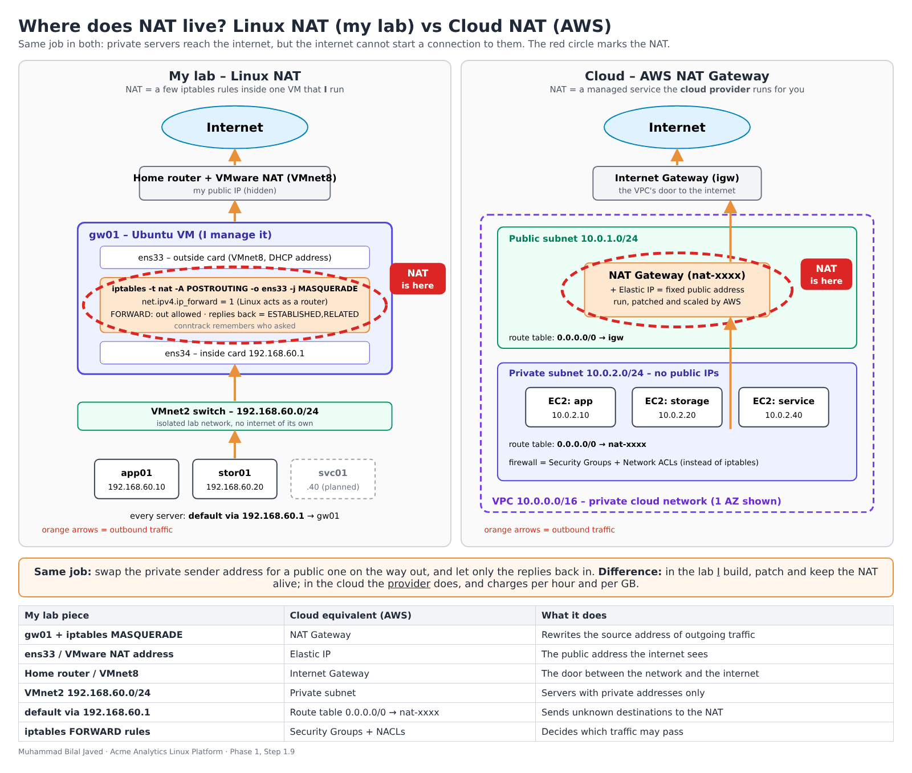
Where does NAT live? Linux NAT in my lab vs AWS NAT Gateway

Where the NAT sits
 | My lab (gw01) | Cloud (AWS)
The NAT itself | 3 kernel settings on one VM: ip_forward = 1, iptables MASQUERADE, FORWARD rules | A NAT Gateway placed in a public subnet
How servers find it | default via 192.168.60.1 in netplan on each server | Private subnet route table 0.0.0.0/0 → nat-xxxx
Public address | The address of gw01’s outside card (VMware NAT / home router) | An Elastic IP attached to the NAT Gateway
Way out to the internet | Home router / VMnet8 | Internet Gateway (public subnet route 0.0.0.0/0 → igw)
Firewall | iptables FORWARD chain | Security Groups + Network ACLs

Comparison across providers
 | gw01 (mine) | AWS NAT Gateway | Azure NAT Gateway | GCP Cloud NAT
Who runs it | Me | AWS (managed) | Azure (managed) | Google (managed)
Where | One VM | Public subnet; private route table 0.0.0.0/0 → nat-xxxx | Attached to a subnet | Configured on a Cloud Router; no NAT VM at all (software-defined)
High availability | None – one VM is a single point of failure | Redundant inside one Availability Zone; one gateway per AZ for full resilience | Managed, zonal | Managed, distributed
Public IP | Address of the NAT adapter | Elastic IP | Public IP(s) or prefix | Auto-allocated or reserved IPs
Cost model | The VM I already run | Per hour + per GB processed | Per hour + per GB processed | Per hour + per GB processed

In three sentences
- What stays the same: the job – outbound source translation, so private servers reach the internet while nobody on the internet can open a connection to them.
- What the cloud adds: the provider runs, patches, scales and keeps the NAT available; in my lab, if gw01 is off, app01 and stor01 lose the internet.
- What I would watch: cost – managed NAT is charged per hour and per GB, so heavy traffic (updates, backups, container image pulls) through it gets expensive; options such as VPC endpoints for cloud storage keep that traffic off the NAT.

Key understanding (in my own words)
In my lab the NAT is not a box – it is three settings inside gw01: forwarding on, a MASQUERADE rule, and FORWARD rules that let replies back. Servers reach it because their default route points to gw01. In the cloud the same job is a managed NAT Gateway in a public subnet, reached through a route table entry and given a fixed Elastic IP; the provider keeps it running and bills per hour and per GB. Same job, different owner.

14. End of Phase 1 – updates and snapshot
All three VMs were updated (sudo apt update && sudo apt -y upgrade), shut down cleanly and given a VMware snapshot – the restore point for everything built in Phase 1.
VM | Snapshot name | Root disk | Used
gw01 | 20-Network-gw01 | 8.1 G | 68 %
app01 | 20-Network-app01 | 9.8 G | 68 %
stor01 | 20-Network-stor01 | 8.1 G | 77 %
Description on every snapshot: Phase 1 done: static IPs, NAT via gw01, hosts, SSH keys, users/groups, updates installed.
📸 Evidence – disk usage on gw01, app01, stor01 before the snapshot:
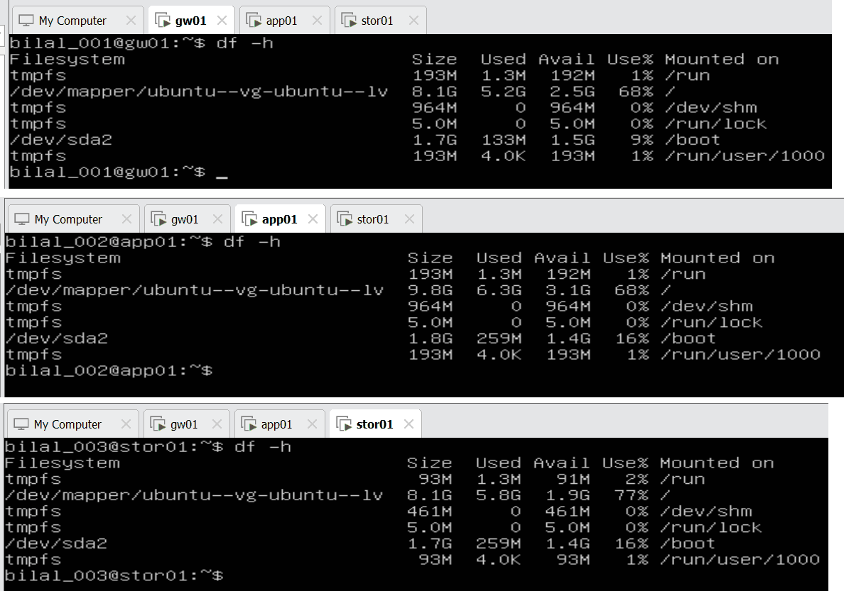
df -h on all three VMs
💡 Why: a snapshot taken while the VM is off is clean and small (no memory saved). If Phase 2 (storage) breaks something, I return to this point in one click instead of rebuilding the network. stor01’s root disk is the fullest, which is fine: backups will go to its separate data disks (sdb, sdc) with LVM in Phase 2.
Phase 1 complete ✅

15. Next steps
- Phase 0 leftover: switch app01 and stor01 to server mode (multi-user.target).
- Phase 1A: GLPI service desk – tickets, knowledge base and inventory on svc01.
- Phase 2: storage – LVM on stor01’s data disks, NFS share, backups with hard links, LVM snapshots.

