

FitHub
A Centralized Multi-Service Fitness Platform
Course | SE 214L — Human Computer Interaction Lab
Instructor | Ms. Itrat Fatima
Submitted By
Student ID | 242259, 242257,242277,243408
Group Members | M. Hasnain, Bilal Khalid, Huzaifa Ali, Abdul Muqeet
Semester | Spring 2026
Submission Date | May 31, 2026

Abstract
The following report describes the designing and evaluation of the FitHub application which is built as a semester project within the Human Computer Interaction (HCI) course. The primary objective behind this project was to address the issue faced by the users in using multiple apps for different purposes such as gym membership, bookings, workout, etc. To understand the problem, we studied existing fitness platforms and identified several usability gaps. On the basis of these findings, FitHub has been developed with the use of user-centric design, with the creation of high-fidelity screens in Figma for various users such as clients, trainers, sellers, and administrators.
Usability testing on the prototype has been conducted with the help of three subjects. The result showed that there is some room for improvements but the whole interface was comprehensible to the users.

Table of Contents
1. Introduction 4
2. Problem Statement 5
3. Literature Review / Background Study 6
4. Methodology 8
5. Interface Design 12
6. Usability Evaluation 16
7. Results And Discussion 18
8. Conclusion 20
9. References 21

1. Introduction
At the moment, there are many apps and tools that help people to stay fit. If a person decides to go to the gym, take personal trainings, keep an eye on the number of calories consumed, and take some additional products, then he or she would require several apps for each particular activity. The fact is that the majority of such fitness tools operate independently from other ones.
Talking to our friends and students who work out regularly, we realized that changing between several apps takes time and effort. That was the point where we came up with the idea of creating a platform where all the apps are gathered in one place.
The main goal of this project is to develop a fitness platform using Human Computer Interaction techniques.

1.1 Project Scope
The scope of this project covers the design and usability evaluation of the FitHub platform. The work includes:
- Identification and analysis of the real-world problem
- Background study of existing fitness applications
- Conceptual design including task models and interaction flows
- High-fidelity interface design using Figma (14 screens across 4 user portals)
- Formative usability testing with three participants
- Analysis of results and recommendations for improvement
The project does not involve any actual software development or backend implementation. The focus is entirely on the user experience design and HCI principles as required by the course objectives.

2. Problem Statement

Fitness procedure for a person will normally involve such stages as search and connection with a gym, recruitment of an experienced personal trainer, collection of nutrition data and workout data, and procurement of fitness accessories and dietary supplements. But presently, all these actions are undertaken separately, with the help of different software solutions. This makes users have separate accounts on multiple platforms, use separate logins for each platform, pay through separate channels, and navigate across multiple applications.

From an HCI perspective, the present scenario is not in line with several usability rules. It violates the rule of consistency in that it forces users to experience a variety of interfaces within each software application. The user’s cognitive burden is increased because he or she is supposed to keep track of various pieces of data from different sources. Efficiency is reduced since accomplishing any fitness task involves switching between three to four different applications.

2.1 Target Users
FitHub is designed for four distinct groups of users, each with their own needs and goals:

User Type | Description | Primary Need
Client / Member | Fitness enthusiasts, gym-goers aged 16-45 | Single platform for all fitness needs
Trainer | Certified personal trainers worldwide | Reach clients globally, manage sessions
Seller | Businesses selling gym gear and supplements | List and sell products, grow customer base
Admin | Platform manager / operator | Approve users, monitor revenue, manage platform

2.2 Justification for the System
The need for FitHub is justified on multiple grounds. First, there is a clear market gap — no platform currently offers all four services (gym access, trainer booking, e-commerce, AI coaching) in a single unified interface. Second, the fragmented user experience in the current market is a measurable usability problem that directly affects user satisfaction and retention. Third, from a business perspective, the aggregator model creates strong network effects: more gyms attract more clients, more clients attract more trainers and sellers, and so on.
In Pakistan specifically, the fitness industry is growing rapidly but is very poorly digitized. Most gym memberships are still managed through paper forms, trainer hiring happens through word-of-mouth, and supplement purchases are made through unorganized social media groups. FitHub has the potential to bring formal structure and a professional user experience to this market.
3. Literature Review / Background Study
Before designing FitHub, we conducted a background study of existing fitness platforms and applications to understand what is currently available in the market, what these systems do well, and where they fall short. No academic research papers were consulted, as the focus of this study is on practical understanding of existing real-world systems.

3.1 Existing Systems and Applications

3.1.1 MyFitnessPal

The world's favorite fitness app is called MyFitnessPal. The first benefit of using the MyFitnessPal application is its ability to monitor calories and nutrients. This becomes possible due to the wide range of foods contained in the database of the application.One disadvantage of MyFitnessPal is that it does not provide facilities for accessing the gym, booking trainers, or even engaging in e-commerce.

3.1.2 ClassPass

The ClassPass app is a subscription service where people can book workout classes at various gyms with a single account. It is the system closest to that of FitHub’s gym booking idea. The company runs across different countries and offers a neat interface. However, ClassPass does not have a trainer marketplace, lacks an AI training feature, and has no e-commerce capability. Furthermore, ClassPass cannot be accessed from Pakistan.

3.1.3 Trainerize

Trainerize is a system that helps personal trainers organize their clients online and assign training programs and communicate using the messaging system. This website is targeted at trainers and coaches, rather than at end clients who discover and hire the trainers from the site. For users, the Trainerize service is one-sided. You can only access it if you are invited by your coach.

3.1.4 Amazon / Daraz (Fitness Products)
For purchasing gym equipment and supplements, most users in Pakistan rely on general e-commerce platforms like Daraz or Amazon. While these platforms have large product catalogs, they are not fitness-specific. Sellers on these platforms cannot target the fitness audience specifically, and the product discovery experience for a fitness user is poor because fitness products are mixed in with millions of unrelated items.

3.1.5 Supplement Store Apps (Local)
Several local supplement brands in Pakistan have their own small apps or websites. These are single-brand stores with limited product variety and no community or fitness integration. They work as standalone shopping applications with no connection to the broader fitness ecosystem.

3.2 Limitations of Current Solutions
Based on the above review, the following limitations were found in today’s fitness solutions:
- Fragmentation: No single platform covers gym access, trainer booking, fitness tracking, and e-commerce together. Users must use 3-4 different apps to meet their fitness needs.
- Geographic limitations: Major platforms like ClassPass and Trainerize are not available or not fully functional in Pakistan.
- Passive trainer discovery: Existing trainer platforms like Trainerize require trainer initiation, whereas clients have no way to independently search and compare trainers.
- No AI integration: None of the local fitness platforms offer AI-powered personalized coaching for workout plans, diet plans, or calorie tracking.
- Lack of revenue sharing model for gyms: There is no current app that gives a revenue-sharing plan to gyms for each client signed up through the app.
- Inconsistent Mobile Service: Several local gym and trainer services only use phone calls or messages on WhatsApp to book appointments.

These limitations collectively make a strong case for a platform like FitHub, which addresses all of these gaps in a single, cohesive user experience. This makes it very clear why there should be a platform like FitHub.

4. Methodology

The approach that was used to design the FitHub system is based on User Centered Design (UCD). This approach puts into account the needs, requirements, capabilities, and limitations of the end user. Four general stages were involved in this process.

4.1 Phase 1 — Research and Problem Understanding

During the initial phase of the project, our team discussed common problems faced by gym members and fitness enthusiasts. We also collected informal feedback from classmates and friends who regularly exercise. Most participants mentioned that they use separate applications for fitness tracking, trainer booking, and online shopping. This helped us define the core features that FitHub should include.

4.2 Phase 2 — Conceptual Design

In Second Phase, we created the conceptual model of the system. We came up with user roles along with their mental models, created the task hierarchy, and also sketched out an interaction flow of the main use cases. In other words, we created a clear vision of what our system should be able to do and how people will see and use it.

4.3 Phase 3 — Interface Design
The third phase involved translating the conceptual models into actual screen designs using Figma. We designed fourteen screens covering all four user portals. The design was guided by established usability heuristics, particularly Nielsen's Ten Usability Heuristics, and followed a consistent dark-theme design language with an orange accent color system throughout all screens.

4.4 Phase 4 — Usability Evaluation

During the final stage, formative usability testing was performed by providing the prototype designed in Figma to three test subjects and analyzing their interaction with the prototype. Feedback from think-aloud sessions as well as task completion metrics were obtained during this stage. The findings were analyzed and used to generate design recommendations.

4.6 Challenges Faced during Design

There were quite a number of challenges in the design stage. Firstly, we had included too many functionalities in the dashboard interface, thus making it cluttered. After a few rounds of discussions and consultations among the group on the basis of HCI rules, we were able to simplify our interface in order to give priority to certain functions.

The second difficulty we faced was the creation of unique interfaces for the clients, trainers, sellers, and administrators.

4.5 HCI Principles Applied
For each stage, the following principles of HCI have been observed constantly:
- Visibility of system status: Inactive navigation buttons, status symbols, and progress bar notifications are always visible.
- User control and freedom: The presence of cancel icons, the ability to navigate backward, and the availability of form editing options in all forms.
- Consistency and standards: A unified design language (color palette, typography, component styles) is maintained across all fourteen screens and all four user portals.
- Error prevention: The use of placeholders and input validation notifications, along with the requirement for form validation before important actions, such as making bookings or payments.
- Recognition rather than recall: Use of icons, labels, and navigation menus ensures users do not have to memorize how to operate within the system.
- Aesthetic and minimalist design: The dark theme with focused content areas reduces visual noise and helps users concentrate on primary tasks.

5. Interface Design
The interface design for FitHub was created using Figma and consists of fourteen high-fidelity screens spread across four user portals. The design follows a consistent dark-theme visual language with an orange (#FF6B28) primary accent color, gold (#FAC033) secondary accent, and a dark charcoal (#141418) background. This color scheme was chosen because it is commonly associated with energy, performance, and fitness in modern applications, and the dark background reduces eye strain during prolonged use.

5.1 Design System
Before designing individual screens, a basic design system was established with the following tokens:

Element | Value / Specification
Primary Color | #FF6B28 (Energetic Orange)
Secondary Color | #FAC033 (Performance Gold)
Background | #141418 (Deep Charcoal)
Card Background | #1E1E28 (Dark Card)
Body Text | #FFFFFF / #8C8C96 (White / Gray)
Primary Font | Inter (Regular, Medium, Semi Bold, Bold, Extra Bold)
Base Font Size | 12-14pt body, 18-32pt headings
Border Radius | 10-22px (cards), 22px (full-round buttons/inputs)
Screen Size | 390 x 844px (iPhone 14 standard)

5.2 Screen Descriptions

Screen 1 — Landing Page
The landing page is the first screen users see when they open the application. It introduces the main features of FitHub, including gym memberships, trainer booking, AI coaching, and fitness shopping. The purpose of this screen is to give users a quick overview of the platform and encourage them to get started.
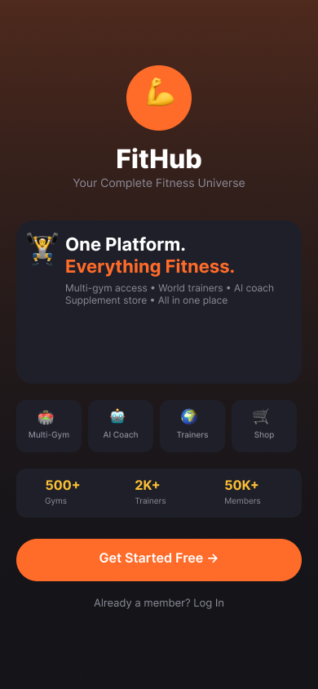
Figure: Screen 1: FitHub Landing Page

Screen 2 — Login / Signup
This screen allows users to create an account or log in to an existing account. Different roles such as Client, Trainer, Seller, and Admin can be selected from the same screen. We kept the design simple so users can easily access their respective portal.

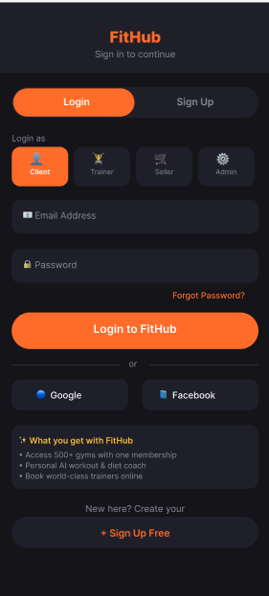

Figure: Screen 2: Login and Signup with Role Selection

Screen 3 — Client Dashboard
The client dashboard provides users with a summary of their fitness activities. Important information such as workout progress, membership status, calorie tracking, and upcoming trainer sessions is displayed in one place for quick access.
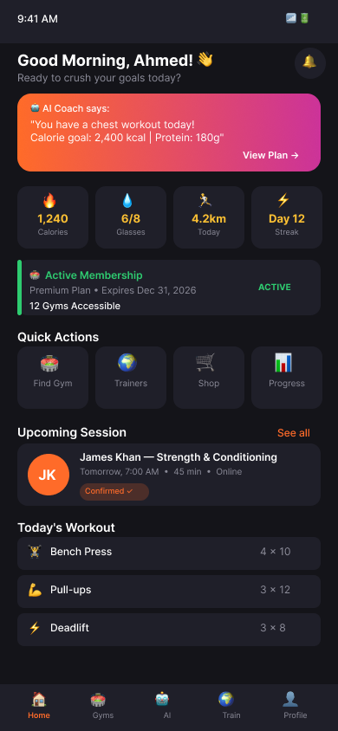
Figure: Screen 3: Client Main Dashboard

Screen 4 — Gym Search and Membership
This screen allows clients to discover partner gyms using a search bar, filter chips (Near Me, Open Now, 24/7, Premium), and an interactive map view. Gym listing cards show the gym name, location, star rating, opening hours, price, and a 'Join' button. The design prioritizes scannability so users can quickly compare options and make a decision.
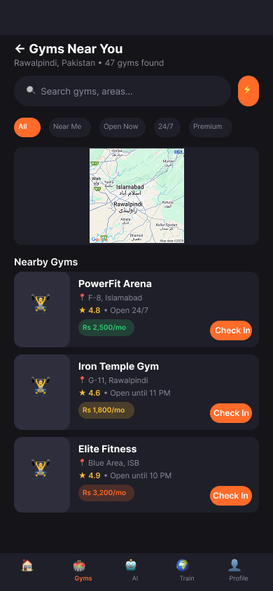

Figure: Screen 4: Gym Search Selection
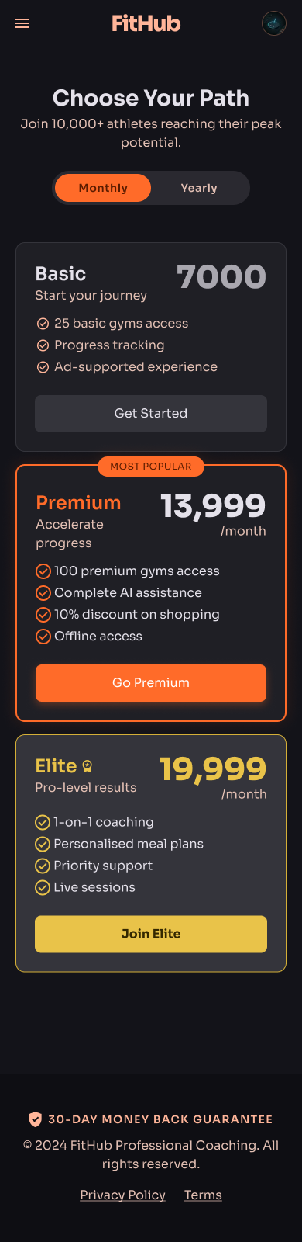
Screen 4: Membership Selection

Screen 5 — AI Fitness Assistant
The AI Assistant screen was designed to help users manage their fitness goals more effectively. Users can view workout plans, track calories, check diet recommendations, and ask fitness-related questions through the chat feature.
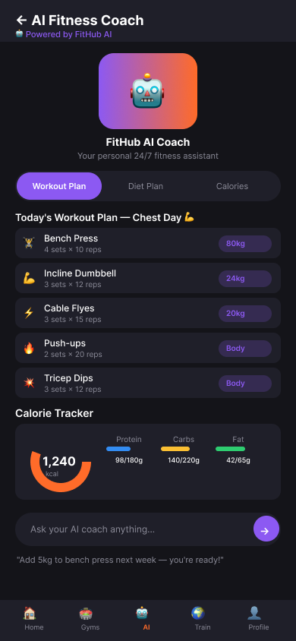
Figure: Screen 5: AI Coach — Workout Plan, Diet, and Calorie Tracker

Screen 6 — Trainer Marketplace
The trainer marketplace displays all available trainers with a featured trainer banner at the top, followed by a searchable, filterable grid of trainer cards. Each card shows the trainer's name, specialization, country, rating, price per session, and a Book button. Filter chips allow users to narrow trainers by specialization (Strength, Yoga, HIIT, Nutrition, Boxing, etc.).
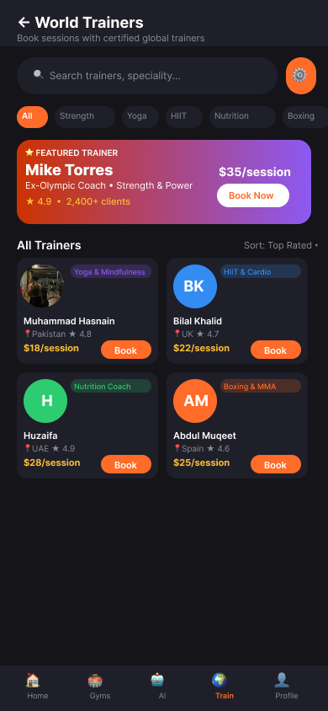

Figure: Screen 6: Worldwide Trainer Marketplace

Screen 7 — E-Commerce Shop
The shop screen features a flash sale banner, product category filter chips, and a 2-column product grid with discount badges, ratings, prices, and add-to-cart buttons. A top sellers section at the bottom highlights verified seller profiles, encouraging users to visit specific stores. The design borrows familiar e-commerce patterns so users feel immediately comfortable.
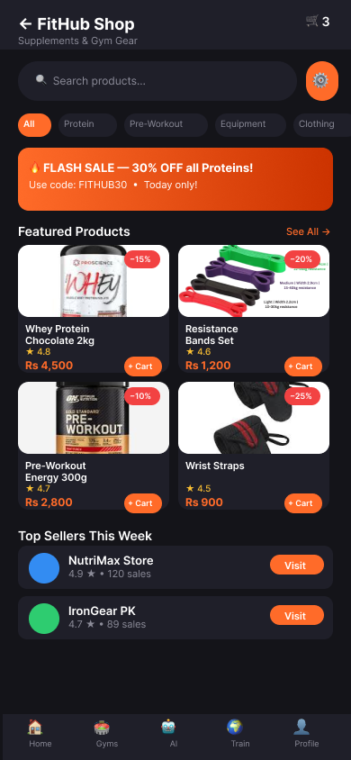

Figure: Screen 7: FitHub E-Commerce Shop

Screen 8 — Trainer Registration
The trainer registration screen is a multi-step form with a progress bar at the top. Fields include personal details, specialization, years of experience, certifications, session rate, and a document upload area for certificates and national ID. A benefits banner reminds registering trainers of the platform's value proposition. A clear call-to-action button submits the application to the admin for review.
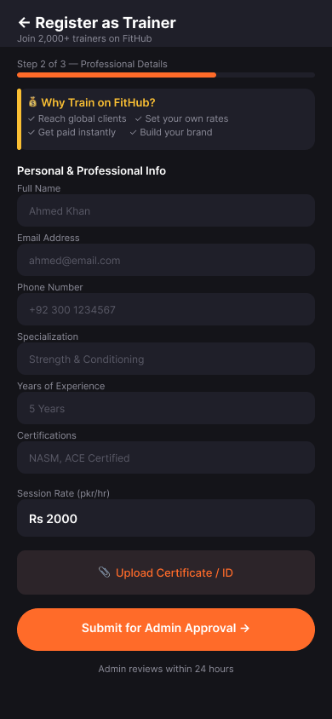

Figure: Screen 8: Trainer Registration Form

Screen 9 — Seller Dashboard
The seller dashboard presents monthly revenue in a gradient banner card, followed by four key metrics (Orders, Products, Rating, Average Order Value). Quick action buttons allow sellers to add products, view orders, access analytics, and check messages. A recent orders table with status badges and a top products section complete the screen.
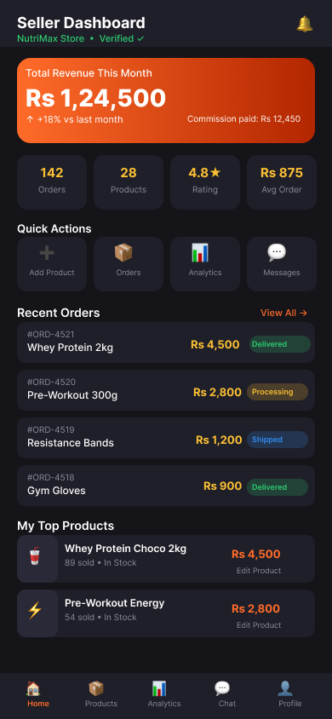

Figure: Screen 9: Seller Dashboard and Revenue Overview

Screen 10 — Admin Dashboard
The admin dashboard provides a high-level overview of platform health. A revenue banner shows today's total earnings with commission and trainer cut breakdowns. A 2x2 stats grid shows total Members, Gyms, Trainers, and Sellers. A prominent pending approvals alert draws attention to items requiring action. A revenue breakdown section uses progress bars to visualize income from each source.
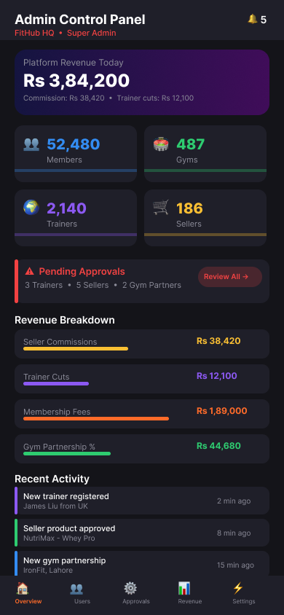

Figure: Screen 10: Admin Control Panel Dashboard

Screen 11 — Admin Approval Panel
This screen lists pending trainer and seller applications with tabbed filtering. Each applicant card shows their name, specialization, country, previous rating, uploaded documents (displayed as file chips), and two action buttons: Approve and Reject. The design makes the review workflow fast and efficient so the admin can process multiple applications without losing context.
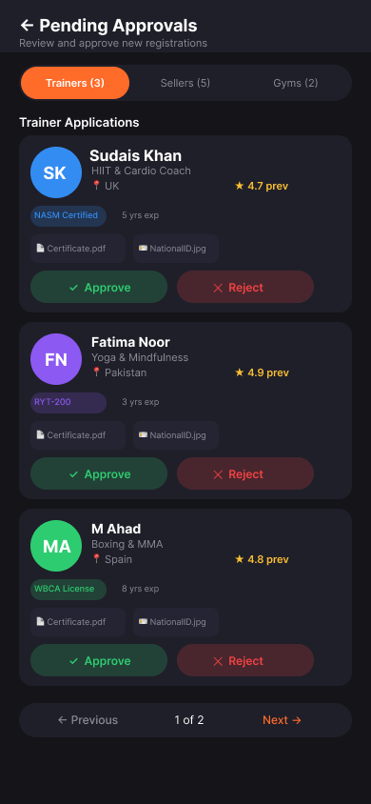

Figure: Screen 11: Admin Approval Panel for Trainer/Seller Applications

Screen 12 — Booking / Session Confirmation
The booking confirmation screen walks the client through the final step of hiring a trainer. It displays the trainer's profile, session type selector (Online/In-Person/Hybrid), a date picker, a time slot grid, a duration selector, a session summary table with itemized pricing, and a payment method display. A large 'Confirm Booking' button at the bottom finalizes the transaction.
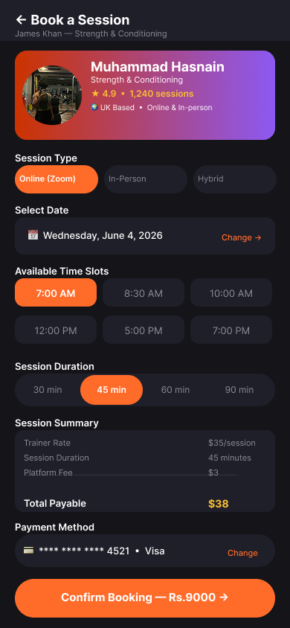

Figure: Screen 12: Trainer Session Booking and Confirmation

6.3 Usability Principles Applied in Design
- Consistency: All screens use the same navigation bar, color system, card components, and typography.
- Feedback: Every button press, form submission, and booking action provides visual confirmation.
- Visibility: The bottom navigation bar is always present, status badges show membership and session states at a glance.
- Error prevention: Multi-step forms with progress indicators prevent users from feeling lost in long flows.
- Flexibility: The platform serves four very different user types without confusing any of them by keeping portals separated at login.

6. Usability Evaluation

6.1 Evaluation Type

The evaluation carried out on FitHub is referred to as Formative Evaluation. Formative evaluation is done when the software is being designed with the aim of detecting any usability issues that would need correction before the software is released. The suitability of carrying out formative evaluation on our application is justified by the fact that our project is in the design stage.

6.2 Evaluation Method

The procedure used for the usability testing was think aloud technique. Participants were required to carry out predefined tasks by use of the Figma prototype while at the same time vocalizing their thought process and feelings on the process and difficulties faced.

Participants underwent this test individually taking a period of about 15-20 minutes. The Figma prototype was accessed by use of its view link on a mobile browser.

6.3 Participants
Three university students volunteered to test the prototype. Since all participants were familiar with smartphones and online applications, they were able to interact with the prototype without requiring instructions. Two participants regularly visit gyms, while one participant mainly follows home workout routines.
Participant | Age | Tech Familiarity | Fitness Habit | Platform Experience
Abdullah P1 | 22 | High | Goes to gym 5x/week | Uses MyFitnessPal
Hissan P2 | 24 | Medium | Goes to gym 3x/week | No fitness app
Ahmad P3 | 23 | High | Home workouts | Uses YouTube workouts

6.4 Tasks Given to Participants
The following tasks were designed to cover the primary user journeys of the platform:
- Start at the landing page and navigate to the client login screen.
- From the client dashboard, find the AI assistant and locate today's workout plan.
- Search for a gym in Islamabad and identify the cheapest available option.
- From the trainer marketplace, find a yoga trainer and initiate the booking process.
- Locate the e-commerce shop and add a protein supplement to the cart.
- (Admin view) Find the pending trainer applications and identify what documents have been submitted.

6.5 Observations and Issues Identified

Task | Issue Observed | Participant(s) | Severity | Notes
Task 1 | P2 hesitated at the role selector on login screen | P2 | Medium | Affordance unclear
Task 2 | All three participants found the AI screen easily via bottom nav | P1, P2, P3 | None | No issues
Task 3 | P3 wanted to filter gyms by price range but could not find a price filter option | P3 | Medium | Missing feature
Task 4 | P1 did not initially notice the time slot section was scrollable | P1 | Low | Missing affordance
Task 5 | P2 found the '+ Cart' button label was unclear | P2 | Medium | Label issue
Task 6 | P3 found the admin panel confusing due to dense revenue data | P3 | Low | Info density

7. Results and Discussion

7.1 Task Completion Summary

Task | P1 | P2 | P3 | Completion Rate
Task 1 — Login Navigation | Pass | Pass (hesitation) | Pass | 100%
Task 2 — AI Workout Plan | Pass | Pass | Pass | 100%
Task 3 — Gym Search | Pass | Pass | Partial | 100%
Task 4 — Trainer Booking | Pass (delay) | Pass | Pass | 100%
Task 5 — Shop + Cart | Pass | Pass (confused) | Pass | 100%
Task 6 — Admin Approvals | Pass | Pass | Pass (delay) | 100%

All six tasks were completed by all three participants, yielding a 100% task completion rate. This indicates that the core user flows are fundamentally sound and learnable. However, the qualitative observations revealed several friction points that should be addressed before the design is finalized.

7.2 Discussion of Key Findings

7.2.1 Role Selector Confusion (Medium Severity)

The role selection widget displayed on the login page, which presents four icons corresponding to roles such as Client, Trainer, Seller, and Admin, made participant P2 pause during the interaction. Participant P2 was unsure about the necessity of pressing the icon and wondered if it would be done automatically. It implies that the affordance of role selection may not be entirely evident from its interface design. One possible modification may be introducing an additional element indicating that the role is selected, such as checkmarking or highlighting.

7.2.2 Missing Price Range Filter (Medium Severity)

P3 Participant explicitly sought out a filter for pricing ranges in the gym search page but was frustrated with its absence. This is an actual functionality gap and needs to be incorporated into the new version. The user interface should include a feature where users can enter the minimum and maximum values for price. This follows the principle of flexibility in HCI. Users should be able to perform their tasks effectively even if they have requirements different from the defaults.

7.2.3 Cart Button Label (Medium Severity)

Due to space limitations within the 2-column grid layout, the product card on the e-commerce website uses the “+Cart” button. Participant P2 felt that it was confusing since he first took it as the seller going into his favorites list instead of the product going into the shopping cart. To remove any confusion, it is recommended that the button label be changed to an easily identifiable shopping cart image.

7.2.4 Time Slot Scrollability (Low Severity)

The booking page provides six time slots on a 2x3 matrix. User P1 did not figure out right away that more time slots were available at the bottom of the page using the scroll option. The inclusion of a small arrow at the bottom of the screen to indicate the availability of more slots would solve this problem.

7.2.5 Positive Findings

However, despite the concerns raised above, there were certain elements in the design that received universally favorable feedback. Specifically, all three participants appreciated the clarity in layout and functionality of the AI Assistant screen since it is able to incorporate information about workouts, dietary restrictions, and caloric intake in one tabbed window. In addition, the Client Dashboard screen was referred to by Participant 1 as everything that is needed in one screen but not overcrowded. Participants liked the overall dark color theme, which made it look very professional and contemporary.

7.3 Recommendations for Improvement

Issue | Recommendation | Priority
Role selector affordance unclear | Add visible selection state (checkmark/border) + micro-label 'Select your role' | High
No price filter for gyms | Add price range slider to gym search filter panel | High
Cart button label ambiguous | Replace '+ Cart' text with universal cart icon | Medium
Time slots not obviously scrollable | Add scroll indicator arrow or 'Show more times' text link | Low
Admin revenue data density | Add a simplified summary card before the detailed breakdown | Low

8. Conclusion
The main aim for this project was to develop an all-in-one fitness platform where several different fitness functions would be integrated. Using the concepts from HCI, we have managed to create a prototype that would assist the user in handling the gym membership management system, booking their personal trainers, monitoring their fitness, and purchasing products.
The results of usability testing showed that the tasks assigned were completed with success by the participants, while some issues concerning usability were spotted. These usability problems helped us better understand the interaction of the user with the interface.
In general, this project offered us great experience related to user centered design, interface design and usability analysis. In the future, more options can be included in FitHub such as the creation of communities, live workout sessions, and online communication between trainers and clients.

9. References
The following references informed the background study and design decisions in this project. References are formatted in APA 7th edition style.

MyFitnessPal. (2024). MyFitnessPal: Calorie counter and diet tracker. Under Armour, Inc. https://www.myfitnesspal.com
ClassPass. (2024). ClassPass: Fitness classes and gym memberships. ClassPass Inc. https://www.classpass.com
Trainerize. (2024). Trainerize: Personal training software for fitness professionals. ABC Trainerize. https://www.trainerize.com
Nielsen, J. (1994). Usability engineering. Morgan Kaufmann Publishers.
Nielsen, J. (1994). 10 usability heuristics for user interface design. Nielsen Norman Group. https://www.nngroup.com/articles/ten-usability-heuristics/
Norman, D. A. (2013). The design of everyday things: Revised and expanded edition. Basic Books.
Interaction Design Foundation. (2024). User-centered design. https://www.interaction-design.org/literature/topics/user-centered-design
Figma Inc. (2024). Figma: The collaborative interface design tool. https://www.figma.com
Daraz Pakistan. (2024). Daraz online shopping. Alibaba Group. https://www.daraz.pk
Rubin, J., & Chisnell, D. (2008). Handbook of usability testing: How to plan, design, and conduct effective tests (2nd ed.). Wiley Publishing.

