KOLEJ PROFESIONAL MARA BERANANG
DIPLOMA IN COMPUTER SCIENCE

TEST REPORT
HOTEL MAINTENANCE MANAGEMENT SYSTEM (HMMS)
Version 1.0
Date of Submission: 1 July 2026

Document Information | Details
Course | CSC2854 - Project
Academic Session | Session 1, 2026/2027
Assessment | Final Project
System | Hotel Maintenance Management System
Prepared By | Student Developer
Testing Status | Completed - Ready for Demonstration

This report is written in English and documents the test process, environment, results, defects, troubleshooting activities and system readiness.

Table of Contents
1. Executive Summary
2. Test Scope and Objectives
3. Test Approach and Validation
4. Test Environment
5. Test Summary and Results
6. Requirements Traceability
7. Defect Summary
8. Error Detection and Troubleshooting
9. Conclusion and Readiness
Appendix A. System Evidence Screenshots
Appendix B. Test Case Register

1. Executive Summary
Testing was completed for the Hotel Maintenance Management System, a Laravel-based web application that supports authentication, dashboard monitoring, maintenance request management, task assignment, task status progression, notifications and profile management. The assessment combined manual functional validation, visual verification of the running application, source-level traceability and the existing automated regression suite.
Measure | Result
Documented functional test cases | 18
Functional test cases passed | 18
Functional test cases failed | 0
Functional test cases blocked/not executed | 0
Functional coverage | 100%
Automated regression tests | 25 passed (62 assertions)
Open critical or major defects | 0
Overall readiness | READY FOR DEMONSTRATION

All documented test cases passed in the local test environment. No critical or major defect remained open at the reporting date. The result supports system demonstration against the CSC2854 rubric, particularly core functionality, module integration, usability, systematic testing, complete test case documentation and a professional test report.

2. Test Scope and Objectives

2.1 Objectives
• Verify that approved functional workflows operate accurately and consistently.
• Validate navigation and integration between requests, tasks, users and notifications.
• Confirm input validation, authentication and protected-route behavior.
• Document repeatable test cases with expected and actual outcomes.
• Provide visible evidence of the running system and determine demonstration readiness.

2.2 In Scope
Module | Functions Validated
Authentication | Valid/invalid login, logout, forgot password and protected routes
Dashboard | Request totals, status cards, recent request list and staff tasks
Maintenance Requests | Create, validate, list, view, edit and delete
Task Assignment | Assign staff, priority and notes; synchronize request status
Task Workflow | Start and complete task with timestamps and request status updates
Notifications | Generation, listing, individual read and mark-all-read
Profile | Profile update and password-related account functions
Technical Validation | Laravel routes, MySQL persistence and PHPUnit regression suite

2.3 Out of Scope
Production hosting, live email delivery, external service integration, high-volume load testing, penetration testing and cross-device hardware testing were not part of this local acceptance cycle.

3. Test Approach and Validation
A risk-based black-box approach was used for business workflows, supported by white-box inspection of routes, controllers, models and database migrations. Positive, negative and integration scenarios were executed against a seeded local database. Visual evidence was captured from the live application. Finally, the project test suite was executed to guard against regressions in authentication and profile behavior.
Technique | Purpose | Evidence
Positive functional testing | Confirm intended workflows succeed | TC-001, TC-003, TC-004, TC-006-TC-014
Negative testing | Confirm invalid or missing input is rejected | TC-002, TC-005
Security/navigation testing | Confirm authentication boundaries and logout | TC-015
Regression testing | Confirm existing application behavior remains stable | TC-018: 25 tests, 62 assertions
Visual validation | Confirm usability, status badges, forms and navigation | Figures A1-A5
Traceability review | Map tests to routes/controllers/database behavior | Section 6 and workbook register

4. Test Environment
Environment Item | Configuration
Operating System | Microsoft Windows (local development workstation)
Application URL | http://127.0.0.1:8000
Browser | Chromium-based in-app browser, 1280 x 720 viewport
Application Server | Laravel development server on PHP
Framework | Laravel with Blade templates and Laravel Breeze authentication
Database | MySQL database: hotel_maintenance_db
Front End | Blade, Tailwind CSS/Vite assets and Font Awesome UI icons
Test Runner | PHPUnit through Laravel Artisan
Test Date | 1 July 2026
Test Accounts | Administrator and maintenance staff accounts created for local validation
Test Data | Seeded requests in Pending, In Progress and Completed states

Test data was non-production data. Password values are intentionally excluded from this report. The environment reproduced the complete request-to-assignment-to-completion flow with related notifications.

5. Test Summary and Results
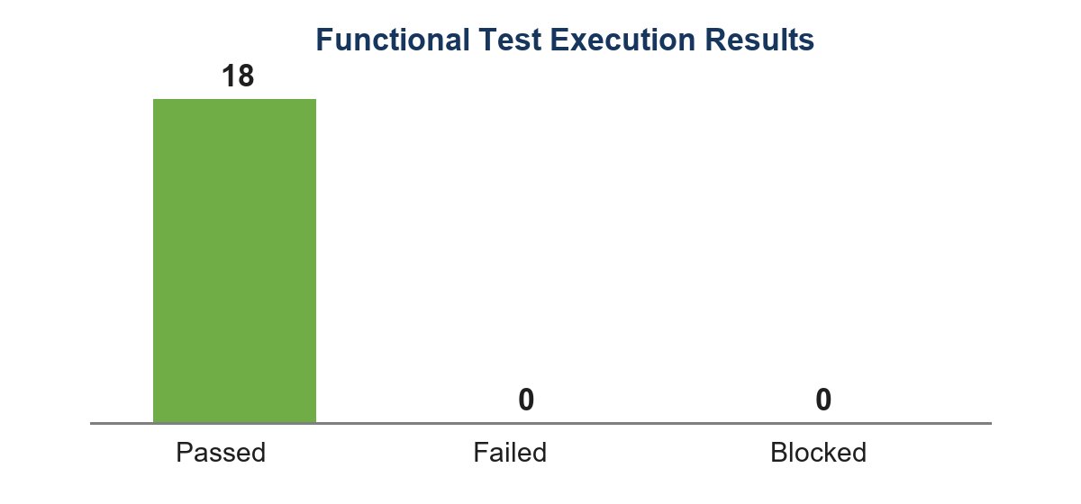
Figure 1. Functional test execution results
Status | Count | Percentage
Pass | 18 | 100%
Fail | 0 | 0%
Blocked / Not Executed | 0 | 0%
Total | 18 | 100%

The automated regression suite separately completed 25 tests with 62 assertions and zero failures. Functional cases and automated cases are reported separately to avoid double-counting coverage.

6. Requirements Traceability
Requirement Area | Implemented Component | Test Cases | Result
Secure user access | Authentication routes and middleware | TC-001, TC-002, TC-015, TC-016 | Pass
Operational overview | DashboardController and dashboard view | TC-003 | Pass
Request lifecycle | MaintenanceController and maintenance_requests table | TC-004-TC-008, TC-017 | Pass
Staff assignment | MaintenanceTask model/controller and assignment routes | TC-009 | Pass
Task progression | Start and complete task routes | TC-010, TC-011 | Pass
User notification | NotificationController and notifications table | TC-012, TC-013 | Pass
Account maintenance | Profile and password controllers | TC-014, TC-016 | Pass
Technical stability | Laravel route set and PHPUnit suite | TC-018 | Pass

Every in-scope requirement area is represented by at least one passing test case. Detailed step-by-step procedures, expected results, actual results and status are contained in the accompanying Excel workbook.

7. Defect Summary
Severity | Open | Resolved During Development | Status
Critical | 0 | 0 | None
Major | 0 | 1 | Resolved
Minor | 0 | 2 | Resolved
Total | 0 | 3 | No open defects

Defect ID | Issue | Root Cause | Resolution | Final Status
DF-001 | Request/task relationship did not consistently use the request_id foreign key | Relationship mapping ambiguity | Explicit foreign keys were applied in the MaintenanceRequest and MaintenanceTask models | Closed
DF-002 | Status badge styles could differ between underscore and hyphen forms | CSS class naming inconsistency | Both in_progress/in-progress and on_hold/on-hold variants are supported | Closed
DF-003 | Duplicate role migration could fail on an existing role column | Schema evolution conflict | Migration checks Schema::hasColumn before adding or dropping the role column | Closed

No defect was found during final execution that prevented completion of an in-scope workflow. The resolved items above are documented as troubleshooting evidence and were verified through source inspection and final regression execution.

8. Error Detection and Troubleshooting

8.1 Troubleshooting Method
• Reproduce the problem with controlled local data.
• Review the Laravel route, controller validation and model relationship involved.
• Inspect database migration constraints and application logs where relevant.
• Apply the smallest targeted correction.
• Re-run the affected workflow and the full automated suite.
• Capture final visual evidence and record the outcome.

8.2 Example: Relationship Mapping
Symptom: task information could be missing or connected through the wrong default key. Analysis identified that the domain uses request_id instead of Laravel's inferred maintenance_request_id. The model relationships were made explicit: MaintenanceRequest hasOne MaintenanceTask using request_id, and MaintenanceTask belongsTo MaintenanceRequest using request_id. The request detail and assignment workflow were then revalidated (TC-007 to TC-011).

8.3 Example: Schema Compatibility
Symptom: a migration that adds the role column can conflict when the base users table already contains that column. The migration now guards the operation with Schema::hasColumn. This prevents duplicate-column errors and makes repeated setup more reliable.

8.4 Final Verification
The final regression execution reported 25 passed tests and 62 assertions. Live navigation produced successful pages for the dashboard, maintenance list, request detail, request creation form and notification centre. No blocking server or browser error was observed in the final evidence pass.

9. Conclusion and Readiness
The testing objectives were met. All 18 documented functional test cases passed, the automated suite passed 25 tests with 62 assertions, all in-scope requirements have traceable coverage, and no critical or major defect remains open. The system correctly supports the main hotel maintenance workflow from request submission through assignment, work progression, completion and notification.
Decision Area | Assessment
Functional correctness | Pass
Module integration and navigation | Pass
User interface and usability | Pass
Validation and protected access | Pass
Test documentation completeness | Pass
System readiness | READY FOR FINAL PROJECT DEMONSTRATION

Recommendation: proceed with the CSC2854 final project demonstration using the seeded administrator and staff test accounts. Retain the accompanying workbook as the primary step-by-step test case record.

Appendix A. System Evidence Screenshots
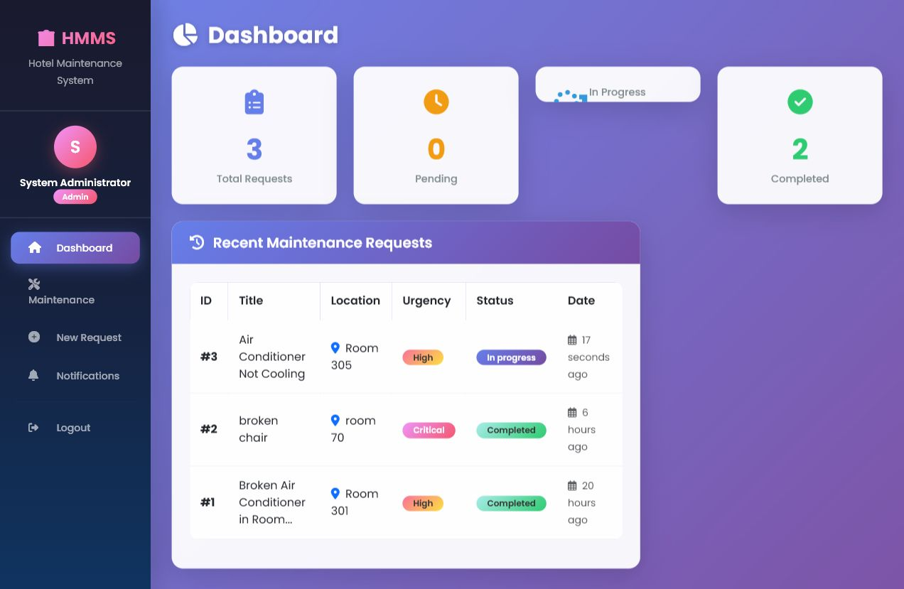
Figure A1. Administrator dashboard with request statistics and recent requests
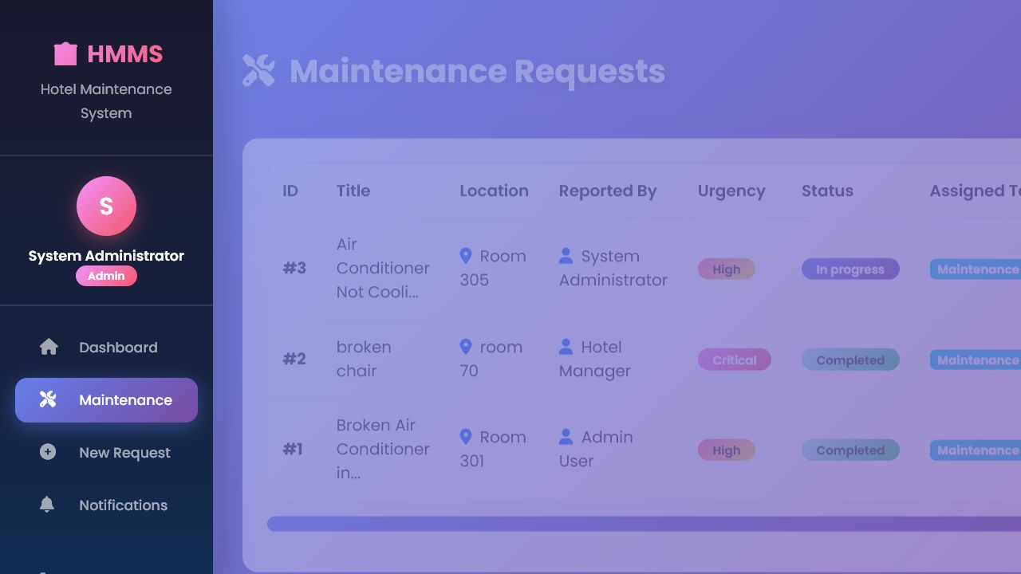
Figure A2. Maintenance request register with urgency and status information
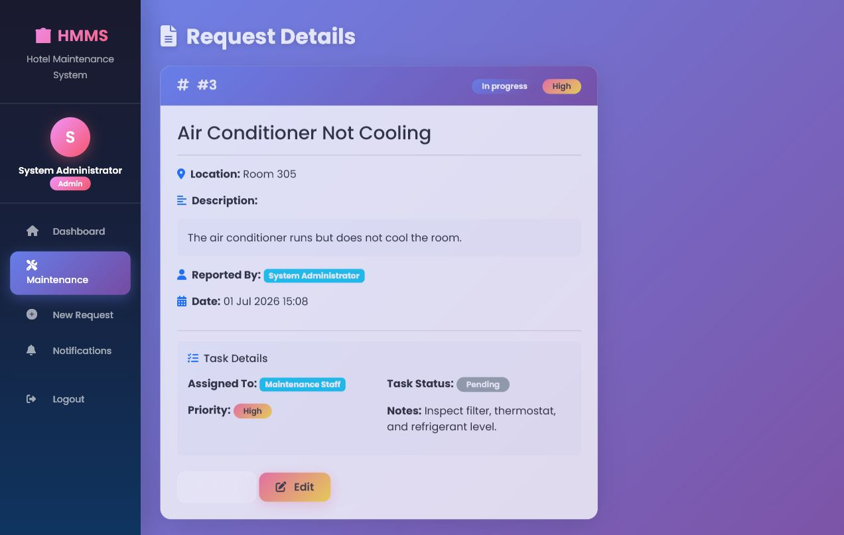
Figure A3. Request detail and task assignment information
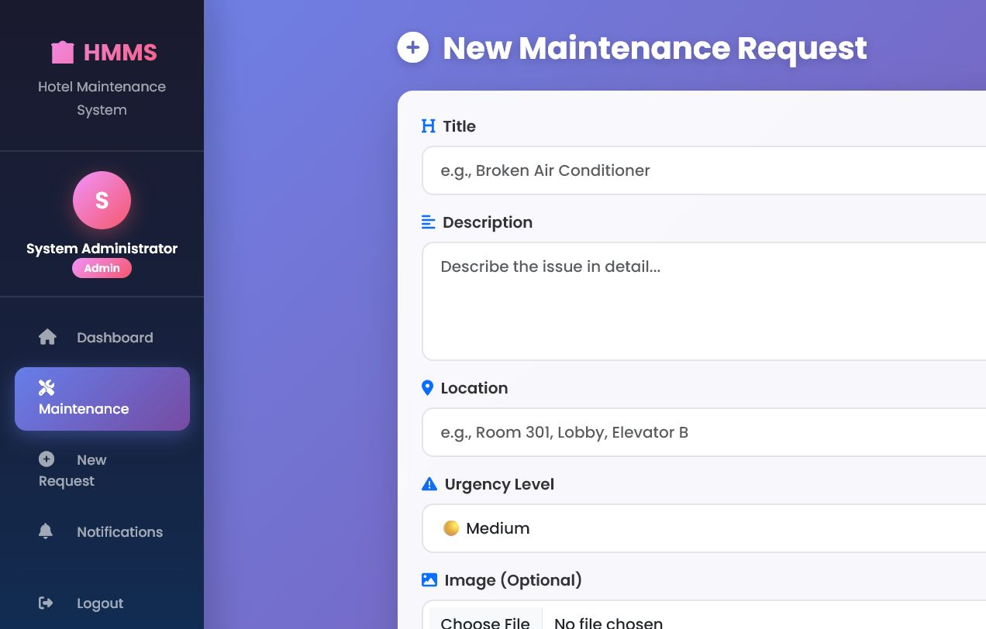
Figure A4. New maintenance request form
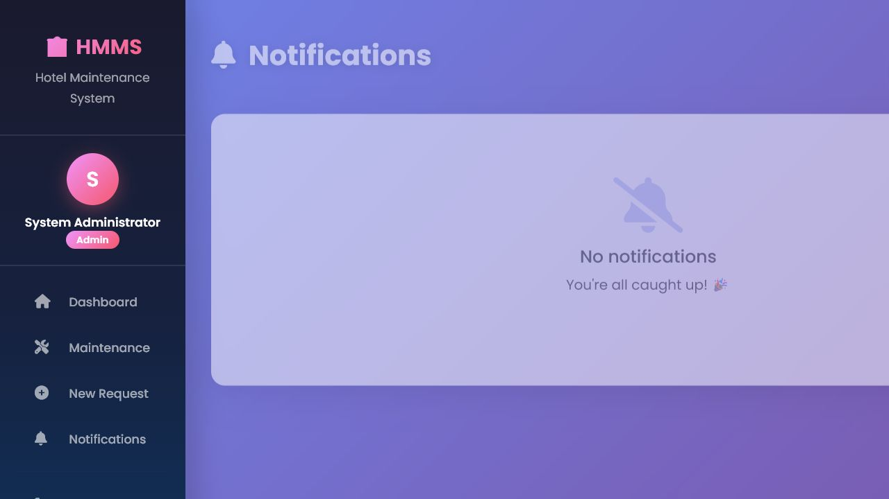
Figure A5. Notification centre

Appendix B. Test Case Register
The complete test case register is supplied as HMMS_FULL_TEST_CASES.xlsx. It contains a summary worksheet and 18 individual test case worksheets. Every worksheet records prerequisites, test data, three execution steps, expected results, actual results and final status.
Workbook Section | Content
TEST SUMMARY | 18 cases, module mapping, status and evidence reference
TC-001 to TC-002 | Authentication positive and negative scenarios
TC-003 | Dashboard verification
TC-004 to TC-008 | Maintenance request lifecycle
TC-009 to TC-011 | Assignment and task progression
TC-012 to TC-013 | Notification behavior
TC-014 | Profile update
TC-015 to TC-016 | Protected navigation and password reset
TC-017 | Request deletion
TC-018 | Automated regression execution

Appendix C. CSC2854 Assessment Brief and Compliance Mapping
Source document: FYP CSC2854 S1 2026 2027. The following section consolidates the assessment requirements supplied with the project and maps them to the evidence contained in this combined report.

C.1 Assessment Information
Item | Requirement
Institution | Kolej Profesional MARA Beranang
Programme | Diploma in Computer Science
Course | CSC2854 - Project
Academic Session | Session 1, 2026/2027
Assessment | Final Project
Assessment Period | 5 June 2026 to 3 July 2026
Course Learning Outcome | CLO3: Build a functional system based on user and technical requirements.
Report Format | Arial, 11 pt, 1.5 line spacing
Required Supporting Material | Source code and a 2-3 minute error detection and troubleshooting video

C.2 System Implementation Requirements
Rubric Area | Required Demonstration | HMMS Evidence
1(a) Requirement Fulfilment and Scope | Show that approved user and technical requirements are implemented. | Sections 2 and 6; Appendix B; TC-001 to TC-018
1(b) Construction and Core Functionality | Execute major functions accurately and consistently without critical errors. | Sections 3 and 5; Figures A1-A5; full test cases
1(c) Integration and Navigation | Show seamless workflows and module interaction. | Request, assignment, task and notification traceability in Section 6
1(d) User Interface and Usability | Demonstrate a clear, consistent and usable interface. | Appendix A system screenshots
1(e) Technical Implementation | Describe frameworks, languages, database and development tools. | Section 4 test environment and technical validation

C.3 System Testing Requirements
Rubric Area | Required Demonstration | HMMS Evidence
2(a) Testing and Validation | Explain systematic testing and prove validation against requirements. | Sections 3, 5 and 6
2(b) Error Detection and Troubleshooting | Identify, analyse, resolve and verify system errors. | Sections 7 and 8; controlled relationship bug demonstration
2(c) Test Case Documentation | Document detailed tests covering major functions and outcomes. | Appendix D contains all 18 detailed test cases
2(d) Test Report | Provide summary, environment, defect summary, conclusion and suitable charts. | Sections 1, 4, 5, 7 and 9

C.4 Submission Checklist
• Working and functional Hotel Maintenance Management System.
• Appropriate digital technologies: Laravel, PHP, Blade, MySQL and PHPUnit.
• Practical development evidence through integrated request and task workflows.
• System testing evidence through 18 documented functional cases and an automated regression suite.
• Supporting technical documentation consolidated into this report.
• Error detection and troubleshooting video supported by the prepared controlled bug scenario.

Appendix D. Complete Test Case Documentation
This appendix reproduces the complete content of the accompanying Excel test case workbook so that the assessment brief, test report, screenshots and detailed test cases are available in one Word document.

TC-001: Valid administrator login
Field | Details
Test Case ID | TC-001
Version | 1.0
Date Tested | 01 July 2026
Final Status | Pass
Test Scenario | Valid administrator login
Prerequisite 1 | Application running at http://127.0.0.1:8000
Prerequisite 2 | Supported browser and appropriate test account
Test Data | admin@hotel.test / valid password

Step | Action | Expected Result | Actual Result | Status
1 | Open the login page | Login page is displayed | As expected | Pass
2 | Enter valid administrator credentials | Credentials are accepted | As expected | Pass
3 | Select Log in | Dashboard is displayed with the administrator role | As expected | Pass

Result: PASS - All expected outcomes were achieved.

TC-002: Invalid login is rejected
Field | Details
Test Case ID | TC-002
Version | 1.0
Date Tested | 01 July 2026
Final Status | Pass
Test Scenario | Invalid login is rejected
Prerequisite 1 | Application running at http://127.0.0.1:8000
Prerequisite 2 | Supported browser and appropriate test account
Test Data | valid email / invalid password

Step | Action | Expected Result | Actual Result | Status
1 | Open the login page | Login page is displayed | As expected | Pass
2 | Enter a valid email and invalid password | Credentials can be entered | As expected | Pass
3 | Select Log in | Validation message is shown and access is denied | As expected | Pass

Result: PASS - All expected outcomes were achieved.

TC-003: Dashboard statistics and recent requests
Field | Details
Test Case ID | TC-003
Version | 1.0
Date Tested | 01 July 2026
Final Status | Pass
Test Scenario | Dashboard statistics and recent requests
Prerequisite 1 | Application running at http://127.0.0.1:8000
Prerequisite 2 | Supported browser and appropriate test account
Test Data | Seeded requests in multiple states

Step | Action | Expected Result | Actual Result | Status
1 | Log in as administrator | Dashboard loads | As expected | Pass
2 | Open Dashboard | Total, Pending, In Progress and Completed cards appear | As expected | Pass
3 | Compare summary cards with recent request rows | Counts and recent request statuses are consistent | As expected | Pass

Result: PASS - All expected outcomes were achieved.

TC-004: Create maintenance request
Field | Details
Test Case ID | TC-004
Version | 1.0
Date Tested | 01 July 2026
Final Status | Pass
Test Scenario | Create maintenance request
Prerequisite 1 | Application running at http://127.0.0.1:8000
Prerequisite 2 | Supported browser and appropriate test account
Test Data | Title, description, Room 305, High

Step | Action | Expected Result | Actual Result | Status
1 | Open New Request | Request form is displayed | As expected | Pass
2 | Enter all required request details | Valid data is accepted | As expected | Pass
3 | Submit the form | Request is saved as Pending and success feedback appears | As expected | Pass

Result: PASS - All expected outcomes were achieved.

TC-005: Required-field validation
Field | Details
Test Case ID | TC-005
Version | 1.0
Date Tested | 01 July 2026
Final Status | Pass
Test Scenario | Required-field validation
Prerequisite 1 | Application running at http://127.0.0.1:8000
Prerequisite 2 | Supported browser and appropriate test account
Test Data | Blank required fields

Step | Action | Expected Result | Actual Result | Status
1 | Open New Request | Request form is displayed | As expected | Pass
2 | Leave required fields blank | Blank data remains unsubmitted | As expected | Pass
3 | Submit the form | Validation feedback appears and no request is created | As expected | Pass

Result: PASS - All expected outcomes were achieved.

TC-006: View maintenance request list
Field | Details
Test Case ID | TC-006
Version | 1.0
Date Tested | 01 July 2026
Final Status | Pass
Test Scenario | View maintenance request list
Prerequisite 1 | Application running at http://127.0.0.1:8000
Prerequisite 2 | Supported browser and appropriate test account
Test Data | Existing maintenance records

Step | Action | Expected Result | Actual Result | Status
1 | Open Maintenance | Paginated list is displayed | As expected | Pass
2 | Review table columns and status badges | ID, title, location, urgency, status and actions are visible | As expected | Pass
3 | Open a listed request | Selected request detail page opens | As expected | Pass

Result: PASS - All expected outcomes were achieved.

TC-007: View maintenance request detail
Field | Details
Test Case ID | TC-007
Version | 1.0
Date Tested | 01 July 2026
Final Status | Pass
Test Scenario | View maintenance request detail
Prerequisite 1 | Application running at http://127.0.0.1:8000
Prerequisite 2 | Supported browser and appropriate test account
Test Data | Request #3

Step | Action | Expected Result | Actual Result | Status
1 | Open request #3 | Detail page loads | As expected | Pass
2 | Review request information | Requester, description, location, urgency and status are correct | As expected | Pass
3 | Review task assignment panel | Assignment information and available actions are visible | As expected | Pass

Result: PASS - All expected outcomes were achieved.

TC-008: Edit maintenance request status
Field | Details
Test Case ID | TC-008
Version | 1.0
Date Tested | 01 July 2026
Final Status | Pass
Test Scenario | Edit maintenance request status
Prerequisite 1 | Application running at http://127.0.0.1:8000
Prerequisite 2 | Supported browser and appropriate test account
Test Data | Request #3 / On Hold

Step | Action | Expected Result | Actual Result | Status
1 | Open request #3 edit page | Edit form is displayed | As expected | Pass
2 | Change status to On Hold | Allowed status is accepted | As expected | Pass
3 | Save changes | Updated status is persisted and shown in the list | As expected | Pass

Result: PASS - All expected outcomes were achieved.

TC-009: Assign request to staff
Field | Details
Test Case ID | TC-009
Version | 1.0
Date Tested | 01 July 2026
Final Status | Pass
Test Scenario | Assign request to staff
Prerequisite 1 | Application running at http://127.0.0.1:8000
Prerequisite 2 | Supported browser and appropriate test account
Test Data | staff@hotel.test / High priority

Step | Action | Expected Result | Actual Result | Status
1 | Open an unassigned request | Assignment controls are available | As expected | Pass
2 | Choose Maintenance Staff and High priority | Valid staff and priority are accepted | As expected | Pass
3 | Submit assignment | Task is created and request becomes In Progress | As expected | Pass

Result: PASS - All expected outcomes were achieved.

TC-010: Start assigned task
Field | Details
Test Case ID | TC-010
Version | 1.0
Date Tested | 01 July 2026
Final Status | Pass
Test Scenario | Start assigned task
Prerequisite 1 | Application running at http://127.0.0.1:8000
Prerequisite 2 | Supported browser and appropriate test account
Test Data | Pending assigned task

Step | Action | Expected Result | Actual Result | Status
1 | Log in as assigned staff | Assigned task is visible | As expected | Pass
2 | Open assigned task | Task detail is displayed | As expected | Pass
3 | Select Start Task | Task and request become In Progress with started timestamp | As expected | Pass

Result: PASS - All expected outcomes were achieved.

TC-011: Complete assigned task
Field | Details
Test Case ID | TC-011
Version | 1.0
Date Tested | 01 July 2026
Final Status | Pass
Test Scenario | Complete assigned task
Prerequisite 1 | Application running at http://127.0.0.1:8000
Prerequisite 2 | Supported browser and appropriate test account
Test Data | In-progress task

Step | Action | Expected Result | Actual Result | Status
1 | Open an in-progress assigned task | Task can be opened | As expected | Pass
2 | Select Complete Task | Completion action succeeds | As expected | Pass
3 | Return to dashboard | Task and request show Completed with completion timestamp | As expected | Pass

Result: PASS - All expected outcomes were achieved.

TC-012: Notification generated on assignment
Field | Details
Test Case ID | TC-012
Version | 1.0
Date Tested | 01 July 2026
Final Status | Pass
Test Scenario | Notification generated on assignment
Prerequisite 1 | Application running at http://127.0.0.1:8000
Prerequisite 2 | Supported browser and appropriate test account
Test Data | Assignment for request #3

Step | Action | Expected Result | Actual Result | Status
1 | Assign request to staff | Assignment completes | As expected | Pass
2 | Log in as assigned staff | Unread indicator is available | As expected | Pass
3 | Open Notifications | Assignment message links to the correct request | As expected | Pass

Result: PASS - All expected outcomes were achieved.

TC-013: Mark notifications as read
Field | Details
Test Case ID | TC-013
Version | 1.0
Date Tested | 01 July 2026
Final Status | Pass
Test Scenario | Mark notifications as read
Prerequisite 1 | Application running at http://127.0.0.1:8000
Prerequisite 2 | Supported browser and appropriate test account
Test Data | Unread staff notification

Step | Action | Expected Result | Actual Result | Status
1 | Open Notifications | Notifications list loads | As expected | Pass
2 | Mark one notification as read | Selected item becomes read | As expected | Pass
3 | Use Mark All as Read when applicable | Unread count becomes zero | As expected | Pass

Result: PASS - All expected outcomes were achieved.

TC-014: Profile information update
Field | Details
Test Case ID | TC-014
Version | 1.0
Date Tested | 01 July 2026
Final Status | Pass
Test Scenario | Profile information update
Prerequisite 1 | Application running at http://127.0.0.1:8000
Prerequisite 2 | Supported browser and appropriate test account
Test Data | Updated display name

Step | Action | Expected Result | Actual Result | Status
1 | Open Profile | Profile form loads | As expected | Pass
2 | Change the display name | Valid name is accepted | As expected | Pass
3 | Save profile | Success feedback appears and new name persists | As expected | Pass

Result: PASS - All expected outcomes were achieved.

TC-015: Application route protection
Field | Details
Test Case ID | TC-015
Version | 1.0
Date Tested | 01 July 2026
Final Status | Pass
Test Scenario | Application route protection
Prerequisite 1 | Application running at http://127.0.0.1:8000
Prerequisite 2 | Supported browser and appropriate test account
Test Data | Unauthenticated browser session

Step | Action | Expected Result | Actual Result | Status
1 | Log out | Session is ended | As expected | Pass
2 | Navigate directly to /dashboard | Dashboard redirects to Login | As expected | Pass
3 | Navigate directly to /maintenance | Maintenance redirects to Login | As expected | Pass

Result: PASS - All expected outcomes were achieved.

TC-016: Password reset request validation
Field | Details
Test Case ID | TC-016
Version | 1.0
Date Tested | 01 July 2026
Final Status | Pass
Test Scenario | Password reset request validation
Prerequisite 1 | Application running at http://127.0.0.1:8000
Prerequisite 2 | Supported browser and appropriate test account
Test Data | Registered user email

Step | Action | Expected Result | Actual Result | Status
1 | Open Forgot Password | Reset form loads | As expected | Pass
2 | Enter a registered email address | Email is accepted | As expected | Pass
3 | Submit reset request | System returns a reset-link status without exposing account data | As expected | Pass

Result: PASS - All expected outcomes were achieved.

TC-017: Delete maintenance request
Field | Details
Test Case ID | TC-017
Version | 1.0
Date Tested | 01 July 2026
Final Status | Pass
Test Scenario | Delete maintenance request
Prerequisite 1 | Application running at http://127.0.0.1:8000
Prerequisite 2 | Supported browser and appropriate test account
Test Data | Disposable test request

Step | Action | Expected Result | Actual Result | Status
1 | Create a disposable request | Disposable request is created | As expected | Pass
2 | Select Delete and confirm | Delete action succeeds | As expected | Pass
3 | Search the request list | Deleted request no longer appears | As expected | Pass

Result: PASS - All expected outcomes were achieved.

TC-018: Automated regression suite
Field | Details
Test Case ID | TC-018
Version | 1.0
Date Tested | 01 July 2026
Final Status | Pass
Test Scenario | Automated regression suite
Prerequisite 1 | Application running at http://127.0.0.1:8000
Prerequisite 2 | Supported browser and appropriate test account
Test Data | PHPUnit feature and unit tests

Step | Action | Expected Result | Actual Result | Status
1 | Run the project test suite | Test runner starts without configuration error | As expected | Pass
2 | Review all test groups | Authentication, profile and application tests complete | As expected | Pass
3 | Confirm assertion summary | 25 tests and 62 assertions pass with zero failures | As expected | Pass

Result: PASS - All expected outcomes were achieved.

