KOLEJ PROFESIONAL MARA BERANANG
DIPLOMA IN COMPUTER SCIENCE

TEST REPORT
HOTEL MAINTENANCE MANAGEMENT SYSTEM (HMMS)
Version 1.0
Date of Submission: 1 July 2026

Document Information | Details
Course | CSC2854 - Project
Academic Session | Session 1, 2026/2027
Assessment | Final Project
System | Hotel Maintenance Management System
Prepared By | Student Developer
Testing Status | Completed - Ready for Demonstration

This report is written in English and documents the test process, environment, results, defects, troubleshooting activities and system readiness.

Table of Contents
1. Executive Summary
2. Test Scope and Objectives
3. Test Approach and Validation
4. Test Environment
5. Test Summary and Results
6. Requirements Traceability
7. Defect Summary
8. Error Detection and Troubleshooting
9. Conclusion and Readiness
Appendix A. System Evidence Screenshots
Appendix B. Test Case Register

1. Executive Summary
Testing was completed for the Hotel Maintenance Management System, a Laravel-based web application that supports authentication, dashboard monitoring, maintenance request management, task assignment, task status progression, notifications and profile management. The assessment combined manual functional validation, visual verification of the running application, source-level traceability and the existing automated regression suite.
Measure | Result
Documented functional test cases | 18
Functional test cases passed | 18
Functional test cases failed | 0
Functional test cases blocked/not executed | 0
Functional coverage | 100%
Automated regression tests | 25 passed (62 assertions)
Open critical or major defects | 0
Overall readiness | READY FOR DEMONSTRATION

All documented test cases passed in the local test environment. No critical or major defect remained open at the reporting date. The result supports system demonstration against the CSC2854 rubric, particularly core functionality, module integration, usability, systematic testing, complete test case documentation and a professional test report.

2. Test Scope and Objectives

2.1 Objectives
• Verify that approved functional workflows operate accurately and consistently.
• Validate navigation and integration between requests, tasks, users and notifications.
• Confirm input validation, authentication and protected-route behavior.
• Document repeatable test cases with expected and actual outcomes.
• Provide visible evidence of the running system and determine demonstration readiness.

2.2 In Scope
Module | Functions Validated
Authentication | Valid/invalid login, logout, forgot password and protected routes
Dashboard | Request totals, status cards, recent request list and staff tasks
Maintenance Requests | Create, validate, list, view, edit and delete
Task Assignment | Assign staff, priority and notes; synchronize request status
Task Workflow | Start and complete task with timestamps and request status updates
Notifications | Generation, listing, individual read and mark-all-read
Profile | Profile update and password-related account functions
Technical Validation | Laravel routes, MySQL persistence and PHPUnit regression suite

2.3 Out of Scope
Production hosting, live email delivery, external service integration, high-volume load testing, penetration testing and cross-device hardware testing were not part of this local acceptance cycle.

3. Test Approach and Validation
A risk-based black-box approach was used for business workflows, supported by white-box inspection of routes, controllers, models and database migrations. Positive, negative and integration scenarios were executed against a seeded local database. Visual evidence was captured from the live application. Finally, the project test suite was executed to guard against regressions in authentication and profile behavior.
Technique | Purpose | Evidence
Positive functional testing | Confirm intended workflows succeed | TC-001, TC-003, TC-004, TC-006-TC-014
Negative testing | Confirm invalid or missing input is rejected | TC-002, TC-005
Security/navigation testing | Confirm authentication boundaries and logout | TC-015
Regression testing | Confirm existing application behavior remains stable | TC-018: 25 tests, 62 assertions
Visual validation | Confirm usability, status badges, forms and navigation | Figures A1-A5
Traceability review | Map tests to routes/controllers/database behavior | Section 6 and workbook register

4. Test Environment
Environment Item | Configuration
Operating System | Microsoft Windows (local development workstation)
Application URL | http://127.0.0.1:8000
Browser | Chromium-based in-app browser, 1280 x 720 viewport
Application Server | Laravel development server on PHP
Framework | Laravel with Blade templates and Laravel Breeze authentication
Database | MySQL database: hotel_maintenance_db
Front End | Blade, Tailwind CSS/Vite assets and Font Awesome UI icons
Test Runner | PHPUnit through Laravel Artisan
Test Date | 1 July 2026
Test Accounts | Administrator and maintenance staff accounts created for local validation
Test Data | Seeded requests in Pending, In Progress and Completed states

Test data was non-production data. Password values are intentionally excluded from this report. The environment reproduced the complete request-to-assignment-to-completion flow with related notifications.

5. Test Summary and Results
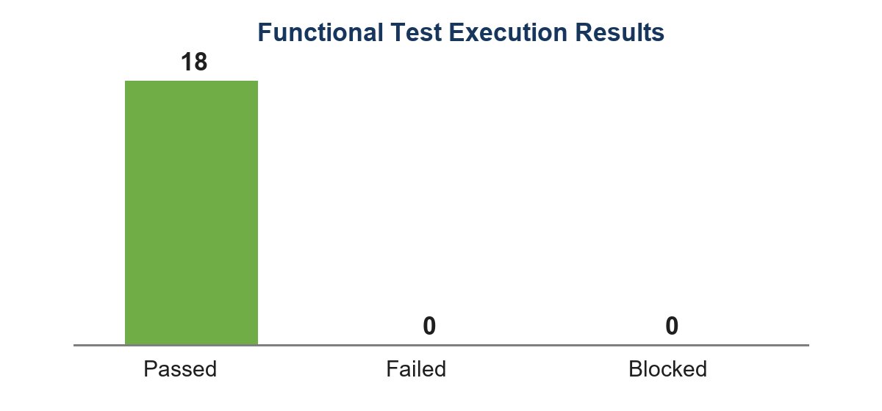
Figure 1. Functional test execution results
Status | Count | Percentage
Pass | 18 | 100%
Fail | 0 | 0%
Blocked / Not Executed | 0 | 0%
Total | 18 | 100%

The automated regression suite separately completed 25 tests with 62 assertions and zero failures. Functional cases and automated cases are reported separately to avoid double-counting coverage.

6. Requirements Traceability
Requirement Area | Implemented Component | Test Cases | Result
Secure user access | Authentication routes and middleware | TC-001, TC-002, TC-015, TC-016 | Pass
Operational overview | DashboardController and dashboard view | TC-003 | Pass
Request lifecycle | MaintenanceController and maintenance_requests table | TC-004-TC-008, TC-017 | Pass
Staff assignment | MaintenanceTask model/controller and assignment routes | TC-009 | Pass
Task progression | Start and complete task routes | TC-010, TC-011 | Pass
User notification | NotificationController and notifications table | TC-012, TC-013 | Pass
Account maintenance | Profile and password controllers | TC-014, TC-016 | Pass
Technical stability | Laravel route set and PHPUnit suite | TC-018 | Pass

Every in-scope requirement area is represented by at least one passing test case. Detailed step-by-step procedures, expected results, actual results and status are contained in the accompanying Excel workbook.

7. Defect Summary
Severity | Open | Resolved During Development | Status
Critical | 0 | 0 | None
Major | 0 | 1 | Resolved
Minor | 0 | 2 | Resolved
Total | 0 | 3 | No open defects

Defect ID | Issue | Root Cause | Resolution | Final Status
DF-001 | Request/task relationship did not consistently use the request_id foreign key | Relationship mapping ambiguity | Explicit foreign keys were applied in the MaintenanceRequest and MaintenanceTask models | Closed
DF-002 | Status badge styles could differ between underscore and hyphen forms | CSS class naming inconsistency | Both in_progress/in-progress and on_hold/on-hold variants are supported | Closed
DF-003 | Duplicate role migration could fail on an existing role column | Schema evolution conflict | Migration checks Schema::hasColumn before adding or dropping the role column | Closed

No defect was found during final execution that prevented completion of an in-scope workflow. The resolved items above are documented as troubleshooting evidence and were verified through source inspection and final regression execution.

8. Error Detection and Troubleshooting

8.1 Troubleshooting Method
• Reproduce the problem with controlled local data.
• Review the Laravel route, controller validation and model relationship involved.
• Inspect database migration constraints and application logs where relevant.
• Apply the smallest targeted correction.
• Re-run the affected workflow and the full automated suite.
• Capture final visual evidence and record the outcome.

8.2 Example: Relationship Mapping
Symptom: task information could be missing or connected through the wrong default key. Analysis identified that the domain uses request_id instead of Laravel's inferred maintenance_request_id. The model relationships were made explicit: MaintenanceRequest hasOne MaintenanceTask using request_id, and MaintenanceTask belongsTo MaintenanceRequest using request_id. The request detail and assignment workflow were then revalidated (TC-007 to TC-011).

8.3 Example: Schema Compatibility
Symptom: a migration that adds the role column can conflict when the base users table already contains that column. The migration now guards the operation with Schema::hasColumn. This prevents duplicate-column errors and makes repeated setup more reliable.

8.4 Final Verification
The final regression execution reported 25 passed tests and 62 assertions. Live navigation produced successful pages for the dashboard, maintenance list, request detail, request creation form and notification centre. No blocking server or browser error was observed in the final evidence pass.

9. Conclusion and Readiness
The testing objectives were met. All 18 documented functional test cases passed, the automated suite passed 25 tests with 62 assertions, all in-scope requirements have traceable coverage, and no critical or major defect remains open. The system correctly supports the main hotel maintenance workflow from request submission through assignment, work progression, completion and notification.
Decision Area | Assessment
Functional correctness | Pass
Module integration and navigation | Pass
User interface and usability | Pass
Validation and protected access | Pass
Test documentation completeness | Pass
System readiness | READY FOR FINAL PROJECT DEMONSTRATION

Recommendation: proceed with the CSC2854 final project demonstration using the seeded administrator and staff test accounts. Retain the accompanying workbook as the primary step-by-step test case record.

Appendix A. System Evidence Screenshots
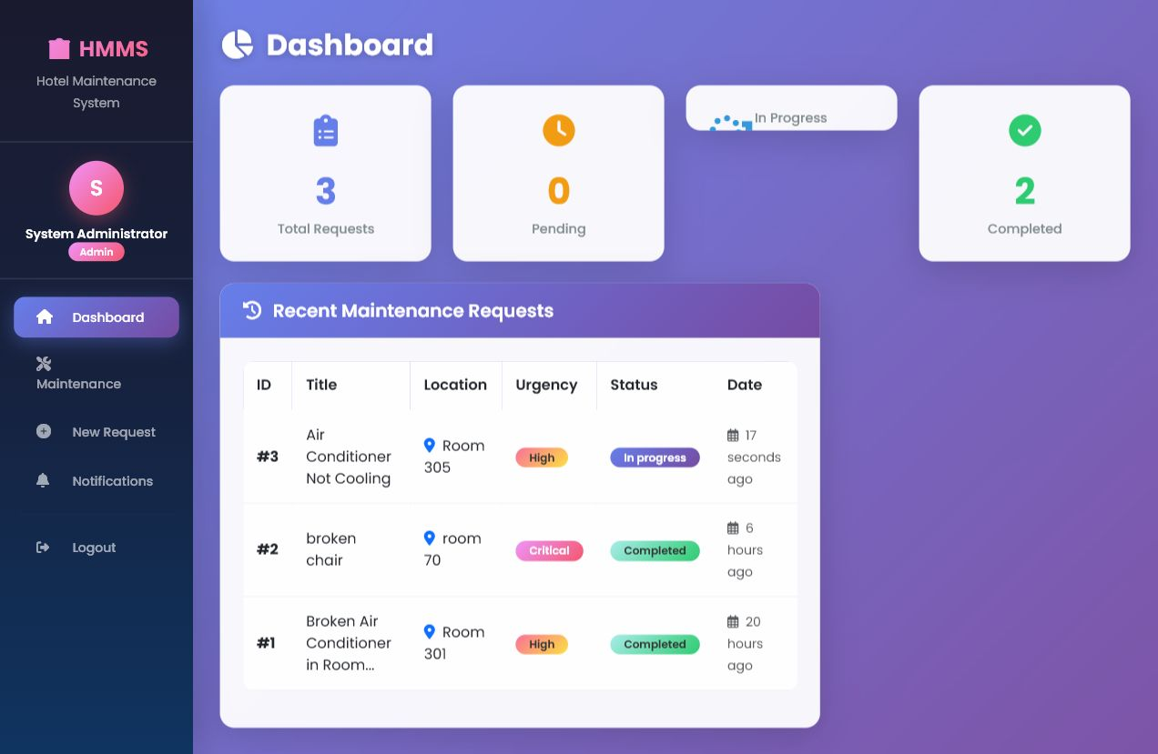
Figure A1. Administrator dashboard with request statistics and recent requests
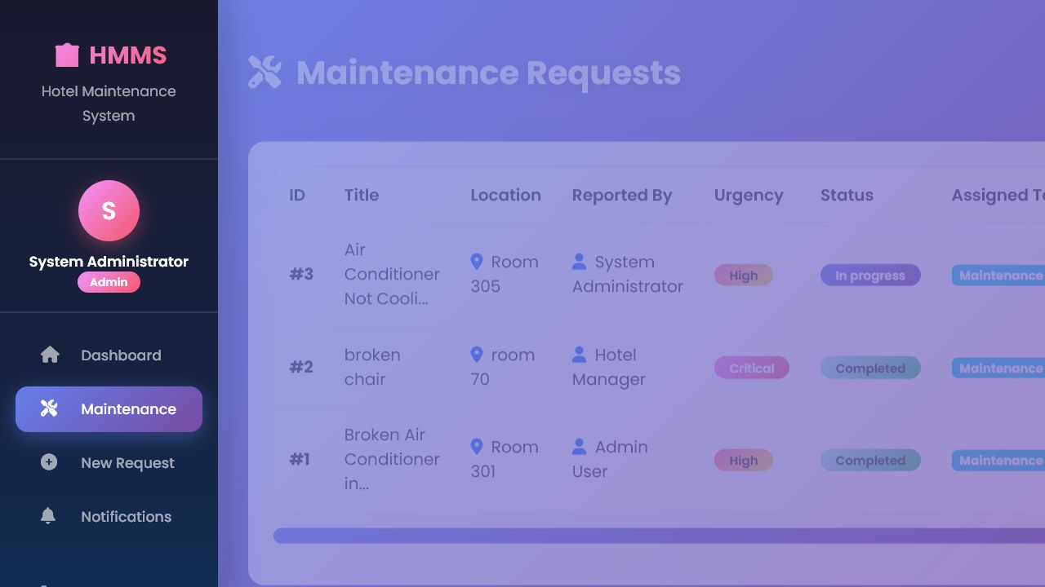
Figure A2. Maintenance request register with urgency and status information
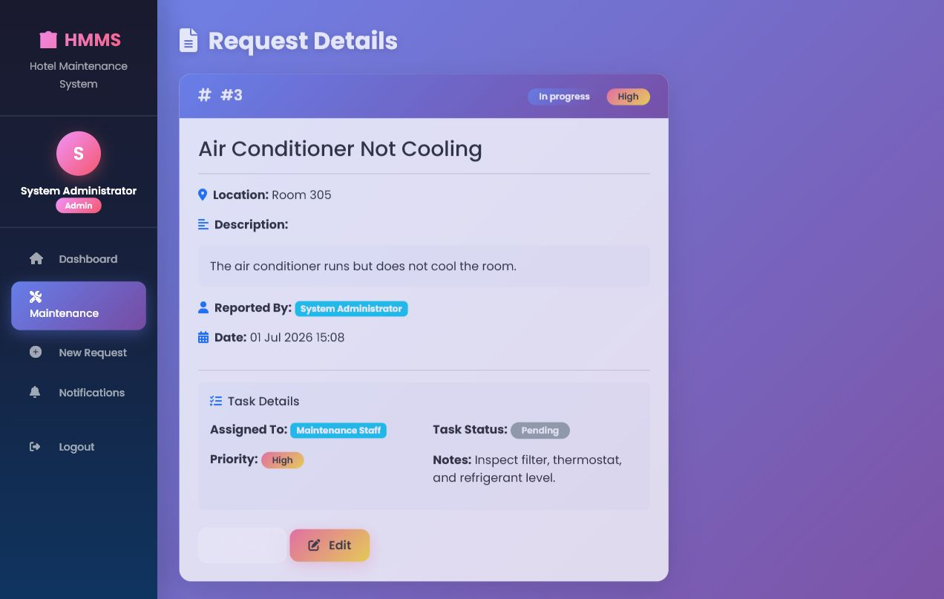
Figure A3. Request detail and task assignment information
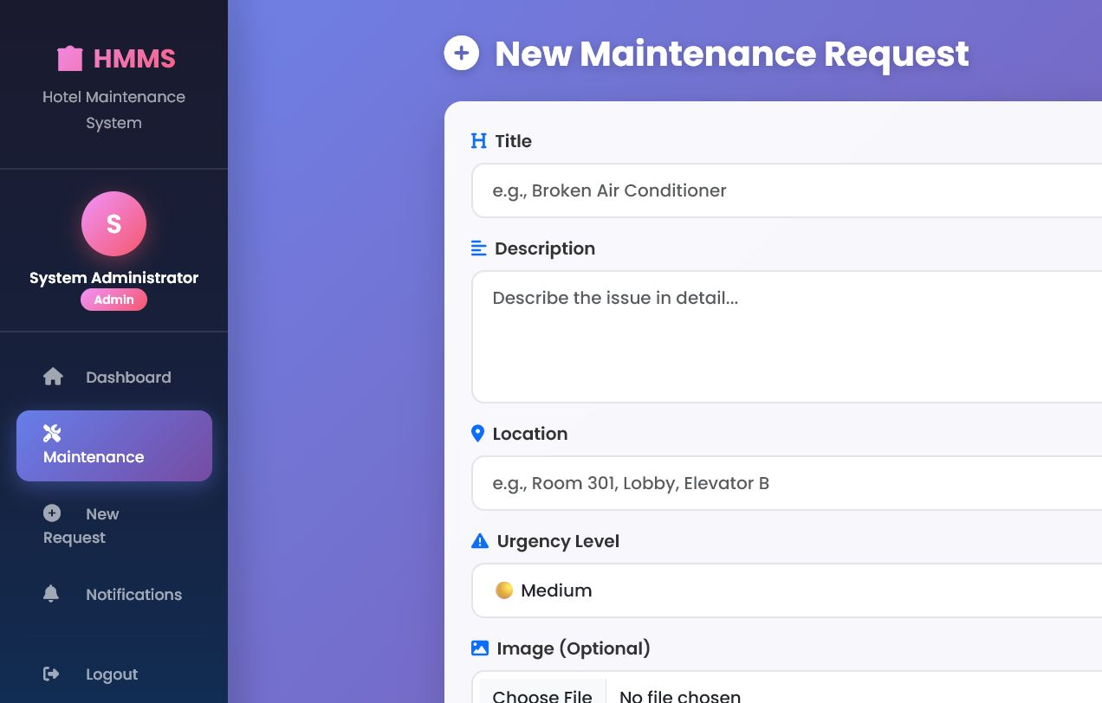
Figure A4. New maintenance request form
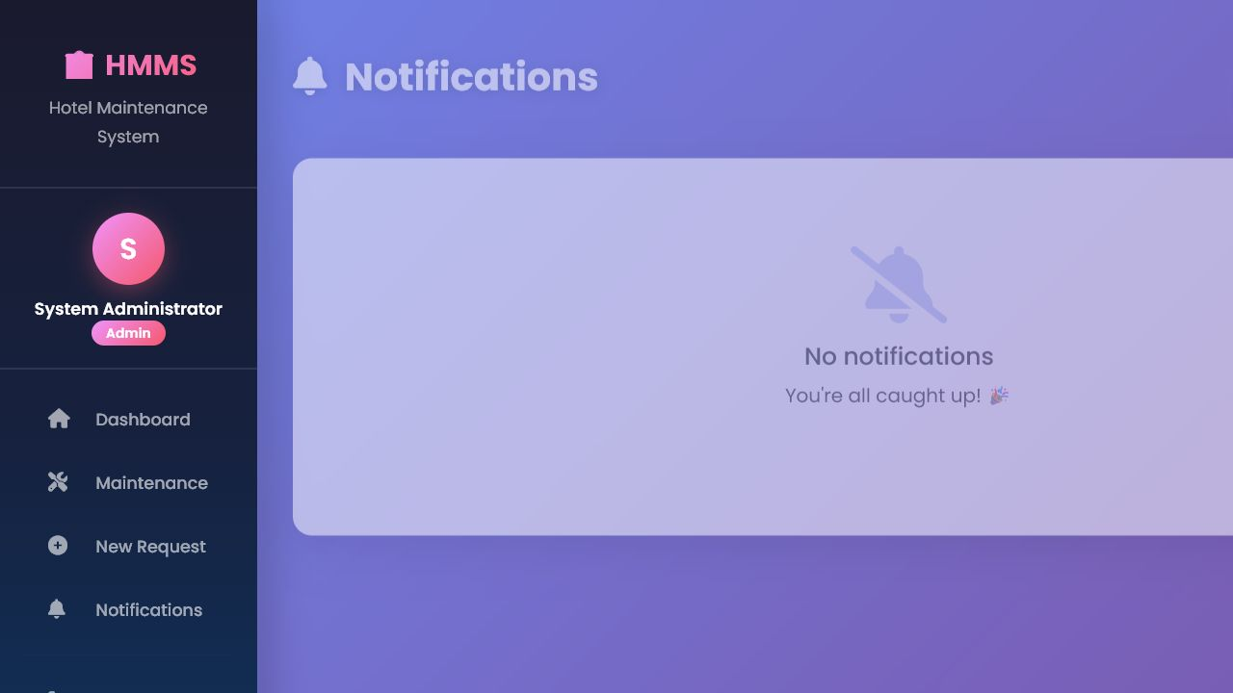
Figure A5. Notification centre

Appendix B. Test Case Register
The complete test case register is supplied as HMMS_FULL_TEST_CASES.xlsx. It contains a summary worksheet and 18 individual test case worksheets. Every worksheet records prerequisites, test data, three execution steps, expected results, actual results and final status.
Workbook Section | Content
TEST SUMMARY | 18 cases, module mapping, status and evidence reference
TC-001 to TC-002 | Authentication positive and negative scenarios
TC-003 | Dashboard verification
TC-004 to TC-008 | Maintenance request lifecycle
TC-009 to TC-011 | Assignment and task progression
TC-012 to TC-013 | Notification behavior
TC-014 | Profile update
TC-015 to TC-016 | Protected navigation and password reset
TC-017 | Request deletion
TC-018 | Automated regression execution

