**How to Use this Template**

1. Create a new document, and copy and paste the text from this template into your new document [ Select All → Copy → Paste into new document ]
2. Name your document file: “**Capstone_Stage1**”
3. Replace the text in green

**GitHub Username**: Muhammadelhady

TheWorld

# Description

TheWorld is a news app enabling user to stay up-to-date with latest news from all over the world by collecting the news from over 30,000 different sources with different categories like Sports, technology, fashion, politics, and economy.  
the sources are from a various countries across the world Like: ae ar at au be bg br ca ch cn co cu cz de eg fr gb gr hk hu id ie il in it jp kr lt lv ma mx my ng nl no nz ph pl pt ro rs ru sa se sg si sk th tr tw ua us ve za

# Intended User

All users from all over the world

# Programming language

Java

# Used Versions

Android studio : 3.1.4

Gradel : 3.1.4

Picaso : 2.71828

# Features

* Reading News
* Categories news
* Saving news to read later
* Searching in news
* Share news

# User Interface Mocks

## Screen 1

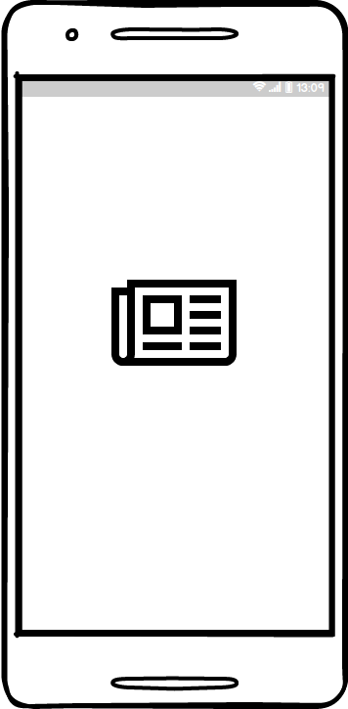

Splash Screen

## Screen 2

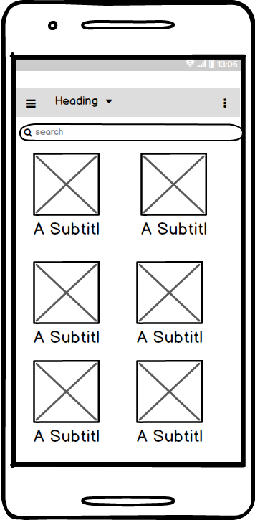

Main screen contains news by category allowing user to read news from specific category or read news from all categories.

## Screen 3

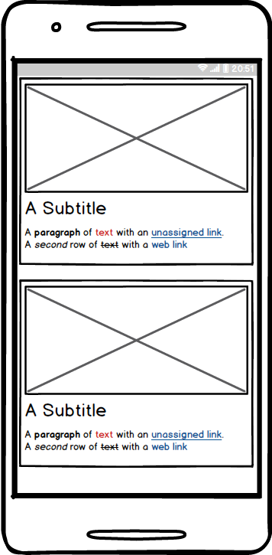

News screen showing the articles with subtitle and picture.

## Screen 4

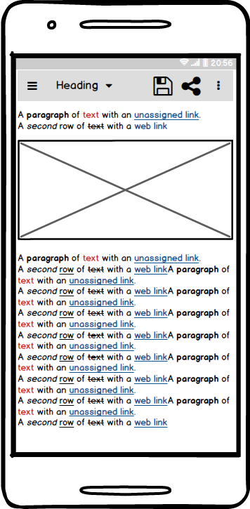

Article screen displaying the article content and image, also contains app bar to share the article with the others or save it to read later.

## Screen 5

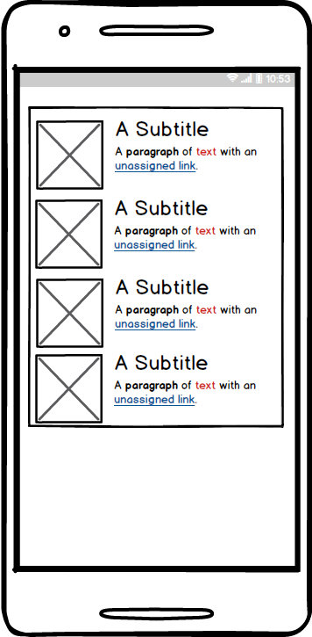

Widget screen contains all the read later articles.

# Key Considerations

### How will your app handle data persistence?

Using firebase real-time database to store user data.

### Describe any edge or corner cases in the UX.

* Prevent network error by checking the availability of the network before any network call and indicates the user if there a network problem.
* Use large image of the article making user have a brief about the article before enter.
* Using small description about the article content before enter the article.
* Use known icon and symbols for function to reduce inconvenient

### Describe any libraries you’ll be using and share your reasoning for including them.

Picasso library to load image from web to the image view cause it`s so simple and fast also allowing caching which reduce the using of internet bandwidth.

Retrofit to parsing the returning Jason from the API cause it`s reduce the development time and making calling the API so easy as calling a regular java method.

### Describe how you will implement Google Play Services or other external services.

1. Firebase real-time database to store the read later articles
2. Google sign in

# Next Steps: Required Tasks

## Task 1: Project Setup

Defining the architecture of the project and how the development will start and end dividing the project into phases and small sprints.

Steps

* State the features of the app
* Make a milestones
* Make a sequence for the development process depending on the requirements
* Prepare the ide and working environment and setup library versions

## Task 2: Implement UI for Each Activity and Fragment

Start building the UI for the activities of the app and define the navigation flow between the activates.

Steps

* Start defining the screen elements and how each element will be build and used views in it.
* Define the needed color schema and writing the color.xml file.
* Define the needed string and write the strings.xml file.
* Building the screens and it`s layout structure.

## Task 3: Database design

Start designing the database and defining it`s schema to save the read later articles data to retrieve it later

## Task 4: Coding

Coding the software functions and implements it like calling the API and parsing it`s data and binding the Data to the views.

Steps

* Structure the code into reusable class
* Building the utile classes needed for the app
* Connect the app to the API and retrieve data to bind it to the views
* Coding the firebase calls and saving data methods

## Task 5: widget

Implementing the widget of the app (Designing and coding, and integrating it with the app to retrieve the read later news to displaying it to the user in the home screen.

## Task 6: testing

Start to finish the app and testing the workflow and stability of the app and solving the bugs if exists.

**Submission Instructions**

* After you’ve completed all the sections, download this document as a PDF [ File → Download as PDF ]
  + Make sure the PDF is named “**Capstone_Stage1.pdf**”
* Submit the PDF as a zip or in a GitHub project repo using the project submission portal

If using GitHub:

* Create a new GitHub repo for the capstone. Name it “**Capstone Project**”
* Add this document to your repo. Make sure it’s named “**Capstone_Stage1.pdf**”